**HIST 380.04/COM 580.07**

**Diversity in the History of Technology**

**Illinois Institute of Technology**

Fall 2019

3:15 pm - 4:30 pm, Mondays and

Wednesdays

007 Hermann Hall

Professor Hicks

[mhicks1@iit.edu](mailto:mhicks1@iit.edu)

Office: 206 Siegel Hall

Office Hours: by appointment (email me)

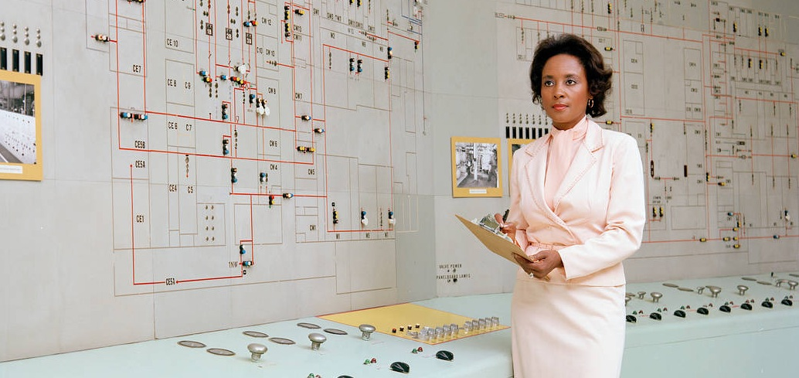

Computer scientist and mathematician Annie Easley at NASA, c. 1981

**Course Description:**

The history of technology has often been written as a US-centric progress narrative focusing on the achievements of a small number of powerful people. Yet, scholarship in a variety of fields has reoriented that narrative over the course of the past three decades. Unearthing these hidden or ignored narratives gives us better insight into the promises and pitfalls of our technological present by expanding and deepening our understanding of our technological past.

In this course we will read major recent works in STS, history of computing, information studies, women's studies, gender and sexuality studies, critical race studies, and other fields. We will analyze how oftentimes technological progress becomes a stand-in for the status quo, rather than true progress, and why US society is reaching a watershed moment where incorporating more viewpoints in the design and deployment of our technological systems is becoming increasingly important. Throughout this class, we will question whether socioeconomic progress and technological advance are always as aligned as they seem, and we will investigate the new insights that emerge when we decouple the two.

Readings will include selections from books, articles, and news items that relate to the historical topics that we’re addressing. Assignments will ask you to reflect on the readings throughout the semester, and—at the end of the term—to either complete a take-home final examination project or, in the case of graduate students, create a longer work that helps you progress in your particular program of graduate study.

**Readings and Assignments:**

You are responsible for doing the reading **before class for the day it is listed** so that we can all discuss what you’ve read. In addition, for certain weeks you will be asked to bring in or share supplementary readings in the form of scholarly articles or pieces from the mainstream press on current events that relate to the histories we’re discussing. Readings will be on Blackboard or linked from the syllabus. Here is a short reading guide you may find helpful as you read for this class: <http://marhicks.com/syllabi/ReadingTipsforHistoryClassesv2.pdf>

Class participation: 20%

Small assignments/homework

(in class or assigned in class): 20%

Midterm exam: 30%

Final take-home exam/project (longer paper for grad students): 30%

**Please note:** I am happy to field general questions about the class or assignments via email but I am unable to individually let students know what they have missed in the event a student misses class. If you miss class, please email one of your *fellow students* to find out about the content or assignments you have missed. If you have further questions after you have talked to a fellow student, or need clarification about what they’ve told you, then feel free to ask or email me.

**Accommodations** will be made for students with disabilities. In order to access these resources or get special provisions in class please [register](https://web.iit.edu/cdr/registration) with the [Center for Disability Resources](https://web.iit.edu/cdr) at the beginning of the semester and speak with me so we can plan ahead for the needed accommodations.

**Academic Honesty:** Cheating, plagiarism, and academic dishonestyare serious offenses and will not be tolerated. They will result in a failing grade on the assignment and possibly in the course (at my discretion) and the University will levy sanctions as well. If you are in doubt about what constitutes plagiarism or academic dishonesty, reread the code of student conduct and the sections on academic honesty in the student handbook: <http://www.iit.edu/student_affairs/handbook/pdfs/handbook_fy13.pdf> (page 27). If you are still confused, speak with me **before** you pass in an assignment. Remember that it is *never* appropriate to use someone’s ideas or words without giving them credit, and that copying text from sources or peers—in addition to being plagiarism and cheating—short-circuits the learning process and is the exact opposite of what I want to see.

**Class Schedule:**

M Aug 19 **Introduction: Hidden Histories of Technology**

*What do we think about when we hear the term “history of technology”? What else should we perhaps be thinking about? And why? What difference does this make?*

W Aug 21 **What are the stakes? Why should we care?**

Readings:

Varma and Kapur, “Decoding Femininity in Computer Science in India,” *Communications of the ACM*

Dar-Nimrod & Heine, “Exposure to Scientific Theories Affects Women’s Math Performance,” *Science*

and, Buolamwini, “Gender Shades,” watch video at: <http://gendershades.org/> or read: <https://www.businessinsider.com/biases-ethics-facial-recognition-ai-mit-joy-buolamwini-2019-1>

M Aug 26 **Do technologies have politics?**

Readings:

Winner, “Do Artifacts Have Politics?”

<https://www.cc.gatech.edu/~beki/cs4001/Winner.pdf>

and start reading Crenshaw, “Demarginalizing the Intersection of Race and Sex”

<http://chicagounbound.uchicago.edu/cgi/viewcontent.cgi?article=1052&context=uclf>

W Aug 28 **Overlapping categories of power**

Readings:

Finish reading Crenshaw, “Demarginalizing the Intersection of Race and Sex”

<http://chicagounbound.uchicago.edu/cgi/viewcontent.cgi?article=1052&context=uclf>

M Sept 2 **NO CLASS—LABOR DAY**

W Sept 4 **Applying what we’ve learned so far**

In-class exercise: Come to class with some ideas written down about an artifact (technology) that “has politics” in the sense that Langdon Winner wrote about. During this class you’ll be asked to explain how and why your chosen technology has politics after having time to discuss and prepare with classmates. Can your technology be stripped of its politics without being completely redesigned, or destroyed? Would this cause more problems? Try to deploy an intersectional analysis of the technology as you answer these questions.

M Sept 9 **Technological “advance”—progress for whom?**

Excerpts from Cooper Owens, *Medical Bondage: Race, Gender, and the Origins of American Gynecology*

and “Eli Whitney's Patent for the Cotton Gin,” at the US National Archives website: <https://www.archives.gov/education/lessons/cotton-gin-patent>

W Sept 11 **Industrialization and manufacture: Who works, who dies, and who profits**

Read “The Story of the Triangle Factory fire”: <https://trianglefire.ilr.cornell.edu/story/introduction.html>

(start at the link above and click through to read the whole narrative)

Read a few of the primary sources: <https://trianglefire.ilr.cornell.edu/primary/index.html>

Suggestions:

<https://trianglefire.ilr.cornell.edu/primary/testimonials/ootss_RoseCohen.html>

<https://trianglefire.ilr.cornell.edu/primary/testimonials/ootss_SamuelGompers.html>

<https://trianglefire.ilr.cornell.edu/primary/testimonials/ootss_WilliamShepherd.html>

<https://trianglefire.ilr.cornell.edu/primary/newspapersMagazines/nyt_032811.html>

<https://trianglefire.ilr.cornell.edu/primary/newspapersMagazines/ld_010612.html>

Article Comparing Triangle and Rana Plaza: <http://ideas.time.com/2013/05/02/what-bangladesh-can-learn-from-new-yorks-triangle-factory-fire/>

M Sept 16 **Modern piecework/Digital factories**

Roberts, “Social Media’s Silent Filter,” <https://www.theatlantic.com/technology/archive/2017/03/commercial-content-moderation/518796/>

Marvit, “How Crowdworkers Became the Ghosts in the Digital Machine,” *The Nation* <https://www.thenation.com/article/how-crowdworkers-became-ghosts-digital-machine/>

*Mother Jones*, “I Was a Warehouse Wage Slave,” April 2012

<http://www.motherjones.com/politics/2012/02/mac-mcclelland-free-online-shipping-warehouses-labor>

W Sept 18 **Who gets hidden—and why? Hidden histories of computing**

Readings:

Nelson, “Race and Computing: The Problem of Sources, the Potential of

Prosopography, and the Lesson of Ebony Magazine” IEEE Annals of the History of Computing (Jan.–Mar. 2017, vol. 39) <https://www.computer.org/csdl/mags/an/2017/01/man2017010029-abs.html>

and begin reading:

Excerpts from Shetterly, *Hidden Figures*

M Sept 23 **Black women in computing history**

Readings:

Excerpts from Shetterly, *Hidden Figures*

W Sept 25 **Refugees, startups, and work-from-home moms**

Readings: Excerpts from Shirley, *Let IT Go*

M Sept 30 **Butterfly Effects**

Readings: Hicks, “How to Kill Your Tech Industry” <https://logicmag.io/failure/how-to-kill-your-tech-industry/>

W Oct 2 **Machine-molded categories**

Readings:

Drucker, “Keying Desire: Alfred Kinsey’s Use of Punched-Card Machines for

Sex Research.” *Journal of the History of Sexuality* 22, no. 1 (2013): 105-125.

M Oct 7 **NO CLASS—FALL BREAK**

W Oct 9 **Machine enforced categories—then and now**

Readings:

Hicks, “Hacking the Cistem” <https://ieeexplore.ieee.org/document/8634814>

and skim: Keyes, “The Misgendering Machines: Trans/HCI Implications of

Automatic Gender Recognition”

M Oct 14 **Skill stereotypes and labor power**

Readings:

Nakamura on Navajo women in hardware manufacturing at Fairchild Semiconductor:

<http://www.computerhistory.org/atchm/indigenous-circuits/>

<https://lnakamur.files.wordpress.com/2011/01/indigenous-circuits-nakamura-aq.pdf>

Excerpt from *Programmed Inequality*

Conger & Schieber, “Employee Activism is Alive in Tech,” <https://www.nytimes.com/2019/07/08/technology/tech-companies-union-organizing.html>

W Oct 16 Midterm review

M Oct 21 **MIDTERM**

W Oct 23 Final project/take-home final assigned (Important! Don’t miss this class!)

M Oct 28 **Labor and diversity in tech today: From the “women’s march” to transphobic ethics panels**

Readings:

Articles on the Google Women’s March, Dragonfly, Maven, ethics panel debacle, and employer retaliation; article on Lesley Miley

W Oct 30 **Algorithmic bias—categories and value judgments**

Sweeney, “Discrimination in online ad delivery.” *Communications of the ACM*

56, no. 5 (2013): 44-54.

M Nov 4 **Algorithmic bias—(un)intended consequences?**

Readings:

Noble, excerpts from *Algorithms of Oppression*

W Nov 6 **More unintended consequences**

CBS News, “Facebook's new rapid response team has a crucial task: Avoid fueling another genocide,” <https://www.nbcnews.com/tech/tech-news/facebook-s-new-rapid-response-team-has-crucial-task-avoid-n1019821>

“The Black Feminists Who Saw the Alt-Right Threat Coming,” <https://slate.com/technology/2019/04/black-feminists-alt-right-twitter-gamergate.html>

M Nov 11 **Your choice**

Readings to be decided in class today (for next time)

W Nov 13 **Your news articles**

M Nov 18 NO CLASS, BUT:

Listen to Prof. Ruha Benjamin interview on FAIR radio:

<https://fair.org/home/black-communities-are-already-living-in-a-tech-dystopia/>

Watch Prof. Chris Gilliard lecture on digital redlining: <https://www.youtube.com/watch?v=MEPI7YctRqY>

We will talk about these when we return to class on November 20th. Also come to class on November 20th with some clear ideas and notes on what you want to do for your final project.

W Nov 20 **Discussion of items above and in-class exercise for final project/take-home final**

Come to class with notes on what you intend to write about.

M Nov 25 **Conclusion (Last Class of the Semester)**

W Nov 27 **THANKSGIVING BREAK (NO CLASS)**

Dec 2-7 FINAL EXAM PERIOD—Your take-home final will be due during the final exam time slot assigned to our class. This time slot will be posted by the registrar about halfway through the semester, when the registrar posts the final exam schedule for the entire university.