ITMD 421: Database Modeling and Applications

Assignment 1

Due Monday, September 4th.

Part 1

- Create an Entity Relational diagram for the football league games and transform the schema into tables.

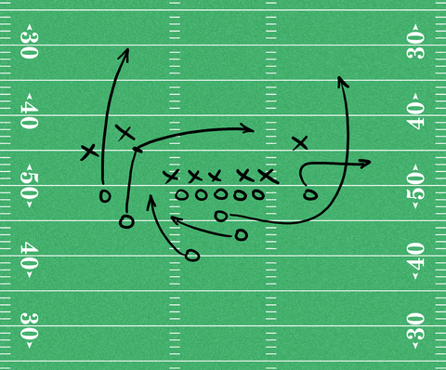
TEAM PLAYERS GAME
The assumptions for the game are provided below.
- The baseball league comprises of many teams
- Each team has a name, city, and a team of players, coach and a captain.
- Each team can play with each other multiple times.
- Each player can play only for one team. (there are no trades/changes)
- Each player has a name, skill level, record of number of wins, total number of games played.
- A team captain also plays for the team.
- A game is played between the two teams.
- A game results in win/loss or a touchdown.

- Create a relational schema with underlined (primary) keys and arrows connecting foreign keys and primary keys for a database containing the following information.
- Authors have Last Name, Firstname, ID, and Birthdate (identified by Author_ID)
- Publishers have Name, ID, address (identified by Publisher_ID)
- Books have ISBN, Title, Publisher (each book has a unique publisher and can be identified by ISBN).
- Authors Write Books; many authors can co-author a book.
Please make sure to write all your assumptions.
- Create an ER diagram for the movie renting application (example: Redbox) and then transform that ER diagram into tables.
- A member can rent more than one movie at a time.
- A movie can be rented by more than one member at the same time.
- Member information comprises of Membership number, Address, Name, Credit Card detail.
- There are different genres to select your movie from.
- Each movie has information – Name, Release Date, Genre, ID
- Payment information stores name on the credit card, payment details, payment information.
Make sure you write all the assumptions that you’re making while writing your work.
Each question is 25 marks each.
Be sure that your name and “Assignment 1” appear at the top of your submitted file.

