ITMD 421 – Data Modeling and Applications

Assignment 5

Due Tuesday, Nov 7th

NOTE :
For this assignment, you will submit a Microsoft word document and a .sql file.
For each SQL statement that you construct in the steps below, you must provide the screenshot of your SQL statement.

You are given the below database
employee(employee-name, street, city)
works(employee-name, company-name, salary)
company(company-name, city)
manages(employee-name, manager-name)

Give an expression in SQL for each of the following queries:

- Find the names, street address, and cities of residence for all employees who work for 'First Bank Corporation' and earn more than $10,000.
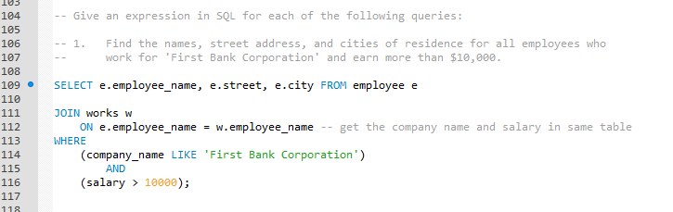
- Find the names of all employees in the database who live in the same cities as the companies for which they work.
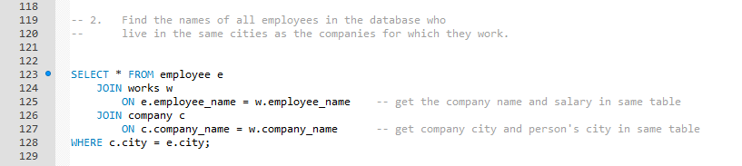
- Find the names of all employees in the database who live in the same cities and on the same streets as do their managers
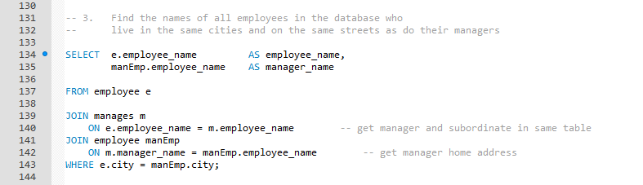
- Find the names of all employees in the database who do not work for 'First Bank Corporation'. Assume that all people work for exactly one company
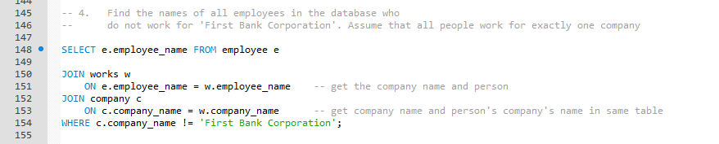
- Find the names of all employees in the database who earn more than every employee of 'Small Bank Corporation'. Assume that all people work for at most one company.
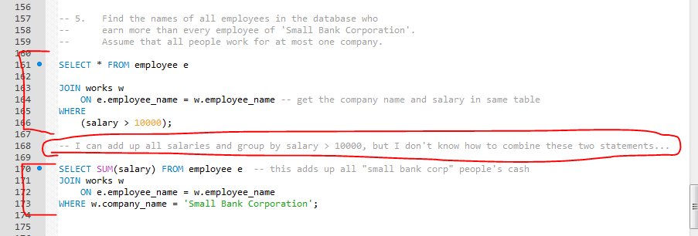
- Assume that the companies may be located in several cities. Find all companies located in every city in which 'Small Bank Corporation' is located.
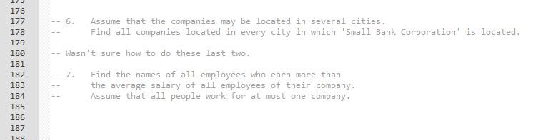
- Find the names of all employees who earn more than the average salary of all employees of their company. Assume that all people work for at most one company.

