ITMD421 – Data Modeling and Applications

Final Project

Due Friday, December 1st

NOTE :
For this final project, you will submit a Microsoft word document and a .sql file.
The word document contains the screenshot of the sql executed with the results.

For each SQL statement that you construct in the steps below, you must provide the screenshot of your SQL statement.

- Create the Person table. Person(person_id,first_name,last_name)
Primary Key: person_id; All the other fields are required.
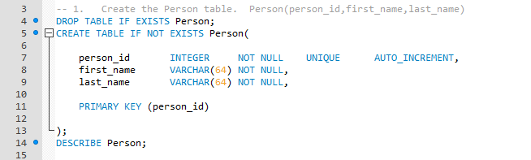

- Create the Building table. Building (building_id,building_name)
Primary Key: building_id; All the other fields are required.
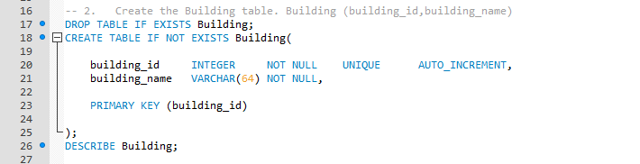
- Create the Room table. Room(room_id, room_number, building_id, capacity)
Primary Key: room_id; All the other fields are required.
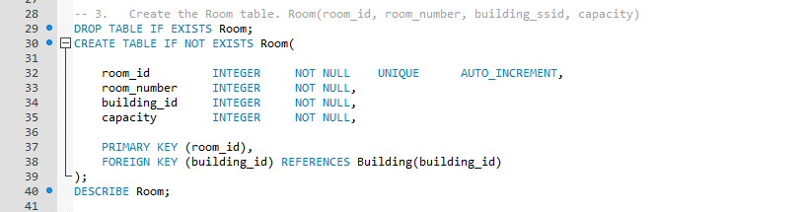
- Create the Meeting table. Meeting (meeting_id,room_id,meeting_start,meeting_end)
Primary Key: meeting_id; ; All the other fields are required.
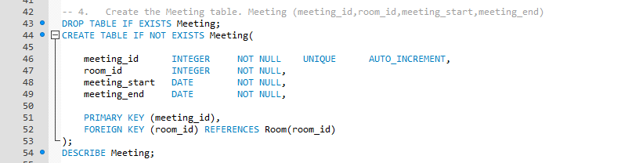
- Create the Person-Meeting intersection table. Person_meeting(person_id,meeting_id)
Primary Key: person_id, meeting_id
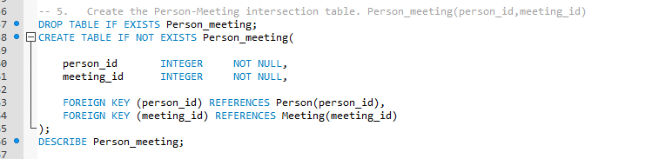
- Insert the below data in the Person table
(Tom, Hanks)
(Anne", Hathaway)
(Tom, Cruise)
(Meryl", Streep)
(Chris, Pratt)
(Halle, Berry)
(Robert, De Niro)
(Julia, "Roberts")
(Denzel, "Washington)
(Melissa, McCarthy)
- Insert the below data in the Building table
(Headquarters)
(Main Street Building)
- Insert the below data in the Room table
(room_number, building_id, capacity)
(100, 1, 5)
(200, 1, 4)
(300, 1, 10)
(10, 2, 4)
(20, 2, 4)
- Insert the below data in meeting table
meeting (room_id, meeting_start, meeting_end)
(1, 2016-12-25 09:00:00, 2016-12-25 10:00:00)
(1, 2016-12-25 10:00:00, 2016-12-25 12:00:00)
(1, 2016-12-25 11:00:00, 2016-12-25 12:00:00)
(2, 2016-12-25 09:00:00, 2016-12-25 10:00:00)
(4, 2016-12-25 09:00:00, 2016-12-25 10:00:00)
(5, 2016-12-25 14:00:00, 2016-12-25 16:00:00)
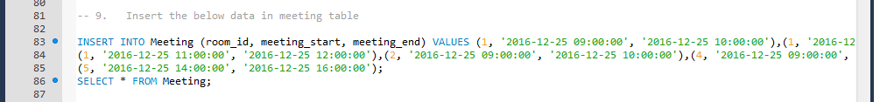
- Insert the below data in person_meeting table
person_meeting (person_id, meeting_id)
VALUES
(1, 1)
(10, 1)
(1, 2)
(2, 2)
(3, 2)
(4, 2)
(5, 2)
(6, 2)
(7, 2)
(8, 2)
(9, 3)
(10, 3)
(1, 4)
(2, 4)
(8, 5)
(9, 5)
(1, 6)
(2, 6)
(3, 6)
- Find all the meetings that Tom Hanks has to attend
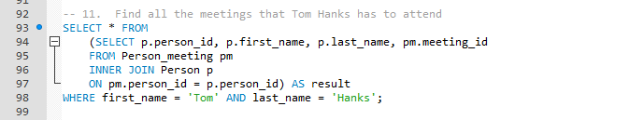
- Find all the people that are attending meeting ID 2

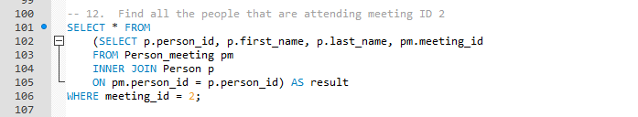
- Find all the people who have meetings in the Main Street building
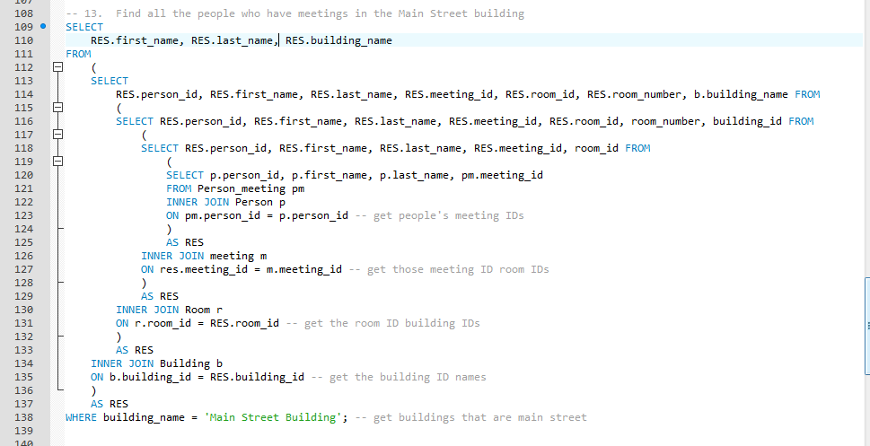
- Find the number of attendees for every meeting

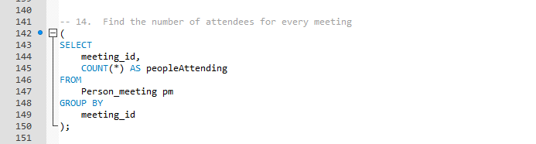
- Find All of the People that Have Meetings Only Before Dec. 25, 2016 at Noon Using INNER JOINs
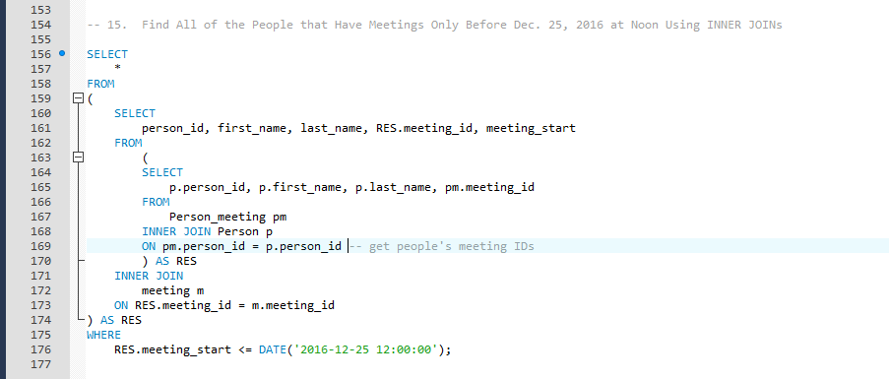
Be sure that your name and “Final Project” appear at the top of your submitted file.

