ITMD 421 – Data Modeling and Applications

Assignment 4

Due Tuesday, October 23^{rd’}

NOTE :
For this assignment, you will submit a Microsoft word document and a .sql file.
For each SQL statement that you construct in the steps below, you must provide the screenshot of your SQL statement.

- We will create a concerts database: create the following tables that will store information about performance types (ex. song, dance, etc.), about performers, arenas (for performances) and concerts.
Save your work as Yourname_lab2_1.sql
Here is the schema for these tables, with primary key underlined and foreign keys in RED italic

- PerformanceTypes(PerformanceTypeName) – types of performance
- Performers(PerformerID, FirstName, LastName, Address, PerformanceTypeName) – Each performer has a performedID (integer), a name, address and type of performance
- Arenas(ArenaID, ArenaName, City, Capacity) -- Each arena has an id (integer), a name (Ex. Allstate Center), a city where the arena is located, and seating capacity of the arena
- Concerts(PerformerID, ArenaID, ConcertDate) – each concert is given by one performer, on a given arena, at a given date .

- Write and execute the SQL statements to create the 4 tables given above. Choose appropriate data types for each column, and declare primary key and foreign key constraints as appropriate.
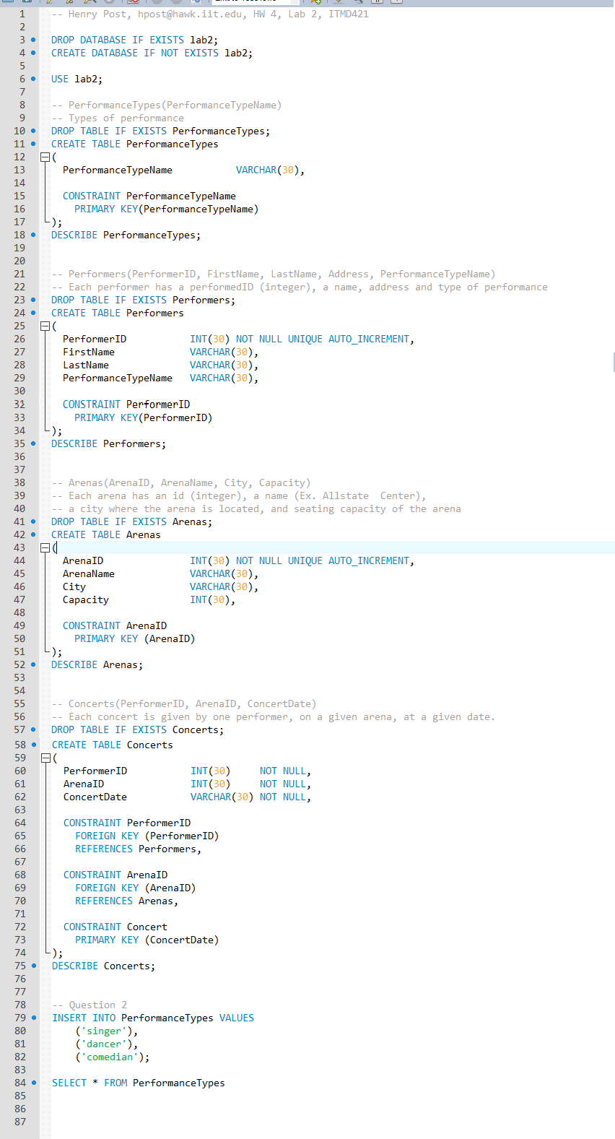
- Insert rows in the PerformanceTypes table, for type ‘singer’, ‘dancer’ and ‘comedian’.
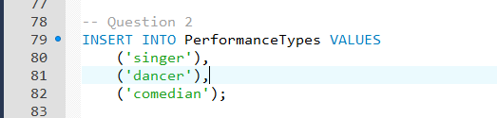
- Write the SQL statement to modify your Performers table to add a new column called DateOfBirth. Choose the appropriate data type for this column. The values in the column could be null.
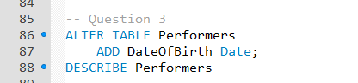
- Insert one row in the Performers table with PerformerID 1, name John Dow, address Annapolis, MD, and performance type ‘singer’.
- Try now to insert a performer row with a PerformanceTypeName that does not exist in PerformanceTypes table (ex. ‘painter’). What happens? Show your work with errors.
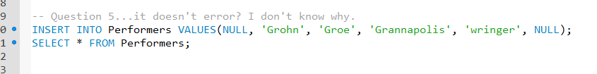
- Insert 3 more rows in the Performers table, with names ‘Matt Smith’, ‘Jane Brown’, and respectively ‘Jennifer Shade’, and addresses ‘Baltimore, MD’, ‘New York, NY’, and respectively ‘Seattle, WA’. All these 3 performers should be of type ‘dancer’.
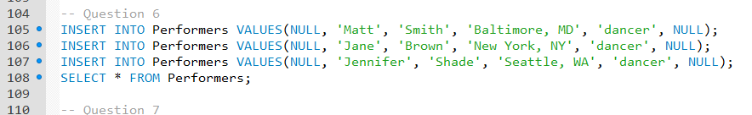
- Change the DateOfBirth of the performer with id 1 to be ‘1990-03-02’.
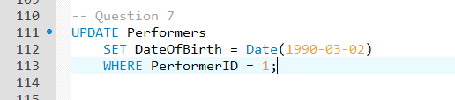
- Remove the performer ‘Matt Smith’ from the Performers table.
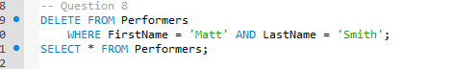
- Write the SQL statement to remove performance type ‘singer’ from the PerformanceTypes table.
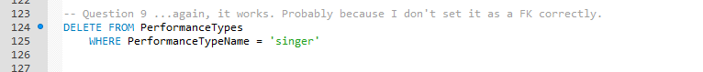
- Execute the statement above, then list all rows from the PerformanceTypes table. Was ‘singer’ removed? Explain why the row was removed from the PerformanceTypes table, or why it was not removed.
- Write the SQL statement to update the performance type name for ‘dancer’ in PerformanceTypes to be ‘dance performer’.
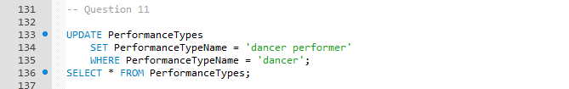
- Execute the statement above. Does the query succeed?
- Write the SQL statements to insert 3 rows with ids 1, 2, and respectively 3 into the Arenas table.
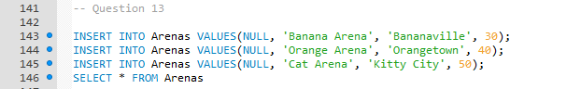
- Write the SQL statements to insert 4 rows in the Concerts table, two of them for arena 1, and two for arena 2.
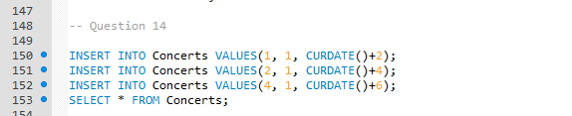
- Write the SQL statement to update all arenas with at least 2 concerts to have the seat capacity 50000. The query should work for any possible data in the database.
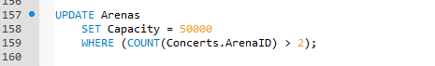
- Create a new ‘Dancers’ table with the same structure as the Performers table
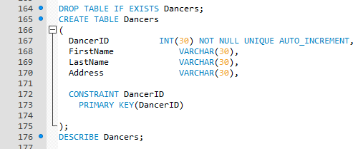
- Insert all performers of type ‘dancer’ from the Performers table into the Dancers table
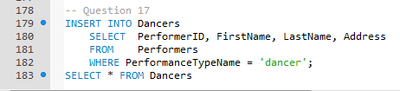

- Consider the below relational schema
Customer (name, email, phone, totalPurchase)
Video (vID, name, year, cost, genre)
Actor (aID, name, dob)
Price (priceCode, cost)
Rents (email-FK, vID-FK, priceCode-FK, rentalFee, lateFee, date, dueDate, returnDate)
Performs (vID-FK, aID-FK)
Here is the schema for these tables, with primary key underlined

write the CREATE TABLE statements to create the physical database structure to hold the data for the Movie Rental Database.
Save your work as Yourname_lab2_2.sql

- -- Henry Post, hpost@hawk.iit.edu, HW 4, Lab 2, ITMD421

- SET SQL_SAFE_UPDATES = 0;

- DROP DATABASE IF EXISTS lab2;
- CREATE DATABASE IF NOT EXISTS lab2;

- USE lab2;

- -- Consider the below relational schema
- -- Customer (name, email, phone, totalPurchase)
- -- Video (vID, name, year, cost, genre)
- -- Actor (aID, name, dob)
- -- Price (priceCode, cost)
- -- Rents (email-FK, vID-FK, priceCode-FK, rentalFee, lateFee, date, dueDate, returnDate)
- -- Performs (vID-FK, aID-FK)
- -- Here is the schema for these tables, with primary key underlined

- -- write the CREATE TABLE statements to create the physical database structure
- -- to hold the data for the Movie Rental Database.

- -- Save your work as Yourname_lab2_2.sql

- DROP TABLE IF EXISTS Customer;
- CREATE TABLE Customer
- (
- name VARCHAR(30) NOT NULL,
- email VARCHAR(30) NOT NULL UNIQUE,
- phone VARCHAR(30) NOT NULL,
- totalPurchase INT,

- CONSTRAINT email
- PRIMARY KEY(email)

- );
- DESCRIBE Customer;

- DROP TABLE IF EXISTS Video;
- CREATE TABLE Video
- (

- vID INT NOT NULL UNIQUE AUTO_INCREMENT,
- name VARCHAR(30) NOT NULL,
- year YEAR NOT NULL,
- cost INT NOT NULL,
- genre VARCHAR(30) NOT NULL,

- CONSTRAINT vID
- PRIMARY KEY(vID)

- );
- DESCRIBE Video;

- DROP TABLE IF EXISTS Actor;
- CREATE TABLE Actor
- (

- aID INT NOT NULL UNIQUE AUTO_INCREMENT,
- name VARCHAR(30) NOT NULL,

- CONSTRAINT aID
- PRIMARY KEY(aID)

- );
- DESCRIBE Actor;

- DROP TABLE IF EXISTS Price;
- CREATE TABLE Price
- (

- priceCode INT NOT NULL UNIQUE AUTO_INCREMENT,
- name VARCHAR(30) NOT NULL,

- CONSTRAINT priceCode
- PRIMARY KEY(priceCode)

- );
- DESCRIBE Price;

- DROP TABLE IF EXISTS Rents;
- CREATE TABLE Rents
- (
- email VARCHAR(30) NOT NULL UNIQUE,
- vID INT NOT NULL UNIQUE,
- priceCode INT NOT NULL UNIQUE,
- rentalFee INT NOT NULL,
- lateFee INT NOT NULL,
- date DATE NOT NULL,
- dueDate DATE NOT NULL,
- returnDate DATE,

- CONSTRAINT email
- FOREIGN KEY (email)
- REFERENCES Customer(email),

- CONSTRAINT vID
- FOREIGN KEY (vID)
- REFERENCES Video(vID),

- FOREIGN KEY (priceCode)
- REFERENCES Price(priceCode)
- );
- DESCRIBE Rents;

Be sure that your name and “Assignment 2” appear at the top of your submitted file.

