ITMD 421: Database Modeling and Applications

Assignment 2

Due Monday, September 18th

Henry Post

1.
This table is un-normalized form. Convert this table from 1NF to 3NF.
Show your work.
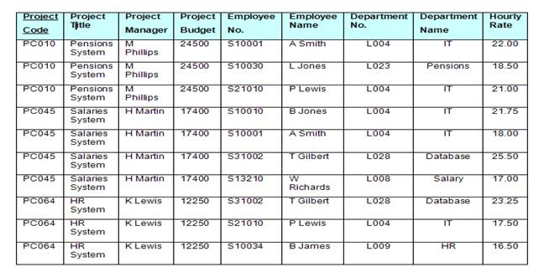

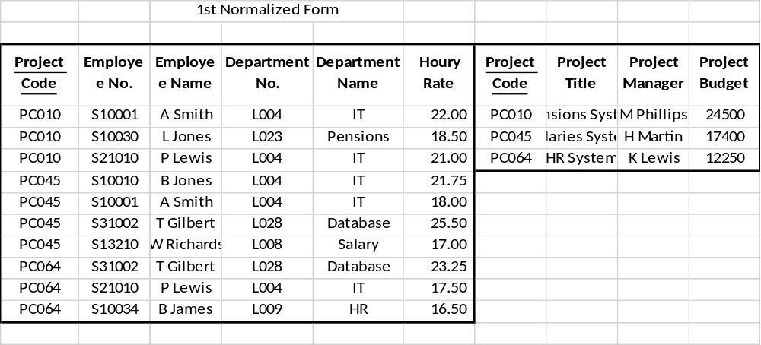
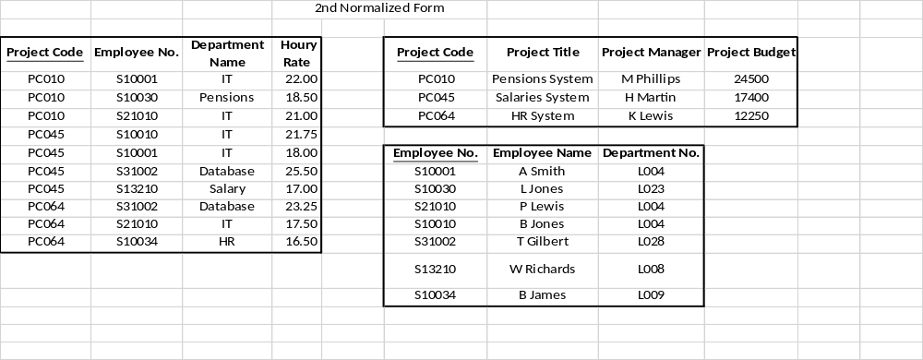
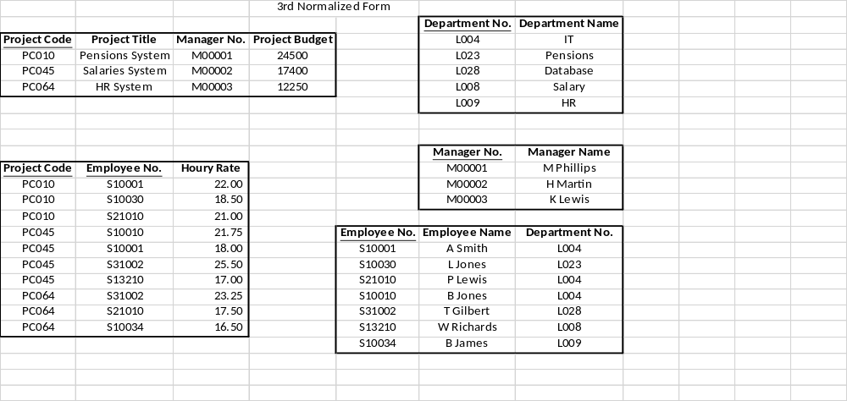

2. What are the 1st, 2nd and 3rd NF?

Pet_id | Pet_Name | PET_Type | Pet_Age | Owner | Visit Date | Procedure
1 | Brown | DOG | 12 | Sam | JAN 13/2002 | 01 - RABIES VACCINATION
 |  |  |  |  | MAR 27/2002 | 10 - EXAMINE and TREAT WOUND
 |  |  |  |  | APR 02/2002 | 05 - HEART WORM TEST
2 | Tucker | DOG | 2 | John | JAN 21/2002 | 08 - TETANUS VACCINATION
 |  |  |  |  | MAR 10/2002 | 05 - HEART WORM TEST
3 | Maggie | CAT | 4 | Sam | JAN 23/2001 | 01 - RABIES VACCINATION
 |  |  |  |  | JAN 13/2002 | 01 - RABIES VACCINATION
4 | Tweety | BIRD | 2 | John | APR 30/2002 | 20 - ANNUAL CHECK UP
 |  |  |  |  | APR 30/2002 | 12 - EYE WASH

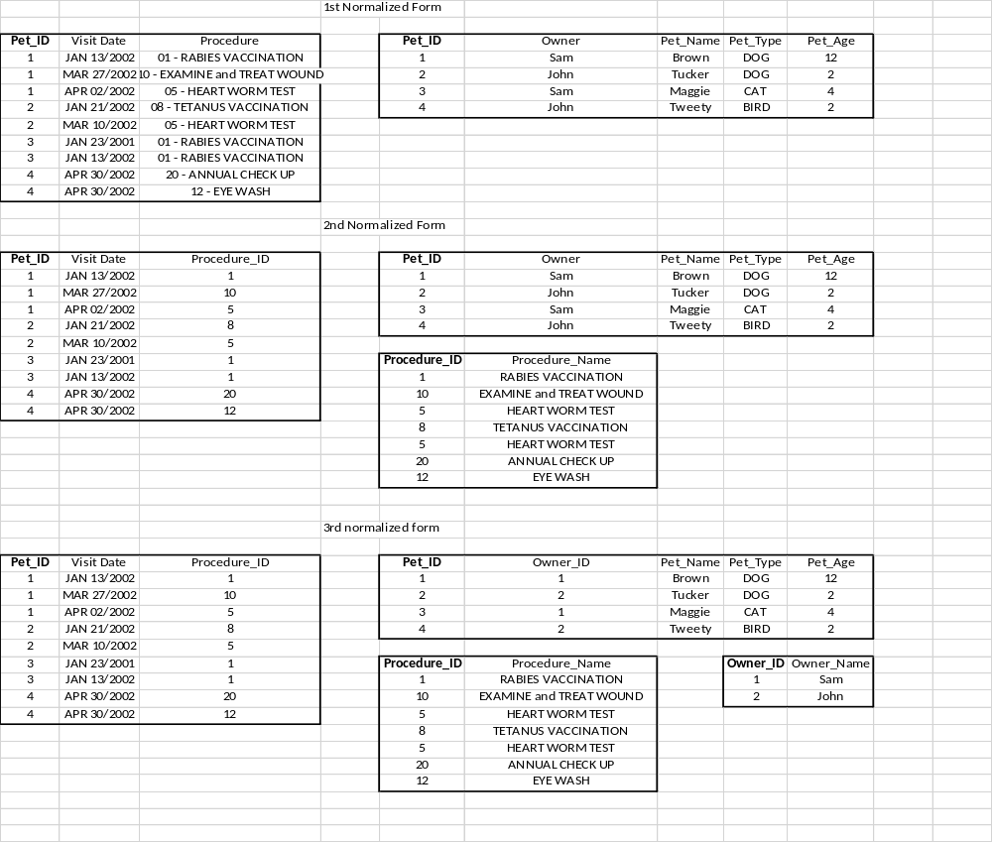
3. The following schema is used to register information on repayment of loans.

Repayment(borrower_id, name, address, loanamount, requestdate, repayment_date, repayment_amount)

Make the normalization to 3rd Normal Form. Show your work.

3rd normal form:
borrower_ID | loanamount | Requestdate | repayment_date
borrower_ID | name | address

Be sure that your name and “Assignment 2” appear at the top of your submitted file.

