**ITMD 421: Database Modeling and Applications**

**Midterm Exam**

**Due Monday, October 16th**

Total points: 65 points

All the work submitted should be original.

The exam should be turned be by the due date. There will be no late exceptions and will be marked zero.

Write all of your answers on the exam sheets, and be sure that your final answer to each question is clearly indicated.

Good luck!

Name: **_______**Henry Post**________**

1. Please give a “True” or a “False” rating to each statement below.

(1 point each for the right answer)

* 1. A schema that is in Third Normal Form (3NF) must also be in Second Normal Form (2NF).

Answer: True

* 1. You can test for records with missing SSN using the following SQL query:

SELECT * FROM Students WHERE SSN = NULL.

Answer: True

* 1. Functional dependency AB🡪D can be decomposed into two functional dependencies A🡪D and B🡪D.

Answer: True

* 1. DBMS stands for ……

Answer:

Database Management System

* 1. A condition Company LIKE ‘_B Corp’ will match both ’AB Corp’ and ‘B Corp’.

Answer: False

1. Describe the structure of the SELECT statement with an example. (3 points)

The SELECT statement is used to select rows, either one or many, from a table, and you can specify criteria that dictate what rows get selected versus which do not.

For example, if I had a table that looked like this called “ColorLocation”:

|  |  |  |  |
| --- | --- | --- | --- |
| Name | Age | Location | Favorite Color |
| Henry | 13 | Chicago | Purple |
| Brady | 19 | Las Vegas | Red |
| Kamal | 23 | Montana | Blue |
| Leo | 17 | Oregon | White |
| Kaleb | 24 | Nebraska | Orange |

And I wanted the age and location of people who have an “e” in the middle of their name, I would construct the following SQL statement:

SELECT * FROM ColorLocation WHERE (NAME LIKE "%e%")

1. Explain 1NF, 2NF, 3NF and BCNF with examples (5 points)

1st normalized form: All columns have one value. (atomicity). All keys exist ONCE. (no tuples)

Duplicate columns are allowed.

Ex:

|  |  |  |  |  |  |
| --- | --- | --- | --- | --- | --- |
| Student ID | Name | Class1 | Teacher1 | Class2 | Teacher2 |
| SID0001 | Henry | ITMD 421 | Aastha Gupta | EG 325 | James Novak |
| SID0002 | Jack | ITMD 421 | Aastha Gupta | PSYC 305 | Mary Sue |

2nd normalized form: All non-attribute keys are fully dependant on the primary key.

|  |  |
| --- | --- |
| Student ID | Name |
| SID0001 | Henry |
| SID0002 | Jack |

|  |  |  |
| --- | --- | --- |
| Student ID | Class | Teacher |
| SID0001 | ITMD 421 | Aastha Gupta |
| SID0001 | EG 325 | James Novak |
| SID0002 | ITMD 421 | Aastha Gupta |
| SID0002 | PSYC 305 | Mary Sue |

3rd normalized form: All attributes have to only describe things about the key, and nothing else. This way, all dependencies that could cause extra updates where they don’t need to exist.

|  |  |
| --- | --- |
| Student ID | Name |
| SID0001 | Henry |
| SID0002 | Jack |

|  |  |
| --- | --- |
| Student ID | Class |
| SID0001 | ITMD 421 |
| SID0001 | EG 325 |
| SID0002 | ITMD 421 |
| SID0002 | PSYC 305 |

|  |  |
| --- | --- |
| Class | Teacher |
| ITMD 421 | Aastha Gupta |
| EG 325 | James Novak |
| PSYC 305 | Mary Sue |

1. In the instance of the relation R(A,B,C,D,E) shown below, which of the following functional dependencies (FD's) hold? Briefly justify your answer. (5 points)

|  |  |  |  |  |
| --- | --- | --- | --- | --- |
| A | B | C | D | E |
| 1 | 2 | 3 | 4 | 5 |
| 1 | 4 | 3 | 4 | 5 |
| 1 | 2 | 4 | 4 | 1 |

I. AB-> C II. B-> D III. DE->A

(A) I only (B) II only (C) I and III only (D) II and III only

1. Construct an E-R diagram for a car-insurance company. Show your work. (10 points)

Also construct a relational schema for the diagram constructed above and mark the primary and foreign keys. (5 points)

1. A customer can own one or more than one car. Each customer has a name, address and drivers_id.
2. A car can be associated with zero to any number of accidents. Accidents have a date and location.

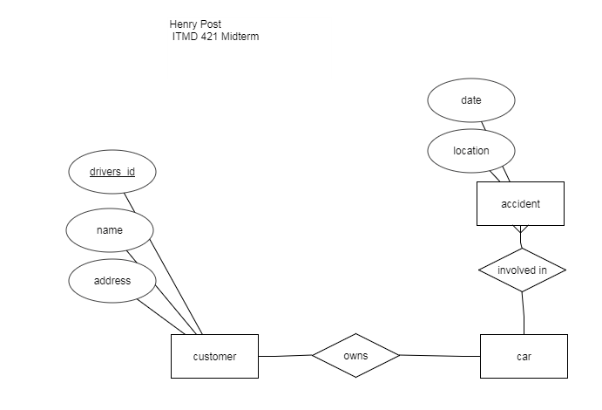

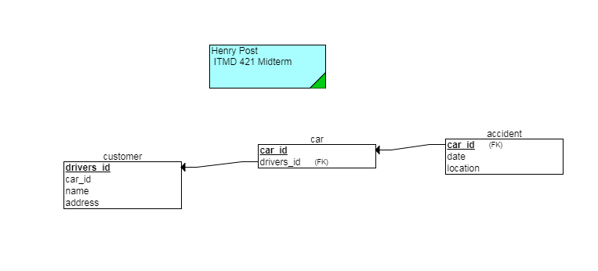

1. Construct an E-R diagram for a hospital. Make your own assumptions. Show your work. (10 points)
2. Hospital has set of patients and doctors.
3. With each patient is associated a medical log which also includes the laboratory tests conducted.

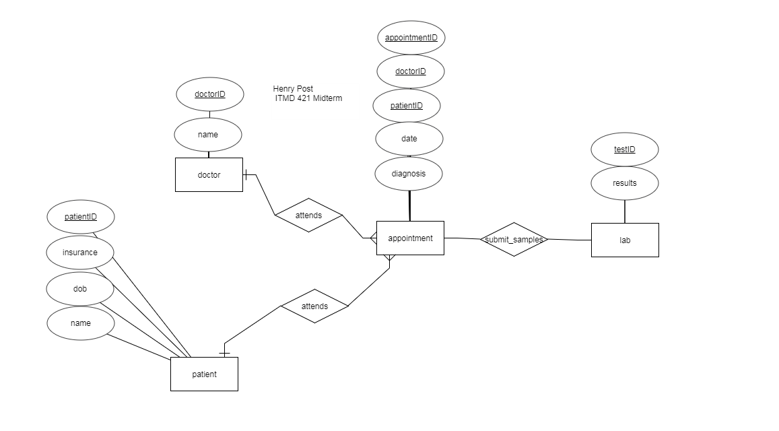

1. Suppose you are given the form below. Assume that a video cannot be rented twice on one receipt. Show your work. (14 points)

|  |  |  |  |  |  |
| --- | --- | --- | --- | --- | --- |
| **Moore Videos** | | | | | |
| Person ID: 226 | | Name: Lindsey Moore | | Receipt: 68395 | |
| Phone: 734 668-4385 | | Date: 9/1/08 | |  | |
|  | | City, ST: Ann Arbor, MI | |  | |
| **Video Information** | | | | | |
| **ID** | **Name** | **Type** | **Days** | **Date Due** | **Cost** |
| 325 | Shrek | N | 1 | 9/2/08 | 3.00 |
| 548 | Remember the Titans | H | 2 | 9/3/08 | 2.50 |
| 6437 | The Replacement Killers | H | 2 | 9/3/08 | 2.50 |
| Total | | | | | 8.00 |

1. Write the 1NF relation.
2. Write the 2NF relations. Identify the identifiers of these relations.
3. Identify any transitive dependencies.
4. Write the 3NF relations.

1st normal form:

|  |  |  |  |  |  |  |  |  |  |
| --- | --- | --- | --- | --- | --- | --- | --- | --- | --- |
| Person ID | Name | Phone | ReceiptID | VideoID | VideoName | VideoType | VideoDays | VideoDateDue | VideoCost |
| 226 | Lindsey Moore | 734 668-4385 | 68395 | 325 | Shrek | N | 1 | 9/2/08 | 3.00 |
| 226 | Lindsey Moore | 734 668-4385 | 68395 | 548 | Remember the Titans | H | 2 | 9/3/08 | 2.50 |
| 226 | Lindsey Moore | 734 668-4385 | 68395 | 6437 | The Replacement Killers | H | 2 | 9/3/08 | 2.50 |

2nd normal form:

|  |  |  |
| --- | --- | --- |
| Person ID | Name | Phone |
| 226 | Lindsey Moore | 734 668-4385 |

|  |  |  |  |  |
| --- | --- | --- | --- | --- |
| Person ID | VideoID | VideoName | VideoDays | VideoDateDue |
| 226 | 325 | Shrek | 1 | 9/2/08 |
| 226 | 548 | Remember the Titans | 2 | 9/3/08 |
| 226 | 6437 | The Replacement Killers | 2 | 9/3/08 |

|  |  |
| --- | --- |
| Person ID | ReceiptID |
| 226 | 68395 |

|  |  |
| --- | --- |
| ReceiptID | VideoID |
| 68395 | 325 |
| 68395 | 548 |
| 68395 | 6437 |

|  |  |  |
| --- | --- | --- |
| VideoID | VideoType | VideoCost |
| 325 | N | 3.00 |
| 548 | H | 2.50 |
| 6437 | H | 2.50 |

There exists a transitive dependency between VideoName and PersonID where there should not be one.

3rd normal form:

|  |  |  |  |
| --- | --- | --- | --- |
| Person ID | VideoID | VideoDays | VideoDateDue |
| 226 | 325 | 1 | 9/2/08 |
| 226 | 548 | 2 | 9/3/08 |
| 226 | 6437 | 2 | 9/3/08 |

|  |  |  |
| --- | --- | --- |
| Person ID | Name | Phone |
| 226 | Lindsey Moore | 734 668-4385 |

|  |  |
| --- | --- |
| Person ID | ReceiptID |
| 226 | 68395 |

|  |  |  |  |
| --- | --- | --- | --- |
| VideoID | VideoName | VideoType | VideoCost |
| 325 | Shrek | N | 3.00 |
| 548 | Remember the Titans | H | 2.50 |
| 6437 | The Replacement Killers | H | 2.50 |

|  |  |
| --- | --- |
| ReceiptID | VideoID |
| 68395 | 325 |
| 68395 | 548 |
| 68395 | 6437 |

1. (8 points) Suppose that we have a logical schema representing movies, movie critics and their movie ratings. The relationship “ratings” captures which reviews were posted by which critics with the rating (0-100) and date. The logical schema is given below:

Movie: (Title, Subtitle, Year, Duration, Edition)

Ratings: (RevID, Title, Subtitle, Rating, RDate)

Reviewer: ReviewerID, Name, Address, Affiliation)

Assume that the tables Movie and Reviewer have already been created with all of the necessary attributes, domains, and keys. Fill out the SQL table below to create the table Ratings with all of the necessary attributes, domains, and keys. Assume that Reviewer ID is an 8 characters string and that neither title nor sub-title needs more than 26 characters and that the rating value cannot be NULL. You only need to create the Ratings table. Do not worry about creating Movie or Reviewer tables.

CREATE TABLE ___ratings___ (

_RevID_____VARCHAR(8)________,

_Title______VARCHAR(26)___________________,

_Subtitle___VARCHAR(26)_____________________,

_Rating____INT(3) NOT NULL____________________,

_RDate_____INT(30)________________,

CONSTRAINT UNIQUE_CONSTRAINT_PK1

PRIMARY KEY(_______Subtitle_____________________________),

CONSTRAINT UNIQUE_CONSTRAINT_FK2

FOREIGN KEY (_______RevID______________________________)

REFERENCES ___reviewer.ReviewerID_______________________________

CONSTRAINT UNIQUE_CONSTRAINT_FK3

FOREIGN KEY(_________Title_____________________________)

REFERENCES _____Movie.title, movie.subtitle______________________________);