Files
Please see attached `.accdb` and `.pdf` files.

Screenshots

SQL Query
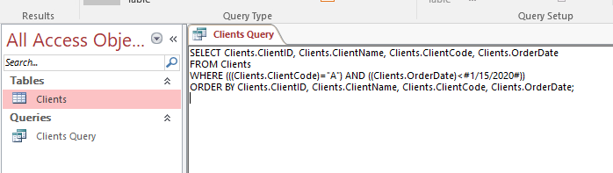

Another Robust Query

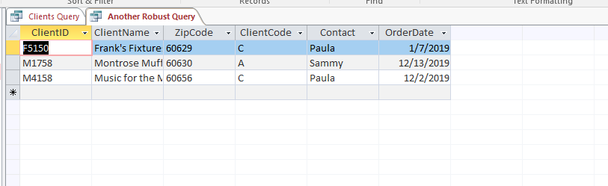

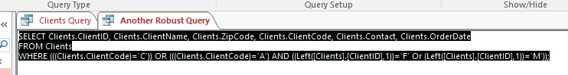

Yet Another Robust Query

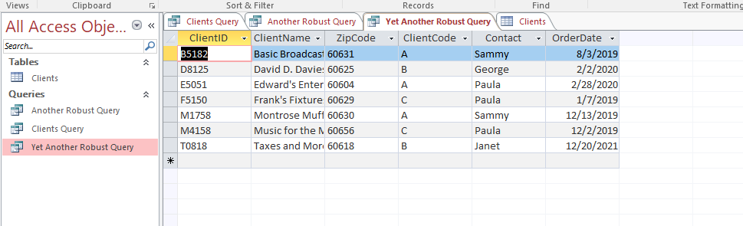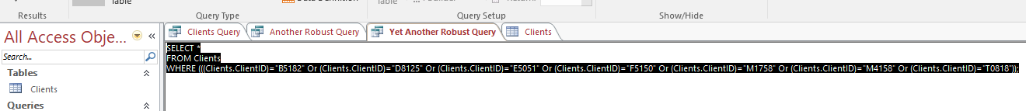

Questions and Reflections Concerning this Database Project
1) Report generation is important for decision - making. What levels of management are apt to request summary reports on the data?
2) How long should summary reports be kept in a business organization?
3) Visit the website http://www.bn.com and find at least two textbooks on database management. Place the pertinent information from the books that you have located.
4) Name at least two new fields that may be added to the Books database table.
5) What are the relative operators and the logical operators that may be used to construct specific queries?

