Cumulative Topics in SQL, Data Modeling and Oracle Database Software

(1) ( ACID and Databases )

Match a concept / topic on the left with its matching description on the right.

__D__ consistency (a) if one part of the transaction fails, the entire transaction fails

__C__ isolation (b) ensures that any transaction committed to the database will not be lost

__B__ durability (c) requires that multiple transactions occurring at the same time not impact each other’s execution

__A__ atomicity (d) states that only valid data will be written to the database

(2) ( 1NF )

Review the given Students table, with the primary key underlined, and the following data:

Alpha | Name | Email | Courses | GradePoints
100111 | John Thomas | jt456@aol.com | NN204, SI204, IT221 | 2,3,3
092244 | Matt Chan | mchan@aol.com | SM223, EE301 | 4,4
113221 | Melinda Suarez | melinda@iit.edu | SI204 | 3
090112 | Tom Patel | tp123@iit.edu | NN204, SI204, IT221 | 4,2,3

(a) Is the Students table in 1NF? Why?
It is not, because there are rows that contain non-atomic values.

(b) If the table is not in 1NF, what are your suggestions to redesign the Students table to be in 1NF. What would be the primary keys and foreign keys for each of any tables that you would use in the normalization process?

There should be a new table called “CourseGrades” that contains three rows: StudentID (PK, int), CourseID (PK, int), and CourseGrade (int). This is where the course id, student id, and grade points can be stored.
(3) ( Top n Analysis )

When would you use the following query? ( choose only one answer )

SELECT *
FROM (select * from suppliers ORDER BY supplier_id) suppliers2
WHERE rownum <= 5
ORDER BY rownum;

(a) If you wish to retrieve the last 5 records from the suppliers table, sorted by supplier_id in ascending order.

(b) If you wish to retrieve any 5 records from the suppliers table, sorted by supplier_id in ascending order.

(c) If you desire to retrieve the last 5 records from the suppliers table, sorted by supplier_id in descending order.

(d) If you desire to retrieve the first 5 records from the suppliers table, sorted by supplier_id in descending order.

(e) If you desire to retrieve the first 5 records from the suppliers table, sorted by supplier_id in ascending order.

(4) ( Oracle NTILE Function )

The following data represents the individual dollar value of the purchases of the first group of customers that visited your retail store during yesterday’s normal business hours.

11 | 16 | 19 | 23 | 25 | 25 | 27 | 29 | 35 | 37 | 42 | 44

As shown below, examine the values that will be returned when the following query is executed. What value would be considered as the median value? Does the actual median value appear in any of the four quartile buckets that are displayed below?

SELECT id, purchase, NTILE(4) OVER (ORDER BY purchase)
AS quartile FROM purchases;

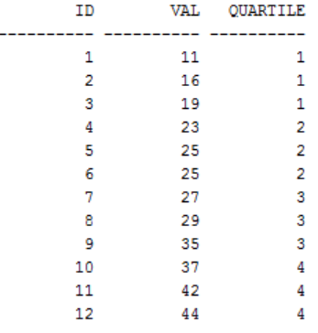

The median value is the number that is positionally in the middle.

It does not exist because there is an even number of numbers in the data set.
(5) ( Oracle Decode Function )

Complete the following table and place the proper values in the bonus column.

SELECT EMP_ID, NAME, DEPT_NO,
DECODE (DEPT_NO,'802', 0.5*10000
'809', 0.6*10000
'837', 0.7*10000
0.8*10000)
"BONUS"
FROM MASTER_EMP;

emp_id | name | dept_no | bonus
0296 | Shruti | 837 | 7000
3986 | Chang | 858 | 8000
6787 | Fiby | 802 | 5000

(6) ( Data Modeling - Tiffany’s Emporium and Thrift Shoppe )

Tiffany has started a new thrift shop retail store business and has requested your assistance as a database professional to assist her in organizing her business data.
List the names of two tables that you would use and describe the fields that you believe would comprise these tables. Comment on any relations between the tables. What transformational analytics would you consider for the enterprise to be aware of its patron’s habits?

Hint: the typical thrift shop has the following sections / services.
desk stationary, gifts, books, odds and ends, toys, hardware tools, educational kits, etc.

Info:
- Thrift shop
- Retail
- Sells various item types

Tables:
todo
(7) ( Oracle PL / SQL )

Describe the output produced by the following block of PL/SQL statements.

set serveroutput on
Declare
v_id number := 12;
Begin
v_id := v_id - 5;
If v_id not Between 5 And 10 Then
dbms_output.put_line('v_id is in the range');
Else
dbms_output.put_line('v_id is not in the range');
End If;
End;

(8) ( Oracle Subqueries )

Dissect and discuss this SQL subquery.

select * from emp where sal >
(select sal from emp where ename = 'Sneha');

(9) ( Oracle Joins )

Distinguish between a Left Outer Join and a Right Outer Join.

(10) Write a CREATE TABLE AS statement that has a subquery to build a table named reports
that consists of a single column that lists the count of the records in table myData.

(11) What type of SQL join is implied here?

select tblA.fld_a, tblB.fld_b
from tblA, tblB
where tblA.id = tblB.id;

(12) What type of join could be used?

"I want to select all unique Ids in table A which do not exist in table B. How can I do this?"

(13) What is returned by the following expression?

GREATEST('blue', 'blew', 'blow')

(14) Label each of the following as either a CRUD rule or a business rule.

__________ A product's cost must be computed as the sum of the cost of all the product's components.

__________ Don't delete a customer that has placed any open orders.

__________ An open order must be placed by a customer.

(15) The ORDERS table has these columns:

ORDER_ID NUMBER(4) NOT NULL
CUSTOMER_ID NUMBER(12) NOT NULL
ORDER_TOTAL NUMBER(10,2)

The ORDERS table tracks the Order number, the order total, and the customer to whom the Order belongs.

Using each of the columns in the Orders table, write a query that will retrieve orders with an inclusive total that ranges between 100.00 and 200.00 dollars?

SELECT _________________________________

FROM _________________________________

WHERE _________________________________

(16) Write a query that will display the total salary drawn by an ANALYST working in department number 10 .

(17) List five observations that concern the following ERD . Your observations, could involve items, such as cardinality and also actions between entities.

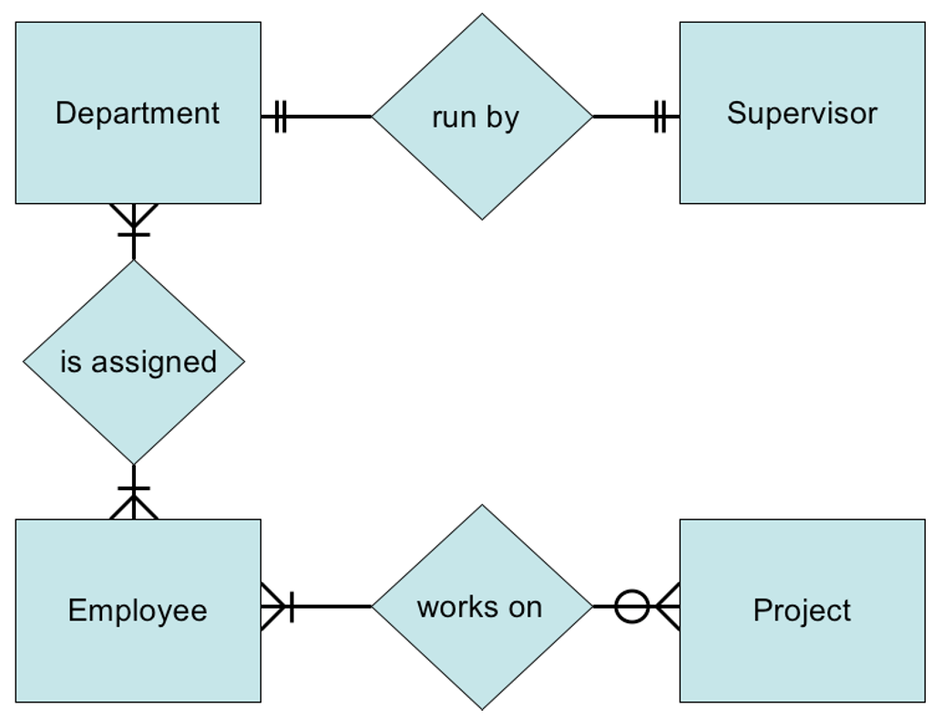
(a)

(b)

(c)

(d)

(e)

(18) Fill the Blank

A(n) __________ value, distinct from zero, represents the absence of any value in a field

(19) Fill the Blank

A(n) __________ key is when more than one field makes up a primary or foreign key.

(20) Multiple Choice

Which is not a category of SQL?

(a) DDL (b) DML (c) DCL (d) DAL

(21) Multiple Choice

Which of the following is not a DML command?

(a) insert (b) create table (c) delete (d) select

