|  |  |  |  |
| --- | --- | --- | --- |
| Instructor |  | Due Date |  |

|  |  |  |  |  |  |  |
| --- | --- | --- | --- | --- | --- | --- |
| **Part** | 1 | 2 | 3 | 4 | **TOTAL** | **Score** |
| *Maximum Points* | 25 points | 25 points | 25 points | 25 points | **100**G101010 pointsG |  |

**Textbook Reading Assignment** Thoroughly read Week 1 - 4 course lecture notes.

**Part 1 Concept Check - Advanced Topics in Data Management**

**(1) ( Data Warehousing: OLAP versus OLTP )**

An information system category that prioritizes transaction processing, which deal with operational data is Online Transaction Processing ( OLTP ) . Another type of information system category is Online Analytical Processing ( OLAP ) .

OLAP concentrates on performing analytical processing and OLTP focuses on providing transactional processing.

View the video production at the link shown below ( or similar video ) and list five facts that you learned concerning these two information systems.

[**https://www.youtube.com/watch?v=q5f1xOA9IQQ**](https://www.youtube.com/watch?v=q5f1xOA9IQQ)

|  |
| --- |
|  |

**(2) ( Data Science and Business Intelligence: OLAP )**

OLAP focuses on multi - dimensional views and analysis of data queries. For example, we can query data from a standpoint of examining company sales by region, year, sales amount and salesperson.

The typical OLAP operations will include: (1) drill - down, (2) dice and slice,   
 (3) rotate or pivot and (4) roll - up or consolidation

Using one or more of the business or organizational entities listed below discuss a multi - dimensional analysis that can be performed on the entities with any or all of the above operations.

**Business / Organizational Entities**

• a global parcel shipping company • a sports memorabilia firm

• a nationwide college or university • an office supply superstore

• a talent agency • a vitamin and health shop

You can review the information at the link below, which summaries the OLAP operations.

[**http://www.cs.ccsu.edu/~markov/ccsu_courses/DataMining-2.html**](http://www.cs.ccsu.edu/~markov/ccsu_courses/DataMining-2.html)

|  |
| --- |
|  |

**(3) ( Data Maintenance: Scrubbing Data in an MS Access Database Table )**

You have been assigned the task of scrubbing an MS Access database table, which is used for data maintenance purposes. Explain how you would use MS Access to perform each of these scrubbing tasks.

(a) Locate any fields that contain two spaces and replace the two spaces with one space.

(b) Locate any duplicate records.

(c) Eliminate any records that have a particular field having a number value.

(d) Eliminate any records that have a field having an alpha - numeric value.

(e) Update any records that have any non - printing characters.

You can create your own sample table and then show explain or how the table is scrubbed.

|  |
| --- |
|  |

**Part 2 DBMS Concepts - Advanced Topics in Data Management**

**(1) ( Entity Relationship Diagrams - ERDs )**

An entity relationship diagram ( ERD ) depicts the conceptual database as viewed by end user. An ERD also illustrates the database’s main components:

Entities, Attributes, Relationships

Examine these tables their attributes and their relationships.

**Orders** {OrderID, OrderDate, CustomerID, ShippingDate, OrderStatus}

**OrderDetails** {OrderID, ProductID, Quantity, LineNumber}

**Products** {ProductID, Name, Description, Quantity, UnitPrice}

Without writing any SQL code statements, discuss five separate queries that would be useful to ascertain information regarding this database schema.

|  |
| --- |
|  |

**(2) ( Types of Relationships )**

When designing an ERD , what is meant by a weak relationship? Provide an example of such a relationship.

|  |
| --- |
|  |

**Part 3 Data Models / Analytics - Advanced Topics in Data Management**

**(1) ( Data Modeling )**

Explain multivalued attributes with the help of examples. How are multivalued attributes indicated in the Chen Entity Relationship model?

|  |
| --- |
|  |

**(2) ( Data Analytics / Predictive Analytics: Aggregate Functions )**

In SQL database systems such as Oracle and DB2 , aggregate functions, such as averages and other statistical measures, can be used for analytical purposes. The following data illustrates company sales for the second half of the year. List five generic aggregate functions that can be used with the following data. Comment on their usefulness in describing the data.

|  |  |  |
| --- | --- | --- |
| **Table: tblSales** | |  |
|  |  |  |
| index | month | sales |
|  |  |  |
| 1 | July | $16,000 |
| 2 | August | $17,280 |
| 3 | September | $23,660 |
| 4 | October | $17,493 |
| 5 | November | $28,805 |
| 6 | December | $32,470 |

|  |
| --- |
|  |

**Part 4 Data Design Concepts - Advanced Topics in Data Management**

**(1) ( Database Models )**

What is a ternary relationship? Provide some business rules examples that specify the need for a ternary or higher - order relationship.

|  |
| --- |
|  |

**(2) ( Data Models and eCommerce Web Databases )**

Visit the home page of the Barnes and Noble Web site and examine especially the links towards the bottom portion of the page.

[**https://www.barnesandnoble.com**](https://www.barnesandnoble.com)

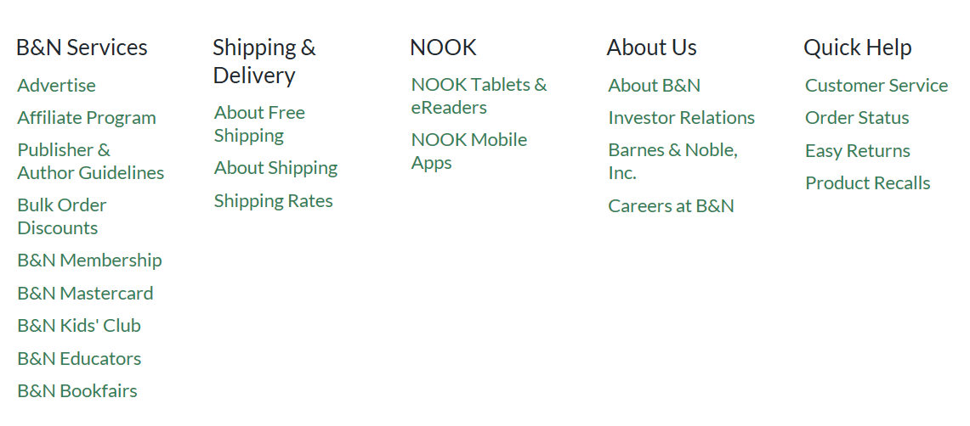

Then choose one of these categories, such as Shipping Rates or B&N Membership, and discuss how database management plays a role in connecting the Web site with the customers of the company.

|  |
| --- |
|  |