|  |  |  |  |
| --- | --- | --- | --- |
| **Instructor** |  | **Due Date** |  |

**PROJECT Using MS Access: Design an Advanced Database Application**

**Objective** To use MS Access to design and utilize a database application.

***PROJECT DESCRIPTION***

This lab project has you constructing and utilizing a database application, per the instructions which follow.

You will use two tables for this database application. The two tables are listed below.

**Consultants Database Table**

|  |  |  |  |
| --- | --- | --- | --- |
| ConsultantID | LastName | HourlyFee | YearsOfService |
| 101 | Patel | $15.00 | 0 |
| 102 | Smithers | $12.00 | 5 |
| 103 | DeMille | $45.00 | 20 |
| 104 | Parker | $28.00 | 22 |
| 105 | Gonzalez | $35.00 | 17 |
| 106 | Pappas | $50.00 | 19 |
| 107 | McDonald | $20.00 | 12 |
| 108 | Larson | $32.00 | 5 |

**Clients Database Table**

|  |  |  |  |  |  |
| --- | --- | --- | --- | --- | --- |
| ClientID | LName | StartDate | EndDate | TotalCharge | ConsultantID |
| A202 | Chan | 3/21/2020 | 4/30/2020 | $960.00 | 101 |
| A350 | Chin | 3/17/2020 | 3/31/2020 | $1,222.00 |  |
| B220 | John | 3/21/2020 |  | $1,759.50 | 102 |
| B315 | Peters | 3/17/2020 | 6/17/2020 | $1,823.79 | 105 |
| B223 | Sherman | 3/15/2020 | 9/15/2020 | $2,122.00 | 105 |

***Information about this Project***

A database file consists of objects such as tables, forms, queries and reports.

***Steps to Complete this Project***

**STEP 1 Download the MS Excel Workbook**

If available from the course Web site, download the MS Excel workbook that contains the two worksheets that are loaded with the **Consultants** and **Clients** data tables and move to the next step in this project.

**PROJECT Using MS Access: Design an Advanced Database Application**

If not available from the course Web site, individually copy each of the above tables into separate worksheets in a new MS Excel workbook. Place the **Consultants** Database Table into a worksheet named **Consultants** and place the **Clients** Database Table into a worksheet named **Clients**.

Save the MS Excel workbook as: **ConsultantsAndClients**

**Step 2** **Open MS Access to Import the External Data**

Create a new blank MS Access accdb database file and, with this format, name it as ( using your own First Name and Last Name ) :

**BusinessData_FirstName_LastName**

**Step 3**  **Import the Tables from MS Excel to MS Access**

On the MS Access **Ribbon**, click [ External Data ] and select [ Excel ] from the **Import & Link** group. Individually, import each of the Excel worksheets into your MS Access database table. Use the same name for your tables as the names shown on the MS Excel worksheets. Set the ConsultantID field as the primary key for the **Consultants** table and set ClientID as the primary key for the **Clients** table.

**Step 4**  **Add New Records to Your MS Access Database Tables**

Open the **Consultants** table in Access and add a new record to the table in the [ Datasheet ] view. But, instead of **Murphy** use **your own**   
 **last name** for the LastName field.

|  |  |  |  |
| --- | --- | --- | --- |
| ConsultantID | LastName | HourlyFee | YearsOfService |
| 109 | Murphy | $72.00 | 17 |

Open also the **Clients** table and add a new record to the table in the

[ Datasheet ] view. But, instead of **Zane** use **your own first name** for

the LName field.

|  |  |  |  |  |  |
| --- | --- | --- | --- | --- | --- |
| ClientID | LName | StartDate | EndDate | TotalCharge | ConsultantID |
| D010 | Zane | 4/22/2020 | 5/22/2021 | $1,960.00 | 107 |

**Step 5**  **Design a Database Form Object**

You will now design an Access Form object. The form will be used for front - end database record input and / or retrieval.

Click [ Create ] on the Ribbon and click [ Form Wizard ] from the **Forms** group.

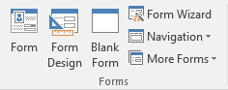

When the **Form Wizard** opens, use these settings and attributes:

**PROJECT Using MS Access: Design an Advanced Database Application**

Table: **Consultants**

Fields: select all the fields in the above table

Layout: Columnar

Title: **ConsultForm**

After you create the Form object, add a new record to the **Consultants** table. Use this data for your new record.

|  |  |  |  |
| --- | --- | --- | --- |
| ConsultantID | LastName | HourlyFee | YearsOfService |
| 111 | Johnson | $78.00 | 11 |

Save and close the Form object and verify that the underlying **Consultants** table has been updated with the new record.

Return to your Form object and **add the current date** and a

time stamp to your MS Access form. In the [ Layout View ] of the

form and under the [ Form Layout Tools ] select the [ Design ] tab to

navigate to the [ Header / Footer ] group where you can apply the time

stamp.

In a manner similar to the above steps, add your own logo graphic to the **Detail** section of your form object. For your logo, you can use MS Paint 3D to create a **PNG** file with your own initials, your own portrait picture or your family crest. Size the image accordingly within the **Detail** section of your form.

Take a **screen snapshot** of your Form object showing the above record as the last record placed into the underlying table. Place the screen snapshot into your MS Word submittal document that you will create for this project. Label the snapshot accordingly.

**Step 6**  **Query the MS Access Database Tables**

With your database file opened in MS Access, click [ Database Tools ] on the Ribbon and navigate to the **Relationships** group. Then, click the

[ Relationships ] link.

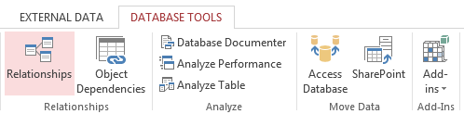

When the **Show Table** dialog box appears, add both of the tables, which your database file contains, to the layout.

Next, in the **Relationships** layout screen, drag the ConsultantID field from the **Consultants** table into the **Clients** table.

When the **Edit Relationships** dialog box appears, be sure to

[ Enforce Referential Integrity ] prior to creating the relationship.

Refer to the following snapshots.

**PROJECT Using MS Access: Design an Advanced Database Application**

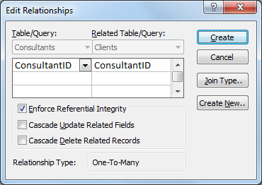

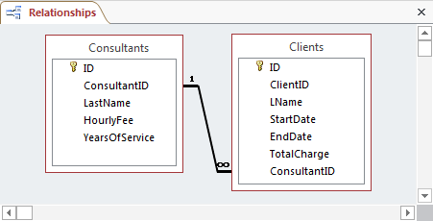

**Step 7**  **Query the MS Access Database Tables**

With your database file opened in MS Access, click [ Create ] on the Ribbon and navigate to the **Queries** group. Then, select the   
 [ Query Design ] link in that Ribbon group.

When the **Show Table** dialog box appears, add both tables to the Query Screen and design a query using the following fields and criteria.

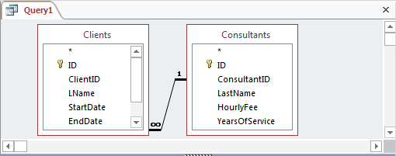

**PROJECT Using MS Access: Design an Advanced Database Application**

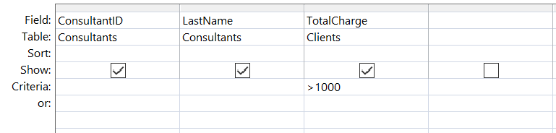

To execute the query, click [ Design ] under [ Query Tools ] and select   
 [ Run ] from the **Results** group. Observe the results and save the query using the default name.

**Step 8**  **Perform an SQL Query with the MS Access Database Tables**

With your database file opened to the above query in MS Access,

click [ Home ] on the Ribbon and change the view to the [ SQL View ] .

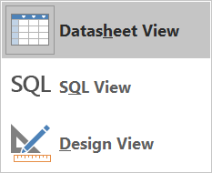

Adjust the original SQL statement such that it appears as follows.

|  |
| --- |
| **SELECT Consultants.ConsultantID, Consultants.LastName, Clients.TotalCharge**  **FROM Clients**  **INNER JOIN Consultants ON**  **Clients.ConsultantID = Consultants.ConsultantID**  **WHERE (((Clients.TotalCharge) > 500)) AND (((Clients.TotalCharge) < 1000));** |

Observe the results and save the query.

**Step 9**  **Perform Multiple SQL Queries with Your Database Tables**

Similar to the above steps, perform each of the following database table queries. Save each query individually to your MS Access database file.  
 Take a snapshot of the results of executing your queries.

Place the snapshots into your assignment submittal document and label them accordingly.

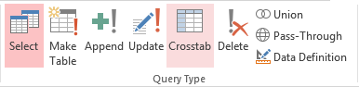

**PROJECT Using MS Access: Design an Advanced Database Application**

**Query 1 ( Select Query )**

Run a query that will return database records based on these criteria.

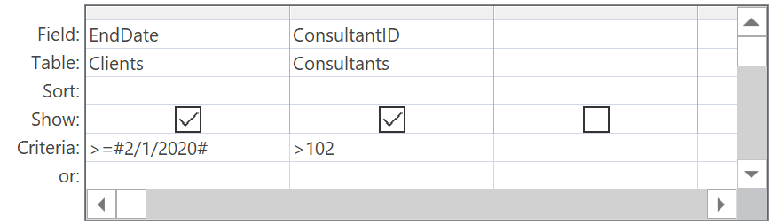

**Query 2 ( Update Query )**

This particular exercise involves running an Update Query.

Attempt to run an update query that will return database records based on these criteria and settings.

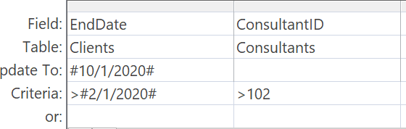

**Query 3 ( Make Table Query )**

In a manner similar to the above steps, run a Make Table Query.

Name the new table as: **Back_Up_Your_Initials**

( i.e. the words Back UP followed by your own initials )

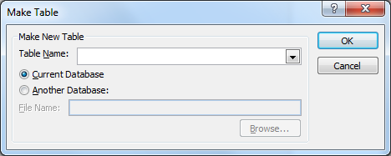

Your Make Table Query is to create a new table based on the fields listed below.

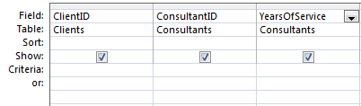

**PROJECT Using MS Access: Design an Advanced Database Application**

**Query 4 ( Delete Query )**

This next exercise involves constructing a Delete Query.

Attempt to design a Delete Query that will remove the consultant whose last name is " Smithers. "

**Query 5 ( Advanced Select Query )**

Using both the **Consultants** and the **Clients** tables in your database, construct a meaningful query, of your own design, that implements both an AND logical operation and an OR logical operation.

**Step 10** **Generate an MS Access Database Report**

With your database file opened in MS Access, click [ Create ] on the Ribbon and select the [ Report Wizard ] from the **Reports** group.

The **Report Wizard** dialog box appears.

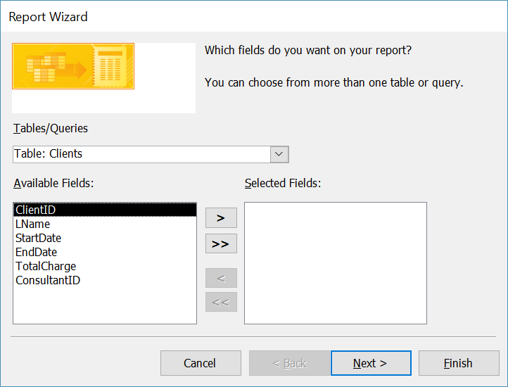

**PROJECT Using MS Access to Design a Database Application**

In the **Report Wizard** dialog box, select the **Clients** table and use the

[ >> ] button to include all the table fields in the report.

Step through the wizard and use these settings for your report:

Grouping Level: StartDate

Sort Order: Ascending

Report Layout: Block Style

Report Name: **rptClients**

View the results after the report is generated and save your report.

**Step 11** **Generate Additional MS Access Database Reports**

Construct each of the following database reports. Save the reports with an appropriate name. Ensure that the field names and data columns area completely visible when preforming a [ Print Preview ] of each report.

Take a screen snapshot of each of your reports and place them into your word processing submittal document. Label each report accordingly.

**Report 1 ( Report: The Consultants Table )**

In the manner of the prior step, generate a new report of your choice based on only the **Consultants** table.

**Report 2 ( Report: ID Fields )**

Create a report that only shows the primary key fields from both the **Consultants** table and the **Clients** table.

**Report 3 ( Report: Based on a Query )**

Create a professional report of your own design that is based on one of the queries that you constructed earlier.

**Report 4 ( Report: Custom )**

In the MS Access **Navigation Pane**, select one of your tables, click

[ Create ] on the menu Ribbon and click [ Report ] in the **Reports** group. In the [ Layout View ]change the property of the Auto_Time text box from the default setting to Short Time.

**Report 5 ( Query Report )**

Design a report based on one of your queries that you designed earlier.

**PROJECT Using MS Access to Design a Database Application**

**Step 12 Database Administrative and Management Tasks**

With your database file opened in MS Access, click [ Database Tools ] on the Ribbon. Observe the groups that are available within this tab and especially those shown below.

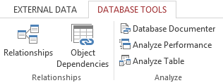

Then, perform each of these administrative tasks. Take a screen snapshot of each of these tasks and place them into your lab submittal document, labeling the snapshots accordingly.

**Administrative Task 1 ( Database Documenter )**

Open the [ Database Documenter ] and examine the properties of your current database.

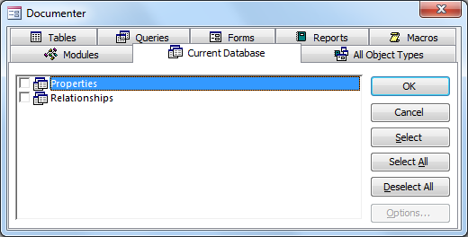

Take a snapshot of the date and time that your current database was last updated.

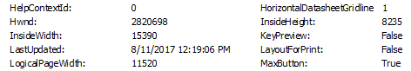

**PROJECT Using MS Access to Design a Database Application**

**Administrative Task 2 ( Analyzing Performance )**

Open the **Performance Analyzer** and analyze a relationship in your database application.

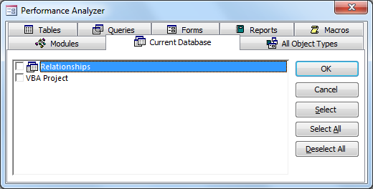

Observe the result of running the **Performance Analyzer**.

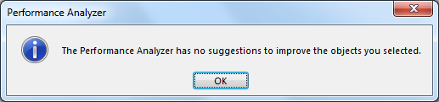

**Administrative Task 3 ( Analyzing Tables )**

Open the **Performance Analyzer** and analyze one of the tables in your database application.

**Administrative Task 4 ( Object Dependencies )**

In the MS Access **Navigation Pane**, select one of your queries.

Open the **Object Dependencies** link and expand all of the database objects that are visible to reveal all of the dependencies. Take a snapshot of the object dependencies.

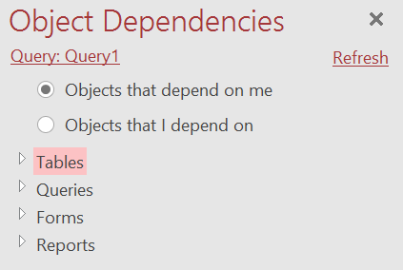

**PROJECT Using MS Access to Design a Database Application**

**Administrative Task 5 ( Backstage View )**

Open the MS Access main menu and click [File ] to navigate to the   
 [ Backstage View ] to create a back - up copy of the database application.

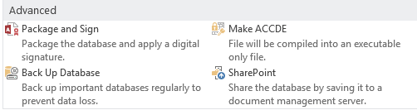

Save the back - up copy using the default name followed by your initials

Take a screen snapshot of your back - up copy in Windows Explorer.

**Step 13 Split Your MS Access Database File**

Next, navigate again to the [ Database Tools ] tab and click the   
 [ Access Database ] link within the [ Move Data ] group.

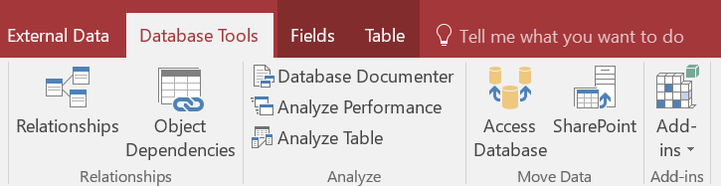

Split your database application and take a screen snapshot of the results of splitting your database in Windows Explorer.

**Step 14 Submit Your MS Access Database File**

Close all the database objects in your file and ensure that the Access

[ Navigation Pane ] has all of the objects that you included with this database application.

Submit your completed MS Access accdb database file for credit.

In addition, submit a copy of your lab project submittal document.

**PROJECT Using MS Access to Design a Database Application**

**Step 15 Questions and Reflections Concerning this Database Project**

Now that you have completed this lab project, review the questions below to reflect on the procedures and settings that you utilized as you followed the steps to complete the project. Place your answers to these questions into your lab submittal document.

**(1) ( Data Types in MS Access )**

List four MS Access data types that were used in one or more of the tables that comprise your database file.

**(2) ( Database Tables )**

The **Consultants** table has the ConsultantID field as the primary key and the **Clients** table has the ClientID as its primary key.

Which of the two tables, **Consultants** or **Clients**, has a foreign key reference to the other table?

**(3) ( SQL )**

SQL is a standard for database management. What do the letters in the abbreviation SQL represent? Does a Table object have an SQL view? How do you open the SQL View of a query object?

**(4) ( Data Queries in MS Access )**

During this project, you queried the two tables that were included in your database file. In your first query, which field of the **Clients** table had this criterion setting? > 1000

**(5) ( Report Writing with MS Access )**

When using the **Report Wizard** to create a report for your tables, which sort order appears by default: Ascending or Descending?

**(6) ( Database Documenter )**

When using the database documenter, explain how you would navigate this feature to reveal the following information.

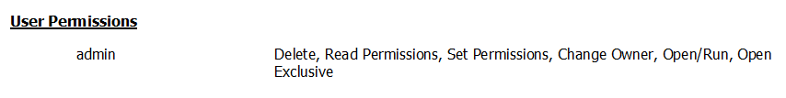

**(7) ( Enforcement of Referential Integrity )**

Explain the importance of referential integrity when performing joins, or any modification of a database. Make sure you first

define referential integrity.