**Cumulative Topics in SQL, Data Modeling and Oracle Database Software**

**(1) ( ACID and Databases )**

Match a concept / topic on the left with its matching description on the right.

**(d)** consistency (a) if one part of the transaction fails, the entire transaction fails

**(c)** isolation (b) ensures that any transaction committed to the database will not be lost

**(b)** durability (c) requires that multiple transactions occurring at the same time not impact each other’s execution

**(a)** atomicity (d) states that only valid data will be written to the database

**(2) ( 1NF )**

Review the given Students table, with the primary key underlined, and the following data:

|  |  |  |  |  |
| --- | --- | --- | --- | --- |
| Alpha | Name | Email | Courses | GradePoints |
|  |  |  |  |  |
| 100111 | John Thomas | jt456@aol.com | NN204, SI204, IT221 | 2,3,3 |
| 092244 | Matt Chan | mchan@aol.com | SM223, EE301 | 4,4 |
| 113221 | Melinda Suarez | melinda@iit.edu | SI204 | 3 |
| 090112 | Tom Patel | tp123@iit.edu | NN204, SI204, IT221 | 4,2,3 |

(a) Is the Students table in 1NF? Why?

**Not in 1NF. Because the data is not atomic, i.e. 1NF eliminates 'lists' of records inside fields (MULTIPLE VALUES appearing in a single field ) .**

(b) If the table is not in 1NF, what are your suggestions to redesign the Students table to be in 1NF. What would be the primary keys and foreign keys for each of any tables that you would use in the normalization process?

**Students Table:**

**[Alpha(PK), Name, eMail]**

**Courses Table:**

**[Courses(PK), Gradepoints, Alpha(FK)]**

**(3) ( Top *n* Analysis )**

When would you use the following query? ( choose only one answer )

**SELECT \***

**FROM (select * from suppliers ORDER BY supplier_id) suppliers2**

**WHERE rownum <= 5**

**ORDER BY rownum;**

(a) If you wish to retrieve the last 5 records from the suppliers table, sorted by supplier_id in ascending order.

(b) If you wish to retrieve any 5 records from the suppliers table, sorted by supplier_id in ascending order.

(c) If you desire to retrieve the last 5 records from the suppliers table, sorted by supplier_id in descending order.

(d) If you desire to retrieve the first 5 records from the suppliers table, sorted by supplier_id in descending order.

**(e) If you desire to retrieve the first 5 records from the suppliers table, sorted by supplier_id in ascending order.**

**(4) ( Oracle NTILE Function )**

The following data represents the individual dollar value of the purchases of the first group of customers that visited your retail store during yesterday’s normal business hours.

|  |  |  |  |  |  |  |  |  |  |  |  |
| --- | --- | --- | --- | --- | --- | --- | --- | --- | --- | --- | --- |
| 11 | 16 | 19 | 23 | 25 | 25 | 27 | 29 | 35 | 37 | 42 | 44 |

As shown below, examine the values that will be returned when the following query is executed. What value would be considered as the median value? Does the actual median value appear in any of the four quartile buckets that are displayed below?

**SELECT id, purchase, NTILE(4) OVER (ORDER BY purchase)**

**AS quartile FROM purchases;**

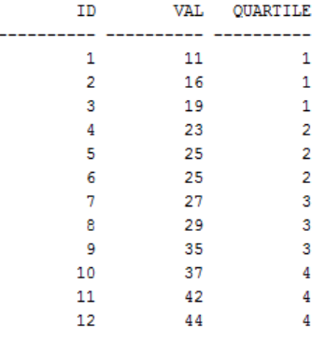

**Answer:**

**What value would be considered as the median value? 26**

**Does the actual median value appear in any of the four quartile buckets that are displayed below? NO**

**(5) ( Oracle Decode Function )**

Complete the following table and place the proper values in the bonus column.

**SELECT EMP_ID, NAME, DEPT_NO,**

**DECODE (DEPT_NO,'802', 0.5*10000,**

**'809', 0.6*10000,**

**'837', 0.7*10000,**

**0.8*10000)**

**"BONUS"**

**FROM MASTER_EMP;**

|  |  |  |  |
| --- | --- | --- | --- |
| **emp_id** | **name** | **dept_no** | **bonus** |
| **0296** | **Shruti** | **837** | **7000** |
| **3986** | **Chang** | **858** | **8000** |
| **6787** | **Fiby** | **802** | **5000** |

**(6) ( Data Modeling - Tiffany’s Emporium and Thrift Shoppe )**

Tiffany has started a new thrift shop retail store business and has requested your assistance as a database professional to assist her in organizing her business data.

List the names of two tables that you would use and describe the fields that you believe would comprise these tables. Comment on any relations between the tables. What transformational analytics would you consider for the enterprise to be aware of its patron’s habits?

Hint: the typical thrift shop has the following sections / services.

desk stationary, gifts, books, odds and ends, toys, hardware tools, educational kits, etc.

**Answer: ( answers will vary )**

**(a) [ The Tables ]**

**Locations Table:**

**[SectionID(PK), LocationDescription, DistanceFromMainDoors, AverageInventory]**

**Products Table:**

**[ProductID(PK), ProdDescription, Type, Price, SectionID(FK)]**

**Purchases Table:**

**[PurchaseId(PK), Price, CustomerID(FK)]**

**(b) [ The Relationships ]**

**• products can have a single location within the store**

**• many products comprise one store section**

**• customers may purchase many products**

**(c) [ The Analytics ]**

**• The number of products per section.**

**• The average price of a purchase by a customer.**

**• The section with the greatest inventory.**

**(7) ( Oracle PL / SQL )**

Describe the output produced by the following block of PL/SQL statements.

**set serveroutput on**

**Declare**

**v_id number := 12;**

**Begin**

**v_id := v_id - 5;**

**If v_id not Between 5 And 10 Then**

**dbms_output.put_line('v_id is in the range');**

**Else**

**dbms_output.put_line('v_id is not in the range');**

**End If;**

**End;**

**Answer: v_id is not in the range**

**since variable v_id becomes 7 or ( 12 − 5 ) , the condition NOT BETWEEN 5 AND 10 is not satisfied and hence the result**

**(8) ( Oracle Subqueries )**

Dissect and discuss this SQL subquery.

**select * from emp where sal >**

**(select sal from emp where ename = 'Sneha');**

**Answer:**

**The inner subquery executes first to identify the salary of employee 'Sneha'. Then the outer query determines all the employee details whose salary is greater than Sneha’s.**

**(9) ( Oracle Joins )**

Distinguish between a Left Outer Join and a Right Outer Join.

**Answer:**

**The LEFT JOIN ( or LEFT OUTER JOIN ) keyword is used to return all rows from the left table ( table_LEFT ) , even if there are no matches in the right table ( table_RIGHT ) . A left outer join returns all the values from the left table and matched values from the right table or NULL in case of no matching join predicate.**

**The RIGHT JOIN ( or RIGHT OUTER JOIN ) keyword is used to return all rows from the right table ( table_RIGHT ) , even if there are no matches in the left table ( table_LEFT ) . A right outer join returns all the values from the right table and matched values from the left table or NULL in case of no matching join predicate.**

**(10)** Write a CREATE TABLE AS statement that has a subquery to build a table named reports

that consists of a single column that lists the count of the records in table myData.

**Answer:**

**create table reports as select count(*) cnt from myData;**

**(11)** What type of SQL join is implied here?

select tblA.fld_a, tblB.fld_b

from tblA, tblB

where tblA.id = tblB.id;

**Answer: equi - join**

**(12)** What type of join could be used?

"I want to select all unique Ids in table A which do not exist in table B. How can I do this?"

**Answer: Left - Outer Join**

**select distinct a.id**

**from a**

**left outer join b**

**on a.id = b.id**

**where b.id is null**

**or implied as:**

**select distinct A.id**

**From A where A.id not in (select B.id from B);**

**(13)** What is returned by the following expression?

**GREATEST('blue', 'blew', 'blow')**

**Answer: blue**

**(14)** Label each of the following as either a CRUD rule or a business rule.

**Business rule** A product's cost must be computed as the sum of the cost of all the product's components.

**CRUD rule** Do not delete a customer that has placed any open orders.

**Business rule** An open order must be placed by a customer.

**(15)** The ORDERS table has these columns:

**ORDER_ID NUMBER(4) NOT NULL**

**CUSTOMER_ID NUMBER(12) NOT NULL**

**ORDER_TOTAL NUMBER(10,2)**

The ORDERS table tracks the Order number, the order total, and the customer to whom the Order belongs.

Using each of the columns in the Orders table, write a query that will retrieve orders with an inclusive total that ranges between 100.00 and 200.00 dollars?

**SELECT \***

**FROM ORDERS**

**WHERE order_total between 100 and 200**

**(16)** Write a query that will display the total salary drawn by an ANALYST working in department number 10 .

**select sum(*) from jobs j, employees e**

**where j.job_id = e.job_id**

**and e.department_id = 10 and**

**j.job_title = 'ANALYST';**

**(17)** List five observations that concern the following ERD . Your observations, could involve items, such as cardinality and also actions between entities.

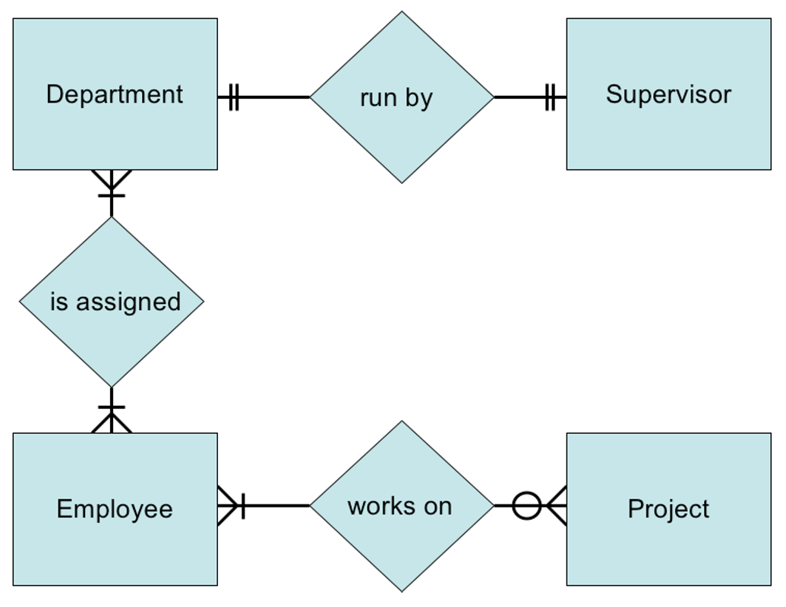

**Answer: ( answers may very )**

**(a) One - to - one (one any only one) relationship between Department and Supervisor, i.e., every department should be run by only one supervisor and one supervisor should only belong to one department.**

**(b) Many - to - many (one or many department to one or many employees) relationship b/w Department and Employee, i.e., an employee can be assigned to multiple departments and a department can contain multiple employees.**

**(c) An employee may not be assigned to a project (zero or many).**

**(d) An employee can be assigned with multiple projects.**

**(e) A project can be assigned to multiple employees.**

**UML**

[**http://people.cs.pitt.edu/~chang/156/03ERmodel.html**](http://people.cs.pitt.edu/~chang/156/03ERmodel.html)

**(18)** Fill the Blank

A(n) **NULL** value, distinct from zero, represents the absence of any value in a field

**(19)** Fill the Blank

A(n) **composite** key is when more than one field makes up a primary or foreign key.

**(20)** Multiple Choice

Which is not a category of SQL?

(a) DDL (b) DML (c) DCL **(d) DAL**

**(21)** Multiple Choice

Which of the following is not a DML command?

(a) insert **(b) create table** (c) delete (d) select

**(22)** Multiple Choice

Which statement is false?

(a) It is possible for tuples to have a null value.

(b) In SQL " P is null " evaluates to null if predicate P evaluates to null.

(c) null signifies an unknown value or that a value does not exist.

(d) The result of any arithmetic expression involving null is null.