Install and configure GNU privacy guard (GNUPG)
┌[henryfbp@pop-os]-(~/D/from-randy)
└> gpg --list-keys (base)
/home/henryfbp/.gnupg/pubring.kbx
---------------------------------
pub rsa3072 2018-09-13 [SC] [expires: 2021-10-17]
0A40840912135F815BD26155C3B02D99C1C244C3
uid [ultimate] Henry Post <HenryFBP@gmail.com>
sub rsa3072 2018-09-13 [E] [expires: 2020-09-12]

pub rsa3072 2018-09-13 [SC] [expires: 2020-09-12]
36EB77CBFCB9FAB819D7A9CA79FC9B69844EF44A
uid [ultimate] Henry Post <hpost@hawk.iit.edu>
sub rsa3072 2018-09-13 [E] [expires: 2020-09-12]

pub rsa4096 2017-08-14 [SCE]
128CF232A9371991C8A65695E08E7E629DB62FB1
uid [ unknown] Fedora 28 (28) <fedora-28@fedoraproject.org>

pub rsa4096 2018-02-17 [SCE]
5A03B4DD8254ECA02FDA1637A20AA56B429476B4
uid [ unknown] Fedora 29 (29) <fedora-29@fedoraproject.org>

pub rsa4096 2018-08-11 [SCE]
F1D8EC98F241AAF20DF69420EF3C111FCFC659B9
uid [ unknown] Fedora (30) <fedora-30-primary@fedoraproject.org>

pub rsa4096 2010-04-23 [SCE]
8C3BE96AF2309184DA5C0DAE3B49DF2A0608B895
uid [ unknown] EPEL (6) <epel@fedoraproject.org>

pub rsa4096 2013-12-16 [SCE]
91E97D7C4A5E96F17F3E888F6A2FAEA2352C64E5
uid [ unknown] Fedora EPEL (7) <epel@fedoraproject.org>

pub rsa4096 2018-11-13 [SCE] [expires: 2028-12-31]
C2A3FA9DC67F68B98BB543F47BB90722DBBDCF7C
uid [ unknown] Fedora (iot 2019) <fedora-iot-2019@fedoraproject.org>

pub rsa4096 2015-01-18 [C] [expires: 2020-01-11]
A490D0F4D311A4153E2BB7CADBB802B258ACD84F
uid [ full ] Tails developers (offline long-term identity key) <tails@boum.org>
uid [ full ] Tails developers <tails@boum.org>
sub rsa4096 2017-08-28 [S] [expires: 2020-01-11]
sub rsa4096 2017-08-28 [S] [expires: 2020-01-11]
sub ed25519 2017-08-28 [S] [expires: 2020-01-11]
sub rsa4096 2018-08-30 [S] [expires: 2020-01-11]

pub rsa4096 2010-09-27 [SC] [expires: 2020-02-07]
4900707DDC5C07F2DECB02839C31503C6D866396
uid [ unknown] Stefano Zacchiroli <zack@upsilon.cc>
uid [ unknown] Stefano Zacchiroli <zack@debian.org>
uid [ unknown] Stefano Zacchiroli <stefano.zacchiroli@inria.fr>
uid [ unknown] Stefano Zacchiroli <zack@softwareheritage.org>
uid [ unknown] Stefano Zacchiroli <zack@irif.fr>
sub rsa4096 2010-09-27 [E]
sub rsa4096 2012-12-01 [S] [expires: 2020-02-07]

pub rsa3072 2019-10-17 [SC] [expires: 2021-10-16]
C2299344CB37649D814509E902FDD80B802CEAA1
uid [ unknown] Randy Random <randyrandom62435123@gmail.com>
sub rsa3072 2019-10-17 [E] [expires: 2021-10-16]

Generate a SHA1 hash from the command-line in Linux
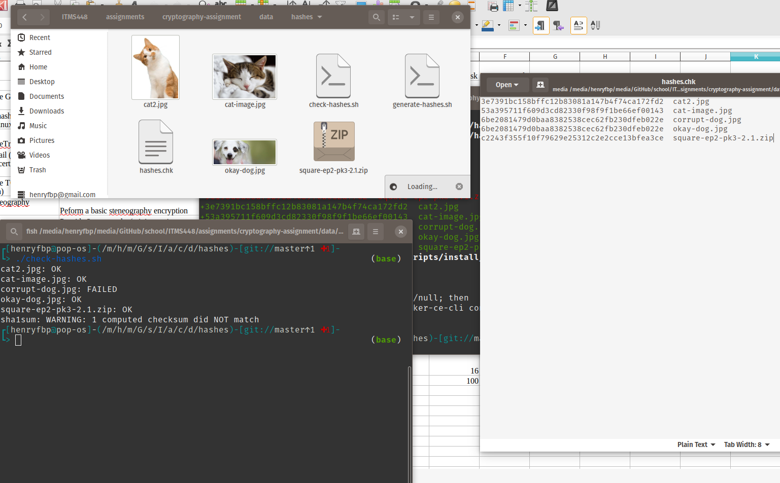

Install and configure TrueCrypt
Asdfasdfasdfasfd :)

Send encrypted email (includes exchanging digital certificates and decrypting email)
Sending pubkey as Randy to Henry
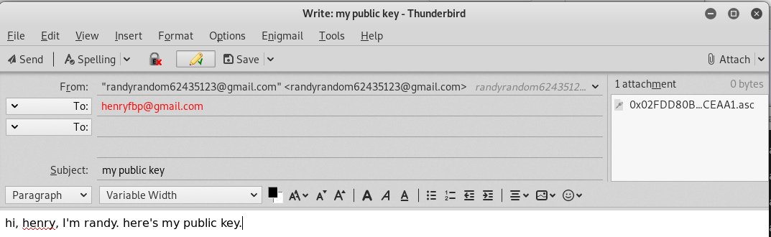
Receiving pubkey as Henry 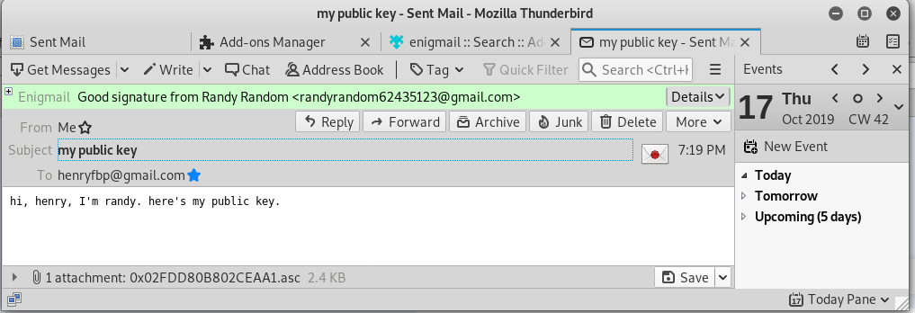
Importing Randy’s pubkey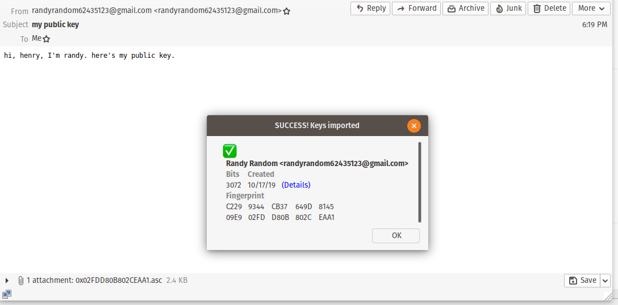
Henry sending his encrypted pubkey to Randy
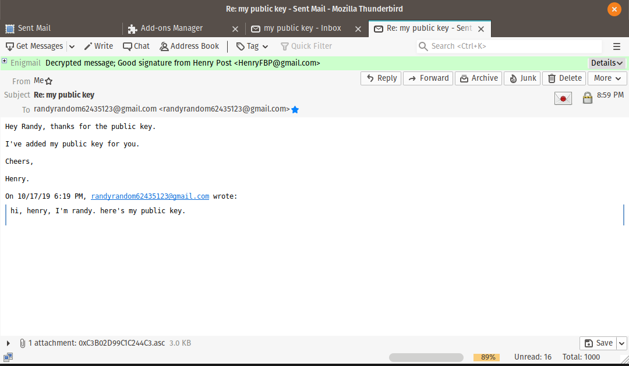
Randy sending a secret plan to Henry using Henry’s pubkey
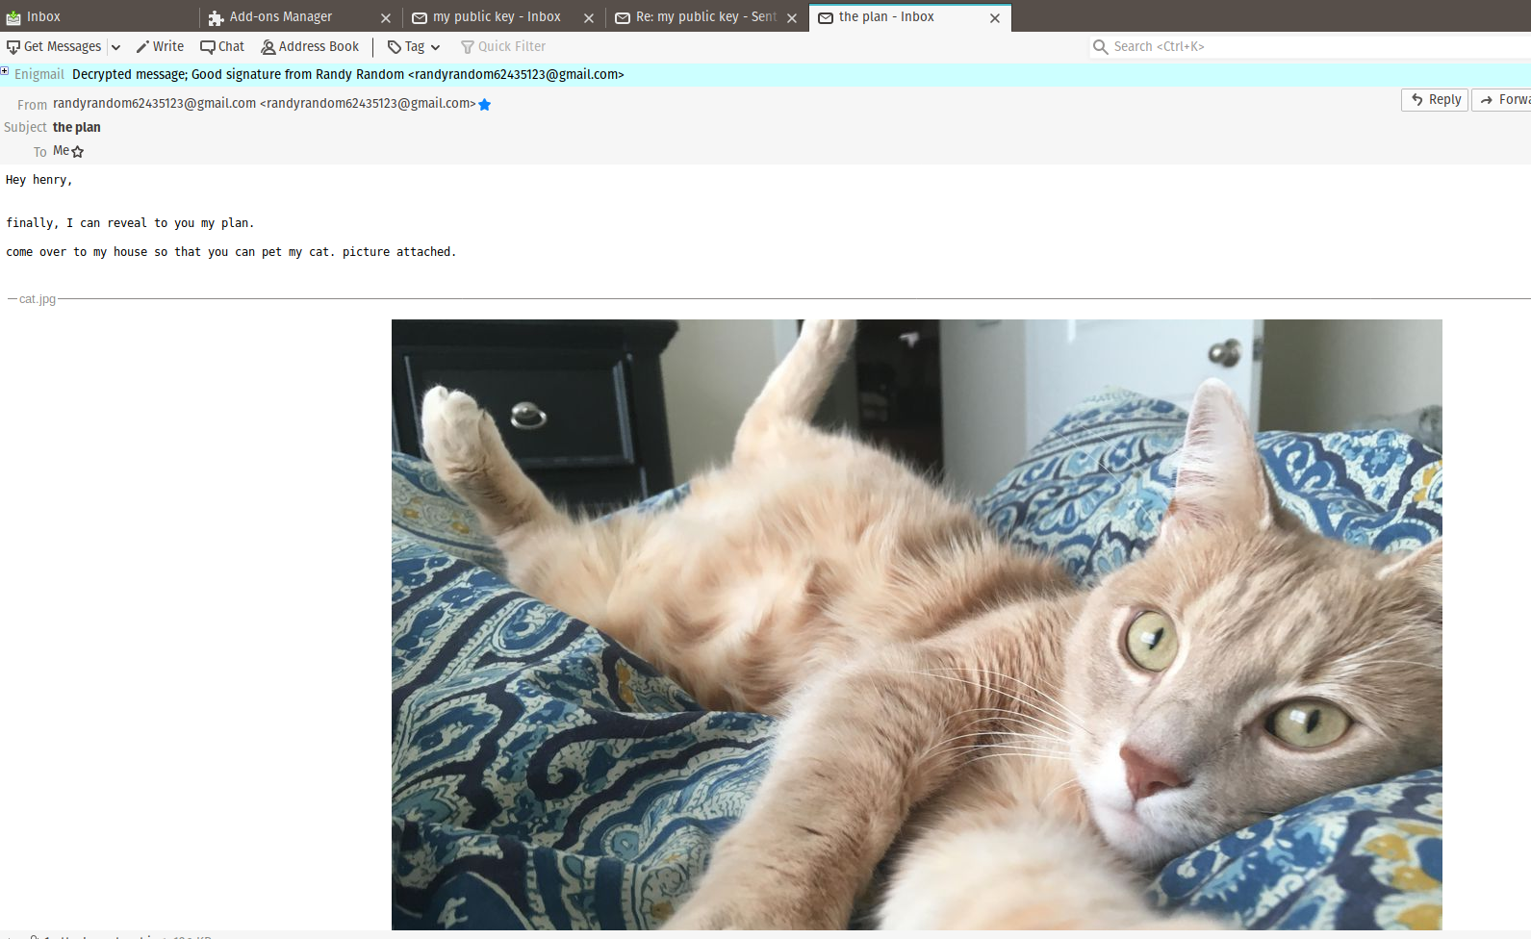
The email without decrypting it:
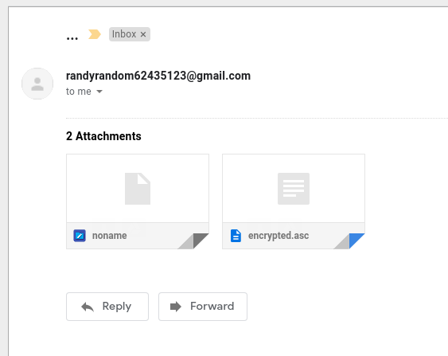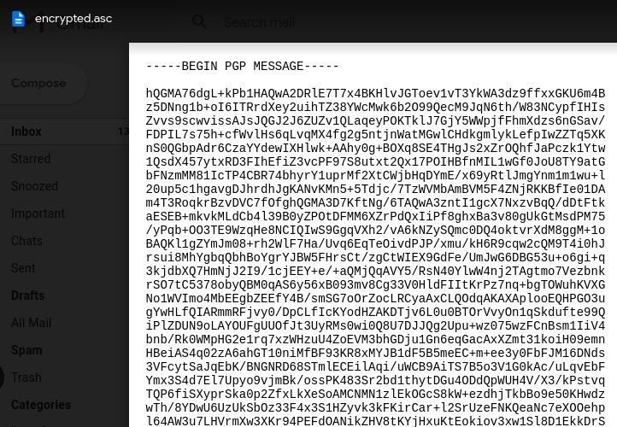

Install and configure TOR (includes performing a search)
Asdfasdfasdf :)

Peform a basic steganography encryption
Asdfasdf asd :)

