What is this popping on the website

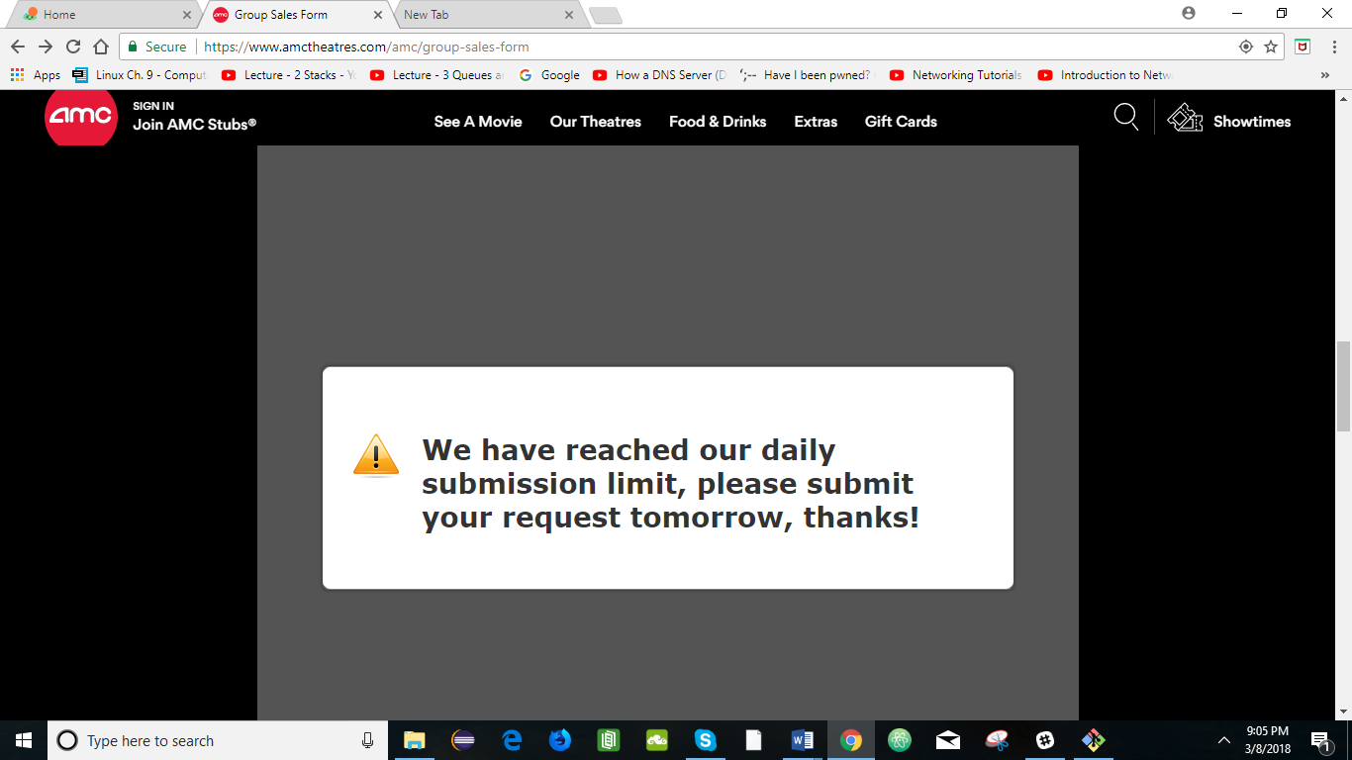

I like this, they have wheelchair companion settings too. When you are dining in and doing reserved seating option.

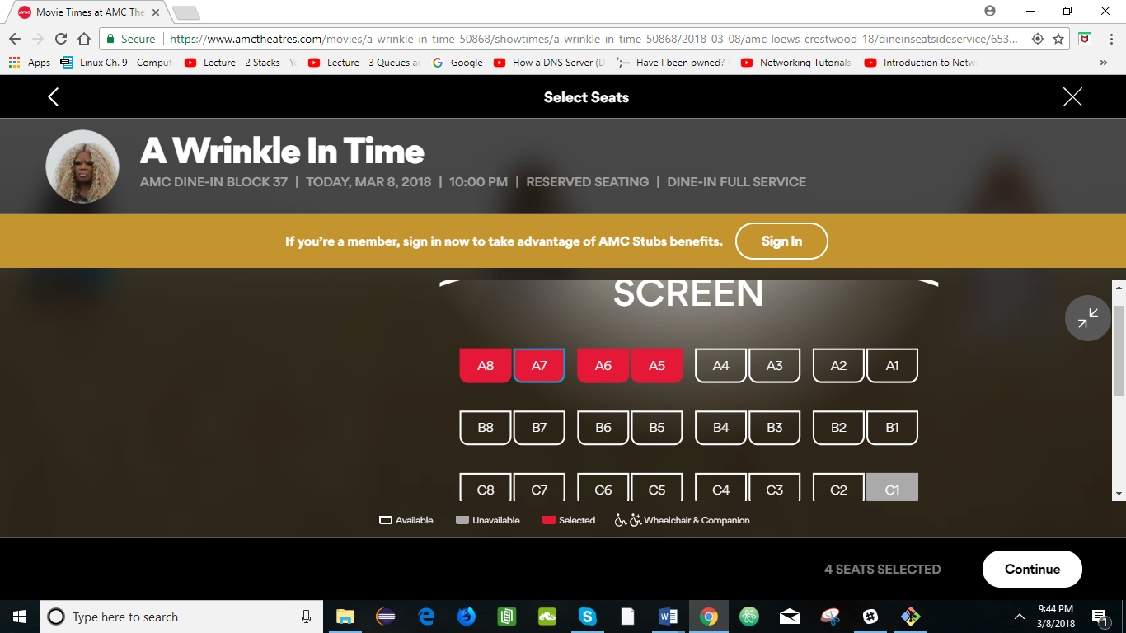

Wow nice, I didn’t know they would give refunds if we can’t make it to the movie

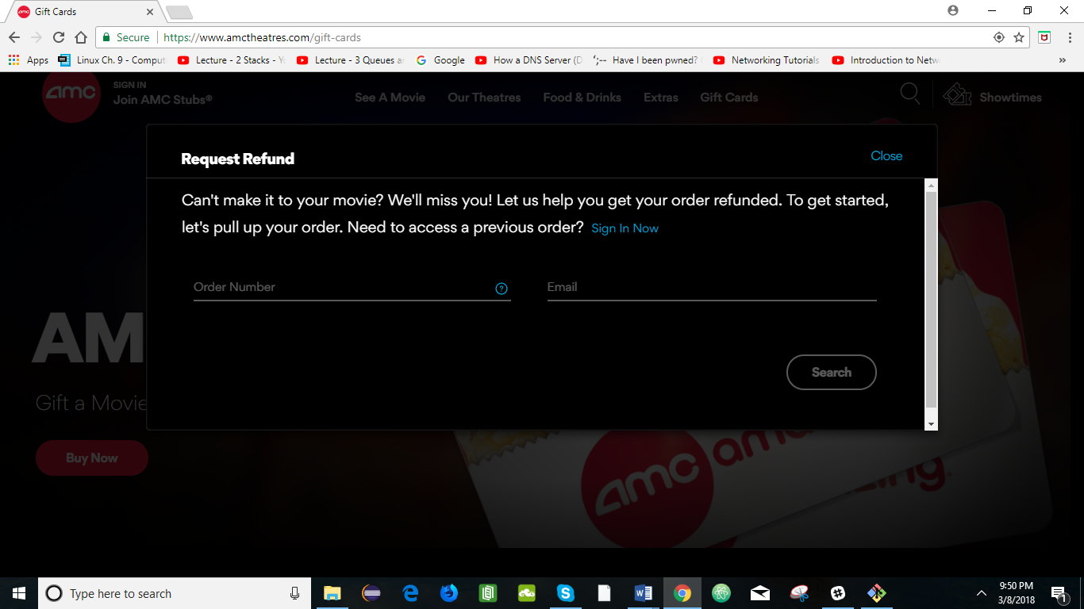

Nice option to add a personalized picture to the gift card.

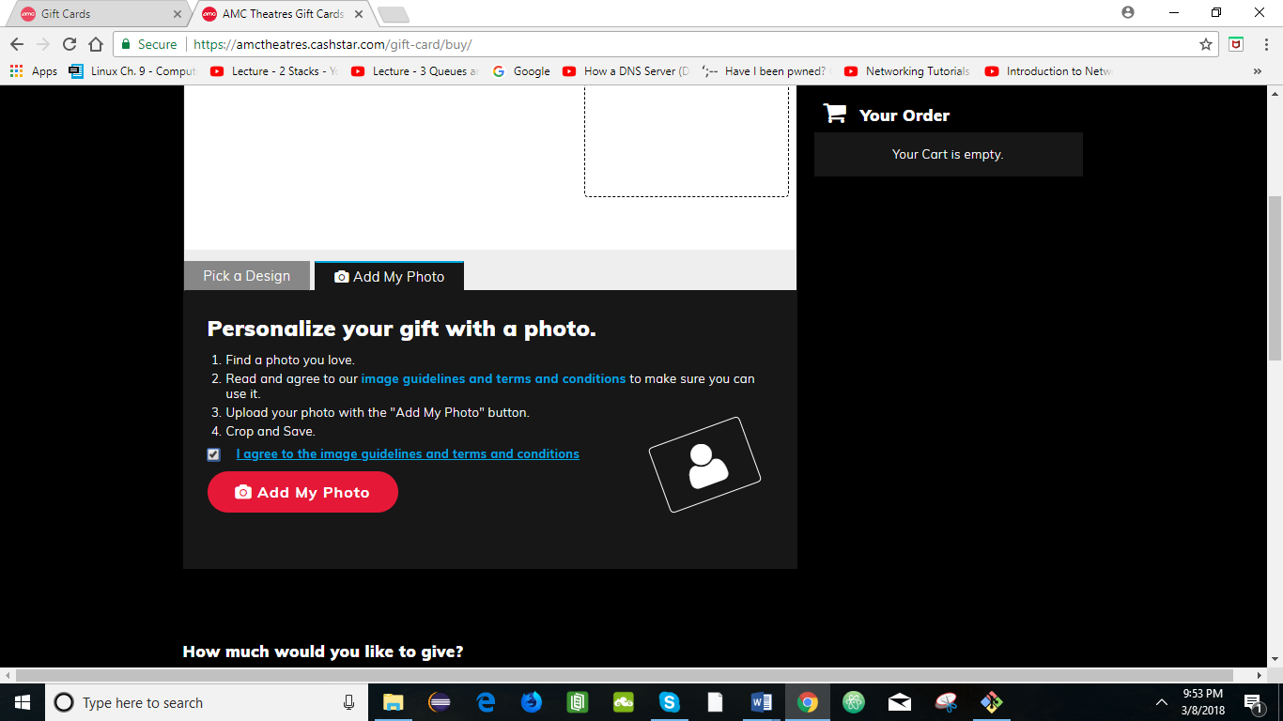

AMC offers summer internships too

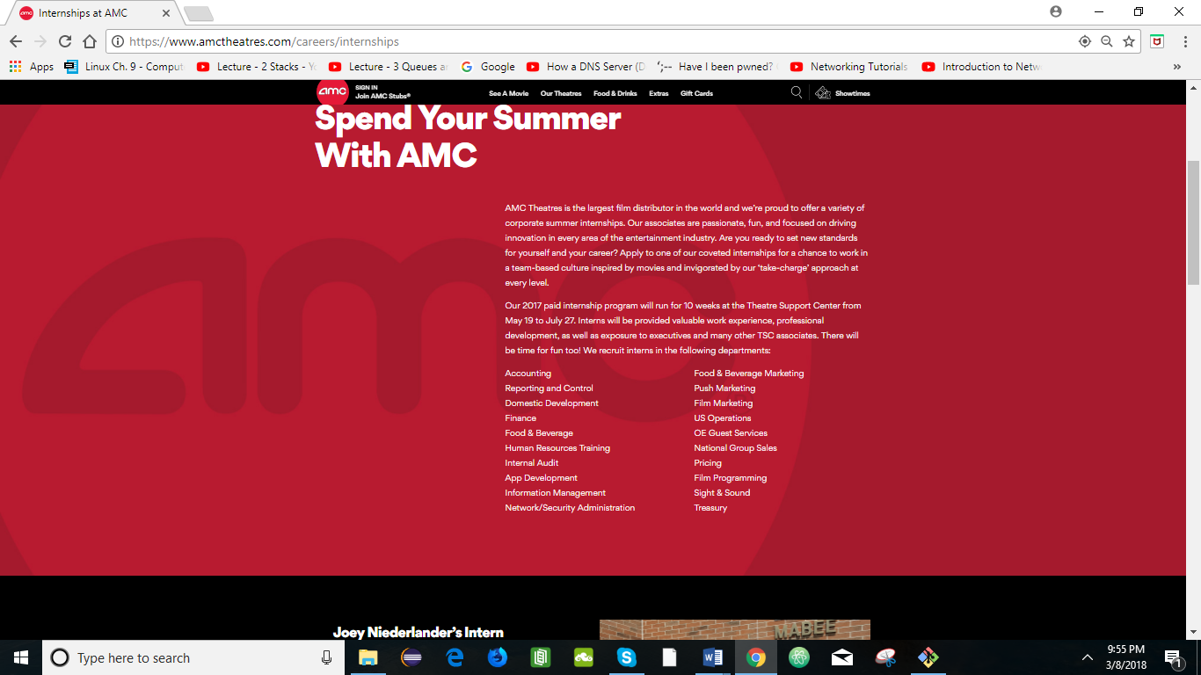

Payment type was not visible and user friendly

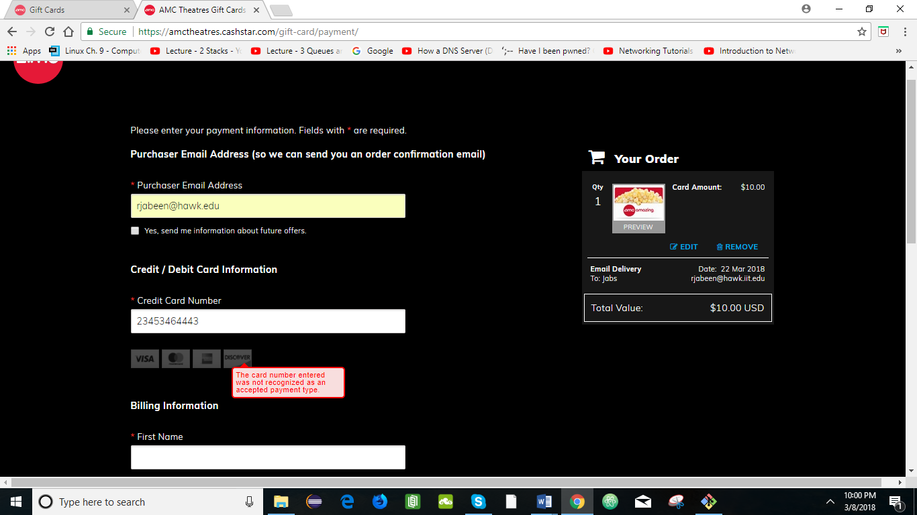

Navigation bar of AMC’s webpage is pretty good

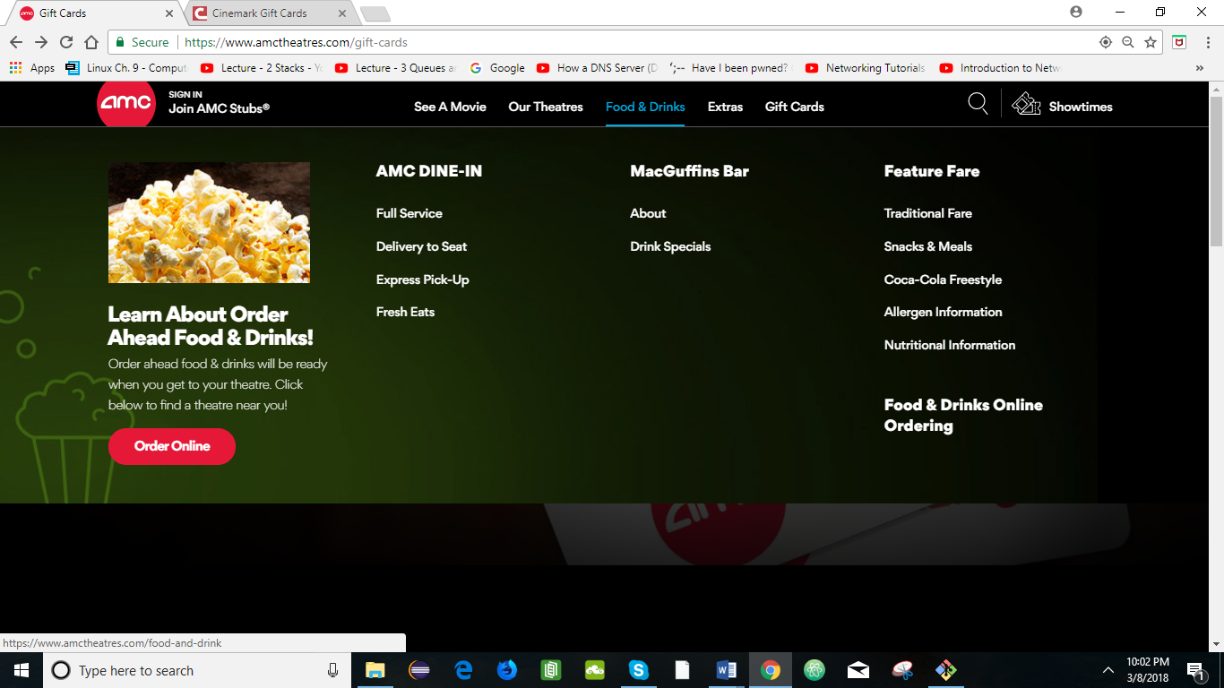

I see a huge difference in AMC site and Cinemark. AMC’s website is very interactive and user friendly.

When you hover over the navigation bar, it displays all the contents it has. In Cinemark, you have to click the titles to see what it has, and it takes you to a different page. It doesn’t have a hover feature and drop-down option. It’s very dull and unattractive to use and go through what it’s offering.

