Site: fandango.com

* Buy a movie ticket
* (not very obvious where the tickets are)
* 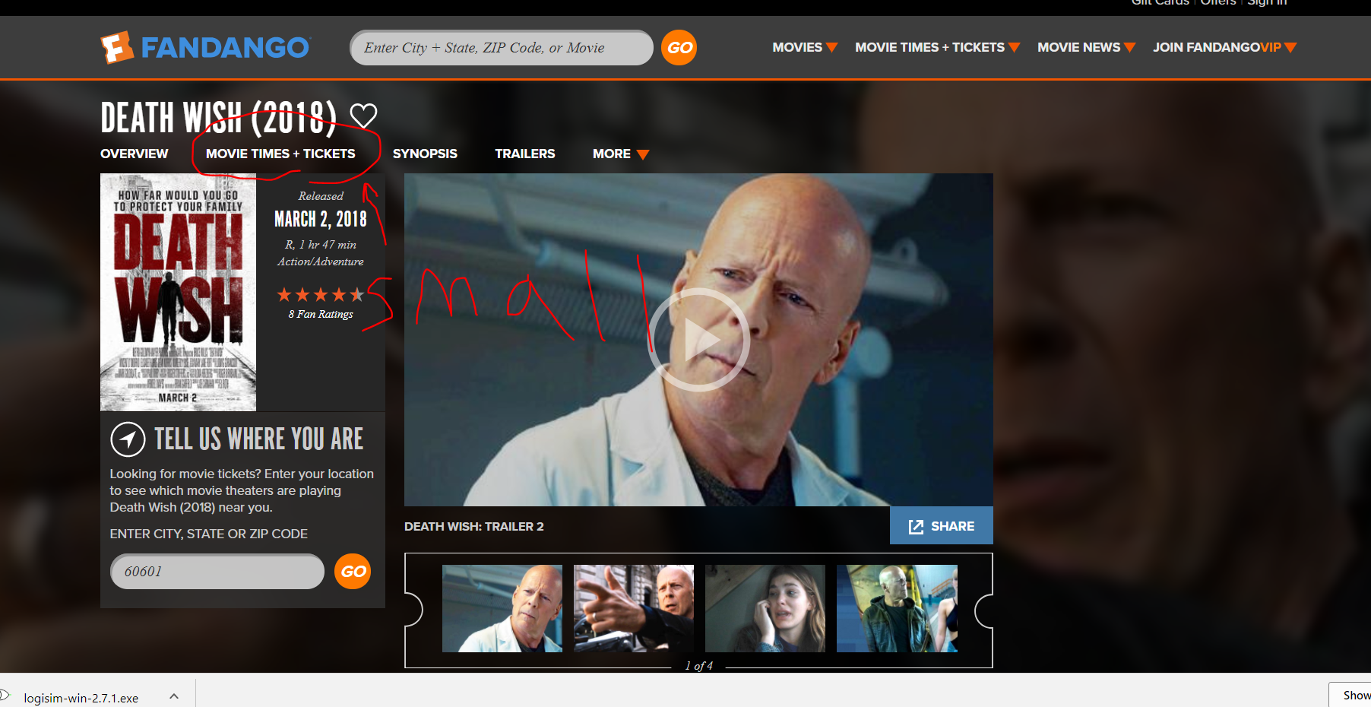
  + Find a movie
    - Time
    - Location
    - Genre
  + Movie already found?  
    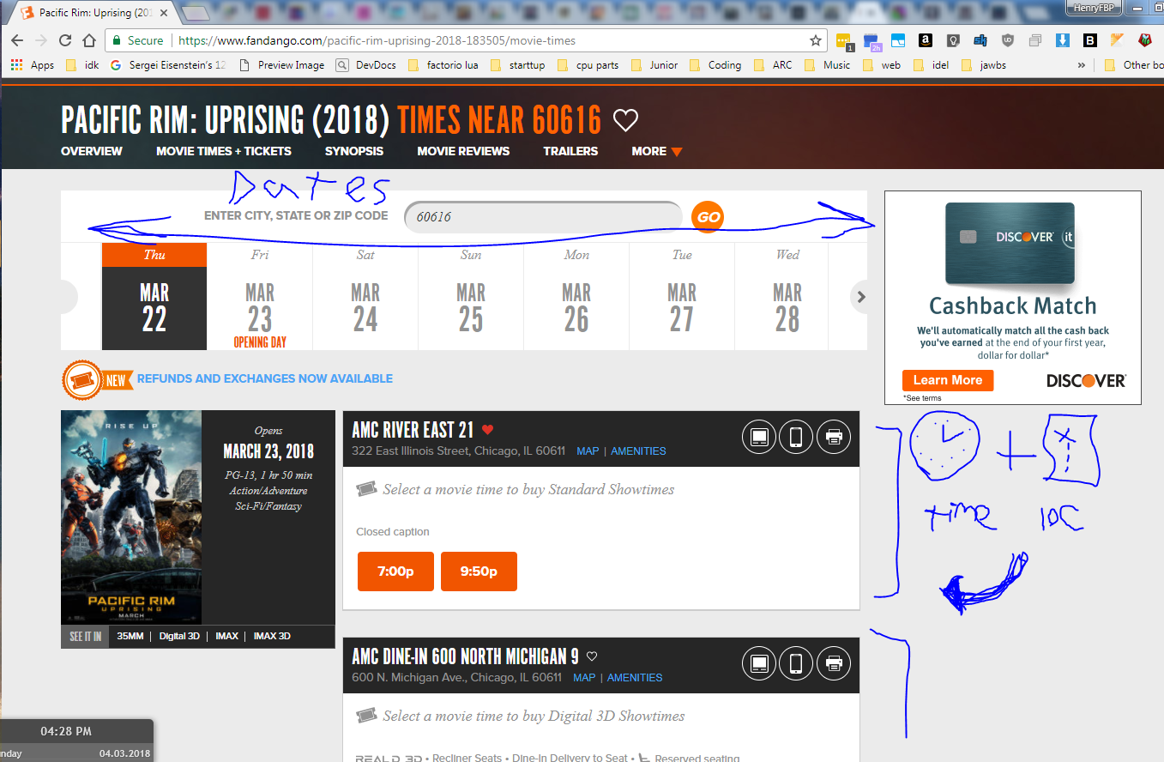
    - Time
    - Location
  + Number of tickets  
    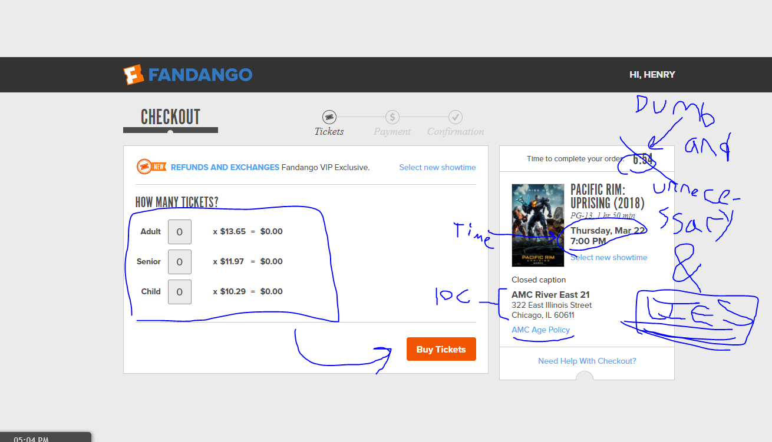
    - Age
  + Seating
* Checkout!  
  