Henry Post

ITMD413

Lab 2, BMI Calculator

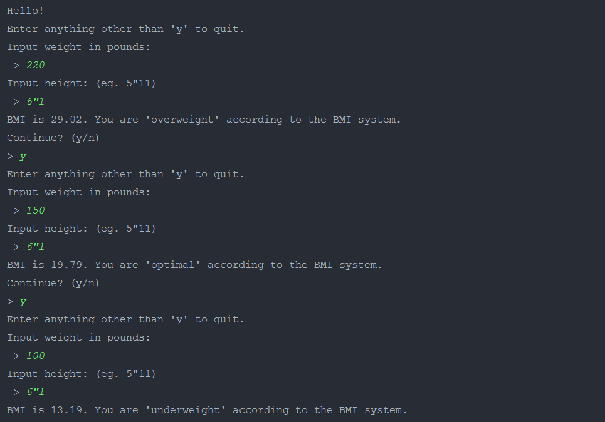

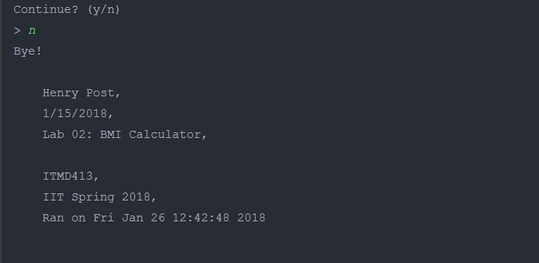

**import** **time**

__info__ = \

f"""

Henry Post,

1/15/2018,

Lab 02: BMI Calculator,

ITMD413,

IIT Spring 2018,

Ran on {time.strftime("%c")}

"""

**def** **BMI**(weight: float, height: float) -> float:

**return** (weight * **703** / (height ** **2**))

**def** **BMIRank**(bmi: float):

**if**(bmi > **25**):

**return** "overweight"

**elif**(bmi > **18.5**):

**return** "optimal"

**else**:

**return** "underweight"

**def** **promptWeight**() -> float:

n = float(input("Input weight in pounds:**\n** > "))

**return** n

**def** **promptHeight**() -> float:

s = input("Input height: (eg. 5**\"**11)**\n** > ").replace("'",'') # get height in foot+inches w/o single quotes

sA = s.split("**\"**") # split by double quote

inches = (float(sA[**0**]) * **12**) + float(sA[**1**])

**return** inches

**def** **prompt**() -> {}:

**while** True:

**try**:

w = promptWeight();

**except**:

**print**("Please enter a valid weight value.")

**else**:

**break**

**while** True:

**try**:

h = promptHeight();

**except**:

**print**("Please enter a valid height value.")

**else**:

**break**

**return** {"weight":w,"height":h}

inp = "y"

**print**("Hello!")

**while** (len(inp) > **0** **and** inp[**0**].upper() == 'Y'):

**print**("Enter anything other than 'y' to quit.")

hw = prompt()

bmi = BMI(hw["weight"], hw["height"])

**print**(f"BMI is {bmi:.2f}. You are '{BMIRank(bmi)}' according to the BMI system.")

**print**("Continue? (y/n)")

inp = input("> ")

**print**("Bye!")

**print**(__info__)