Henry Post

ITMD413

Lab 7, Tkinter GUI

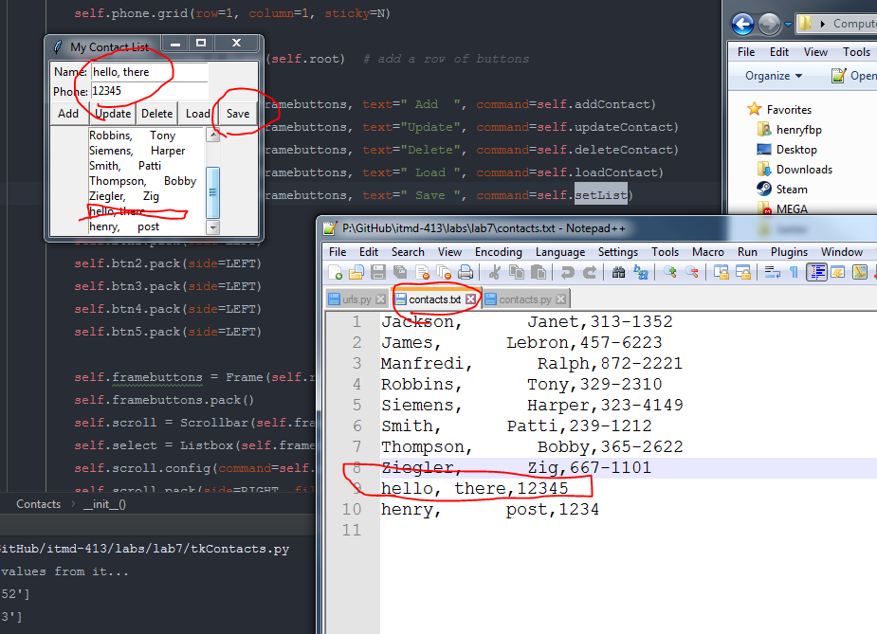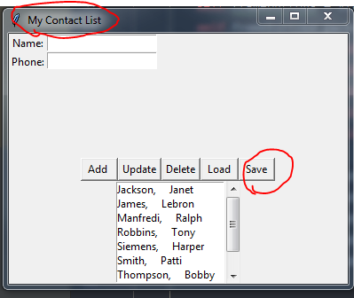

1. **import** os
2. **from** tkinter **import** *
4. **from** contacts **import** *
6. contacts_file = 'contacts.txt'

9. **class** Contacts:
10. **def** selection(self):
11. **print**("At %s of %d" % (self.select.curselection(), len(self.contacts)))
12. **return** int(self.select.curselection()[0])
14. **def** addContact(self):
15. self.contacts.append([self.nameVar.get(), self.phoneVar.get()])
16. self.setList()
18. **def** updateContact(self):
19. self.contacts[self.selection()] = [self.nameVar.get(), self.phoneVar.get()]
20. self.setList()
22. **def** deleteContact(self):
23. **del** self.contacts[selection()]
24. self.setList()
26. **def** loadContact(self):
27. name, phone = self.contacts[self.selection()]
28. self.nameVar.set(name)
29. self.phoneVar.set(phone)
31. **def** __init__(self, contactsList, path):
32. self.contacts = contactsList
33. self.path = path
35. self.root = Tk()
37. self.root.winfo_toplevel().title("My Contact List")
39. self.framebuttons = Frame(self.root)
40. self.framebuttons.pack(fill=BOTH, expand=YES)
42. Label(self.framebuttons, text="Name:").grid(row=0, column=0, sticky=N)
43. self.nameVar = StringVar()
44. self.name = Entry(self.framebuttons, textvariable=self.nameVar)
45. self.name.grid(row=0, column=1, sticky=W)
47. Label(self.framebuttons, text="Phone:").grid(row=1, column=0, sticky=N)
48. self.phoneVar = StringVar()
49. self.phone = Entry(self.framebuttons, textvariable=self.phoneVar)
50. self.phone.grid(row=1, column=1, sticky=N)
52. self.framebuttons = Frame(self.root)  # add a row of buttons
53. self.framebuttons.pack()
54. self.btn1 = Button(self.framebuttons, text=" Add  ", command=self.addContact)
55. self.btn2 = Button(self.framebuttons, text="Update", command=self.updateContact)
56. self.btn3 = Button(self.framebuttons, text="Delete", command=self.deleteContact)
57. self.btn4 = Button(self.framebuttons, text=" Load ", command=self.loadContact)
58. self.btn5 = Button(self.framebuttons, text=" Save ", command=self.setList)
60. self.btn1.pack(side=LEFT)
61. self.btn2.pack(side=LEFT)
62. self.btn3.pack(side=LEFT)
63. self.btn4.pack(side=LEFT)
64. self.btn5.pack(side=LEFT)
66. self.framebuttons = Frame(self.root)  # allow for selection of names
67. self.framebuttons.pack()
68. self.scroll = Scrollbar(self.framebuttons, orient=VERTICAL)
69. self.select = Listbox(self.framebuttons, yscrollcommand=self.scroll.set, height=7)
70. self.scroll.config(command=self.select.yview)
71. self.scroll.pack(side=RIGHT, fill=Y)
72. self.select.pack(side=LEFT, fill=BOTH)
74. self.setList()
76. **def** setList(self):
77. self.contacts.sort()
78. self.select.delete(0, END)
79. **for** name, phone **in** self.contacts:
80. self.select.insert(END, name)
82. with open(self.path, 'w') as f:
84. **print**("Writing list to file at '" + self.path + "'.")
86. **for** contact **in** self.contacts:
87. line = ','.join(contact)
88. f.write(line + '\n')

91. **def** contactFromLine(line: str):
92. lines = line.split(',')
94. fname = lines[0]
95. lname = lines[1]
96. pn = lines[2]
98. ret = [(fname + ', ' + lname), pn]
99. **print**(ret)
100. **return** ret

103. **def** loadListFromFile(path: str):
104. ret = []
105. with open(path, 'r') as f:
106. **for** line **in** f:
107. line = line.replace('\r', '').replace('\n', '')
108. ret.append(contactFromLine(line))
109. **return** ret

112. **if** __name__ == '__main__':
113. **if** os.path.exists(contacts_file):
114. **print**("'" + contacts_file + "' exists! Loading values from it...")
115. contactlist = loadListFromFile(contacts_file)
117. contacts = Contacts(contactlist, contacts_file)
119. contacts.root.mainloop()