Henry Post

ITMD 455

Lab 1: Temperature Converter

Contents

Color gradients and unit auto-conversion: 2

Custom LinearLayout subclass, ‘TemperatureElement’ 5

HashMap-backed formula solving system 6

# Color gradients and unit auto-conversion:

I designed my application to convert the units whenever any textbox changed, and It accomplishes this through an OnTextChanged listener.

I also made the colors *interpolate* between two values, #FF0000 and #0000FF.   
  
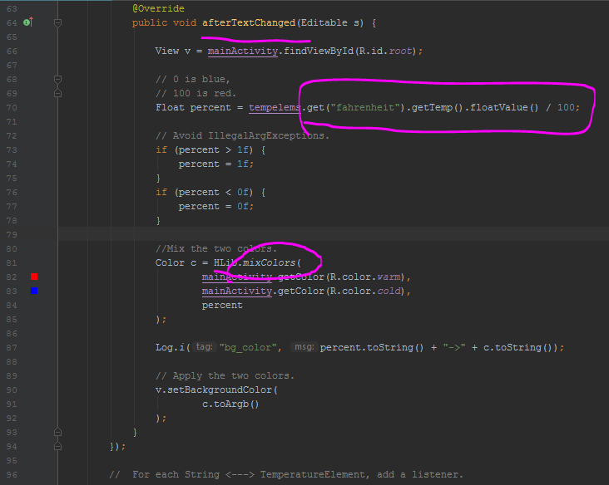  
  
As you can see here, I convert the fahrenheit value to a float, divide it by 100, and then use it to scale how intensely I mix the ‘warm’ and ‘cold’ colors.  
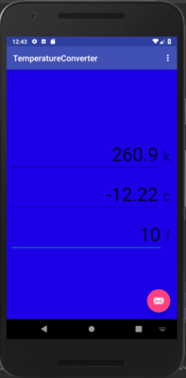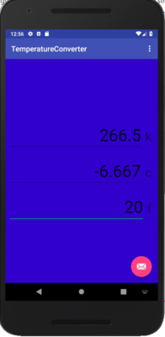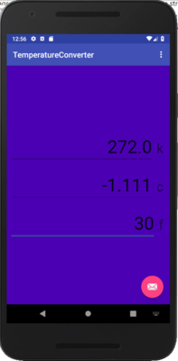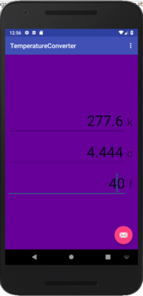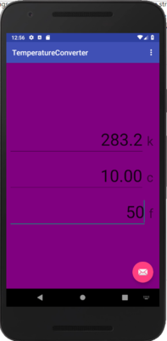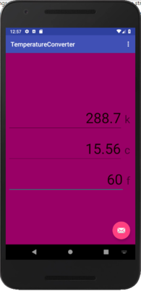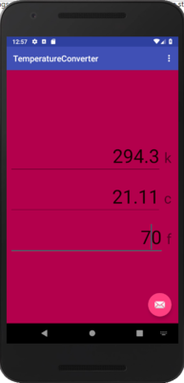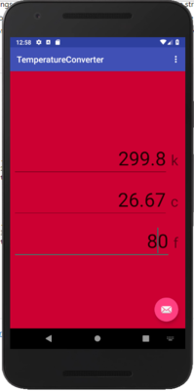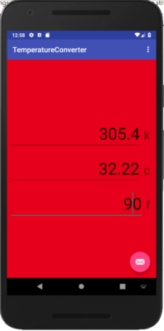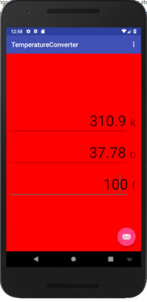

# Custom LinearLayout subclass, ‘TemperatureElement’

I wrote a custom LinearLayout subclass called a TemperatureElement that stores extra metadata like a removable TextWatcher, a TemperatureUnit, and has some convenience text-to-BigDecimal functions.

It also allows inflating layouts to GUI elements with a SINGLE LINE OF CODE!

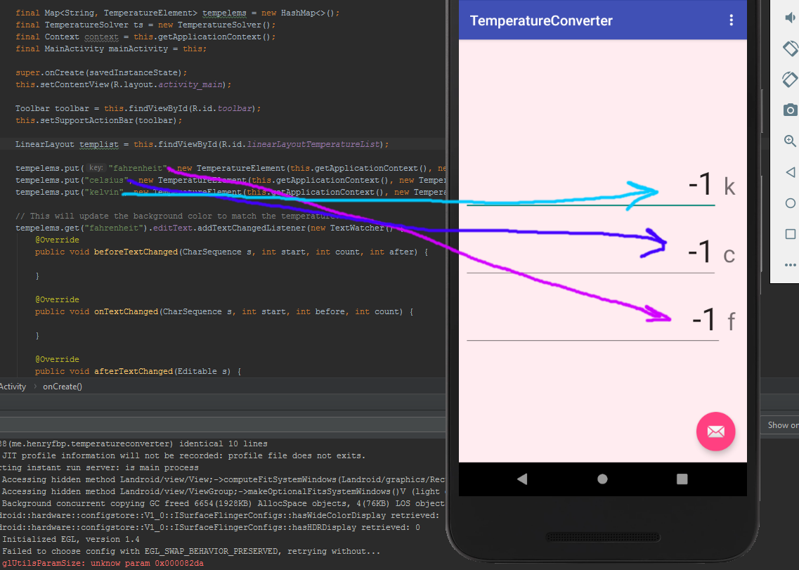

As you can see, it takes little effort to populate the screen.

They draw their style from a single, 20-line XML file.

# HashMap-backed formula solving system

You may notice that I have absolutely no hard-coded logic for turning one unit into another.

That is because I define them all inside of TemperatureSolver and TemperatureSolverSingle!

I use the MXParser library to turn strings into algebraic expressions.

*/***  
 * Solve any temperature.  
 */*public class TemperatureSolver {  
  
 public Map<ImmutableList, TemperatureSolverSingle> map = new HashMap<>();  
  
 public TemperatureSolver() { //*TODO: Use linear algebra to automatically fill-in missing formulas.* this.addTemp(  
 new TemperatureSolverSingle("celsius", "fahrenheit", "F(x) = ((9/5) * x) + 32"),  
 new TemperatureSolverSingle("celsius", "kelvin", "F(x) = x + 273.15"),  
 new TemperatureSolverSingle("fahrenheit", "kelvin", "F(x) = (x + 459.67) * (5/9)"),  
 new TemperatureSolverSingle("fahrenheit", "celsius", "F(x) = (x - 32) * (5/9)"),  
 new TemperatureSolverSingle("kelvin", "celsius", "F(x) = x - 273.15"),  
 new TemperatureSolverSingle("kelvin", "fahrenheit", "F(x) = ((9/5) * x) - 459.67")  
 );  
 (…)}  
}