Henry Post

ITMD 455

Lab 2: Temperature Converter Part Deux

Contents

Temperature Slider 2

Temperature List 3

# Temperature Slider

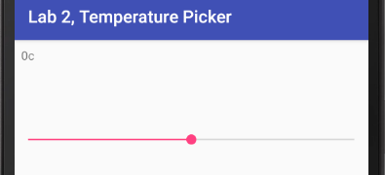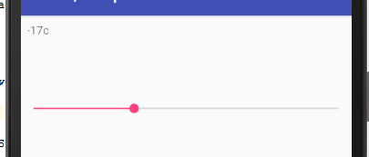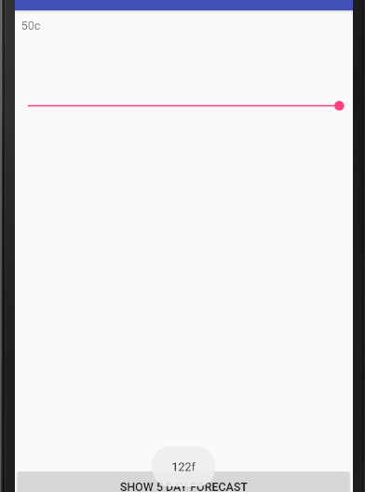As you can see, the temperature slider shows the temperature in celsius, and in fahrenheit on the bottom.

# Temperature List

Being an overachieving masochist, I decided to dynamically build the list of temperatures from live JSON data taken from [www.openweathermap.org](http://www.openweathermap.org)!

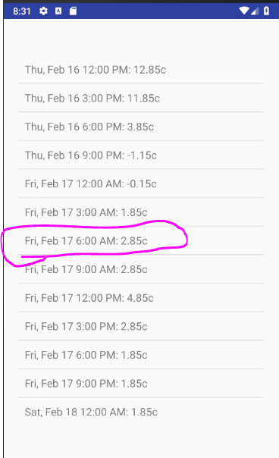This list of data is taken from an HTTP GET request, and parsed and loaded into an ArrayList of my custom TemperatureDate class.

This ArrayList is then loaded into a ListAdapter that uses my TemperatureDate’s toString method to display the text you are seeing.

When a user clicks on a ListItem, the Intent is switched to MainActivity, and the TemperatureDate is serialized and passed to the MainActivity through a Bundle object.

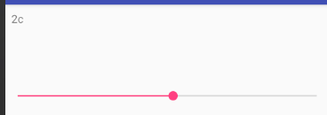It is then applied to the SeekBar’s position on the MainActivity Activity.