Henry Post

ITMD 455

Lab 3: Quotes

Contents

QuoteReaderActivity activity 2

# QuoteReaderActivity activity

This is an overview of all quotes.

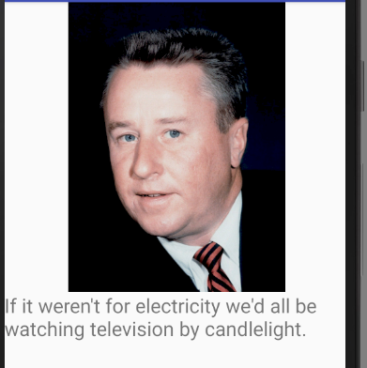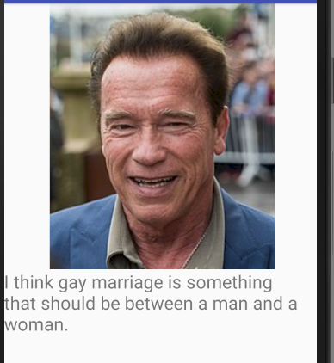Below you’ll see the expanded versions of all of them. [1]

1. These are stupid quotes. And funny.