Henry Post

ITMD 455

Lab 4: SAX XML Parsing

Contents

LoginActivity 2

MainActivity 3

# LoginActivity

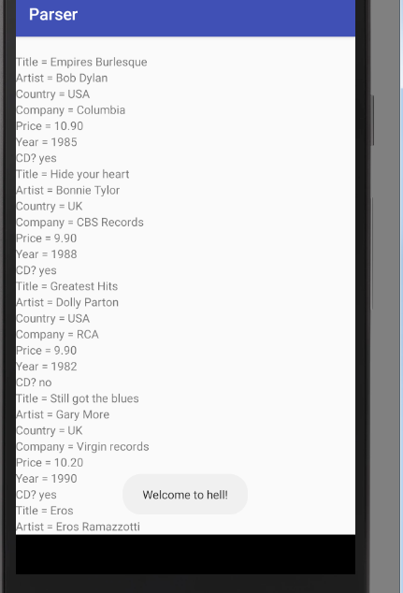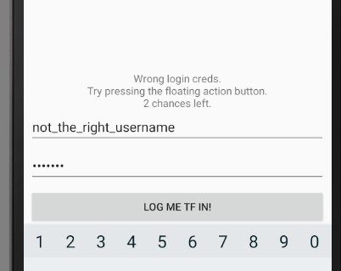

Above, that’s what’s displayed when you don’t login successfully.

There’s a floating action button in the lower-right that populates the login fields with the correct credentials.

On the right, there’s the toast message “Welcome to hell!” along with our view of the XML data in a TextListView.

# MainActivity

Below you can see that only albums with CD=YES are shown.

