Henry Hoekel

Hshkcc

14207985

CS 4850 LAB 1

PERFORMANCE ANALYZES OF HUB AND SWITCH

9/25/2017

By: Henry Hoekel

Lab Description

In Lab 1, we used The Riverbed Modeler to create two scenarios. Both tested the performance of networks with 16 nodes in a simulated office environment. The first scenario, OnlyHub, depicted 16 nodes attached to one singular hub, pictured below.

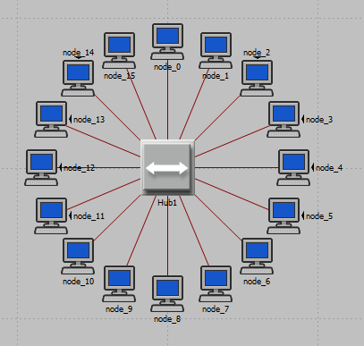

The second scenario, HubAndSwitch, splits the 16 nodes into groups of 8 linked to a hub each with 10bT ethernet. This scenario is pictured below.

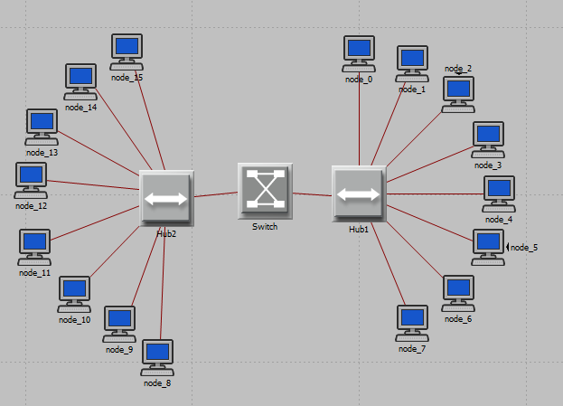

These two scenarios were ran using scenarios lasting 2 minutes each. In each scenario, the software graphed an average over time was delay (in seconds), traffic sent (in packets per second), traffic received (in packets per second), and the collision count. These graphs are displayed below in order as they are listed.

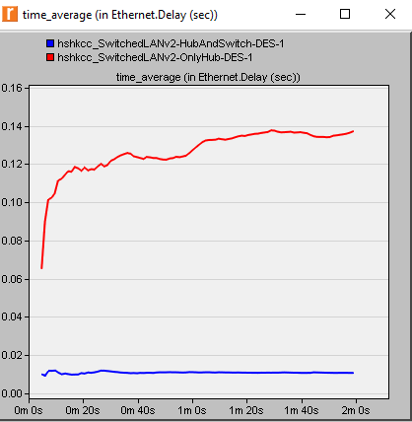

The delay for the HubAndSwitch scenario was noticeably less and consistent. As you can see in the graph, the delay in seconds continuously rose for the singular hub scenario, OnlyHub.

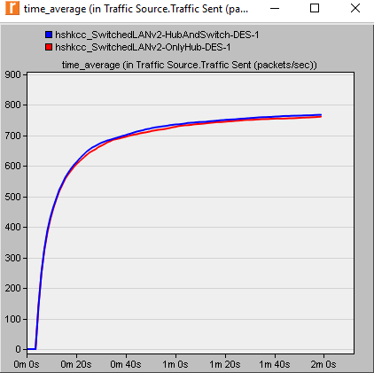

As depicted in the graph above, the traffic sent in packets per second is essentially the same for both scenarios.

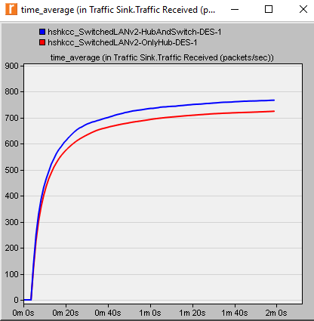

The time_average for packets received per second is essentially the same for both scenarios. However, as you can notice in the graph, the OnlyHub scenario has a slightly lower time.

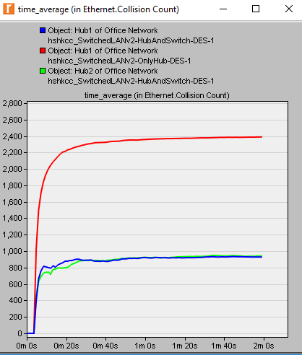

The collision for Hub1 in the OnlyHub scenario as seen in the graph is greatly higher than the amount for HubAndSwitch. Hub1 and Hub2 in HubAndSwitch have very similar collision counts. We can conclude that one hub as opposed to 2 hubs linked to a switch is a correlation to the amount of collisions.

**Exercises:**

1. **Explain why adding a switch makes the network perform better in terms of throughput and delay.**

Adding a switch makes the network perform better in throughput because one singular hub is not the limiting factor in data transmission. By adding a second hub and connecting these hubs via a switch, the data transmission can be spread among 2 hubs and now the switch is the “chokepoint,” in the network. This also reduces the delay because more hubs on the network can reduce the rising time delay displayed in the graphs in the scenario. By adding two hubs linked to a switch, this delay was decreased while also maintaining a steady time. This makes the network perform better because the singular hub is most likely not overloaded by adding another hub to the network and a switch. Previously, the delay continuously rises as seen in the graph of OnlyHub due most likely to the overload of data transmission on the singular hub device. This is counteracted by adding another.

1. **We analyzed the collision counts of the hubs. Can you analyze the collision count of the “switch”? Explain your answer.**

No, you cannot. You cannot because the switch is “dumber,” than the hub. The switch’s job is just to “switch,” data onto the particular node. The switch only maintains a list of addresses to forward data to. The hub can count the amount of collisions because the hub contains the CSMA/CD, or carrier sense multiple access and collision detection protocol. The switch doesn’t contain this protocol, so we cannot analyze the collision count on the switch.

**3. Create two new scenarios. The first new scenario is the same as the OnlyHub scenario with the hub replaced by a switch. The second new scenario is the same as the HubAndSwitch scenario with both hubs replaced by two switches, the old switch removed, and the two switches you just added together connected with a 10BaseT link. Compare the performance of the four scenarios in terms of delay, throughput, and collision count. Analyze the results.**

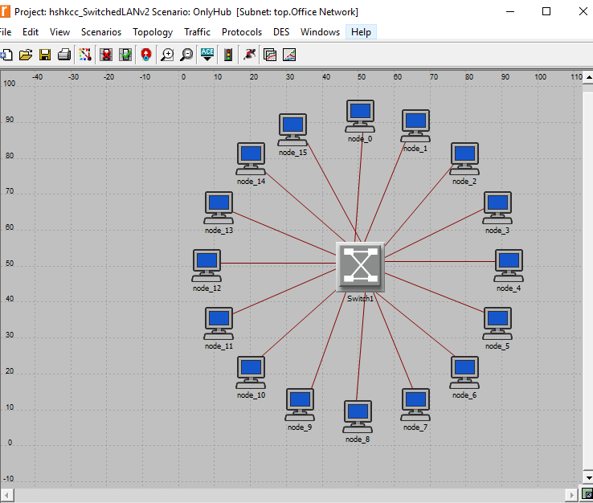

OnlyHub except swapped with a switch instead of a hub.

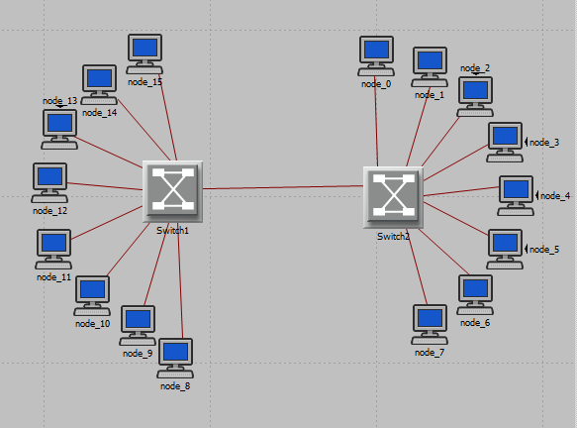

HubAndSwitch with hub removed and two switches.

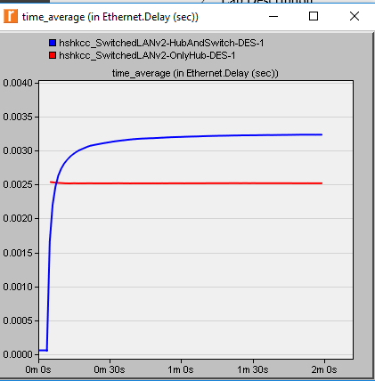

Above is the delay depicted for the two new scenarios. You can conclude from the graph that the two switches delay is constantly rising then levels off, whereas the singular switch maintains a constant delay. Although the two switches delay may begin to be lower, the delay rises a higher value than the singular switch. One can conclude that the addition of another switch increases the delay.

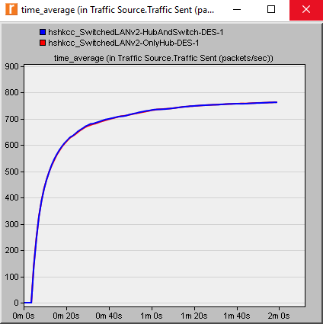

Traffic sent in packets/ second is consistent for both.

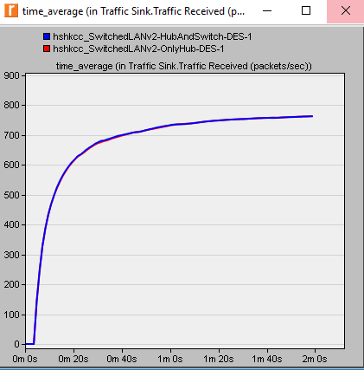

Traffic received in packets/ second is consistent for both as well.

Collision Count: As answered in question 2, switches do not detect collisions because they do not contain the CSMA/CD, or Carrier Sense Multiple Access and Collision Detection protocol, thus the collision count could not be observed for these two scenarios.

In conclusion to exercise 3, the delay between two switches as opposed to one is on average higher. The addition of a switch causes the delay to originally be less, however over time it becomes greater than the delay of just one singular switch. This is displayed in the graph above for delay, in seconds.

**Observation**

In this lab, we observed the difference in throughput in two scenarios both with 16 nodes in a simulated office environment. The first was 16 nodes linked to one singular hub, and the second split the 16 nodes among two switches and these switches were linked to a hub. The nodes split among two switches and linked by a hub, named HubAndSwitch, overall performed much better than the singular, OnlyHub. This can be seen in the lower delay in seconds, as well as a much more consistent delay, which proves essential on a network, in particular an office environment.

In addition, the collision count for the HubAndSwitch scenario was much lower than that for the OnlyHub. This is important for scalability, especially in an office environment. For a successful and efficient network, the network needs to be configured to minimize the amount of collisions in order to improve the network speeds. This was solved by the addition of the hub. In exercise 3 when we removed the hub, we couldn’t tell how many collisions occurred, however the delay was noticeably higher.

**Conclusion**

In conclusion, the HubAndSwitch scenario, which split the 16 nodes evenly among two switches, linked to a hub performed much better than the OnlyHub scenario where 16 nodes were linked to one singular hub. The delay was dramatically reduced, in addition to the collision count. In exercise 3, we removed the hub and compared the results, and can conclude that the addition of the hub greatly improved network performance across the board. The difference in switches and hubs did not change throughput, however it did affect the delay and collision count when a hub was present.

The collision count cannot be observed on a switch because it does not contain the CSMA/CD, or essential collision detection protocol. The hub contains this protocol which is why we can observe the collision count when a hub is present.

Exercise 3 interestingly provided a counterargument to the previous scenarios in the lab. The two switch and no hub scenario had a higher delay than the singular switch scenario. This contradicts the scenario where we added another switch to the hub and this reduced the delay. One can conclude that the addition of another switch without being linked to the hub, the delay will increase. This could be due to the addition of another hardware device forwarding data thus causing a higher delay.