板单元程序使用说明

* 原理

作者依据高阶板理论编写了一个8节点，每节点7自由度，横向正应变呈线性分布的板单元。基于Abaqus的uel子程序编写，重点在于给出单元刚度矩阵AMATRX和残差矢量RHS。AMATRX即单元刚度矩阵K，RHS=-K\*U。可参考：

Smith I M, Griffiths D V, MARGETTS L. Programming the finite element method[M]. John Wiley & Sons, 2013.

Moreira J A, Moleiro F, Araújo A L. Layerwise electro-elastic user-elements in Abaqus for static and free vibration analysis of piezoelectric composite plates[J]. Mechanics of Advanced Materials and Structures, 2021, 29(21):3109-3121.

Moreira J A, Moleiro F, Araújo A L, et al. Assessment of layerwise user-elements in Abaqus for static and free vibration analysis of variable stiffness composite laminates[J]. Composite Structures, 2023, 303.

Ferreira G F O, Almeida J H S, Ribeiro M L, et al. Development of a finite element via Unified Formulation: Implementation as a User Element subroutine to predict stress profiles in composite plates[J]. Thin-Walled Structures, 2020, 157.

* 数据流

如图所示：

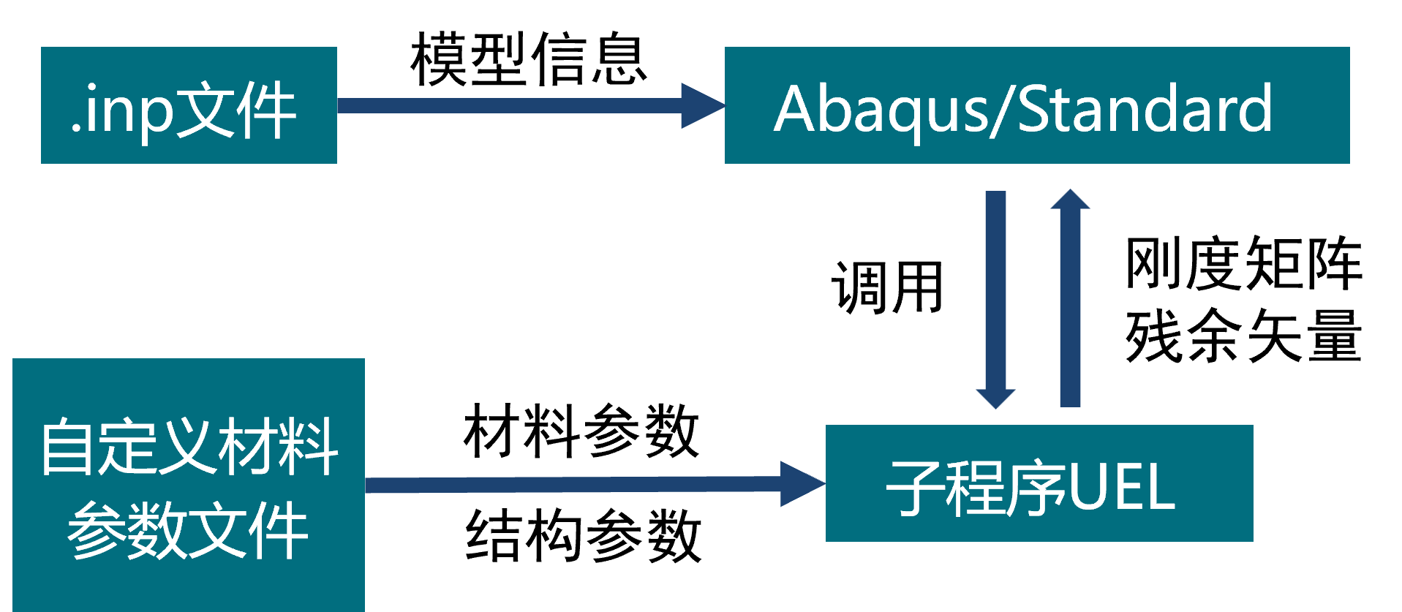

* 使用方法

需要子程序文件corrugated plate.for；xxx.inp文件，里面对uel部分做好了修改，其中\*uel property部分为瓦楞纸板的md方向和面外方向向量；材料参数文件matprop.txt，每行的含义如下：

#纸板类型

corrugated

#瓦楞数

1/2/3

#几何模式

full/simplify

#面纸参数(t,E1,E2,v12,G12,G13,G23)

0.29,3326,1694,0.34,860,60,48

0.29,3326,1694,0.34,860,60,48

0.29,3326,1694,0.34,860,60,48

#芯纸参数(t,E1,E2,v12,G12,G13,G23,p,h)

0.3,2614,1532,0.33,792,47,43,8,3.42

0.3,2614,1532,0.33,792,47,43,8,3.42

在工作目录下打开cmd窗口，输入‘abaqus job=<jobname.inp> user=<user subroutine.for> int ’启动分析，其中int表示交互模式，程序运行的信息会打印在命令行中。在Abaqus CAE中查看ODB文件。