Design log: a phone client for the same backend
22 October 2026 · COMP1110 Group 08, Empty Classroom
1. Why
The question this project answers is asked between classes: you are walking out of one room, the next one is 15 minutes away, and you want to know where to sit. At that moment the device in your hand is a phone.
The web app we had built was a desktop layout. It works, but it asks for a laptop, and a laptop is exactly what nobody is carrying at that moment.
The backend already had everything needed: the same endpoints, the same token, the same rules. So the work was a second front end, not a second system.
2. What I built
- A separate Vue 3 + Vite app in mobile/, on port 5174, next to the desktop client on 5173.
- Four screens: sign in, find a free room, a room (timetable strip, reviews, photos), and account.
- Three languages: English, 简体, 繁體.
- No component library. Hand-written CSS keeps the whole app at 161 KB of JavaScript (61 KB gzipped) and 4 KB of CSS.
- No backend change. It calls the same /api with the same token.
The backend does not know this app exists. That is the point: one API, two front ends.
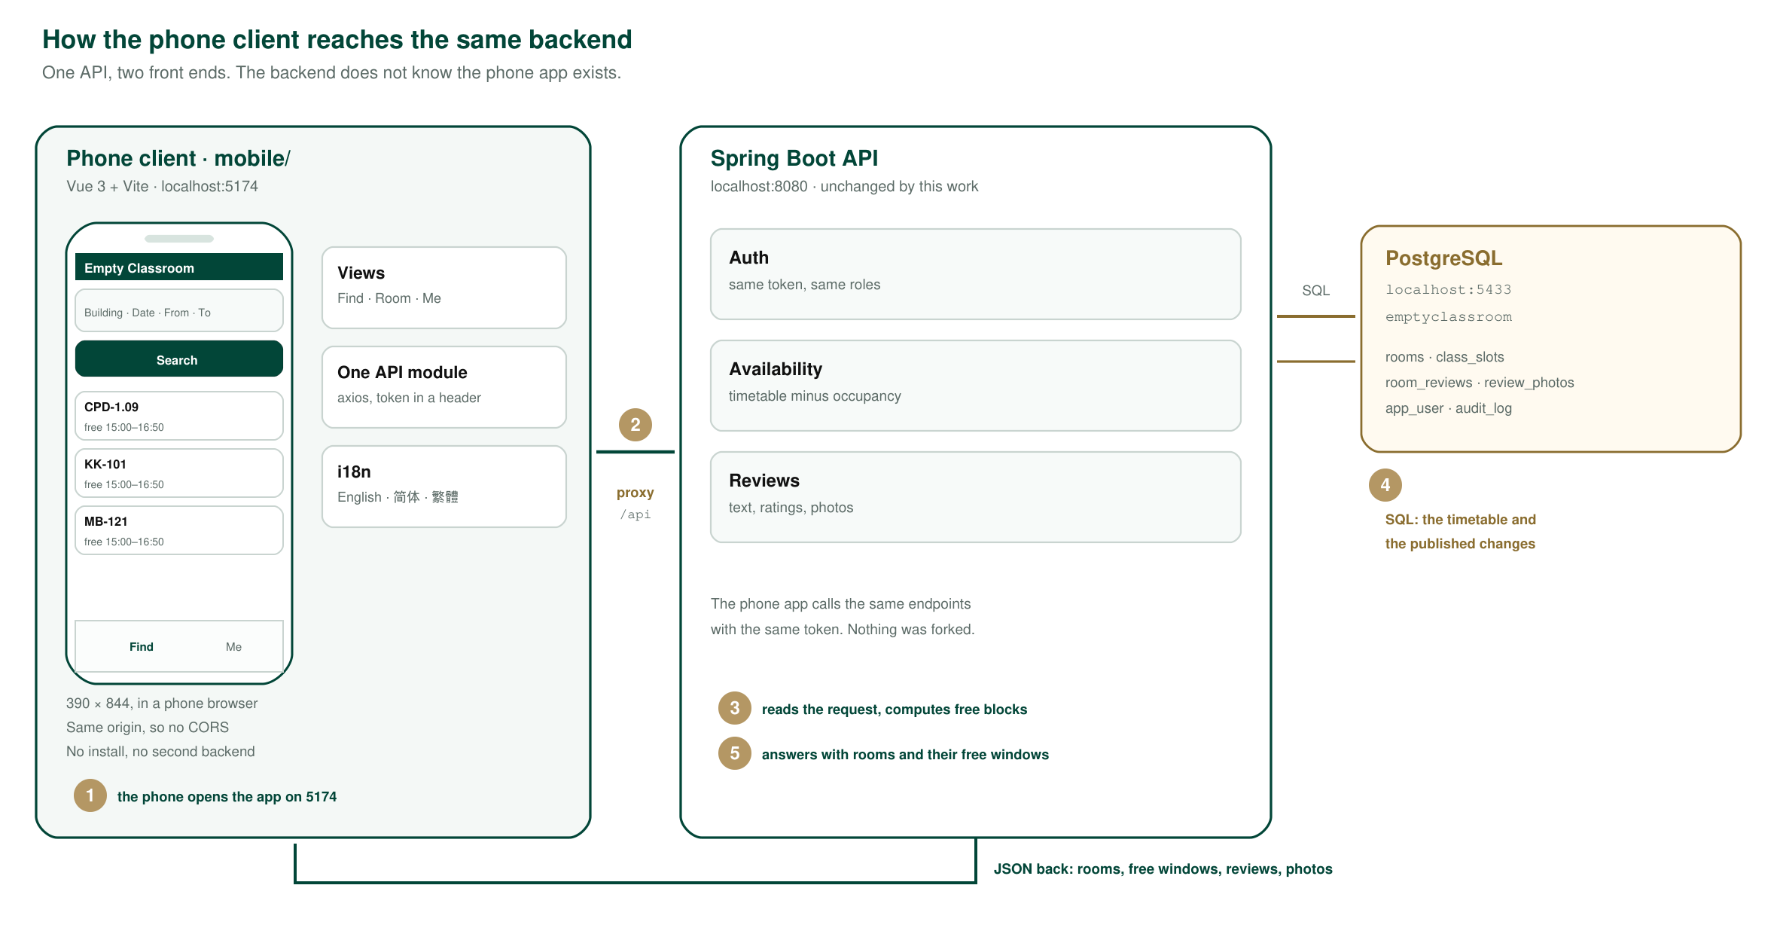
Figure 1. The phone client, the backend it shares, and the database behind it.
3. How it reaches the backend
The numbers match the badges in the figure.
Step | What happens | Endpoint
1 | The phone opens the app on port 5174 | http://localhost:5174
2 | The page asks for rooms free in a window, sending the token it got at sign in | GET /api/availability?date=&from=&to=
3 | The dev server forwards /api/* to port 8080, so the page is same-origin and there is no CORS setup | in-process (Vite proxy)
4 | The backend checks the token and subtracts occupancy from the timetable to get free blocks | in-process
5 | The answer comes back as JSON and is drawn as cards: room, building, seats, and when it is next busy | GET /api/availability

A room's page makes the same kind of call: GET /api/rooms/{code}/timeline?date= for the day strip, and GET /api/rooms/{code}/reviews for the reviews and their photos.
4. What it deliberately does not do
- No administrator screens. Locking a room, editing facilities and managing accounts are not one-thumb tasks, and hiding them keeps the phone app a student view.
- No install. It is a web app in a phone browser, not something from an app store. Nothing to review, nothing to update.
- No offline mode. An answer about free rooms is only useful if it is current; a cached answer would be worse than none.
- No push notifications. The system has no way to know what you want, and a notification that arrives after the class started is noise.
5. Problems and handling
Problem | Handling
Port 5174 was already taken. Another Vite instance had started on it, so the phone app silently moved to 5175 and I spent time looking at the *desktop* app in a phone window | Port pinned with strictPort: true, so it now fails loudly instead of moving. The stray instance was stopped
Timetable labels were clipped. A blocked block two hours wide cannot fit "14:00–15:50" at phone size, so the text ran over the edge | Draw the label only when the block spans three hours or more; the title attribute keeps the time for the rest
Review photos were too small to read. 64 × 48 on a 390 pt screen tells you nothing about a room | 104 × 78 thumbnails, and a tap opens the photo full screen on an opaque backdrop
Every room looked free on a Thursday. Not a logic bug: the first seed data only covered Monday, Tuesday, Wednesday and Friday | Migration V16 adds a Thursday, so the demo shows a real day
The desktop screenshots were stale. They dated from 2 October and predated the photo feature | Retaken from the running app and grouped by client

6. Next
- No one has used it yet. There has been no follow-up feedback for the phone client, so nothing here claims it helped. Information collection and follow-up visits are separate tasks in the division of labour.
- The freshness of the timetable data is not shown on the phone yet. The backend exposes it; the phone does not display it.
- A room list sorted by walking distance would be more useful than a list sorted by room code, but that needs a decision about whether the system should know where people are, which the Plan says it should not.

