DCF255 Assignment 1

1 [5 Marks]

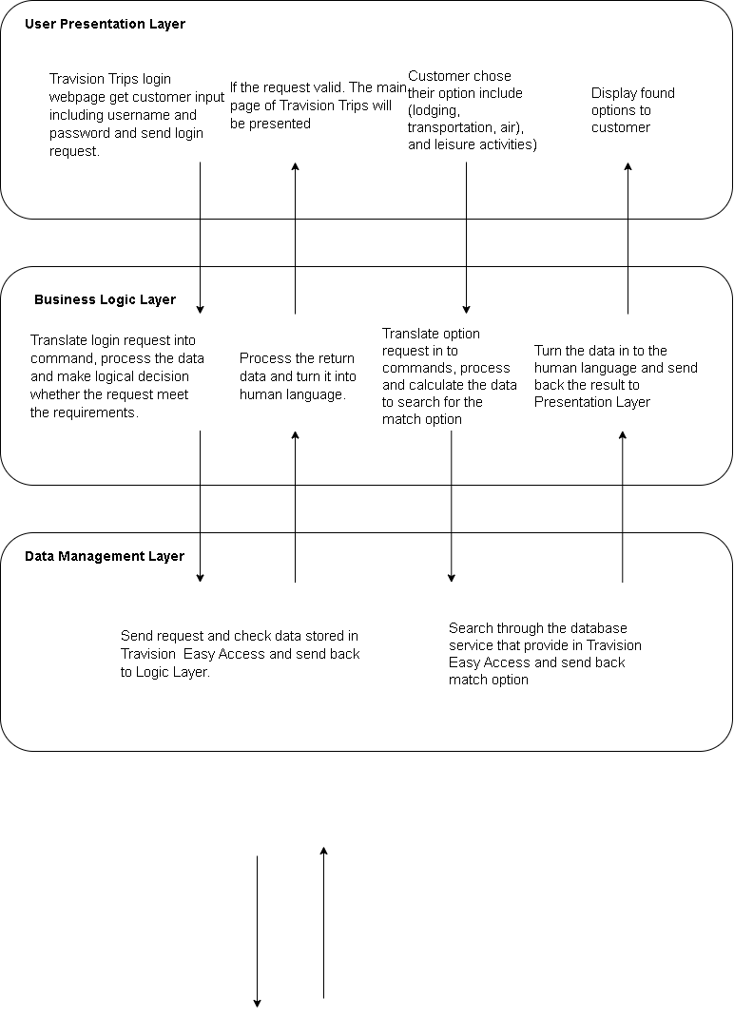

2 [5 Marks]

In Toronto

1. 1. Book the ticket and go to the airport
2. 2. Check-in to get the ticket and load the luggage
3. 3. Pass through the airport security, immigration and go the boarding terminal
4. 4. Pass the boarding gate and enter the plane
5. 5. The plane taking off and heading to London
6. In London
7. 1. The plane landing and arriving at London
8. 2. Exit the plane and pass the boarding gate
9. 3. Go through the immigration procedure
10. 4. Claim the luggage and exit the airport
11. 5. Grab a cab and go the hotel/desired destination

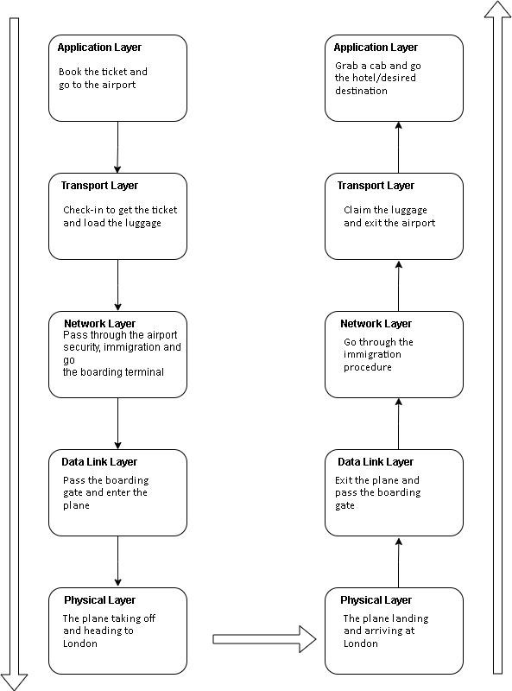

3 [5 Marks]

The method used for the connection between my device and the Seneca web server is Transmission Control Protocol (TCP). My laptop is connected through a wireless router connection (Wi-Fi). The IP address allows its device to send and receive messages. The device use Internet Service Provider (ISP) to gain access to the Internet after passing the firewall. In the browser, for the URL type https:// followed by server’s domain. The http request will be sent to servers. Sever will respond the request.

