2D RPG
Henry Prestwich

Table of Contents
Analysis 2
Project Background 2
Client Interview 2
Reflections of Client Interview 4
Objectives 4
Modelling 4
Design 4
Technical solution 4
Testing 4
Evaluation 4

Analysis

Project Background

For my project, I aim to create a 2D, top-down RPG game including exploration and combat. The game will include semi-intelligent enemies which will use a pathfinding algorithm to follow the player and a Finite-State system to make their decisions seem planned. I will make the game somewhat difficult as I want it to be a ‘souls-like’, meaning it is similar to the games from the Dark Souls series. This series contains very difficult enemies which present the player with a great challenge which can be enjoyable and very rewarding. The game will be targeted towards players of this genre as they enjoy this style of game.

I have chosen this as my project as I am interested in game development and would like to expand my knowledge of the techniques used by creating my own game. Through my research for my NEA I will hopefully learn how video games are created by large companies and also pick up some skills which may become useful in my future.

Client Interview

For my interview I will talk to someone within my school who is interested in this genre of game. I feel that asking questions to the intended audience will be the best way to gauge what is wanted from my project by potential players. This interview will assist me in tailoring my design to the needs of the player and will give me an insight into this genre of games as the person I will talk to is experienced in this genre.

Q – What games do you currently play in this genre that the game should draw inspiration from?
A – I currently play games such as Dark souls and Elden ring which fit well into this genre. I feel as though the game should draw inspiration from these games and the others in the series as they form the basis of ‘souls-like’ games.

Q – How do you think the enemies should feel to fight?
A – I think the enemies should feel like a challenge to face in combat but should not be so difficult as to overwhelm the player. I enjoy when I have to spend time planning how I will fight each enemy as thing brings a sense of achievement when I defeat it so they need to be difficult enough that I can do this. This also means that they need to be somewhat predictable as I find it annoying as a player if the enemy behaves in one way but changes once I feel I have worked out how I will defeat it.

Q – How do you think the speed of the movement/combat should feel as a player?
A – I enjoy when the movement and combat is fast paced but sometimes find as a player that too much speed can become chaotic. You will need to find a balance to make the game engaging but not overwhelming. I often find that games with slow movement speed can make me very bored. Same for combat, if I’m waiting ages for an opening I get tired of the fight. I do enjoy when games give you the choice of pace. Some games use armour weight systems which give s the player the decision how fast they want to play based on the build they intend to use.

Q – How would you like the interface/HUD to look?
A – I find that a good interface is one that gives the most amount of information without taking too much space on the screen. Same games have so little that I have no idea what is going on and some games have so much I can hardly see the game behind it. Id like the game to have a good balance as is think information is very useful in this style of game.

Q – How would you like the weapon system to work?
A – I would like there to be many weapons that can be collected in the game. I think it is fun to try combat with different styles of weapon. I know some games in this genre use weapons with durability but I think this would not work well for this as it can get tedious to replace them so often.

Reflections of Client Interview

From the client interview I now feel I have a better understanding of the game I am to create. I know where I am to draw inspiration from which gives me the ability to create a for of plan as to the direction I will take the game. The client has requested a good balance between speed and control of the player and wants the combat to feel difficult but manageable. To achieve this I understand I will have to put my game through many stages of testing both on my own and with the client to ensure the feel of the game is right for them. The interview has also given some insight into how the game should look as the client gave details regarding the HUD (Head-Up Display) which will allow me to create an immersive but not overwhelming experience to the end user.

Objectives

Initial objectives:
- Provide a menu upon opening the game
  - Upon the start of the game, a window will be displayed
  - The opening menu will contain multiple buttons for the player to select what they would like to do
    - The player will be able to exit the game through this menu
    - The player will be able to enter a separate menu containing a set of settings which they can change
    - The player will be able to start playing the game
- Provide a player controllable character
  - The player will be able to move the character using WASD on the keyboard
    - The character will have other forms of movement such as a dash
    - Some of these movement forms may be acquired from upgrades or items
  - There will be a camera which follows the player
    - The player will be kept constantly in the centre of the screen
    - The camera will use a matrix system which will allow for certain effects t o be applied to the view
  - The character will be able to detect collisions and not walk through objects
  - The character will be able to tell when it has taken damage and reduce this from its health
  - The player will be able to attack using weapons acquired in the game
  - The player will have stats which affect different qualities
  - The player will be animated
    - The animations will be based on the direction the player is moving
- Provide a map for the player
  - The map will consist of a series of nodes in a grid
  - The player will be able to navigate through the map
  - The map will contain many textures
    - These will be mapped to the grid using a tile map
  - The map will have solid objects which the character cannot pass through
- Create enemies which will follow and attack the player
  - Enemies will use the A* algorithm to follow the player around the map
  - They will follow a finite-state system allowing them to make decisions based on the situation
  - They will have attacks which can damage the player
    - Their attacks will have hit boxes which can be detected by the player
    - Different attacks and different enemies will be able to do different damages
  - There will be different enemies with different attack patterns
    - There will be boss type enemies which will be difficult and deal more damage
  - New enemies will spawn in designated locations
  - Enemies will have health which can be reduced by the players attacks
    - When an enemy’s health is 0, the enemy will die and be removed from the screen
    - Some enemies will have more or less health depending on how difficult they are intended to be to kill
    - Boss enemies will have large amounts of health
  - Enemies will have animations that depend on their direction of movement
- Provide a menu within the game which will pause the game behind it
  - The menu will allow the player to view their stats
  - The player will be able to equip new items
  - the player will be able to change their settings the player will be able to save the game and exit
    - The current game state will be saved to a file
    - The player will be able to open to this save again

The initial objective form the core of the game. Completion of these objectives will form a complete game which will be in a playable state.

Additional objectives:
- Provide friendly NPCs that the player can interact with
  - Friendly characters will be able to be interacted with
    - The player will be able to press a button to begin dialogue
    - The NPC will talk to the player and may provide advice, quests or a shop menu
- Add a levelling system
  - Killing enemies and completing quests may provide Experience points
  - The player will be able to allocate points gained into different stats
- Upgrade the menu system to include XP
  - Add a page in the menu to allow for allocation of experience

The additional objectives will form a complete game. The user experience will be complete and the user should have a good time playing the game. The game after completion of the additional objectives will meet the full set of desires set by the client.

Modelling

Pathfinding
For my game I have chosen to use the A* pathfinding algorithm as this is most likely to be the most efficient pathfinding algorithm for my game. A* is usually the algorithm chosen to be used in Video games.
A* combines the benefits of multiple alternate algorithms to create a more efficient method of finding a route to a single target. By using a Heuristic function, the A* algorithm focuses its search on nodes which follow in the direction of the target node. However, this method can be inefficient if implemented on its own as any obstacles directly between the target and start node may cause the algorithm to find a sub-optimal path. To account for this, A* also uses a path cost system which ensures that the algorithm also takes into account the total cost of the journey. As well as ensuring that the algorithm finds the optimal route, this can also allow for different terrain types that enemies in my game may avoid unless necessary.

Implementation
A* is relatively simple to implement. It uses a priority queue to decide which node is checked next. It then assigns each node’s neighbours a value based on a total of its current cost and its heuristic value and adds them
to the queue.

Code:
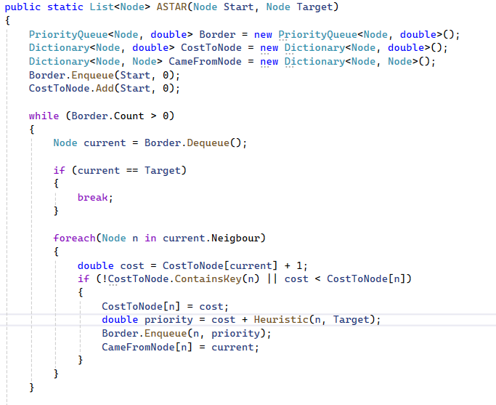

Design

Technical solution

Testing

Evaluation

