1.1  
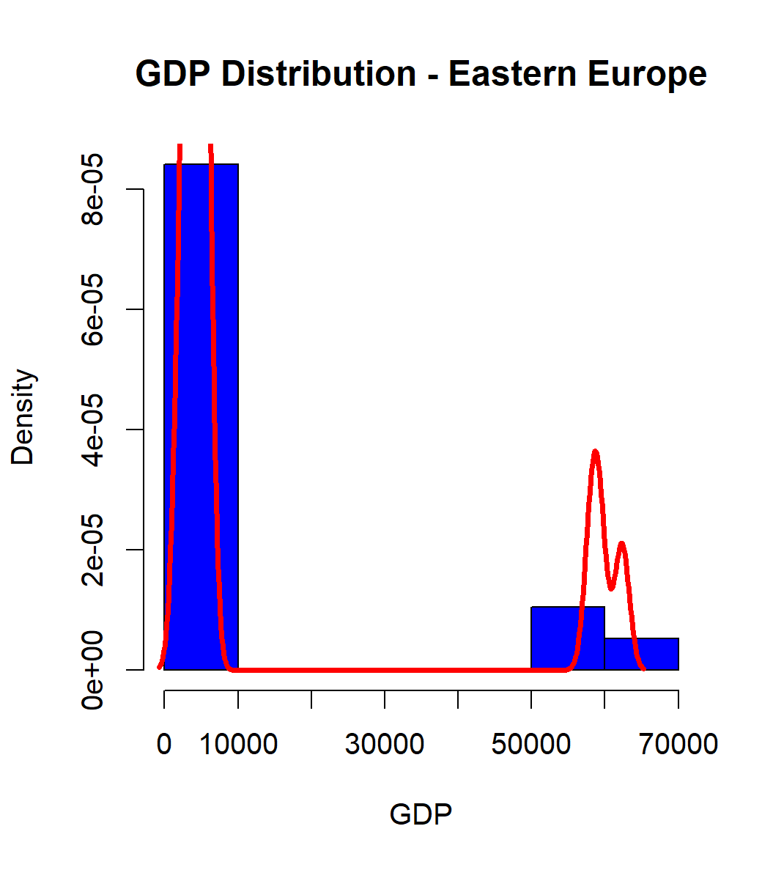

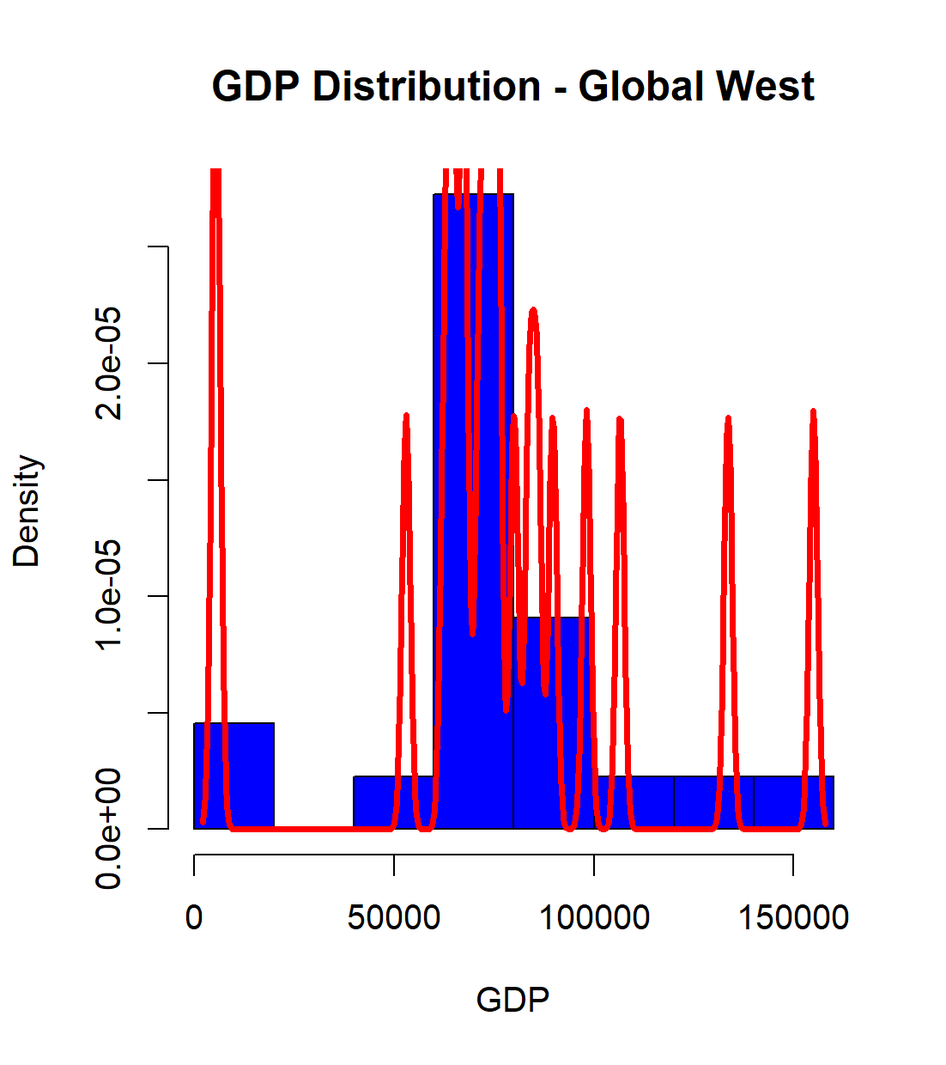

1.2  
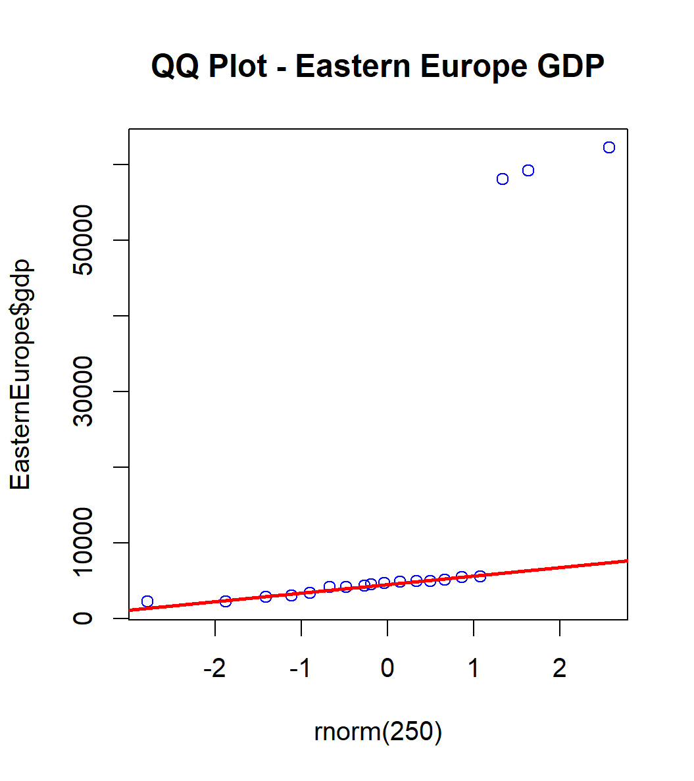

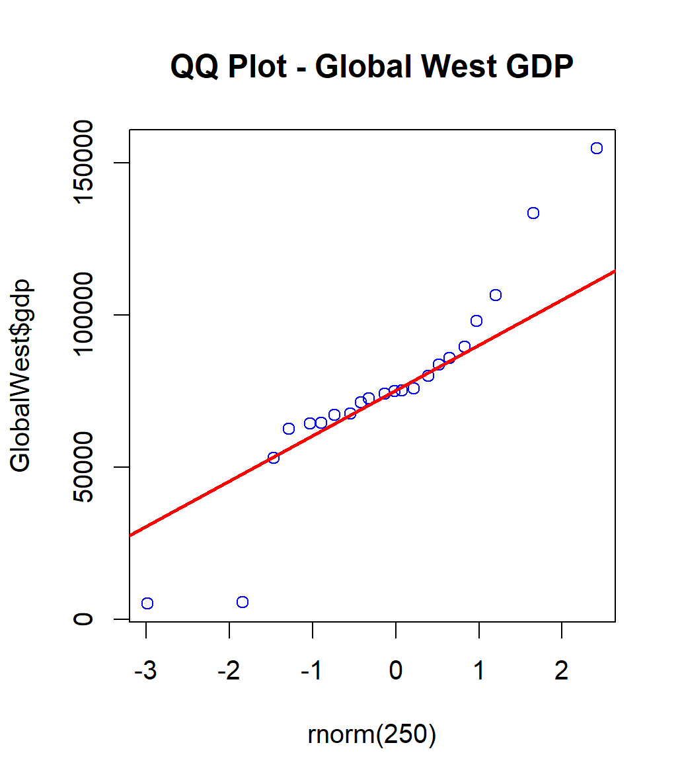

2.1

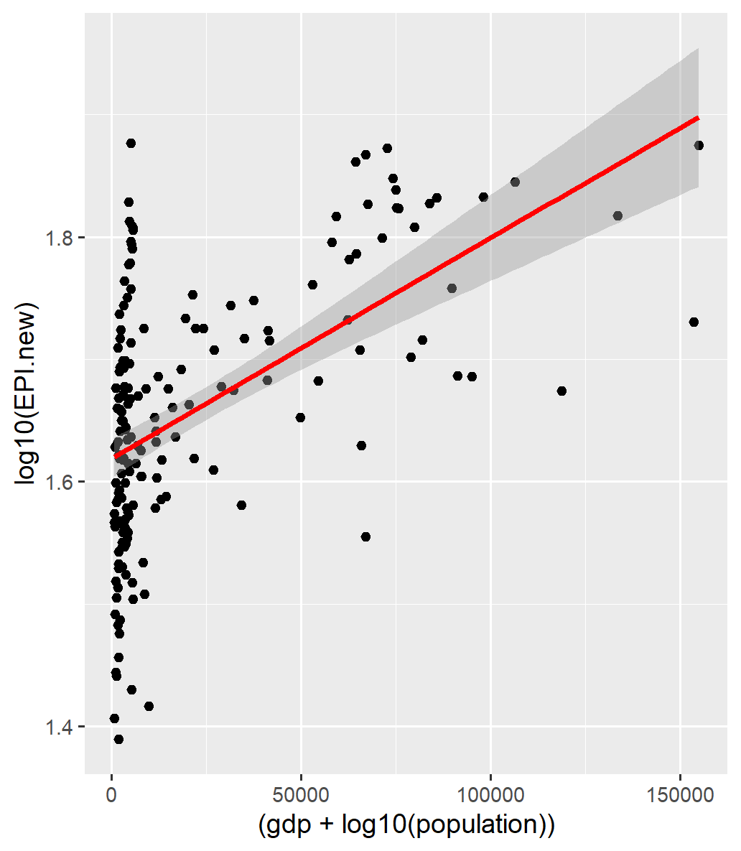

2.2

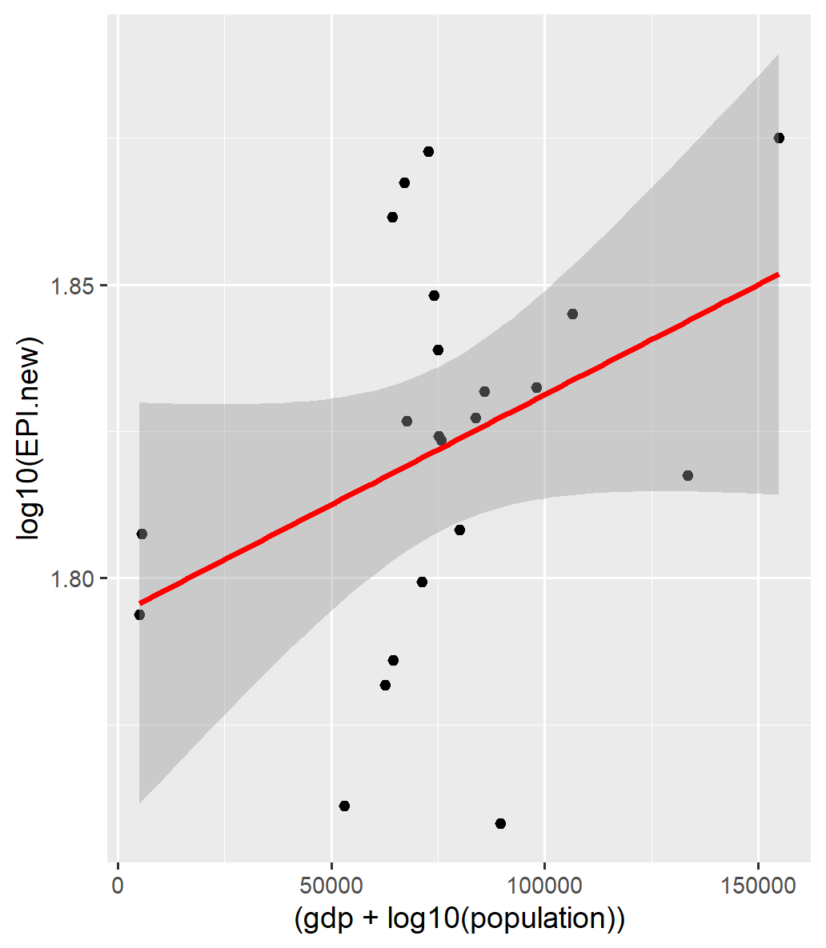

I think that in terms of models I think that the one estimating the EPI.new is better. I have reached that conclusion after looking at the R^2 values and seeing that it was the highest.

3.1

contingency.table

predicted Eastern Europe Global West

Eastern Europe 5 0

Global West 2 2

> # calculate classification accuracy

> sum(diag(contingency.table))/length(EEandGW.test$region)

[1] 0.7777778

This was for the values of EPI.new, ECO.new, BDH.new and k=2

contingency.table

predicted Eastern Europe Global West

Eastern Europe 7 0

Global West 0 2

> # calculate classification accuracy

> sum(diag(contingency.table))/length(EEandGW.test$region)

[1] 1

This was for the values of EPI.old, ECO.old, BDH.old and k=2.

3.2

We can clearly see with this accuracy that using the old values of the variables made a better KNN model. Considering geopolitics, we might be able to hypothesize that under Soviet control, the Eastern Europe nations had more divergent numbers in describing their productivity. However, Eastern Europe’s newer numbers after the fall of the USSR are more like those of the Global West, making the regions harder to distinguish.