**GRIDLY** PLUGIN

Document

1. **What this plugin can do**

This Plugin can help you get data from Gridly to Unity and turn it into local data, using the path you can get information based on the target language.

1. **Setup**

First, you need to open gridly setting window.

Go to: window-> Gridly -> Setting

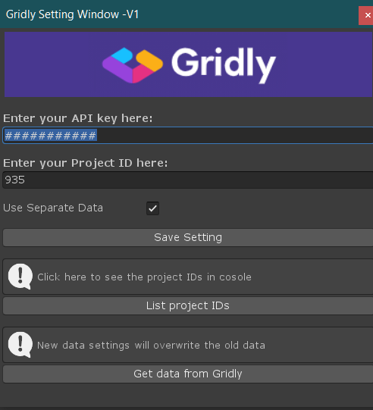

Enter your API at below “Enter your API key” then enter your project ID. If you don’t know your project ID, you can click list project IDs to see all your project IDs at console. Please click save when you done then click “Get data from Gridly”.

Note: API key,Project ID will be on your device and it will not be included when you build the product so don’t worry.

* 1. **Use Separate Data**

By default “Use separate data” is off. When you use separate data all your data will be separate into small ScriptableObject base on there type.

Advantages:

+ You can use some feature: Update, Remove, Add record

Disadvantages:

+ Take more time when you get data from gridly

On the other hand, when “Use separate data” is off, it will significantly increase setup time but cannot use some features

Note: when you toggle “USD” make sure you have visual studio turned on

* 1. **Setup data on Gridly**

To be able to use this plugin with Gridly, you must set up something on Gridly and that is columnID

Your columnID should follow this format: <language code>_<index code>

Language code: You can refer to the language code in the Language field

Index code: Index code is to distinguish many different types of information on the same record

For example: if you have two words "cat" and "dog" both translated into Vietnamese on the same record, you MUST put column IDs under this name: enUS_1, enUS_2, viVN_1, viVN_2

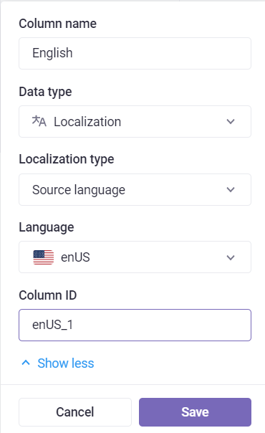

1. **Get data from local data**

+ Import Gridly

+ Setup your target language

* Project.singleton. targetLanguage
* Or go to Asset -> Gridly -> Resources -> Project.asset

+ your path must follow this: <DatabaseName>.<GridName>.<RecordID>.<Index code>

