**Create custom object**

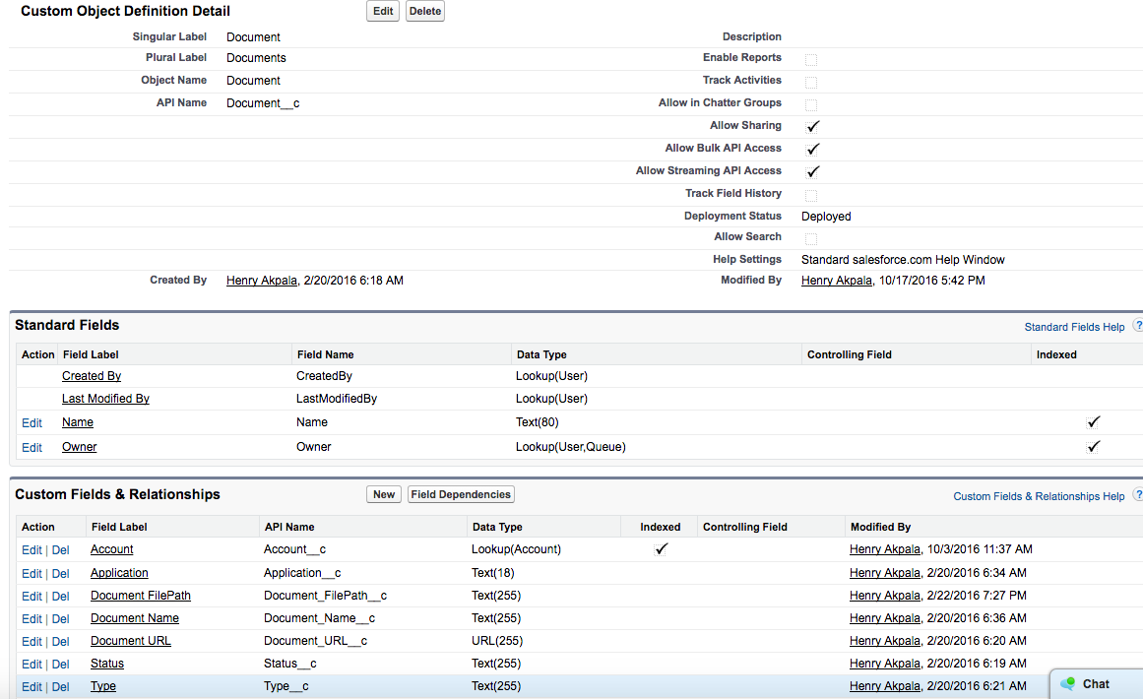

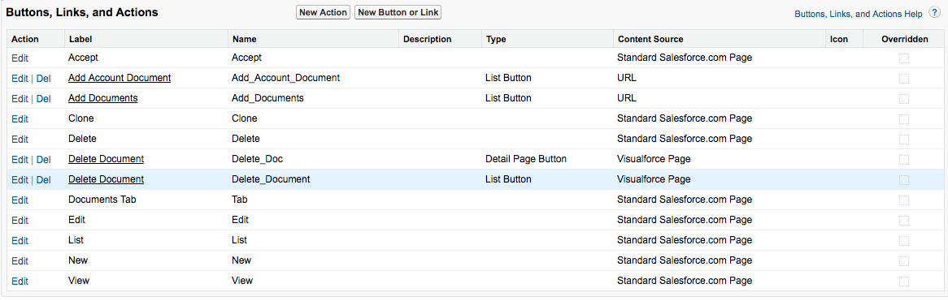

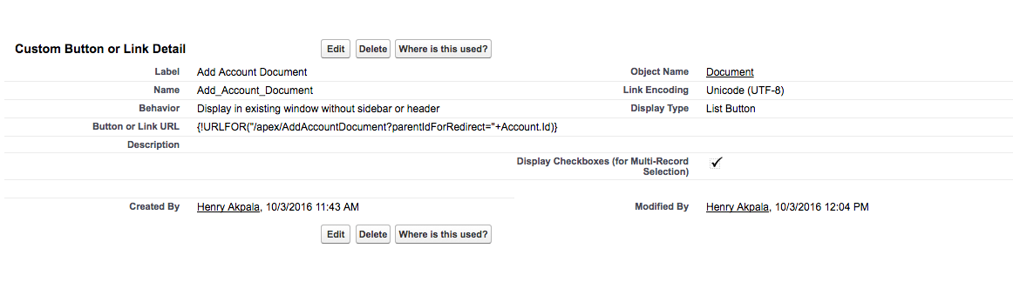

{!URLFOR("/apex/AddAccountDocument?parentIdForRedirect="+Account.Id)}

**Create custom buttons**

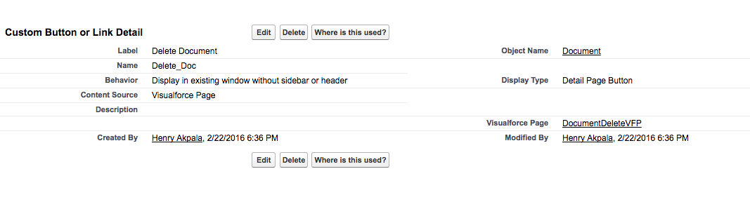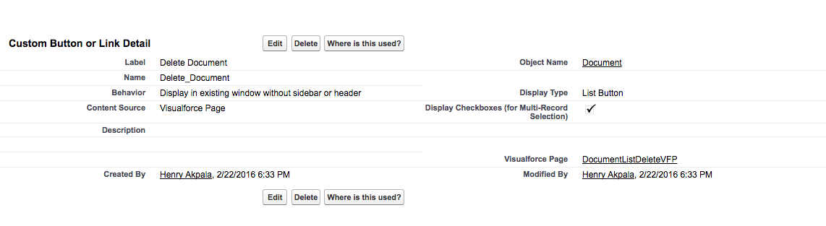

**Create Custom Settings**

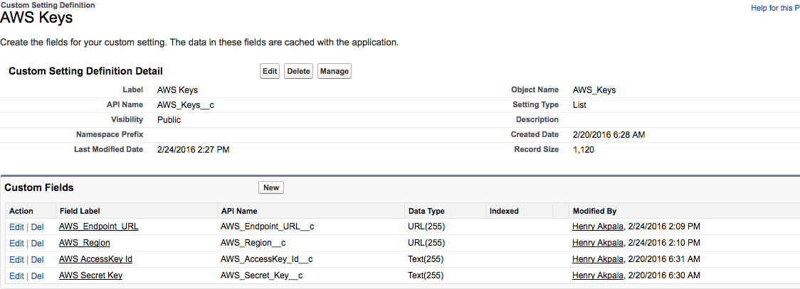

Create Apex Class

CustomObjectAccountController.cls

DF_AWSIntegration.cls

Create VFPages

DF2016SucessRedirectPage.page

DocumentDeleteVFP.page

DocumentListDeleteVFP.page

AddAccountDocument.page