1) What genre is the movie CopyCat in?

My answer: Crime,Drama,Horror,Mystery,Thriller

Query:

db.movie.find({"Title":/Copycat/}).pretty()

Screen shot:

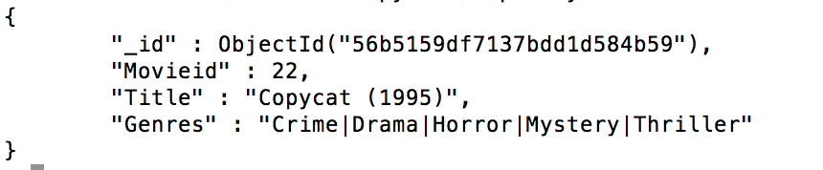

2) What genre has the most movies?

My answer: Drama.

Query: (Same query with different value of genre and then find the genre that has the most movies)

db.movie.count({"Genres":/Action/})

db.movie.count({"Genres":/Adventure/})

db.movie.count({"Genres":/Animation/})

…

Search Result:

Action: 1473

Adventure: 1025

Animation: 286

Children: 528

Comedy: 3703

Crime: 1118

Documentary: 482

Drama: 5339

Fantasy: 543

Film-Noir: 148

Horror: 1013

Musical: 436

Mystery: 509

Romance: 1685

Sci-Fi: 754

Thriller: 1706

War: 511

Western: 275

3) What tags did user 146 use to describe the movie "2001: A Space Odyssey”

My answer: Arthur C. Clarke; artificial intelligence; based on a book

Query:

db.movie.find({"Title":/2001: A Space Odyssey/},{Movieid:1}).pretty()

db.Tag.find({"Movieid":924,"Userid":146},{Tag:1}).pretty()

Screen shot:Screen%20Shot%202016-02-08%20at%2010.56.17%20AM.png

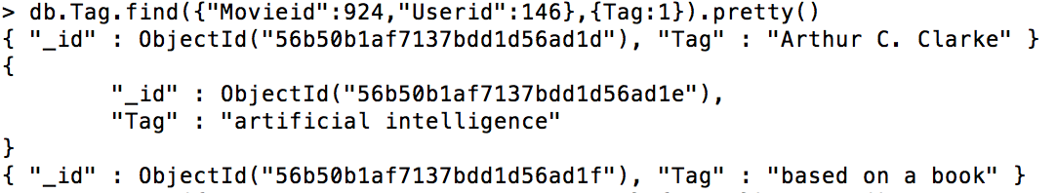

4) What are the top 5 movies with the highest avg rating?

My answer: "Satan's Tango (Sátántangó) (1994)",

"Shadows of Forgotten Ancestors (1964)",

"Fighting Elegy (Kenka erejii) (1966)",

"Sun Alley (Sonnenallee) (1999)",

"Blue Light. The (Das Blaue Licht) (1932)"

Query: db.rating.aggregate([{$group:{_id:"$Movieid",num_tutorial:{$avg:"$Rating"}}},{$sort:{num_tutorial:-1}},{$limit:5}])

db.movie.find({$or:[{Movieid:33264},{Movieid:64275},{Movieid:42783},{Movieid:51209},{Movieid:53355}]}).pretty()

Screen shot:

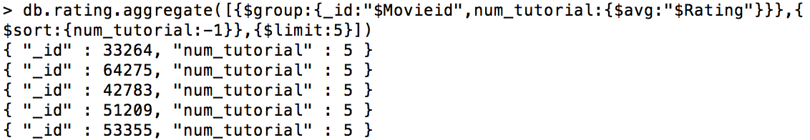

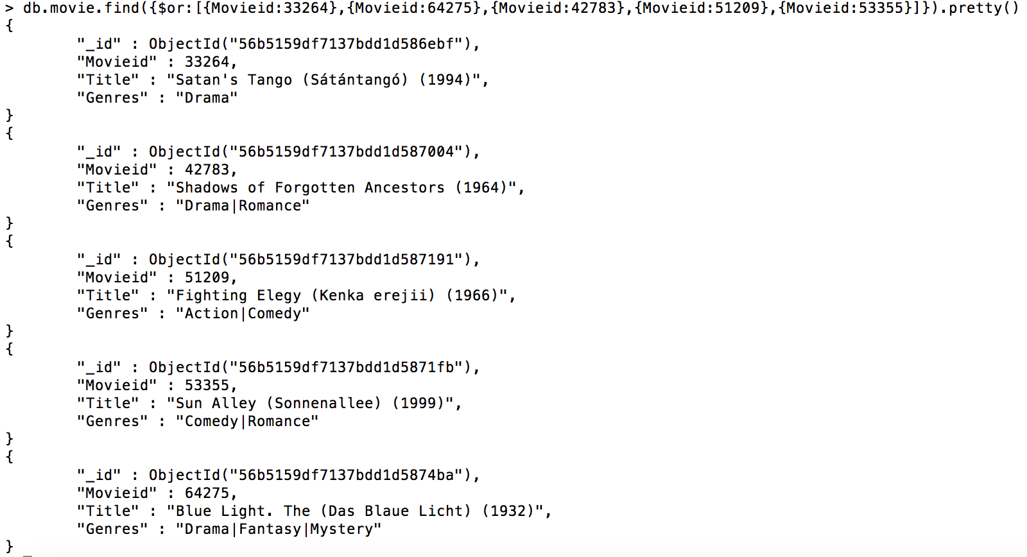

5)What is the highest avg rating possible?

My answer: 5

It is possible that a movie get a rating 5 from everyone which will result in an average rating 5.

5) Write 3 different queries of your choice to demonstrate that your data storage is working.

1.How many movies has the user whose id is 1 rated?

My answer:22

Query:

Screen%20Shot%202016-02-08%20at%2011.10.14%20AM.png

2.Among these records, how many ratings is greater than or equal to 4.

My answer:5005684

Query:

3.What is the tenth movie in the file “movies.dat”

My answer: GoldenEye(1995)

Query:

