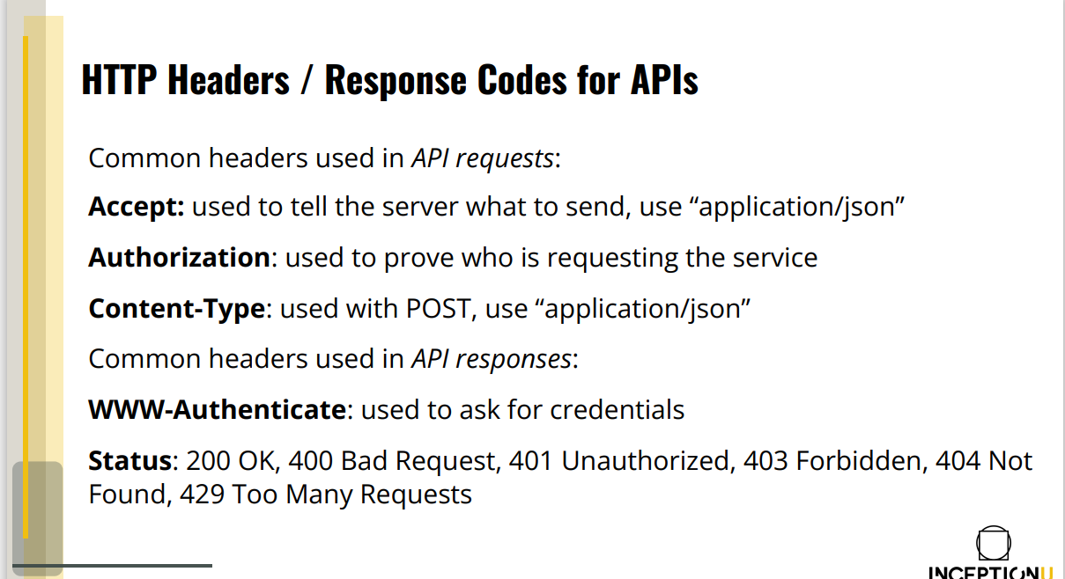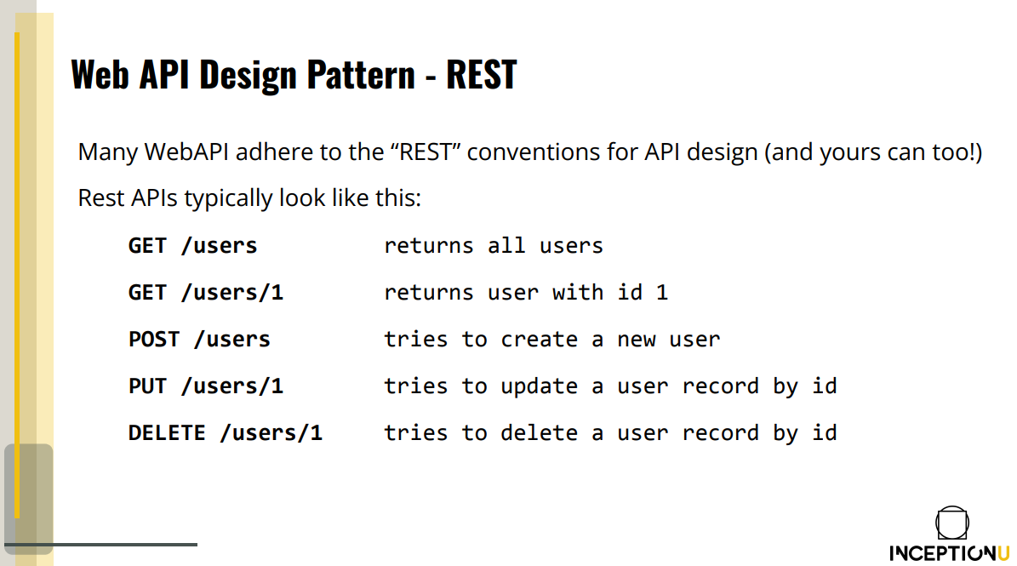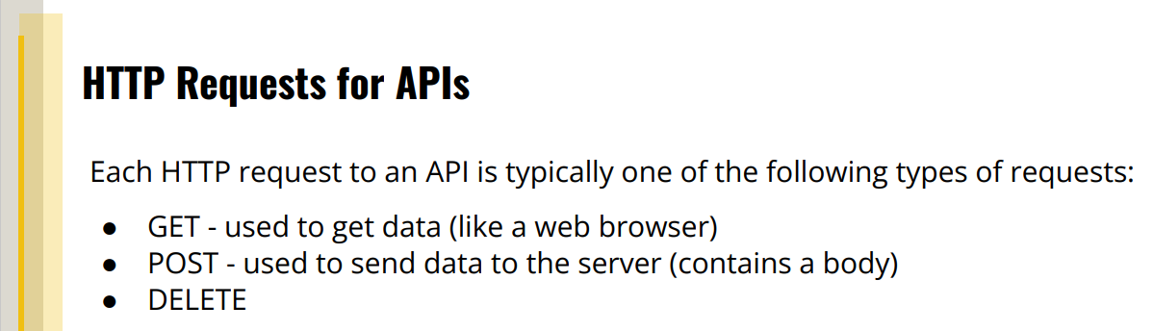

- Note: good idea to get multiple version of API; it’s good to leave about 6 months to a year before forcing an update of your API

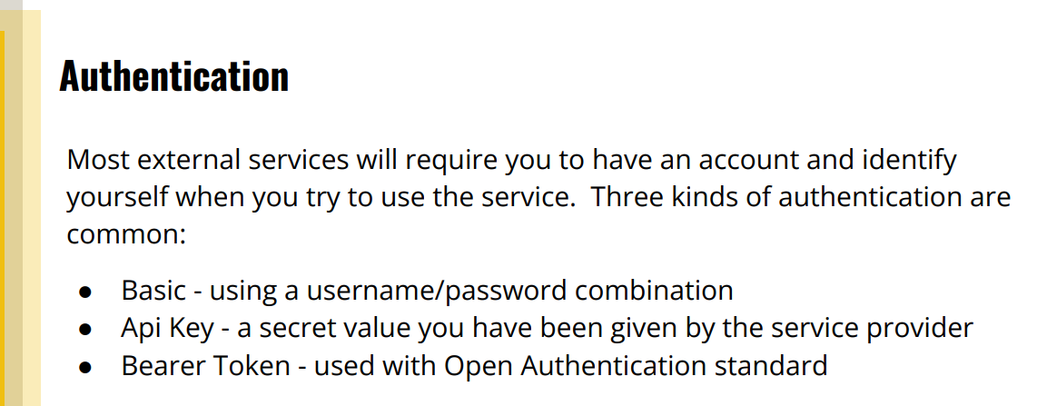

Authentication: Use HTTPS!

**Use Basic** when you are just interested in knowing who it is that is grabbing the request

**API Key** is a bit less structured and used when a server is trying to talk to another server and identifying the original user is not important.

**Bearer Tokens** are most complex and is a variation of Basic. It’s done when you want to authenticate users by having something else authenticate them. (Ex: Sign in with Google)