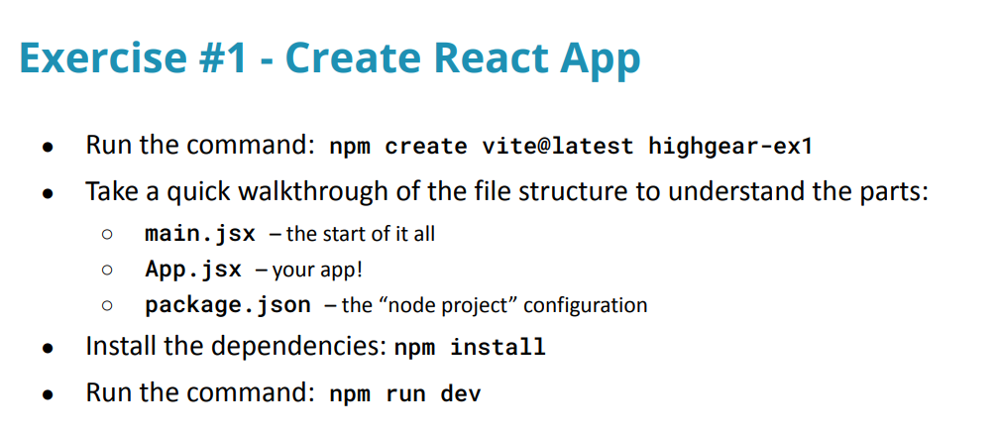

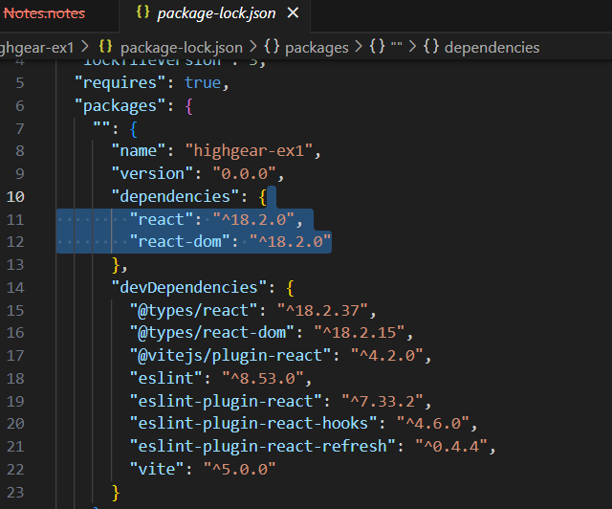

Dependencies on right

eslint helps enforce best practices

Beginners uninstall eslint dev dependencies

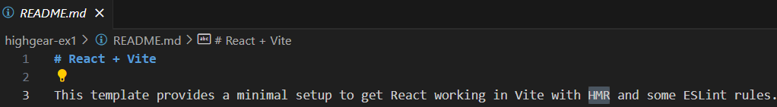HMR will get it to react quickly to changes

BEGIN BY DELETING ESLINT rules

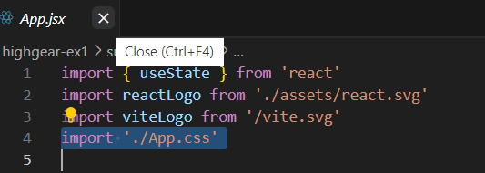

Import the css in the .jsx file to get the style

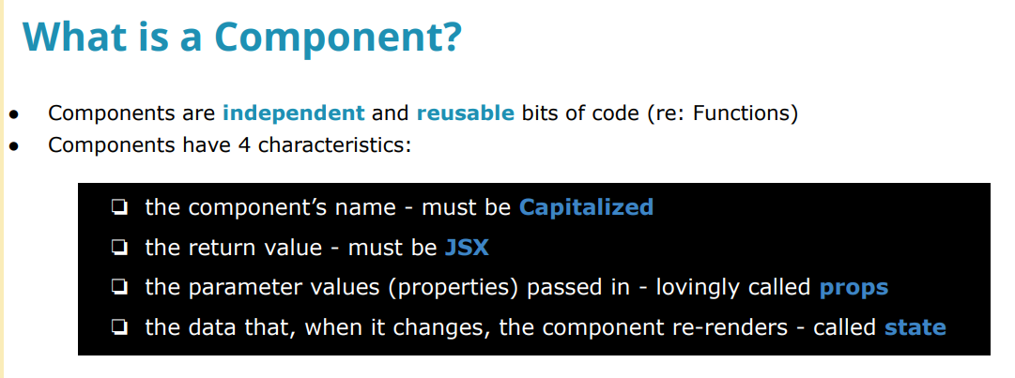ALL JSX FILES ARE COMPONENTS

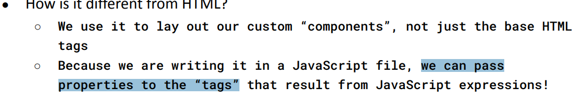

Tags are like the onclick and ids and etc put on the front of the <p> on an HTML

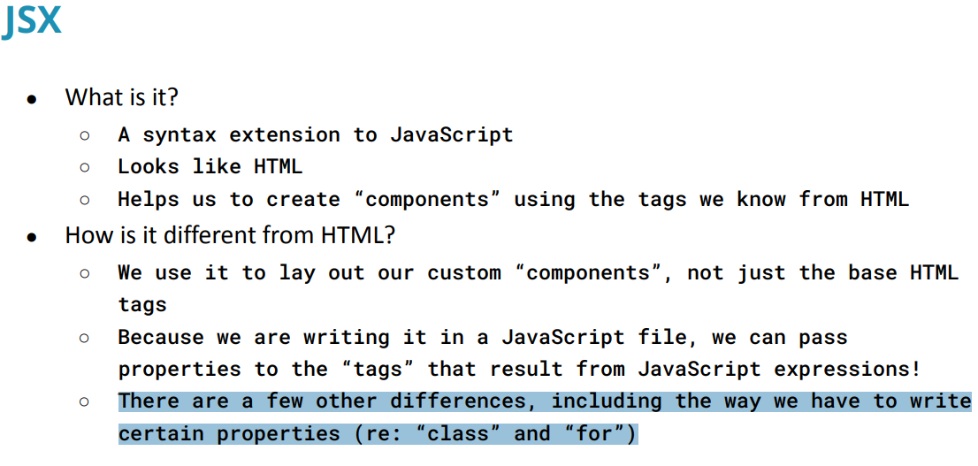

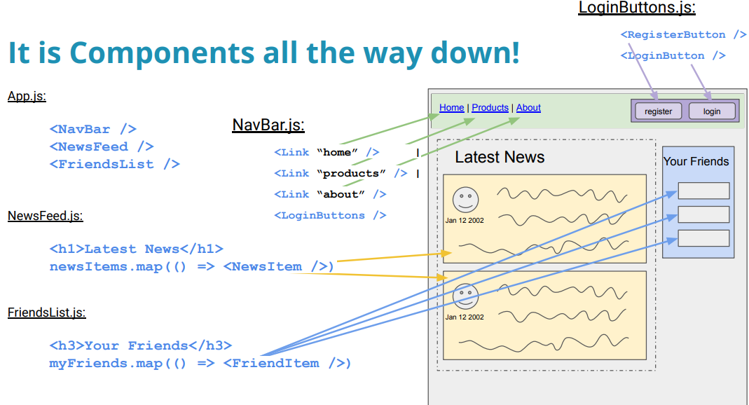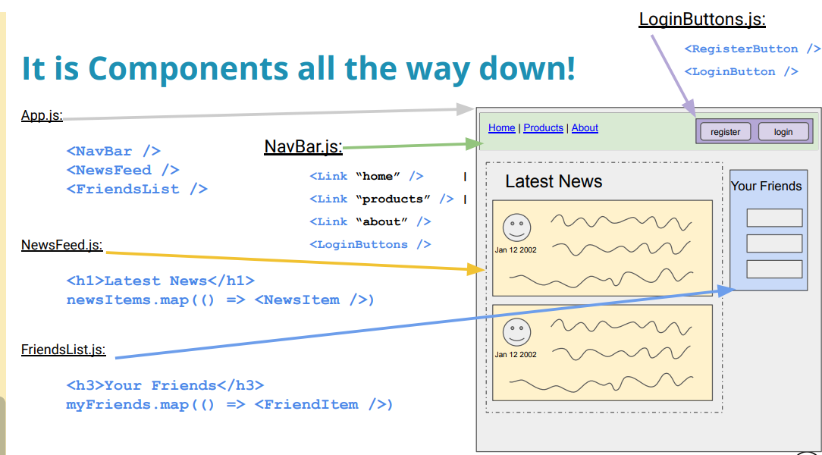

**Use the ReactRouter package to take URL to grab variable to change what React shows up on the page.**

Or use conditional rendering: if this state variable this string is equal to a page name, go to that page then.

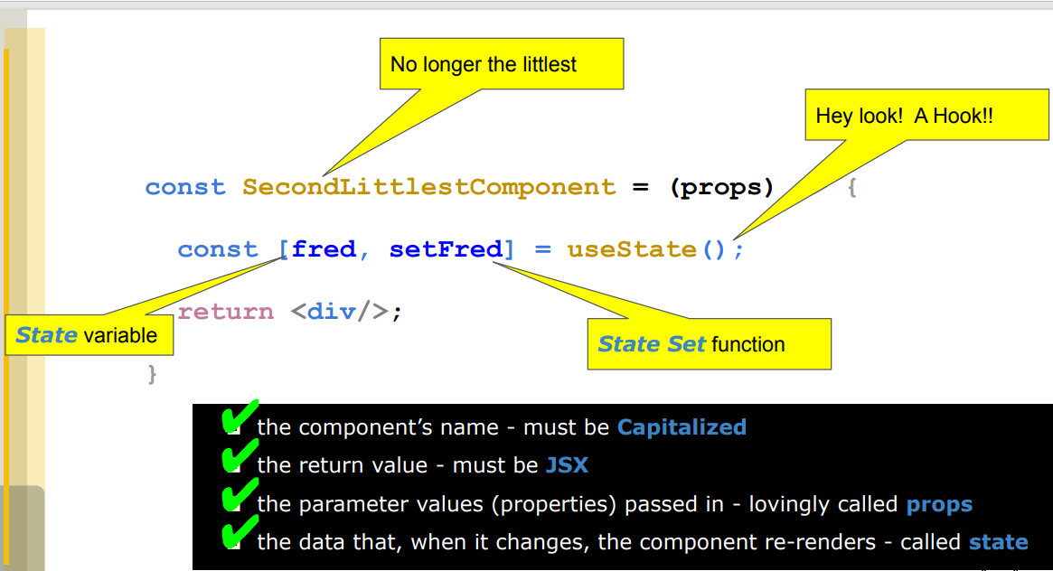

**AVOID REACT TUTORIALS BEFORE 2020**

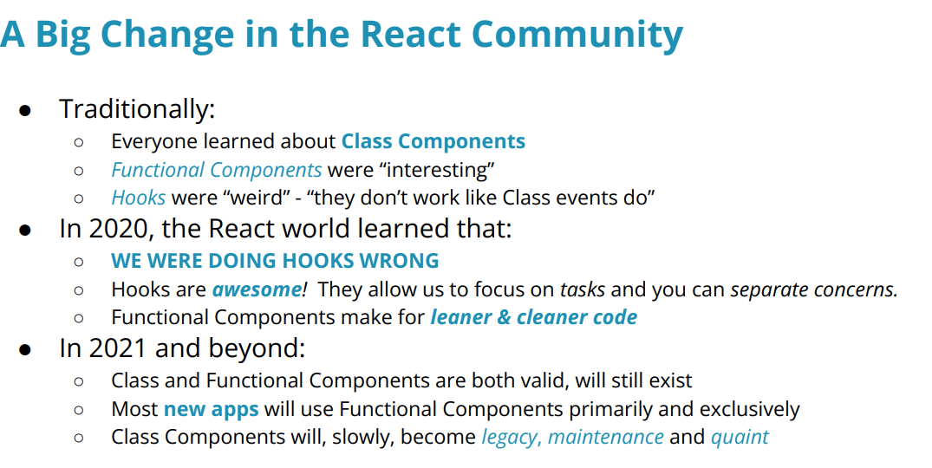



rafce

and then tab to initialize React file