**What is Building informatics?**

leveraging information technology, computer science, and related data science technologies → to improve building operation efficiency & user comfort in buildings.

dealing with collecting, managing, and analysing building data → improve building efficiency & user comfort.

**What is the target of Smart Building?**

user experience, increase productivity, reduce costs, mitigate physical & cybersecurity risks

**What most Smart Building system contain?**

HVAC, lighting, electrical, drainage & plumbing, alarm, fire safety, security & access control

**What is the core of Smart Building?**

Adaptability, not reactivity

**What are the divers for building progression?**

1. Energy & efficiency
2. Longevity
3. Comfort & satisfaction

**What is similar and difference between Smart Building and Intelligent Building?**

* Similar:
  + Use information technology and data generated by building [Data]
  + Focus on creating **integrated system** interrelates various subsystems → single control frame work [Frame]
* Difference:
  + Smart Building also **includes wider integration** with utilities and city infrastructure to realize smart city （Smart Building 有公共设施和城市基建，实现 Smart city）
  + Smart Building includes use of emerging **machine learning and AI** for advanced control and diagnostics （Smart Building有AI和ML）
  + Smart Building encompasses the use of emerging IoT, wireless communication, and other related technologies (technologies were not developed when Intelligent building concept was proposed) （Smart Building 会用一些 Intelligent Building 时期未开发的技术）
  + Smart Building considers interaction of users with building and surrounding environment → improve comfort of users apart from building operations.

**What is characteristic/feature of Smart Building?**

Climate Response: buildings to adapt to external climate conditions

Grid Response: buildings to adapt the information coming from grid （电网） → maximize the energy/economic efficiency at district/city scale

User Response: enable a real-time interaction between users and technologies → optimized performance & user comfort

Monitoring and Supervision: enable real-time monitoring of building operations and users’ behaviour.

**Benefit for using Smart Building?**

Lower operation cost

Lower energy cost

More flexibility

Improve user comfort, efficiency, wellbeing

**Smart Building Framework? And explain the layers.**

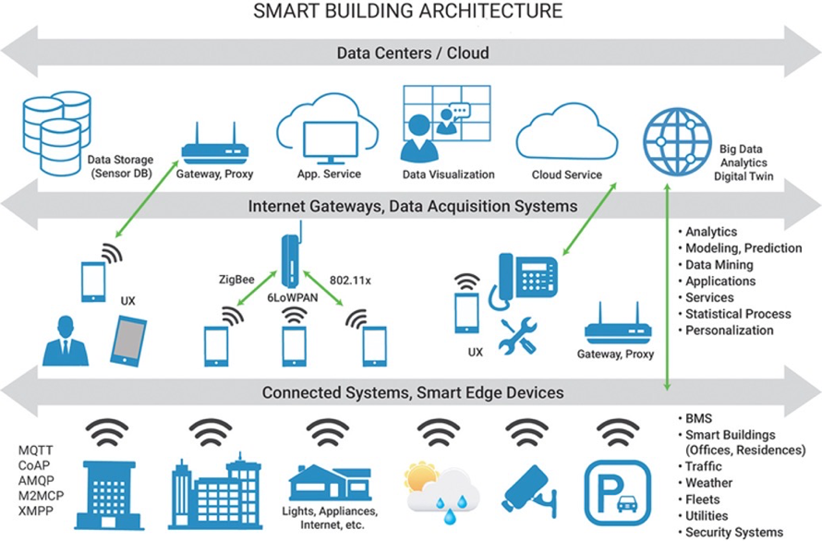

**What aspect to analyse Smart building framework?**

Different systems/devices within the smart buildings

Different technologies used within the smart buildings

Different use cases/features supported within the smart building

**What is Smart Building underlying system?**

Building automation system

**What technology does BAS use?**

AI, IT, IoT, Big Data, modern control…

**What is the major component of BAS?**

Sensor, controller, actuator, computer & server, software, network

**What are BAS typical functions?**

HVAC control, lighting control, Fire detection & alarm, Security & access control, Lift control, Utility management interface

**What is popular Smart Building popular certification? And what is important to consider in this certification?**

Smart Building collective

Consider how the building data is utilized

**How many certifications in Smart Building collective? And what are they?**

4, Platinum; Gold; Silver; Bronze

**What themes in Smart Building collective?**

1. Building usage
2. Building performance
3. Building environment
4. Health, Safety, Security
5. User Behavior & collaboration
6. Interactive design & Connectivity

**What certification HK apply? And describe what characteristic of building?**

Beam Plus, characteristic: New building, existing building, neighbourhood, interior, data centre, existing school

**What are the challenges of Smart Building?**

Limited interoperability – due to heterogeneity

Limited integration across system and technology

Complex dependency of different systems

Lack standard

Large scale of devices and data

Security & Privacy

**What is IoT structure?**

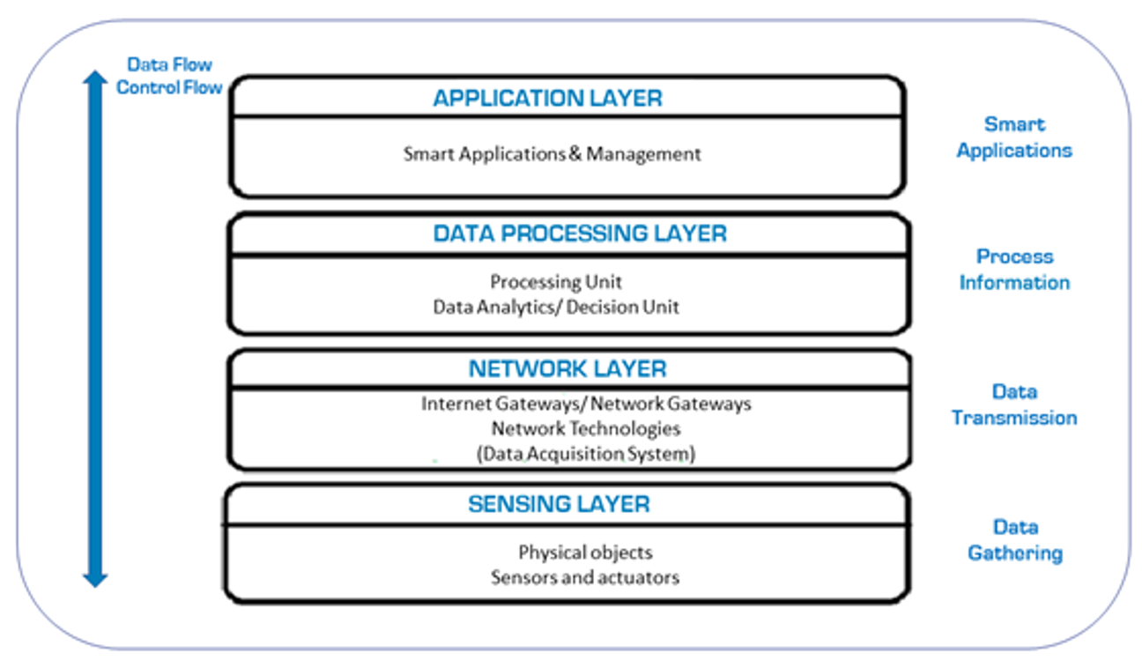

**What benefit IoT have?**

Save time & energy

Efficient utilisation & monitoring

Enhance real-time data use

Reduce human effort

Security & Efficiency

Get new analytic insights

Create new business opportunities

**Challenges for IoT?**

Heterogeneity

Integration of device

Lack of standardised protocols

Scalability

Remote device management & diagnostic

Network concern

Energy concern

Reliability concern

Privacy and Security

**Solve IoT challenges?**

Interoperability of devices and system

Low-cost and low-power sensing

Low-cost and high-rate networking

Cloud/edge computing

New security and privacy solution

AI ML to get new business insight

**What standard does OSI model coordinate?**

[ISO] standards

**What Layer in OSI model use protocols and what these protocols are?**

Transport layer [transmit data]

TCP & UCP

**What the differences between TCP/IP and OSI model? Sketch it.**

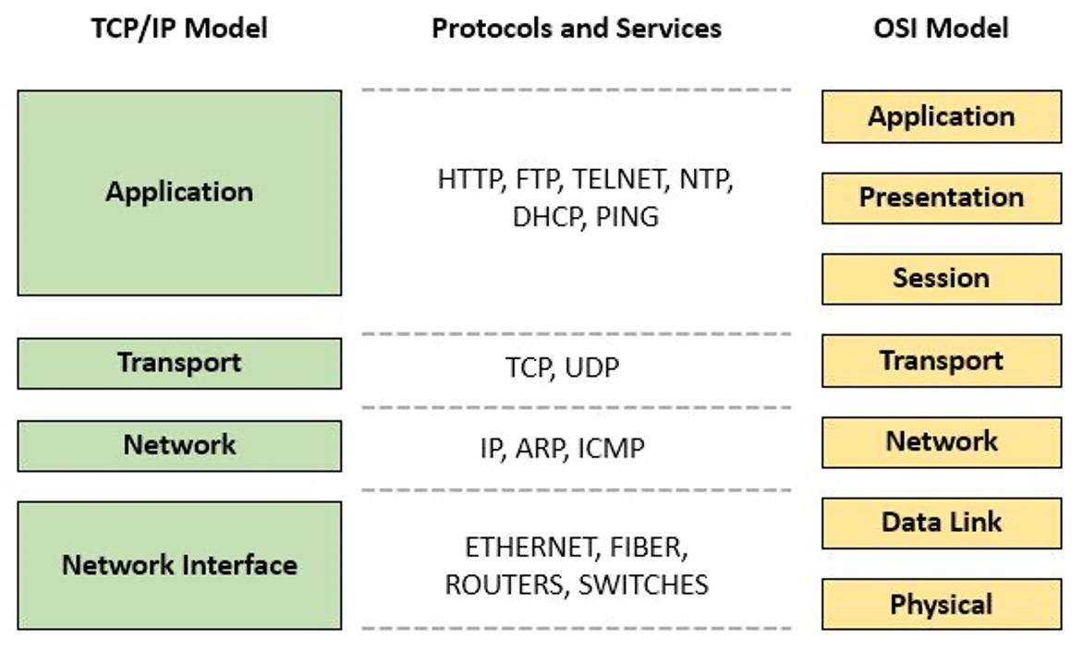

**What communication medium use in IoT, is it same as protocols in IoT?**

Yes, communication medium is same as protocols

Wire: BACnet, KNX, Ethernet, DALI, LonWork

Wireless: WiFi, 3G/4G/5G, Bluetooth, NBIoT, ZigBee, 6LoWPAN

**What differences between wire and wireless protocols?**

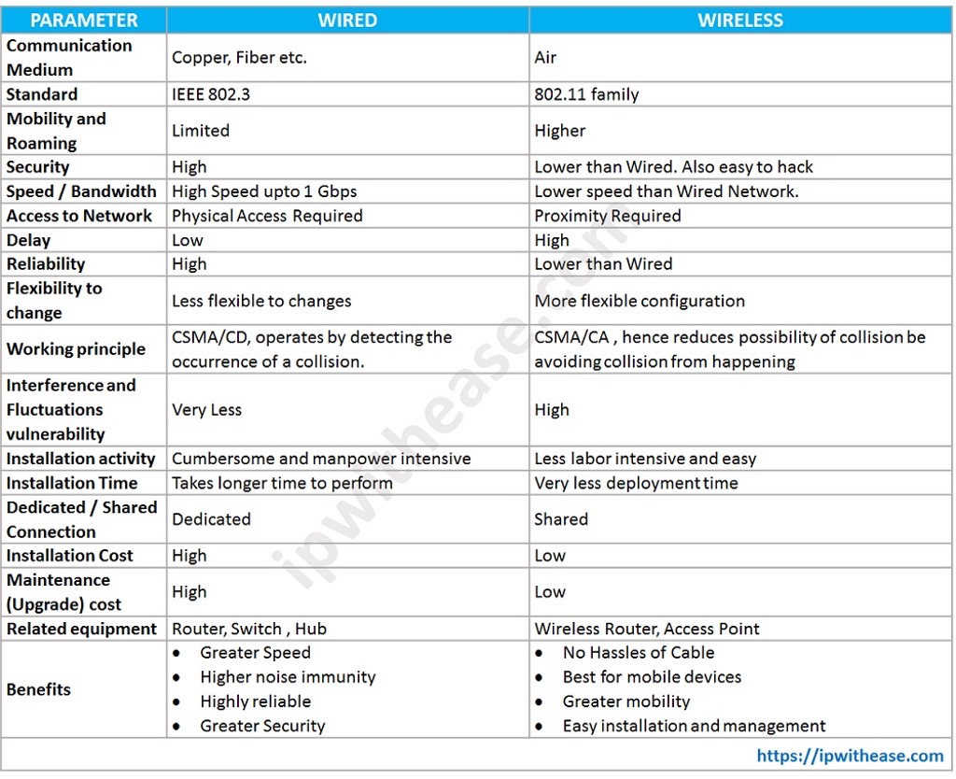

**IoT solution for Smart Building?**

Localization for occupants and resource tracking

Occupants’ safety and health security

Building health control

Resource management

Energy management

Facility management

Indoor comfort enhancement

**What are Big Data Features?**

5V’s

Velocity

Veracity

Variety

Volume

Value (Not all big data have it)

**Big Data Challenges?**

Data processing: Data mining & cleansing; Data acquiring & warehousing; Data aggregation & integration; Data analysis and modelling; Data interpretation

Data management: Cost & Operation cost; Data governess; Data and information sharing; Data ownership; Privacy & security

**Great Cloud Bottleneck? And drawbacks**

Bottleneck: cannot apply in IoT

Drawbacks: High cost; High response time (delay); Bandwidth congestion; Limited scalability; Privacy leakage

**What does Edge computing do?**

Push computation, storage, and other services close to the data sources

**What is the component of Edge computing?**

Local devices

Localize data centre

Regional data centre

**What is Edge computing function?**

Caching

Storage

Processing

Decision making

Security

**What is benefit to edge computing?**

Low cost

Interoperability of old and new systems

Fast response

Reliable system (intermittent Connectivity)

Security & Compliance

**What is Edge network platform features?**

On-demand services

Wide access to the network

Pooling resources

Rapid elastically

Measured services

**What challenges of Edge network?**

Heterogenetic

Resource-constraint

Dynamic network & intermittent connection failure

Sharing & management distributed network

Large scale of divices

Security