PHP Web Developer Exam (Entry-Level, AI-Enhanced)

Instructions

- This exam is open-resource: you may use AI tools (ChatGPT, GitHub Copilot, etc.) but you must document how

you used them.

- If AI was used for code generation, explain what prompt you gave, what you changed, and why.

- Plagiarism without understanding will result in failure.

Section 1: Fundamentals (20%)

1) Explain the difference between include, require, and require_once in PHP. Ask AI to explain, then summarize

the answer in your own words. Deliverable: Your explanation (max 3 sentences) + AI output screenshot.

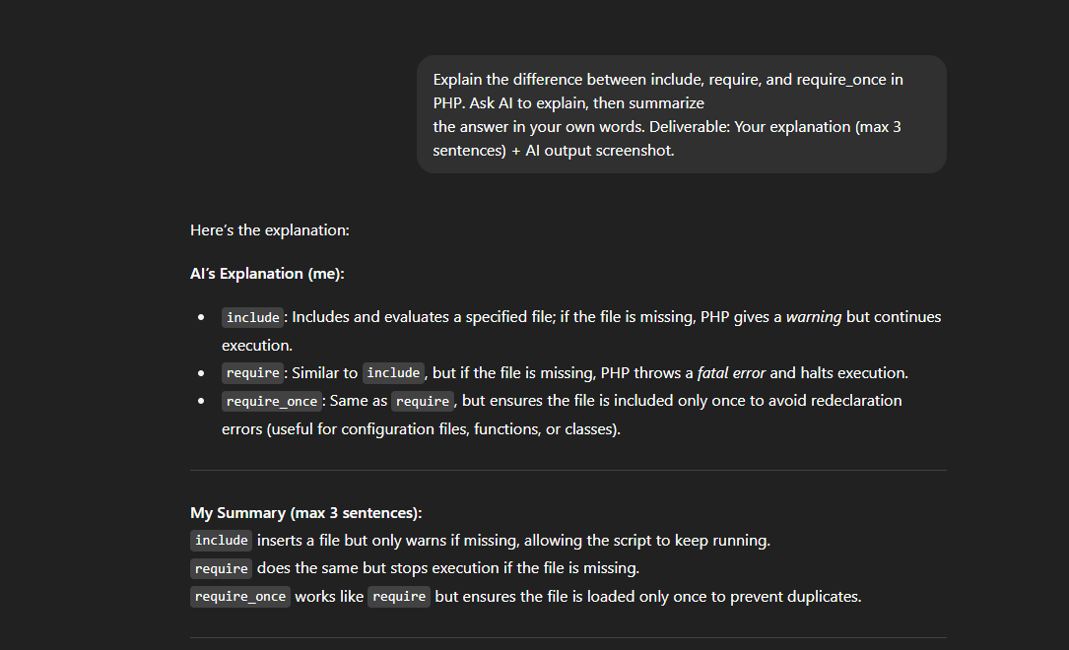

**include**: If the file cannot be found, it will generate a **warning** (E_WARNING), but the script will continue to execute.

**require**: If the file cannot be found, it will generate a **fatal error** (E_COMPILE_ERROR) and halt the script

**Require once:** this is commonly used to prevent duplicating of file.

2. Arrays: Write a PHP script that creates an array of 5 student names, sorts them alphabetically, and prints them in an HTML unordered list. If you used AI, describe what part you asked AI to help with.

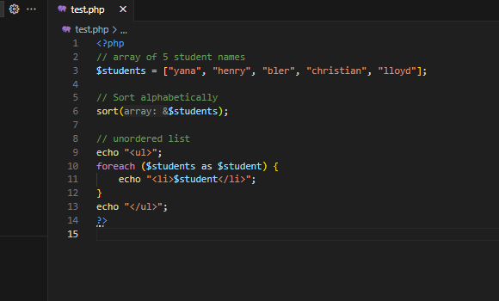

1. **You are given the following buggy PHP code. Fix it and explain why the bug happens**

<?php

$price = "100";

$vat = 0.12;

$total = $price * $vat;

echo "Total price with VAT: " . $total;

?>

**Task A: Find the bug and fix it (edit the code above).**

**Task B: Use AI to ask why this bug happens and paste the explanation. Deliverable: Fixed code + explanation.**

<?php

$price = 100; I change this into string to integer

$vat = 0.12;

$total = $price + ($price * $vat); and add VAT instead of multiplying only

echo "Total price with VAT: " . $total;

?>

1. I find the bug using ai tools using chat gpt he said that the $price is written in string while PHP can convert it to a number automatically, he said its better to used numeric type for mathemathical operation to avoid unexpected result.

2. Second, the calculation was wrong because it only multiplied $price * $vat, which gives just the VAT amount (12). The correct formula is price + (price * vat), which gives the total price including VAT (112).

**Section 3: Mini Project (30%)**

**4) Create a basic PHP contact form (name, email, message) that: - Validates inputs (all fields required, email**

**format check) - Saves submissions to a .txt file (append mode) - Displays a success message after submission**

**Rules: - You may use AI to generate boilerplate code. - You must explain which part was generated by AI, what**

**changes you made, and why those changes were necessary.**

THE ONLY AI GENERATED

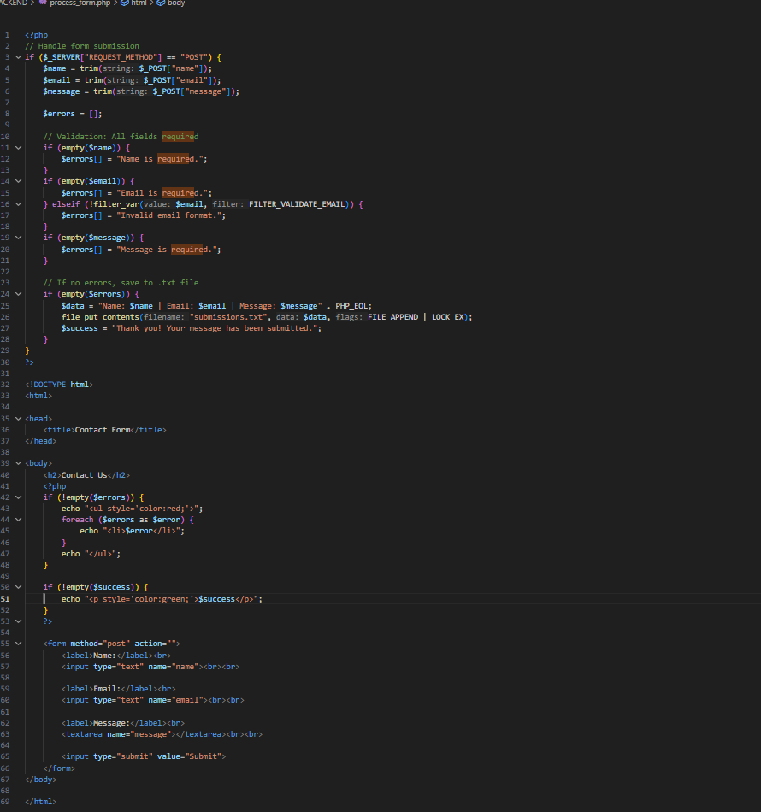

I CHANGE THIS FOR BETTER STRUCTURE AND HANDLING DATA TROUGH FILE AND FOLDER STRUCTURE

FRONTEND HTML - form + display messages

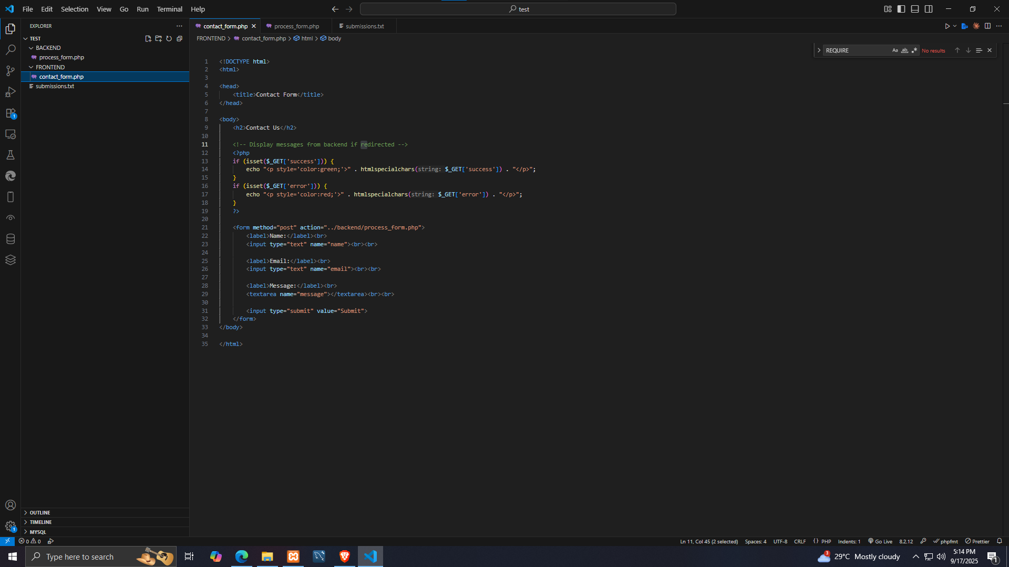

BACKEND - PHP form handler (validation + saving)

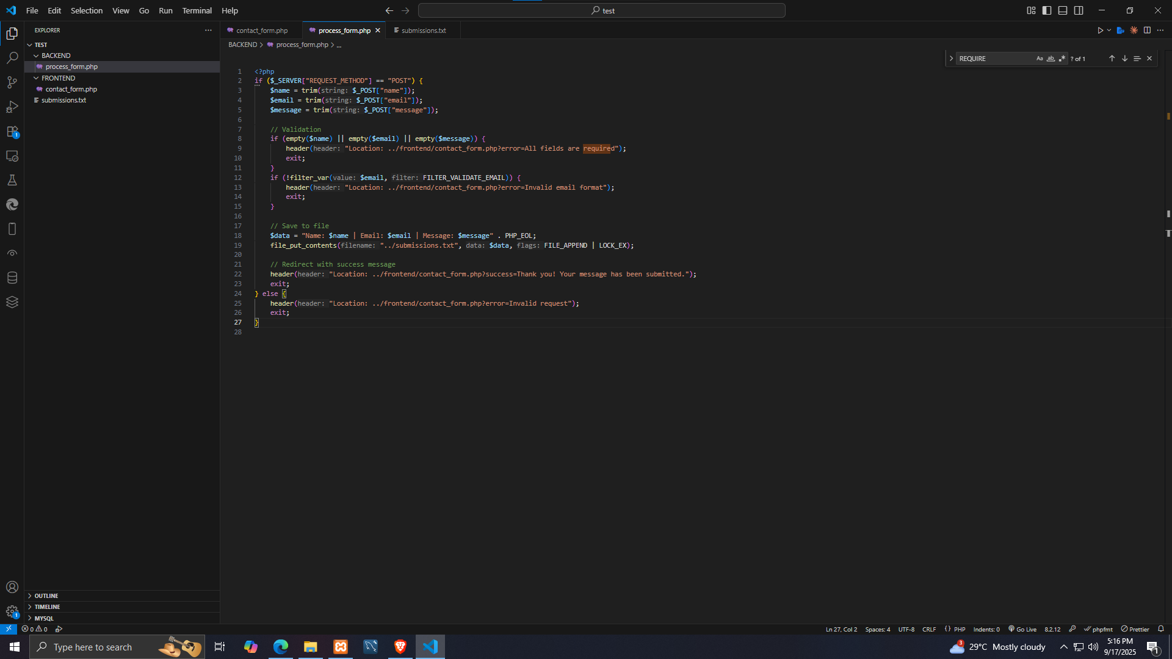

SUBMISSION.TXT - storage file (saved messages)



I USED CHAT GPT TO SEPERATE THE FILE AND FOLDER STRUTURE AND BEST PRACTICES FOR HANDLING A contact form.

Section 4: SQL & Backend Logic (20%) 5) Database Interaction: You have a MySQL table users(id, name, email, created_at). Write a PHP script to: Connect to the database - Retrieve all users created in the last 7 days - Print them in an HTML table Task: Use AI to generate the SQL query, then explain the logic in plain English

This is the ai generated for code

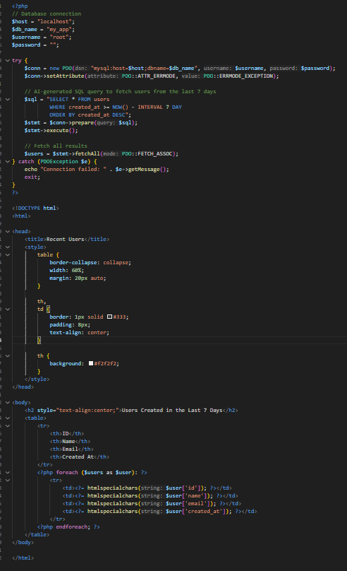

This is the result

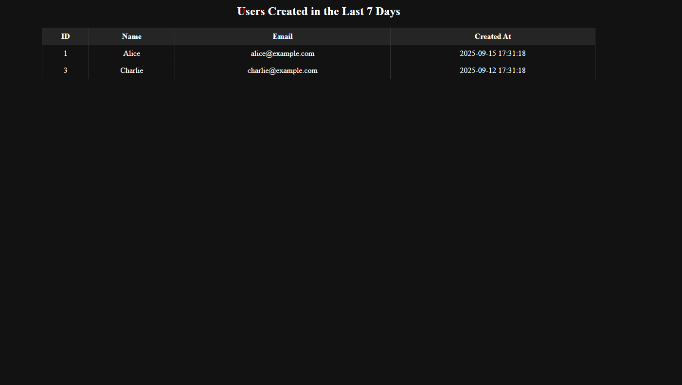

This is the databases connection

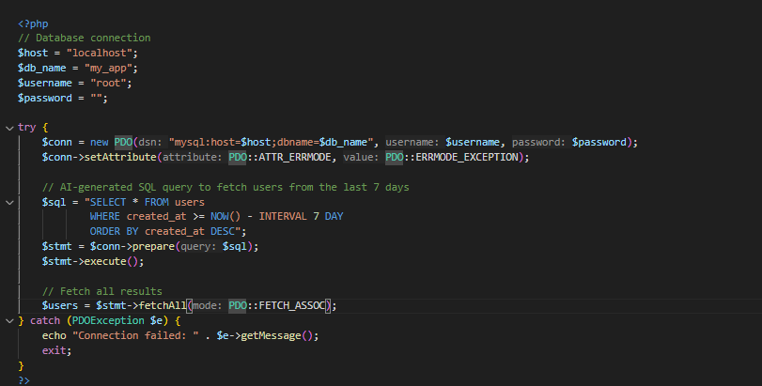

The ai generated queries to Retrieve all users created in the last 7 days 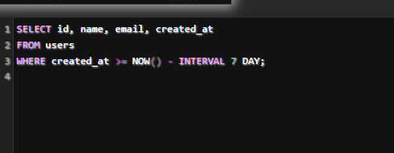

then explain the logic in plain English.?

1. **Connect to the database**

1.1 i create databases connection using php to react mysql databases providing a host, database name , username and password.

1.2 bonus part for secure PDO (PHP Data Objects) is used so that the connection is secure and flexible.

2. Write the SQL query

2.1 You want users who signed up **within the last 7 days**.

2.2 ai generate a sql query to retrived data from the last 7 days.

the query

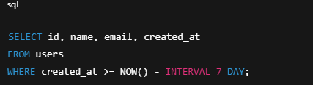

* NOW() gives today’s date and time.
* INTERVAL 7 DAY means "go back 7 days from now."
* So the WHERE condition makes sure we only get users created **on or after that date**.

**3. Run the query**

* PHP sends the query to MySQL and fetches all matching rows.
* If there are no new users in the last 7 days, it returns an empty result.

**4. Display the results**

* An **HTML table** is built.
* For every user found, the script prints their id, name, email, and created_at date as table rows.
* If no users match, the table shows a message: *“No users created in the last 7 days.”*

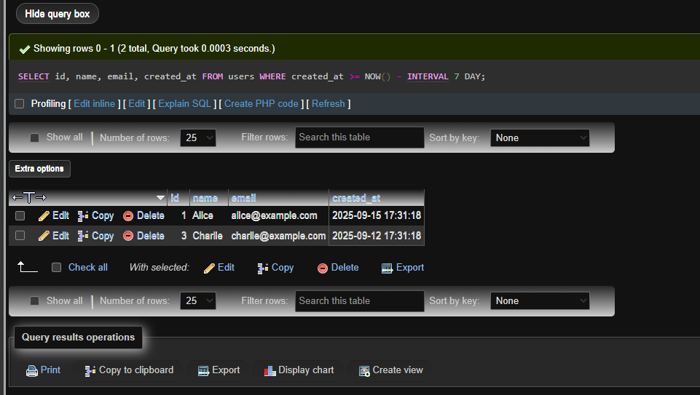

**Section 5: Responsible AI Use & Reflection (10%) 6) Reflection Questions: - Which tasks did you find AI most useful for?**

5.1 I used AI for better and fast output i make hardcoding but i make sure that this skills is common beacause ai is here and impossible task make it easyly and possible to make

A dynamic result example better clean architectured for file and folder for easy to understand and maintainability for changing codings style for team handling

**5.2 Which parts did AI give wrong or incomplete answers?**

There is no wrong in ai the only wrong is your command or prompth that you ask in ai

**5.3 How do you make sure you don’t blindly trust AI in coding?**

“I make sure I don’t blindly trust AI in coding by carefully testing the code it generates, reviewing the logic behind it, and checking it against official documentation or reliable sources. AI is a helpful tool, but I take responsibility for verifying the results, debugging when needed, and making adjustments to fit the exact requirements of my project.”