Summarize data:

1. Top 6 brands in term of dollar sales are: DI GIORNO, TOMBSTONE, RED BARON, FRESCHETTA, PRIVATE LABEL, TONYS. Within these 6 brands, the market share of each brand is as below:

|  |  |  |
| --- | --- | --- |
| **Obs** | **Brand name** | **Market share** |
| **1** | DI GIORNO | 0.25469 |
| **2** | TOMBSTONE | 0.23206 |
| **3** | RED BARON | 0.15010 |
| **4** | FRESCHETTA | 0.14288 |
| **5** | PRIVATE LABEL | 0.11046 |
| **6** | TONYS | 0.10981 |

1. Which companies are the major players in the category? Which company owns which brands?

The top 5 companies in the market are as in the below table. Kraft Foods is the leading company in the pizza market, with over 65 million USD in sales. Scwan Food is in the second place with 48.75 million USD in sales. General Mills, Private Label and Nestle USA made 13.32 million, 10.71 million and 8.69 million, respectively.

|  |  |  |
| --- | --- | --- |
| Obs | COMPANY | SALES |
| 1 | KRAFT FOODS INC. | 65011971.92 |
| 2 | SCHWAN FOOD CO | 48749710.35 |
| 3 | GENERAL MILLS | 13319257.92 |
| 4 | PRIVATE LABEL | 10707767.83 |
| 5 | NESTLE USA INC. | 8694009.89 |

A list of brands owned by top 5 companies:

|  |  |  |
| --- | --- | --- |
| **Obs** | **COMPANY** | **L5** |
| **1** | GENERAL MILLS | JENOS CRISP N TASTY |
| **2** | TOTINOS |
| **3** | TOTINOS FOR ONE |
| **4** | TOTINOS PARTY PIZZA |
| **5** | KRAFT FOODS INC. | CALIFORNIA PIZZA KITCHEN |
| **6** | DI GIORNO |
| **7** | JACKS |
| **8** | JACKS GREAT COMBINATIONS |
| **9** | JACKS NATURALLY RISING |
| **10** | JACKS NATURALLY RISING P |
| **11** | JACKS ORIGINAL |
| **12** | JACKS ORIGINAL SUPER CHE |
| **13** | TOMBSTONE |
| **14** | TOMBSTONE DOUBLE TOP |
| **15** | TOMBSTONE FOOD SERVICE |
| **16** | TOMBSTONE FOR ONE |
| **17** | TOMBSTONE LIGHT |
| **18** | TOMBSTONE OVEN RISING |
| **19** | NESTLE USA INC. | STOUFFERS |
| **20** | STOUFFERS LEAN CUISINE |
| **21** | PRIVATE LABEL | PRIVATE LABEL |
| **22** | SCHWAN FOOD CO | BELLAFINO |
| **23** | CHICAGO TOWN |
| **24** | FASTBREAK RISERS |
| **25** | FRESCHETTA |
| **26** | RED BARON |
| **27** | RED BARON BAKE TO RISE |
| **28** | RED BARON SUPER SINGLES |
| **29** | TONYS |
| **30** | TONYS LITTLE CHARLIES |
| **31** | TONYS PERSONAL PIZZA |
| **32** | TONYS PIZZA FOR ONE |

1. Find average prices, display, feature of each of the 7 brands

The average price per unit we use to work on this report is the average price per oz.

|  |  |  |  |  |
| --- | --- | --- | --- | --- |
| **Obs** | **avg_P_per_unit** | **avg_d** | **avg_F** | **brand** |
| **1** | 0.19540 | 0.13748 | 0.22253 | DI GIORNO |
| **2** | 0.17411 | 0.26120 | 0.43970 | TOMBSTONE |
| **3** | 0.16948 | 0.34382 | 0.39970 | RED BARON |
| **4** | 0.20838 | 0.21761 | 0.33108 | FRESCHETTA |
| **5** | 0.12822 | 0.16708 | 0.26770 | PRIVATE LABEL |
| **6** | 0.16750 | 0.30456 | 0.39875 | TONYS |
| **7** | 0.17702 | 0.21253 | 0.30385 | OTHERS |

1. What are the top 5 regions in terms of dollar sales?

The top 5 regions in terms of dollar sales are Chicago, St. Louis, Los Angeles, Milwaukee, and New York.

|  |  |  |
| --- | --- | --- |
| **Obs** | **Region** | **SALES** |
| **1** | CHICAGO | 12087351.47 |
| **2** | ST. LOUIS | 8910475.07 |
| **3** | LOS ANGELES | 8053550.38 |
| **4** | MILWAUKEE | 7685027.27 |
| **5** | NEW YORK | 7375911.94 |

1. What are **the top 10 store chains** that sell a lot of your category in terms of dollar sales?

The top 10 store chains that have the highest total sales of pizza are: Chain 115, Chain 97, Chain 55, Chain 75, Chain 53, Chain 114, Chain 103, Chain 10, Chain 94, and Chain 35.

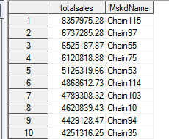

1. What is the average price per unit of 7 brands by week? Plot the average price by week (I wish to see a line plot of price by week). Comment on your findings.

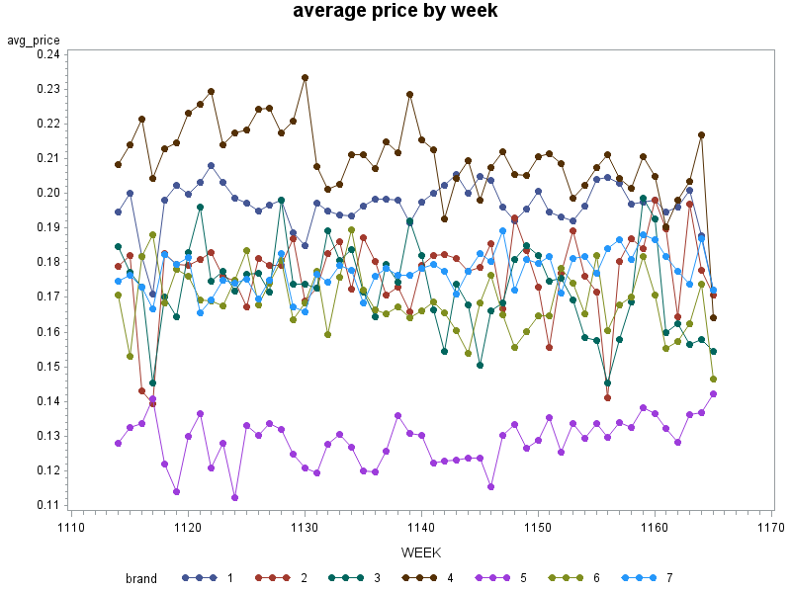

1.Di Giorno 2.Tombstone 3.Red Baron 4.Frescheta 5.Private Label 6.Tonys 7.Others

Among the top 7 brands in terms of dollar sales, Private Label (brand 5) has the lowest average price per unit by week, while Freschetta (brand 4) has the highest average price per unit by week. Di Giorno (brand 1) has the second highest average price per unit by week. Brand 2, 3, 6, and 7 have been approximately in the same range of price.

The average price per unit of Tombstone, Red Baron, Di Giorno do not change much, the price per week of other brands fluctuate more during the year.

1. Assume you are manager of a brand (out of the top 6). Write a short paragraph stating what you learned from this descriptive analysis (steps 1-7).

We choose brand Di Giorno. From the descriptive analysis above, we can see our brand has the highest market share (25.5%) in terms of dollar sales, followed by Tombstone with 23.2% market share. For all the brands in the market, the average weekly price fluctuates over weeks. Our brand’s average price per unit by week is the second highest after Francheta, the 4th highest market share in the frozen pizza industry. Our brand’s average weekly price per unit $0.195, which is highest among 6 best brands in the industry. Our products are displayed 13.75% of the times and featured 22.25% of the times

For targeted market, our brand should distribute our pizza to the top 10 store chains in terms of dollar sales as well as focus more on the top 5 regions that has highest dollar sales: Chicago, St. Louis, Los Angeles, Milwaukee, and New York.

Statistical Analysis

1. Do large stores (top 3 stores) have higher average price per unit than small stores (stores ranked 8-10) for brand 1 (the top brand in Q1). Test and report your results and comments.

Large stores (top 3 stores): 259495; 276392; 225023

Small stores (Store ranked 8-10): 649405; 243941; 646857

|  |  |  |  |
| --- | --- | --- | --- |
| **Obs** | **totalsales** | **avg_P_per_unit** | **IRI_KEY** |
| **1** | 116369.30 | 0.21586 | 259495 |
| **2** | 114895.23 | 0.17614 | 276392 |
| **3** | 106433.75 | 0.17451 | 225023 |
| **4** | 105105.28 | 0.17810 | 278571 |
| **5** | 101766.30 | 0.18287 | 534075 |
| **6** | 92965.10 | 0.14618 | 291278 |
| **7** | 88936.00 | 0.17400 | 647512 |
| **8** | 87320.55 | 0.18454 | 649405 |
| **9** | 84053.56 | 0.20388 | 243941 |
| **10** | 76464.91 | 0.17395 | 646857 |

We reject the null hypothesis that the large stores and small stores have equal price per unit variances and used a t-test for unequal variances. This t-test gave P-value = 3.94% so we reject the null hypothesis that large and small stores have equal price per unit at 5% significance level. Also, there’s 95% certainty that large stores’ average price per oz is higher than small stores’ average price per oz because the difference diff(1-2) is positive. Therefore, we can conclude that large stores have higher average price per unit than small stores. This gap is small but significantly different from 0.

1. Develop three additional hypotheses linking useful variables to dollar sales, test them and report your findings.

① Do large size pizzas have more dollar sales per week than mini pizza

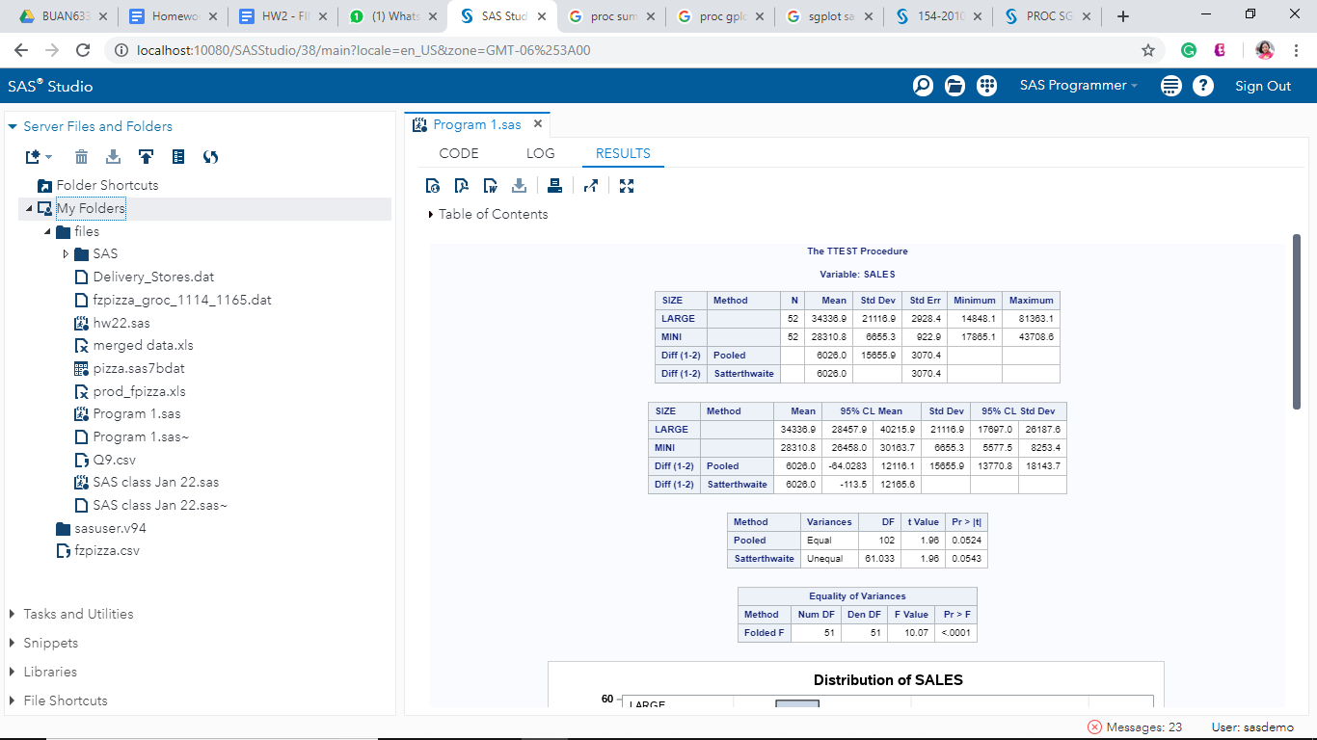

In the test for equality of Variance, P value is smaller than 0.05 so we reject the null hypothesis that the variance of dollar sales per unit for these two sizes of pizza are the same.

We performed a t test assuming unequal variance and receive t value = 1.96; P value larger than 0.05. Therefore, we cannot reject the null hypothesis and conclude that the dollar sales per week of large pizza and mini pizza are equal.

②Are there any differences in dollars sales per week of these flavors: VEGGIE ULTIMATE, VEGETABLE PRIMAVERA, VEGETABLE?

We utilized ANOVA test, the p-value is smaller than 0.01, so we can reject the null hypothesis that three veggie flavor pizzas have the same dollars sales per week. And then, we ran the ANOVA TUKEY’s Test to see the difference among these flavors in term of dollar sales per week. The 95% confidence interval of difference between vegetable and the other two flavors are positive. Therefore, we can conclude that VEGETABLE flavor has the highest sales per week within these three flavors.

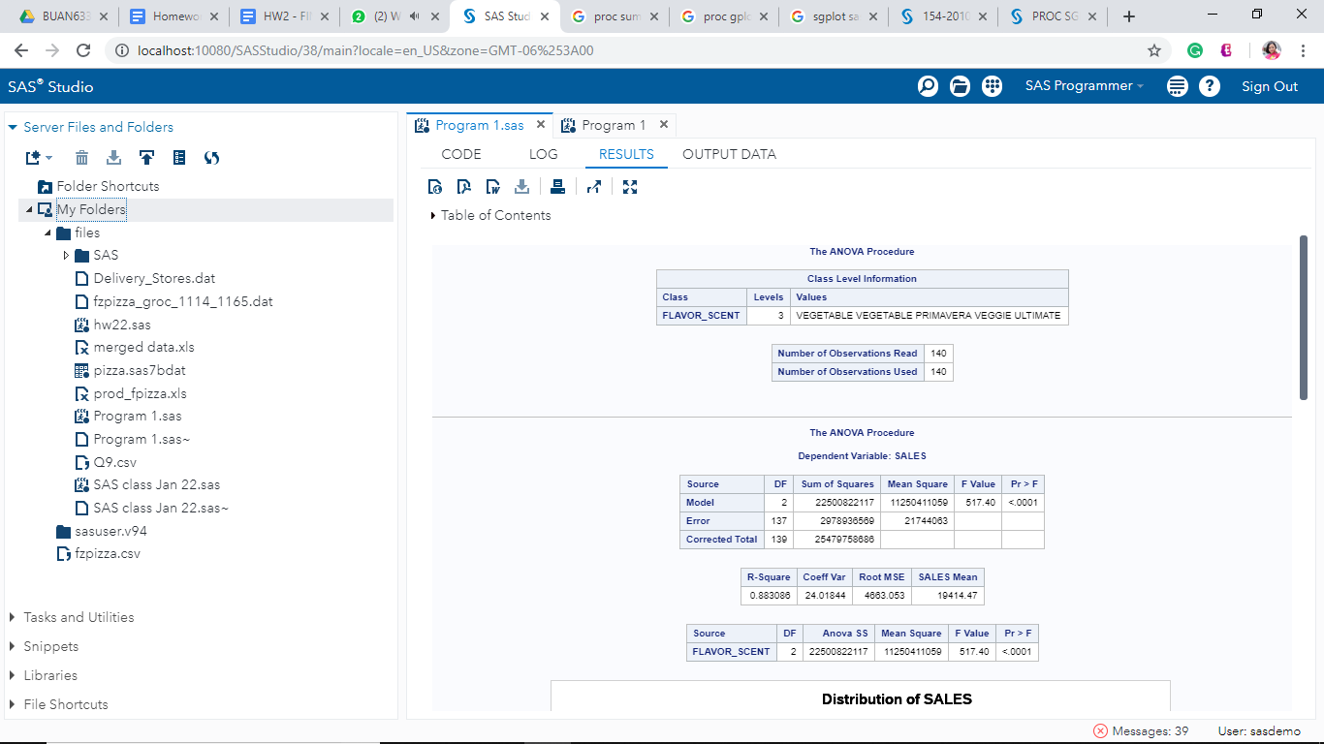

③Does different microwavabilitiy affect dollars sold per week?

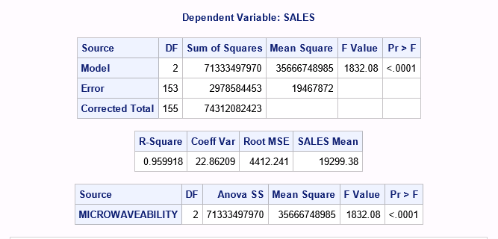

We utilized ANOVA test, the p-value is smaller than 0.01, so we reject the null hypothesis that all types of microwavability have the same dollar sales/week. We conclude that microwavability does affect dollar sales/week.

1. For the top brand: run a regression model with weekly dollar sales as dependent variable. Use average weekly price per unit, average display, average feature, and other useful variables in your regression and answer the following questions:

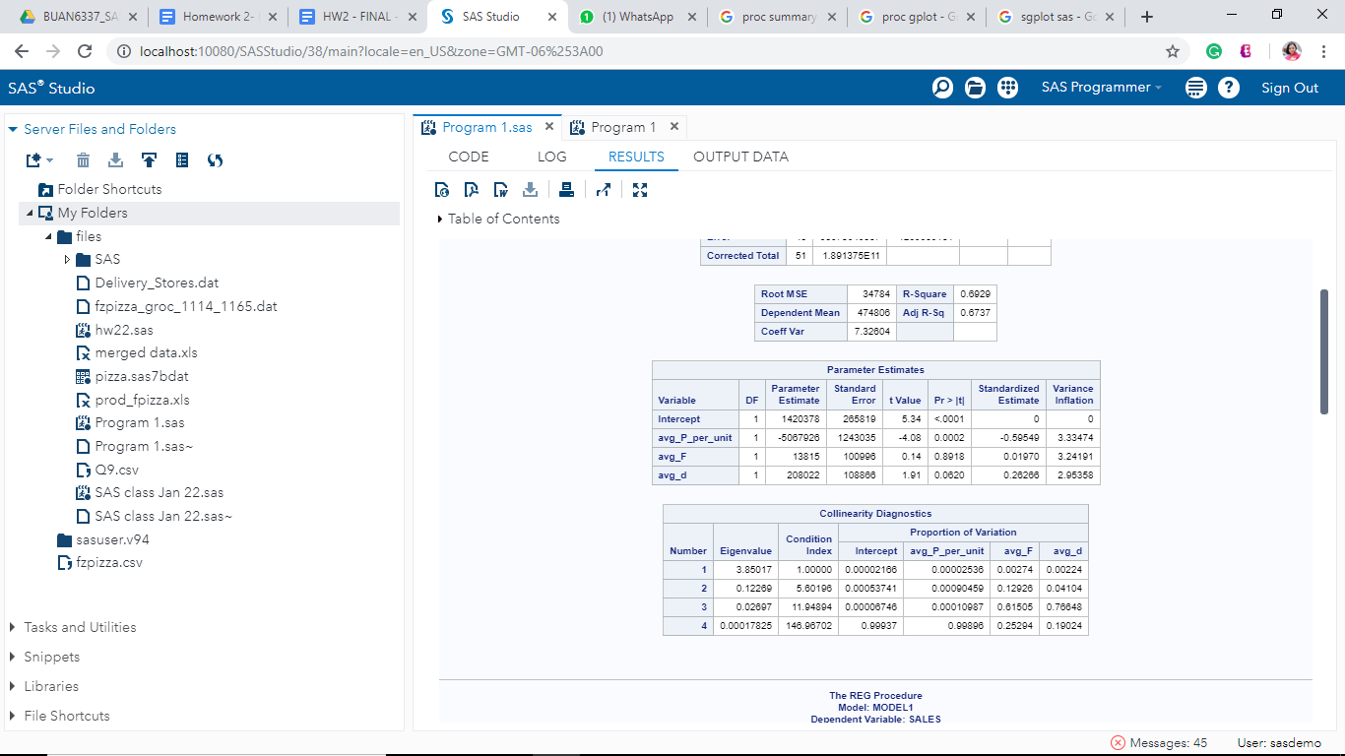

The regression model we decided to run is:

Sales = beta0 + beta1*(avg_P_per_unit) + beta2*(avg_f) + beta3*(avg_d)

where:

the dependent variable is the weekly dollar sales

the independent variables are average weekly price per ounce, average display, and average feature.

1. What is the R-sq and adj R-sq of the model?

R-sq is 0.6929

Adjust R-sq is 0.6737

The R-sq of 0.6929 indicates that the independent variables (average weekly price per ounce, average display, and average feature) can explain 69% of the variation in the dependent variable (the dollar sales per week).

1. Which coefficients are significant?

The coefficient on weekly average price per oz is the only significant coefficient because it has a p-value less than 0.05.

1. Which variables are most important in explaining sales?

Variable average price per unit has the highest absolute value of the standardized estimate, thus, it is the most important variable in explaining sales.

1. Interpret the meaning of the price coefficient? What is the price elasticity?

* the beta1 or price per unit’s coefficient is -5067926, which means that if we increase $1 in average weekly price per ounce, the weekly dollar sales will go down by $5067926.

This is reasonable because normally the total price of a pizza is around $5-$6 and an increase of $1/oz makes a really high change in price

* we ran another regression model log(sales) = log(price per unit) and the coefficient on log(price per unit) is -2.55, which means price elasticity is -2.55. When price per unit increase by 1%, sales will decrease by 2.55%

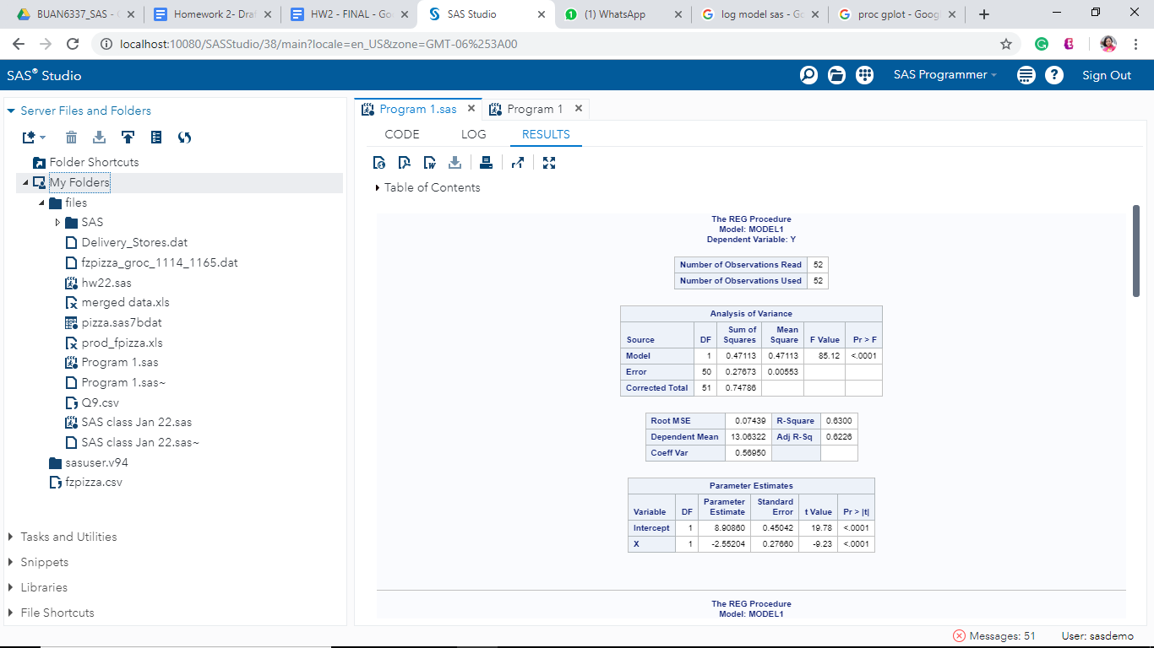

1. Interpret the meaning of the display coefficient?

Based on the regression result, the avg_display coefficient has p-value > 0.05. Thus, we cannot reject the null hypothesis that the coefficient is equal to 0 and conclude that the average display does not have any impact on the weekly dollar sales.

1. Test whether there is an interaction between display, feature and price. Comment on your findings.

We ran an interaction model. Based on the result, the p-value of all the interactions are greater than 0.05. Thus, we cannot reject the null hypothesis, and we conclude that there is no interaction effect among display, feature, and price.

1. Test whether the effect of price is non-linear. Comment on your findings.

We tried using quadratic and cubic terms of average price per unit in the regression model. The p values of quadratic and cubic terms are both greater than 0.05, suggesting that there is no non-linear effect of average price per unit. This is reasonable because pizza is a common goods and people will not buy it if it is more and more expensive.

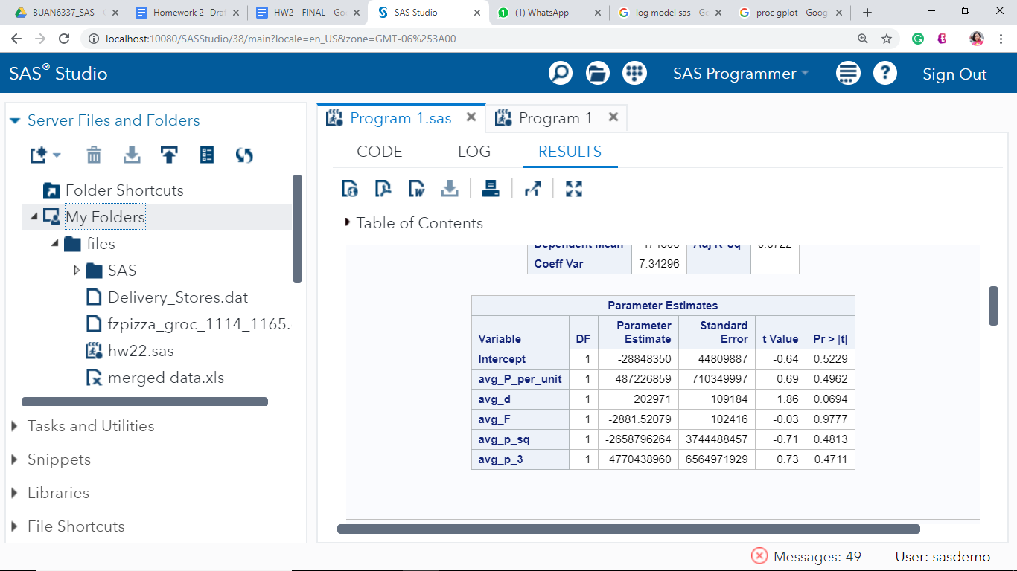

1. Test using VIF and COLLIN whether there is multicollinearity in the model? Comment on your findings.

Based on the outputs with VIF option, none of the Variance Inflation is greater than 10. Therefore, we conclude that there is no multicollinearity in the model.

Based on the outputs with the COLLIN option, we have 1 component that has condition index which is greater than 100. However, this component does not contribute strongly to the variance of two or more variables. Therefore, there is no multicollinearity.

1. Test for presence of heteroscedasticity using White test. Do A WLS if needed. Comment on your findings.

After running the White test, we have a p-value of 0.6878, which is greater than 0.05. Therefore, we fail to reject the null hypothesis that the variances are equal and thus conclude that there is no heteroscedasticity. In this case, we don’t need to do a WLS regression.