Week 7- Network Basics

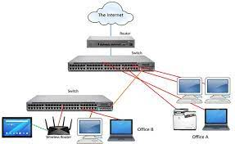

**Class:cb08**

**Student numbers:** **4597826**

**Student names: Gilton Thomas Denislav Deshkov**

Date: March 2020   
Version 2.1

# First reader

This document is a guideline to Practical assignment from week7 to 11. Make sure you read this document carefully to know how you must deliver your assignments.

How to deliver your assignments?

1. From week 7 to 11 you will work in pair on weekly assignments which includes a Netkit project and several questions. Both students in pair must deliver an individual report file including all weekly assignments. For every question make sure you write your answer in detail and include the solution’s evidence for example screen shots.
2. This is how to structure your report:

* Cover page
* Revision table
* Introduction about student
* assignment Week7 (including all the answers and evidences)
* assignment Week8 (including all the answers and evidences)
* assignment Week9 (including all the answers and evidences)
* assignment Week10 (including all the answers and evidences)
* Conclusion
* Personal refraction

1. Create a git repository and both pair submit your assignments every week in the repository. Make sure you use this pattern for naming the repository: **< IEO-pairNumber-1stStudentFullName -2ndStudentFullName** >. Any other repository name will not be accepted!
2. Make a proper folder structure in your repo. This is how you need to structure your repository:

1stStudent-folder

Report.docx

2ndStudent-Folder

Report.docx

Netkit-folder

Group deliverables

1. Work on the weekly assignments with your pair and deliver your Netkit project together and your report individually.

**Example code for configuring your git repository and working directory**

#make a new directory named ieo

mkdir ieo

#go to this directory and initialize your local repository

cd ieo

git init

git remote add origin <your-project-url>

git pull origin master

#now create a sub-directory inside your working directory, with your full name

mkdir <your-full-name>

#go to this sub-directory

cd <your-full-name>

#enter the following command so that a void file with your i-account is created

touch <your-i-account>

#stage the contents of this directory to your git project

git add .

#one of the group members needs to make also a sub-directory named "netkit-lab" inside the working directory

#the other group member(s) will get access to it after synchronizing with the remote repository using "git pull"

#go back to ieo

cd ..

mkdir netkit-lab

#go to this sub-directory

cd netkit-lab

#enter the following command so that a void file with your i-account is created

touch readme

#stage the contents also of this directory to your git project

git add .

#commit the changes to the local repository

git commit -m "<your-full-name> folder initialized"

#now you can update the remote repository

git push -u origin master

You can share a folder from your Desktop into your virtual machine on VMWare(Windows) or Fusion(MAC).

In VMWare you need to enable the shared folders feature and include the folder of your windows machine you want to access from the Linux virtual machine:

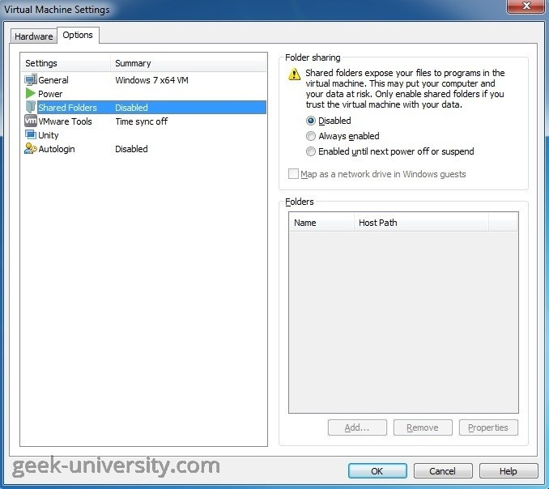

Your folder can be accessed in linux by the path /mnt/hgfs/<name_of_shared_folder>

# name Investigation of hardware

Task 1: install and Test Netkit Tool

Consult this week’s theory presentation and use the Netkit commands to start and halt a network node as described in the presentation. Netkity and Wireshark are already installed in the preconfigured Linux. If you installed the Linux yourself, then you need to install these tools yourself. (there is a guideline in the Canvas)

TESTING INSTALLATION

vstart pc1, vlist,vhalt -r pc1, -f $SHELL,. $NETKIT_HOME/bin/netkit_bash_completion

.

Task 2: TCP/IP Layers in Wireshark

Find a Wireshark Tutorial on the web. Run Wireshark.

Start capturing the network traffic. To generate HTTP traffic, go to [http://courses.codemax.net/w2. html](http://courses.codemax.net/w2.%09%09html) web browser. Don’t forget to stop capturing as you can get a lot of traffic in your capture. Look at your captured packets and find an HTTP GET packet and Answer the following questions and provide the screenshots:

* What is the source and destination MAC address of this HTTP packet?

Source MAC address: 16:4a:7b:d0:42:b4  
Destination MAC address: 60.a4.b7.69.86.90

Provide a screenshot below with the Wireshark snapshot and highlight these addresses:

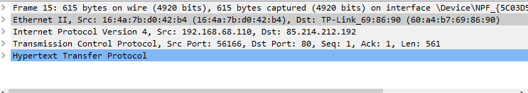

* What is the source and destination IP address of this HTTP packet?

Source IP address :192.168.68.110  
Destination IP address :85.214.212.192

Provide a screenshot below with the Wireshark snapshot and highlight these addresses:



* What is the source and destination port of this HTTP packet? Provide a screenshot to prove it

Source port :56166  
Destination port:80

Provide a screenshot below with the Wireshark snapshot and highlight these addresses:



* What is the host name of this HTTP Get packet?

Host name: courses.codemax.net\r\n

Provide a screenshot below with the Wireshark snapshot and highlight the host name:

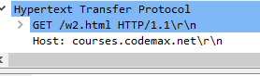

* Find the HTTP Response belonging to the HTTP Get packet. How much time elapsed between the HTTP Get and HTTP response?

Time elapsed: 3.089402000

Provide a screenshot below with the Wireshark snapshot and highlight the elapsed time:

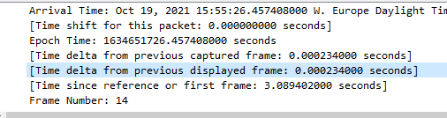

Task 3: Do Linux Tutorial

Go to <http://www.ee.surrey.ac.uk/Teaching/Unix/index.html> and do the tutorial three.

Provide screenshots of all exercises in section 3.4

