DEMOLISHER

Or Pin-Bomb? I cannot decide yet.

# Mock-Up

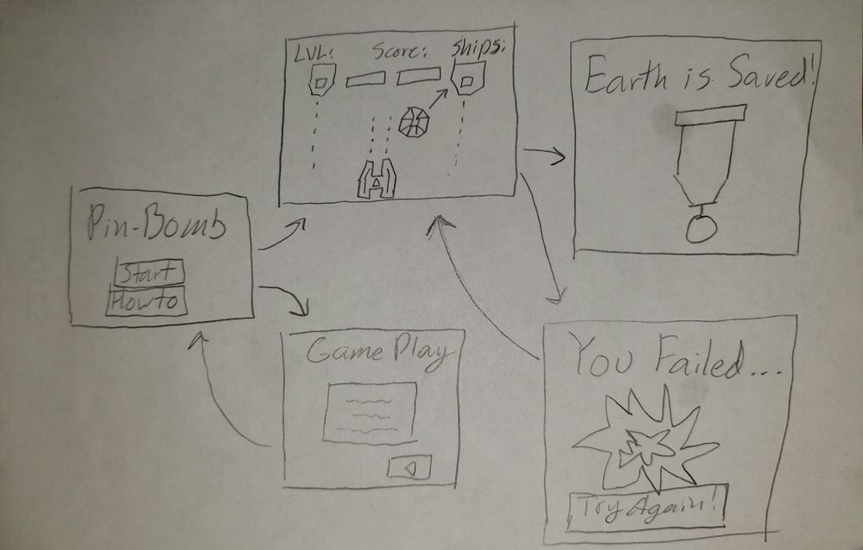Crummy drawing courtesy of Matt...

# **Feature List (Priority #)**

**Main Scene** (2)

* Play button(2)
* Gameplay/Help button(3)

**Game Scene** (1)

* User-controlled ship(1)
* Angled bomb movement(1)
* Shoot the bomb to knock it towards bricks/enemies(1)
* Enemies shoot bullets occasionally that can damage the player(1)
* Multicolored bricks(1)
* Collision detection(1)
* Life display(2)
* Score display(2)
* Sound effects(2)

**Help Scene** (3)

* Help text(3)
* Back button(3)

**Win Scene** (2)

* Announcement(2)
* Medal animation(2)

**Lose Scene** (2)

* Announcement(2)
* Explosion animation(2)
* Restart button(2)

# Potential New Classes

* Bullet
  + Moves vertically (+/- y velocity)
  + Collides with the player or bomb
  + Does not destroy enemy ships
* Enemy Ship
  + Can be stationary or move left or right
  + Shoots bullets at set intervals
  + Enemy bullets can hit the bomb? (Needs play testing)
* Player Ship
  + Moves left and right
  + Can fire bullets to hit the rally the bomb
  + Can be destroyed by the bomb
* Bomb
  + Can be bounced by the player’s bullets
  + Destroys bricks and ships
  + Cannot bounce off the bottom