1.
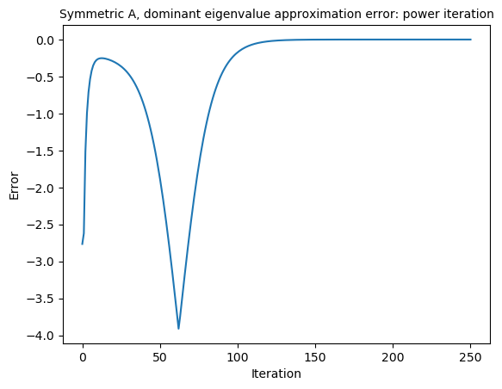
abc. Using the power iteration, I found the dominant eigenvalue pretty accurately, as shown below. It converged after only 125 iterations and was accurate to over eight decimal places.

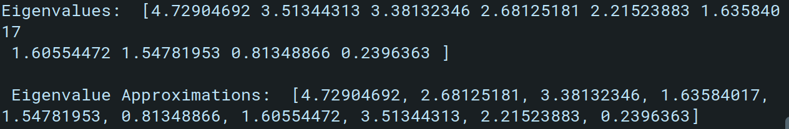
To find all eigenvalue / eigenvector pairs using the Rayleigh Quotient iteration, I started with a random vector that converged to the nearest eigenvalue. Then created another random vector. If that one converged to the same eigenvalue, I started the iteration over, repeating until all ten unique eigenvalues were found. This took quite awhile, oftentimes north of 10 – 15 minutes. But it eventually got all ten, again with an accuracy over eight decimal places. This is shown below:

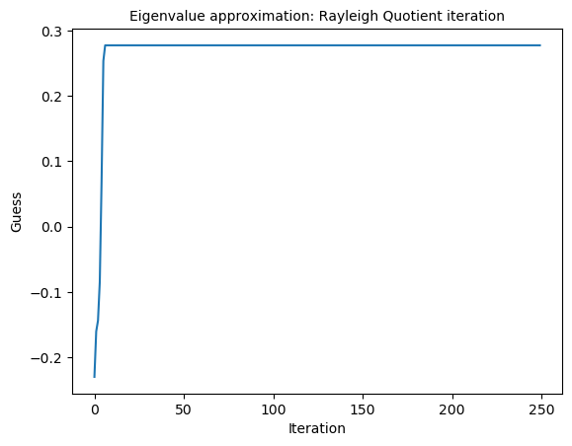
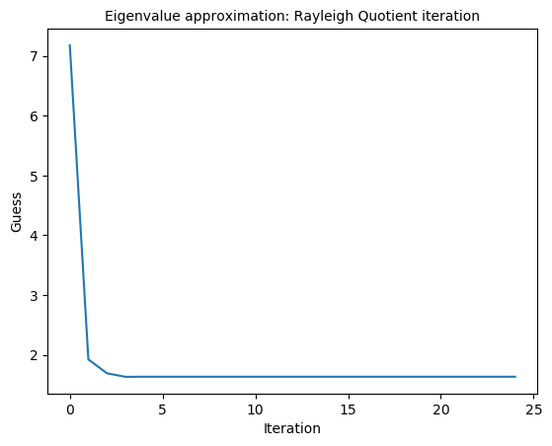
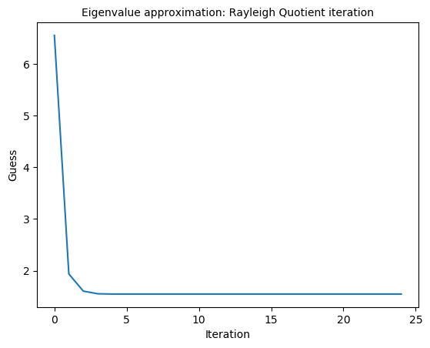
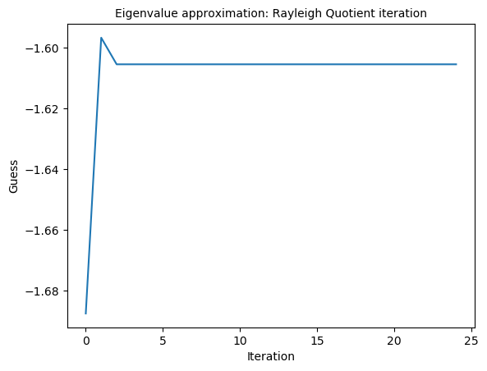
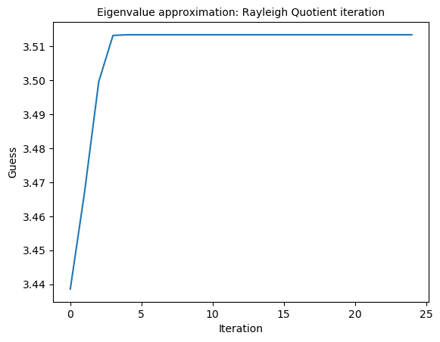
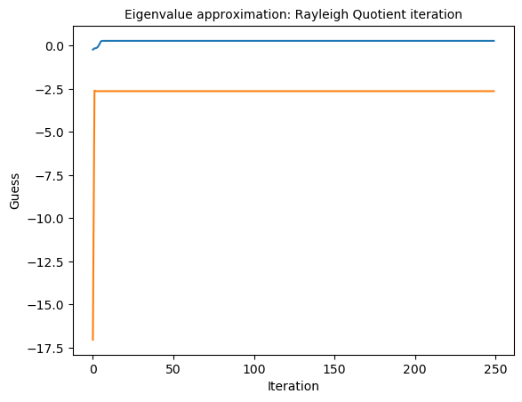
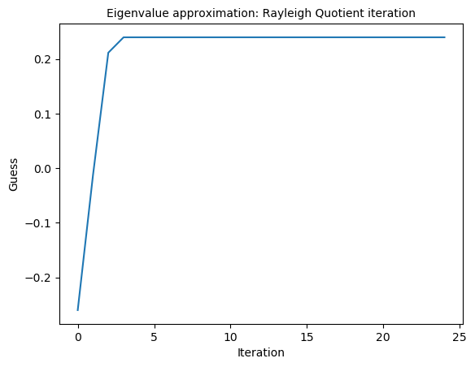
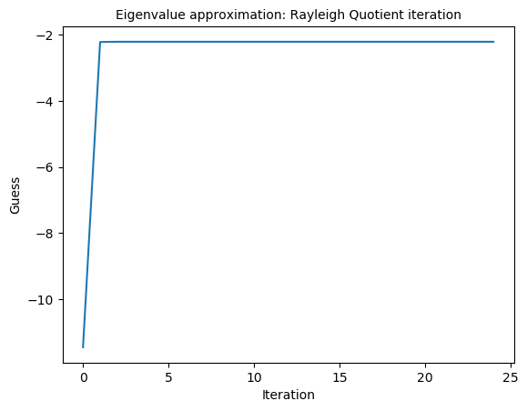
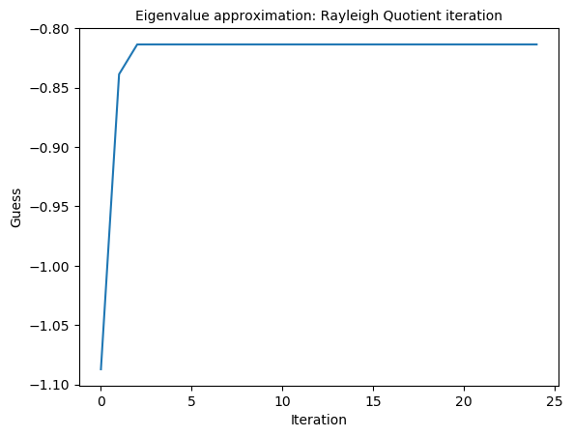
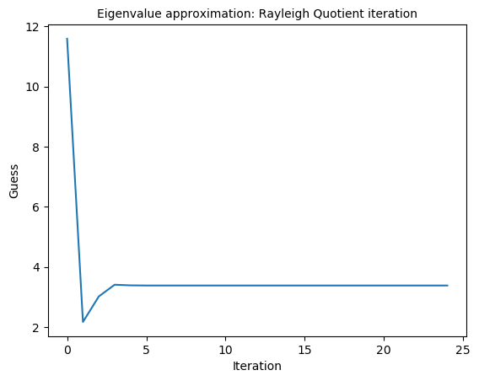

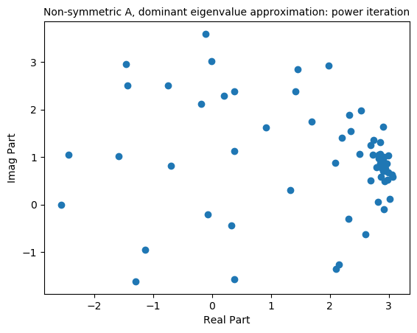
d. For non-symmetric, it was a lot trickier because complex eigenvalues are involved. Power iteration is below:

I read this as, wherever most of the points on this complex plane congregate is where the dominant eigenvalue estimate is. The error is very small, calculated as the difference in modulus between the approximate and the ground truth:

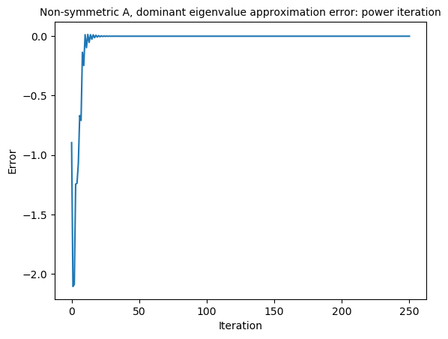
For the Rayleigh Quotient iteration for non-symmetric matrix, I was unable to understand what to do there. The modulus didn’t seem logical to me, as sometimes my code would spit out complex eigenvalues but were comparing to real ground truth eigenvalues. It didn’t make sense to me that those can just be compared and “walked downhill” (as they would be considered equal if there moduli were equal, even though one was complex and one was not.)

2.
a. I found the dominant eigenvalue and eigenvector using power iterations, producing the error plot below:

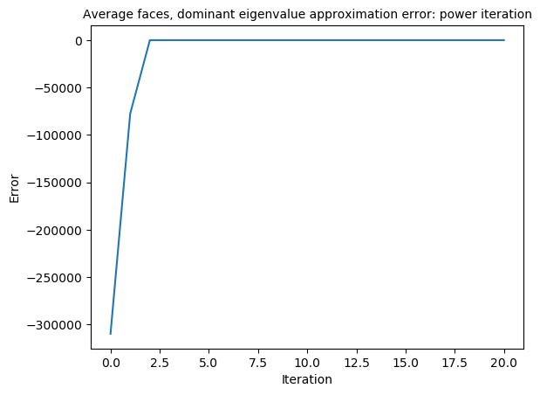
Turns out the solution converged very quickly, within five iterations. Showing the eigenvalue spectrum for more detail:

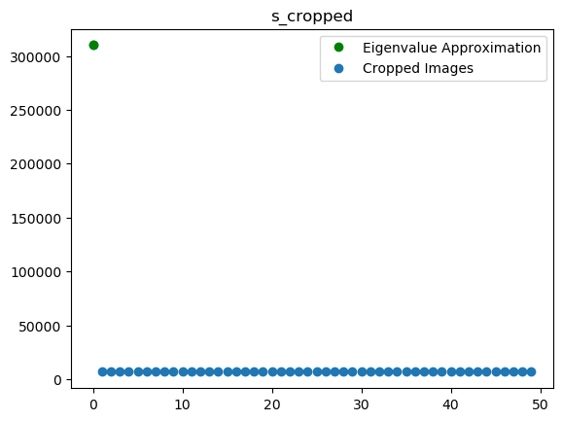
c. I wasn’t entirely sure what was being asked here, and my code did not work out in time to produce anything here. But what I was going to do was: iterate through ten different randomized samples of different numbers, perform SVD on the image matrix and reconstructing the imsage matrix using the first five modes. Then I was going to plot the reconstructions of each randomized sample against the truth and compare. It was all too much, so I had not produced anything for this. My code is mostly complete, though.

