<https://github.com/HenshawW-io/HenshawW-io.github.io>

Task 6 screenshot:

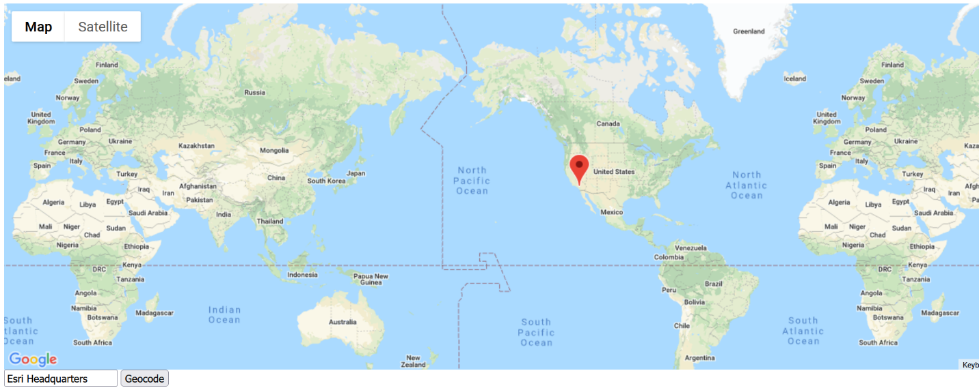

Task 5 screenshot:

