UNITEDWORLD INSTITUTE OF TECHNOLOGY
KARNAVATI UNIVERSITY
Uvarsad, Gandhinagar, Gujarat – 382422
MINI PROJECT REPORT
PROJECT REPORT
AI-BASED NETWORK
INTRUSION DETECTION SYSTEM
Submitted by
Student Name: Chauhan Heny
Enrollment No.: 202407020545
Group Members : Yashvi Dhanani, Soumya khode, ashvi ladani
202407020543,202407020202,202407020675
in partial fulfilment for the award of the degree of
BACHELOR OF TECHNOLOGY
COMPUTER SCIENCE ENGINEERING
Project Mentor
Ms. Pragya Vats
UNITEDWORLD INSTITUTE OF TECHNOLOGY
KARNAVATI UNIVERSITY
Uvarsad, Gandhinagar, Gujarat – 382422
July – November, 2026

TABLE OF CONTENTS
1. Abstract
2. Introduction
a) Problem Statement
b) Aim and Objectives
c) Scope of the Project
3. System Requirements and Design
a) Hardware Requirements
b) Software Requirements
c) System Architecture
d) Diagrams
4. Implementation
a) Technologies Used
b) Screenshots and Outputs
5. Conclusion
6. Future Scope
References

1. ABSTRACT
Computer networks are used to exchange information between computers, servers, and other connected devices. As network traffic increases, manually checking every communication flow becomes difficult. Some traffic may be unusual or potentially harmful, and delayed identification can affect the availability, confidentiality, and integrity of network resources.
The AI-Based Network Intrusion Detection System is proposed as a learning prototype that applies machine-learning techniques to network-flow information to classify traffic as Normal or Suspicious. The planned workflow includes preparing a labelled dataset, selecting relevant traffic features, splitting the data into training and testing sets, training a classifier such as Random Forest, and evaluating its predictions using accuracy, precision, recall, F1-score, and a confusion matrix. A simple dashboard or notebook-based interface may be used to display the results.
The networking foundation for the project is modelled in Cisco Packet Tracer. The simulated campus network separates Student, Staff, and Server devices into different VLANs, uses router subinterfaces for inter-VLAN routing, and includes an external test network. DNS and HTTP services demonstrate application-level communication, while an extended Access Control List (ACL) is used to restrict traffic from the external test host to the server subnet. Connectivity tests and ACL counters provide evidence of the configured network behaviour.
This report documents the project concept, objectives, system requirements, network design, proposed machine-learning methodology, and the current Phase 1 implementation. The Packet Tracer network simulation is the demonstrated networking component. Dataset preparation, model training, measured evaluation results, and dashboard development must be completed and documented in the subsequent AI/ML implementation phase. No real-world detection accuracy is claimed in this report.

2. INTRODUCTION
A computer network allows multiple devices to communicate and share resources through protocols such as IP, TCP, UDP, DNS, and HTTP. In an organisation or campus, many users access shared servers and services at the same time. Network administrators therefore need ways to monitor communication, understand traffic behaviour, and identify activity that may indicate misuse or an attack.
Traditional network monitoring commonly relies on fixed rules, known signatures, firewall policies, and manual inspection. These methods are useful, but they may require frequent updates and can overlook patterns that are not represented by existing rules. Machine learning can support the first stage of traffic review by learning relationships between labelled network-flow features and producing a Normal or Suspicious classification. Such predictions are decision-support information and should be reviewed by a human analyst.
The project combines a simulated networking environment with a planned AI-based classification workflow. Cisco Packet Tracer is used to model network devices, addressing, VLANs, routing, services, and access control. Python libraries such as Pandas and Scikit-learn are proposed for dataset preparation and model development. A dashboard may be added to present sample predictions and evaluation measures.

2.a) Problem Statement
Large networks can generate substantial volumes of traffic. Inspecting every packet or connection manually is time-consuming, and rule-based monitoring may not identify unfamiliar or changing traffic patterns. There is a need for a prototype that analyses selected network-flow features and highlights flows that may be suspicious, while also demonstrating the underlying computer-network concepts.
The project addresses this problem by designing a segmented network for controlled traffic observation and proposing a machine-learning workflow that classifies labelled network-flow records. The system is intended for academic demonstration and learning. It is not a production-grade security product, and its alerts require human review.

2.b) Aim and Objectives
Aim: To design and develop an academic prototype that uses machine-learning techniques to identify potentially suspicious network traffic from selected network-flow features.
- Understand the role of network monitoring and intrusion detection in computer-network security.
- Design a simulated campus network containing Student, Staff, Server, and external test segments.
- Configure VLANs, IP addressing, routing, DNS/HTTP services, and router-based access control in Cisco Packet Tracer.
- Identify suitable network-flow features such as protocol, source and destination information, flow duration, packet counts, byte counts, and destination port, depending on dataset availability.
- Prepare a labelled dataset by checking missing values, invalid records, feature types, and class labels.
- Train and test a suitable machine-learning classifier, with Random Forest as the proposed primary model and a Decision Tree as a baseline.
- Evaluate the model using accuracy, precision, recall, F1-score, and a confusion matrix.
- Present sample predictions and evaluation results through a notebook or a simple dashboard.

2.c) Scope of the Project
The project scope is divided into a networking component and an AI/ML component.
Networking component:
- Build a campus-style topology in Cisco Packet Tracer using routers, switches, client PCs, servers, and an external test host.
- Separate Students, Staff, and Servers using VLAN 10, VLAN 20, and VLAN 30.
- Enable inter-VLAN routing using Router-on-a-Stick and IEEE 802.1Q trunking.
- Configure static routes between the campus and external test networks.
- Enable DNS and HTTP on Server-A and verify domain-based web access from client devices.
- Apply an extended ACL to deny the external test host access to the server subnet and verify the ACL match counters.
AI/ML component:
- Use a documented public dataset, such as CIC-IDS2017, or authorised lab-generated traffic records if appropriate.
- Preprocess labelled flow records and select relevant features.
- Train and evaluate classification models using separate training and testing data.
- Display results using evaluation metrics and visualisations.
- Treat any simulated or augmented records as such, and do not present them as independent real-world traffic.
The project is an academic prototype. It does not claim to detect every attack, replace firewalls or security analysts, or provide live monitoring of a production network. Actual model results are to be added only after the AI/ML implementation and evaluation have been completed.

3. SYSTEM REQUIREMENTS AND DESIGN

3.a) Hardware Requirements
Component | Minimum / Suggested Requirement | Purpose
Computer or laptop | A system capable of running Cisco Packet Tracer and Python tools | Development and simulation
Memory (RAM) | 4 GB minimum; 8 GB or more recommended | Run simulator, editor, and data tools
Storage | At least 2 GB free space, with additional space for datasets | Store project files, datasets, and outputs
Input/output | Keyboard, mouse, and display | Configuration and development

3.b) Software Requirements
Software / Tool | Purpose / Use
Cisco Packet Tracer | Create and simulate the network topology, configure devices, and verify communication.
Python 3 | Implement dataset preprocessing and machine-learning analysis in the AI/ML phase.
Visual Studio Code or Jupyter Notebook | Write, run, and organise Python code.
Pandas and NumPy | Load, inspect, clean, and transform structured network-flow data.
Scikit-learn | Split datasets, train classifiers, and calculate evaluation metrics.
Matplotlib | Create charts and model evaluation visualisations.
Streamlit (optional) | Build a simple interactive interface for predictions and results.
Wireshark (optional) | Inspect authorised packet captures and understand protocol behaviour.

The Python environment and AI/ML libraries must be installed and their versions recorded when the implementation is performed. Tools listed as optional are proposed extensions and should not be described as completed unless they have actually been used.

3.c) System Architecture
The proposed system follows a data-to-prediction workflow. Network-flow data is first obtained from a documented dataset or authorised lab activity. The data is inspected and preprocessed, relevant features are selected, and the records are divided into training and testing subsets. A machine-learning model is trained using the training subset. The trained model then predicts labels for unseen test records. Evaluation metrics and selected predictions are presented to the user.
Stage | Description | Output
1. Data input | Load labelled network-flow records from a documented source. | Raw dataset
2. Data preparation | Inspect missing values, remove or handle invalid records, encode categories, and select features. | Prepared feature table
3. Train/test split | Separate records for model training and independent evaluation. | Training and testing sets
4. Model training | Train a classifier such as Random Forest; compare with a Decision Tree baseline. | Trained model
5. Prediction | Predict whether each test flow is Normal or Suspicious. | Predicted labels
6. Evaluation | Calculate accuracy, precision, recall, F1-score, and confusion matrix. | Measured model performance
7. Presentation | Display predictions, metrics, and charts in a notebook or dashboard. | User-readable results

The Packet Tracer network is a separate but related networking demonstration. It provides a controlled topology for understanding addressing, VLAN segmentation, routing, services, and access-control behaviour. Packet Tracer does not automatically provide a production NetFlow export in this project workflow. If its traffic observations are manually recorded, the report must identify them as simulation observations and describe the recording and any augmentation process accurately.

Network Design and Addressing Plan
Network Segment | Network Address | Default Gateway | Assigned Hosts
VLAN 10 – Students | 192.168.10.0/24 | 192.168.10.1 | Student-PC1: 192.168.10.2; Student-PC2: 192.168.10.3
VLAN 20 – Staff | 192.168.20.0/24 | 192.168.20.1 | Staff-PC: 192.168.20.2
VLAN 30 – Servers | 192.168.30.0/24 | 192.168.30.1 | Server-A: 192.168.30.10; Server-B: 192.168.30.11
R1–R2 point-to-point link | 172.16.0.0/30 | Not applicable | R1: 172.16.0.1; R2: 172.16.0.2
External test network | 203.0.113.0/24 | 203.0.113.1 | Attacker-PC: 203.0.113.10

VLAN 10 is assigned to Student devices, VLAN 20 to Staff devices, and VLAN 30 to Servers. R1 provides the VLAN default gateways through subinterfaces. The point-to-point link connects R1 and R2, while R2 provides connectivity to the external test subnet. The exact switch port assignments should be taken from the final saved Packet Tracer file and the verified device configuration, because physical port numbering may differ from an initial design sketch.

Network Services and Security
- DNS and HTTP: Server-A (192.168.30.10) hosts the DNS and HTTP services. The configured DNS name www.network.local resolves to 192.168.30.10, and client browsers are used to verify web access.
- Access Control List: An extended ACL on R1 denies IP traffic from the external test host 203.0.113.10 to the server subnet 192.168.30.0/24 and permits other IP traffic according to the configured rule set.
- Connectivity testing: ICMP ping tests are used to verify gateways, inter-VLAN reachability, and access to the server. ACL counters are checked to confirm that the deny rule has matched traffic.
- Security boundary: The ACL demonstration is a basic rule-based control. It is not itself an AI intrusion detector and does not establish that all attack types are detected.

3.d) Diagrams
Insert the final topology screenshot from the saved Cisco Packet Tracer project. Ensure that device names, links, and labels are readable.
Figure 1. Final Cisco Packet Tracer network topology
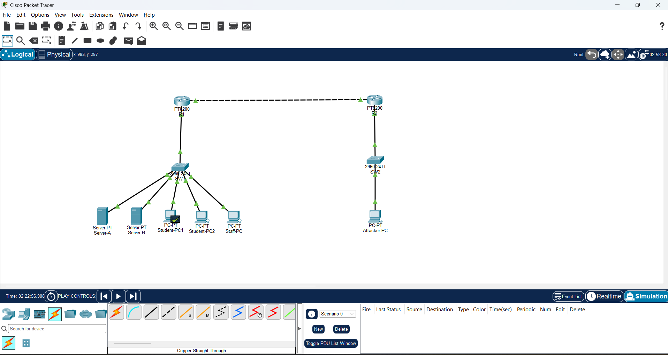
Figure 2. Proposed AI-based intrusion detection workflow
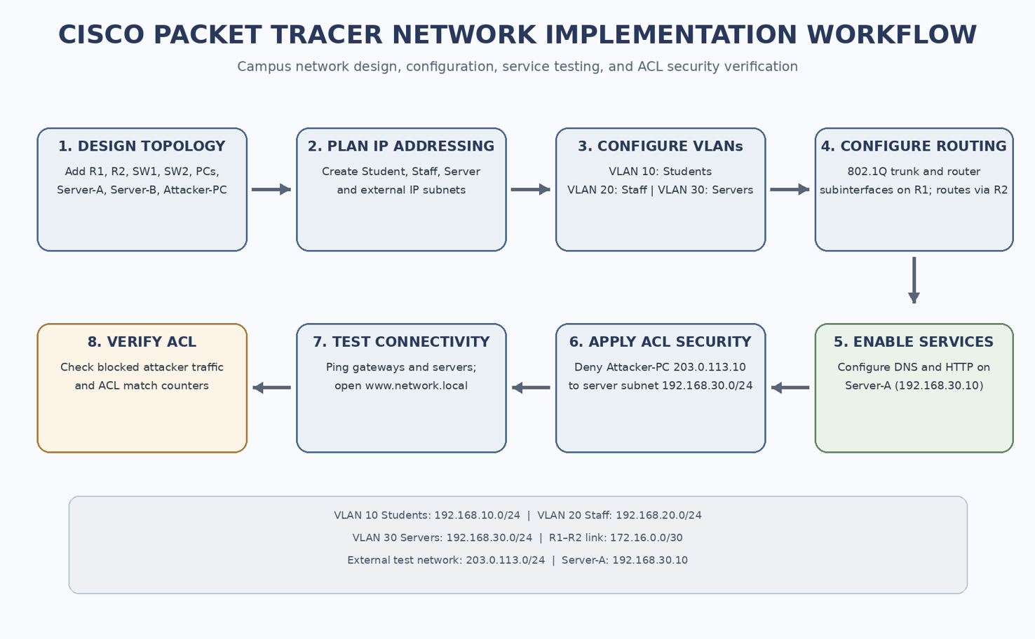

4. IMPLEMENTATION

4.a) Technologies Used
Technology | How it is used in the project
Cisco Packet Tracer | Network topology design and simulation of routers, switches, end devices, and services.
Virtual LAN (VLAN) | Logical separation of Student, Staff, and Server devices.
IEEE 802.1Q trunking | Carries traffic for multiple VLANs over a single trunk link.
Router-on-a-Stick | Uses router subinterfaces to route traffic between VLANs.
Static routing | Provides routes between the campus network and external test network.
DNS and HTTP | Demonstrate name resolution and web-server access.
Extended ACL | Applies a rule to restrict traffic from the external test host to the server subnet.
Python, Pandas, NumPy | Proposed tools for loading and preparing network-flow data.
Scikit-learn | Proposed library for training and evaluating classification models.
Matplotlib / Streamlit | Proposed tools for visualising results and presenting the prototype.

Network Implementation Summary
- Created the campus network using two routers, two switches, two student PCs, one staff PC, two servers, and one external test PC.
- Configured VLAN 10 for Students, VLAN 20 for Staff, and VLAN 30 for Servers on the campus switch.
- Configured router subinterfaces on R1 and enabled 802.1Q encapsulation for the VLANs.
- Configured the point-to-point connection between R1 and R2 and static routes for the external test network.
- Configured Server-A with DNS and HTTP services and verified access through the configured domain name.
- Configured an extended ACL on R1 to deny traffic from Attacker-PC to the server subnet.
- Verified legitimate client connectivity and checked ACL counters to confirm that the deny rule matched traffic.
The above items describe the Packet Tracer work completed and verified during the network simulation. Server-B FTP and email services, port-security settings, and additional attack scenarios should only be included as completed outputs if they are configured and tested in the final project file.

Proposed AI/ML Implementation Methodology
- Select a suitable labelled network-flow dataset and record its source, version, and licence or usage conditions.
- Inspect the dataset to understand the target label, feature meanings, class distribution, missing values, and duplicate records.
- Remove identifiers or fields that could cause target leakage. Fit preprocessing steps only on the training data where required.
- Select relevant numerical and categorical features, such as protocol, flow duration, packet totals, byte totals, packet lengths, and destination port, subject to the chosen dataset.
- Split the dataset into training and testing subsets using a documented method. Use stratification when appropriate for imbalanced classes.
- Train a Decision Tree baseline and a Random Forest classifier using the training data.
- Predict labels for the held-out test data and calculate accuracy, precision, recall, F1-score, and the confusion matrix.
- Review false positives and false negatives. Record the dataset, split, features, model settings, and library versions to make the experiment reproducible.
- Display the final measured results in a notebook or dashboard. Do not enter estimated or illustrative values as experimental results.

4.b) Screenshots and Outputs
Insert clear screenshots from the final saved Packet Tracer project. Each screenshot should show the relevant device, command, or test result. Do not use sample or illustrative screenshots as proof of a completed configuration.
Figure 3. Complete Packet Tracer topology

Figure 4. VLAN configuration on SW1 (show vlan brief)
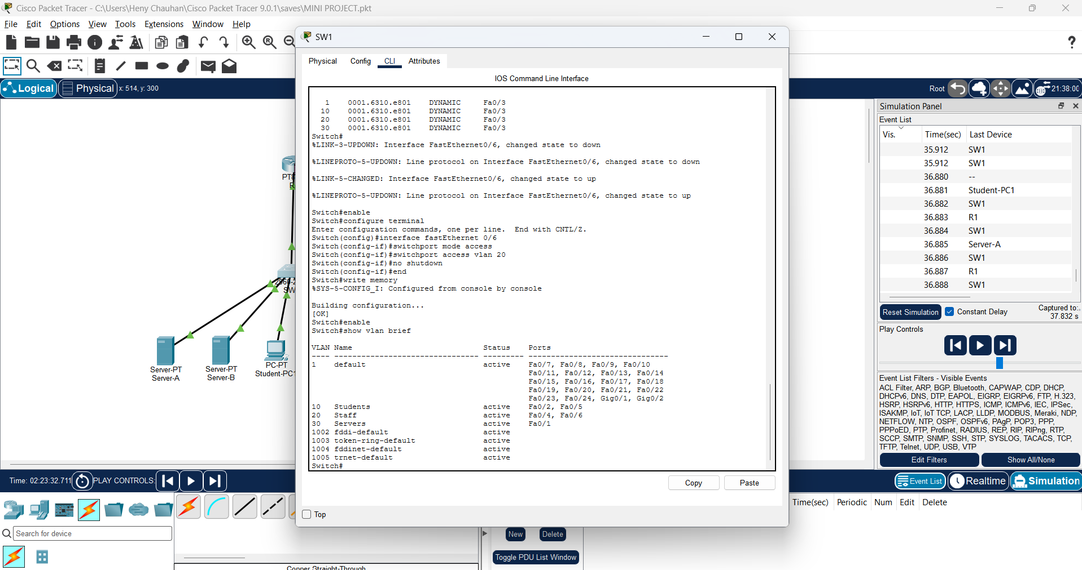

Figure 5. Trunk configuration (show interfaces trunk)
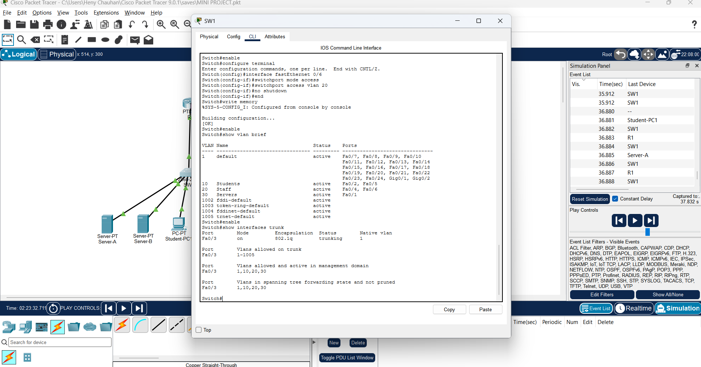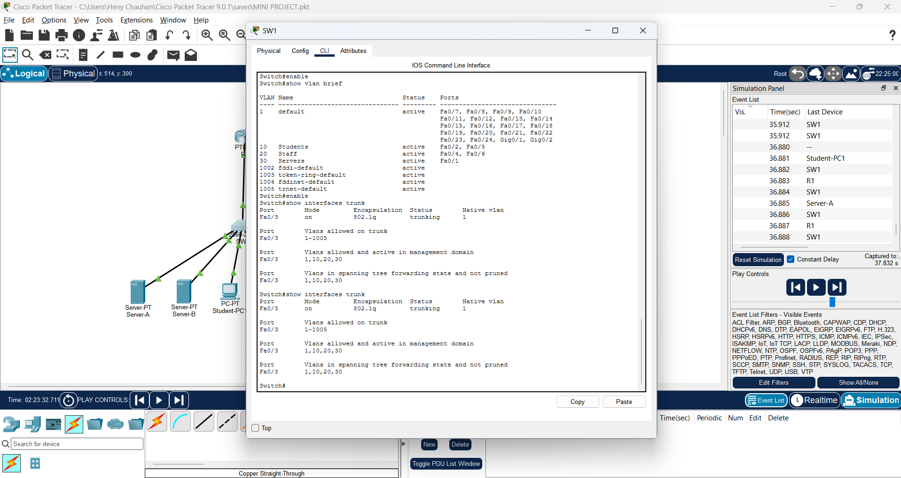

Figure 6. R1 interface status (show ip interface brief)
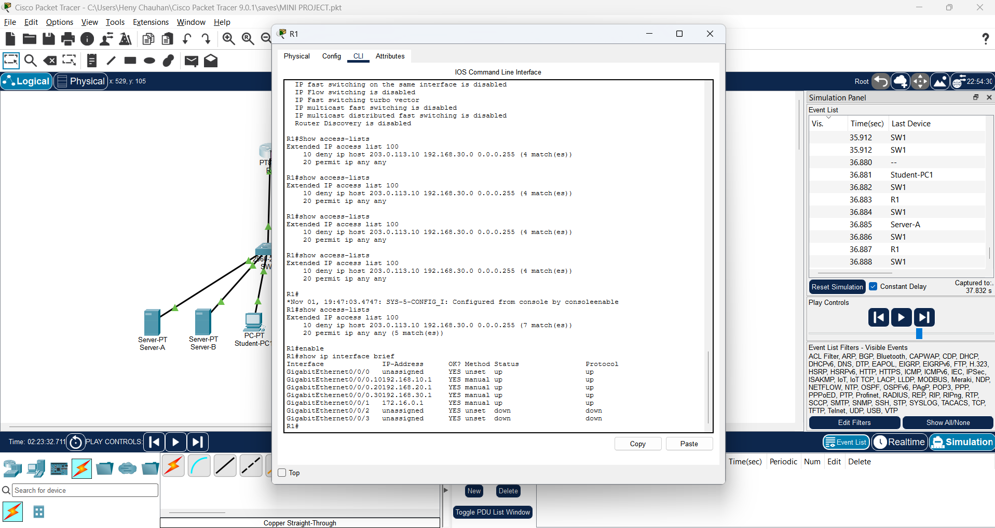

Figure 7. Student-PC connectivity test
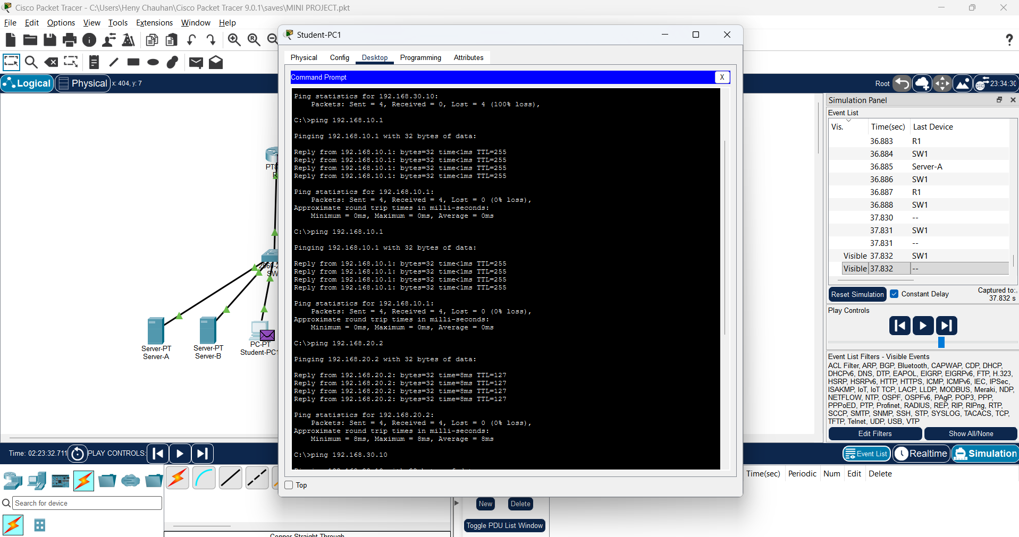

Figure 8. Staff-PC connectivity test
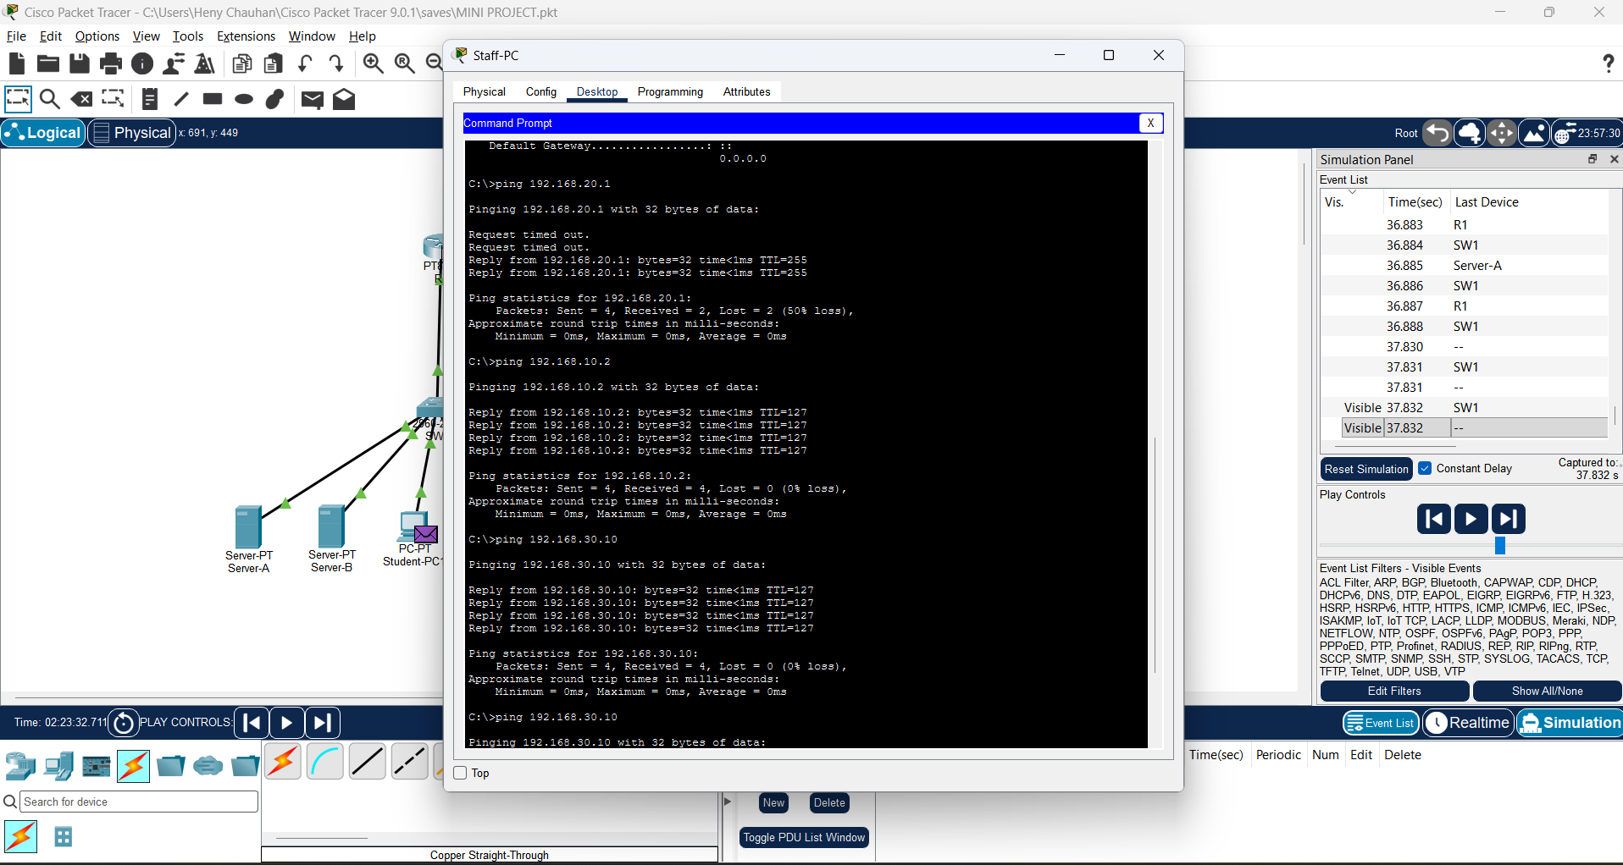

Figure 9. DNS resolution and HTTP website access
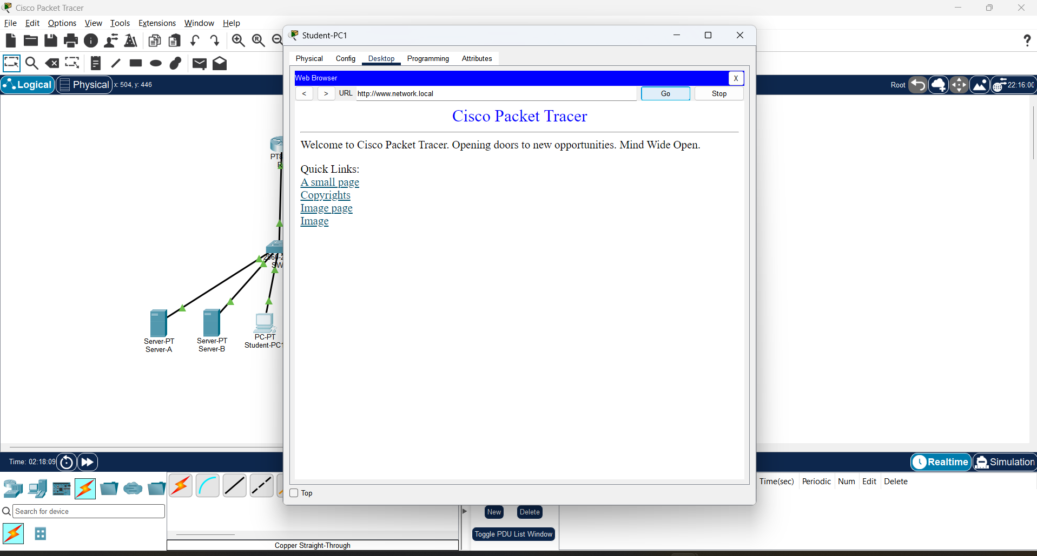
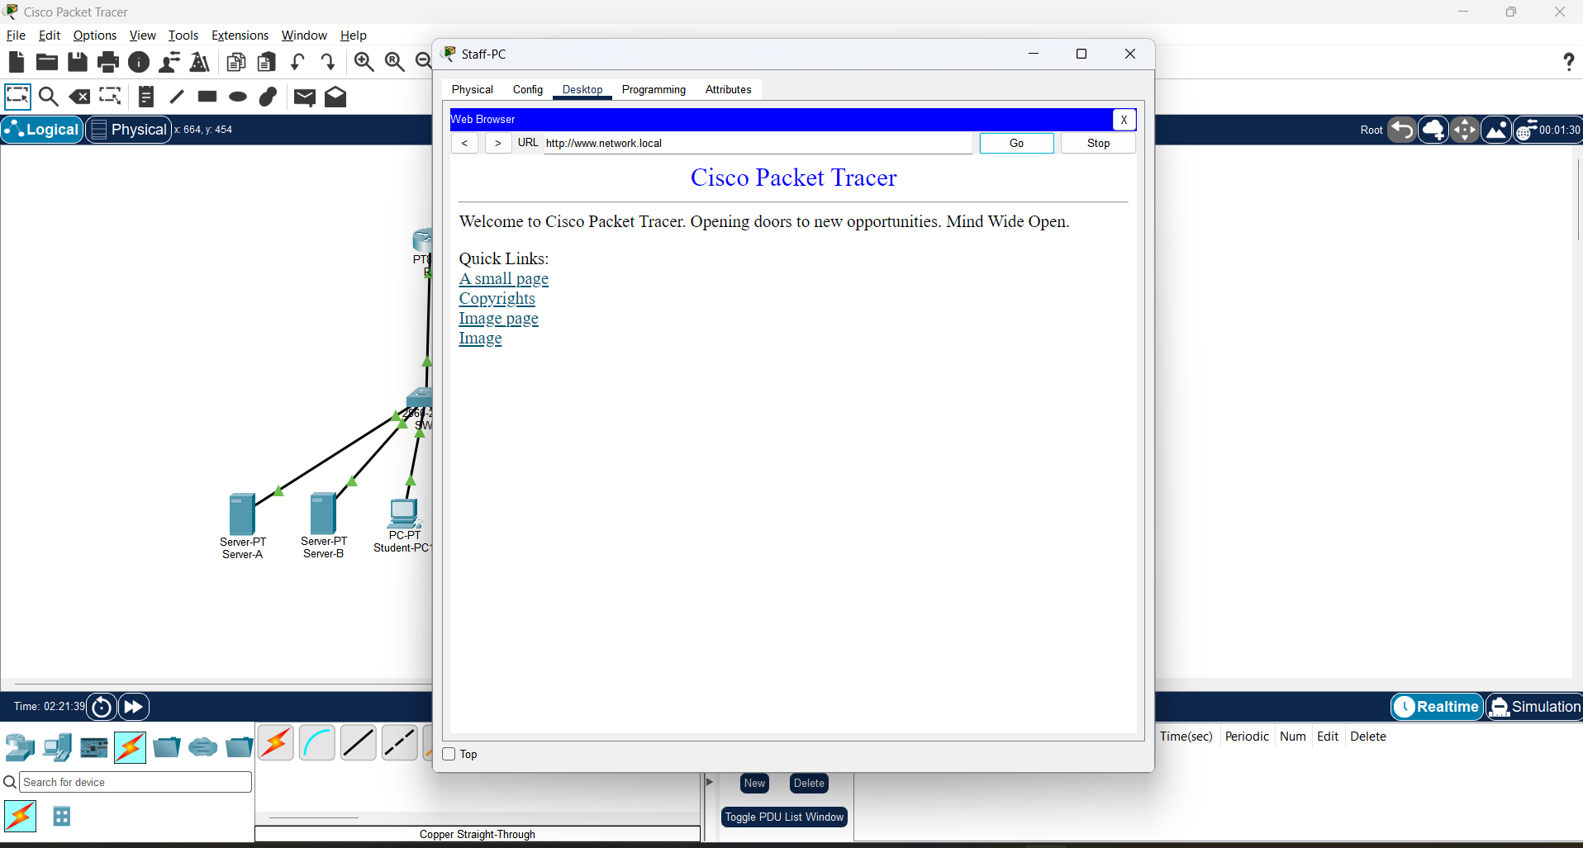

Figure 10. Extended ACL configuration and application
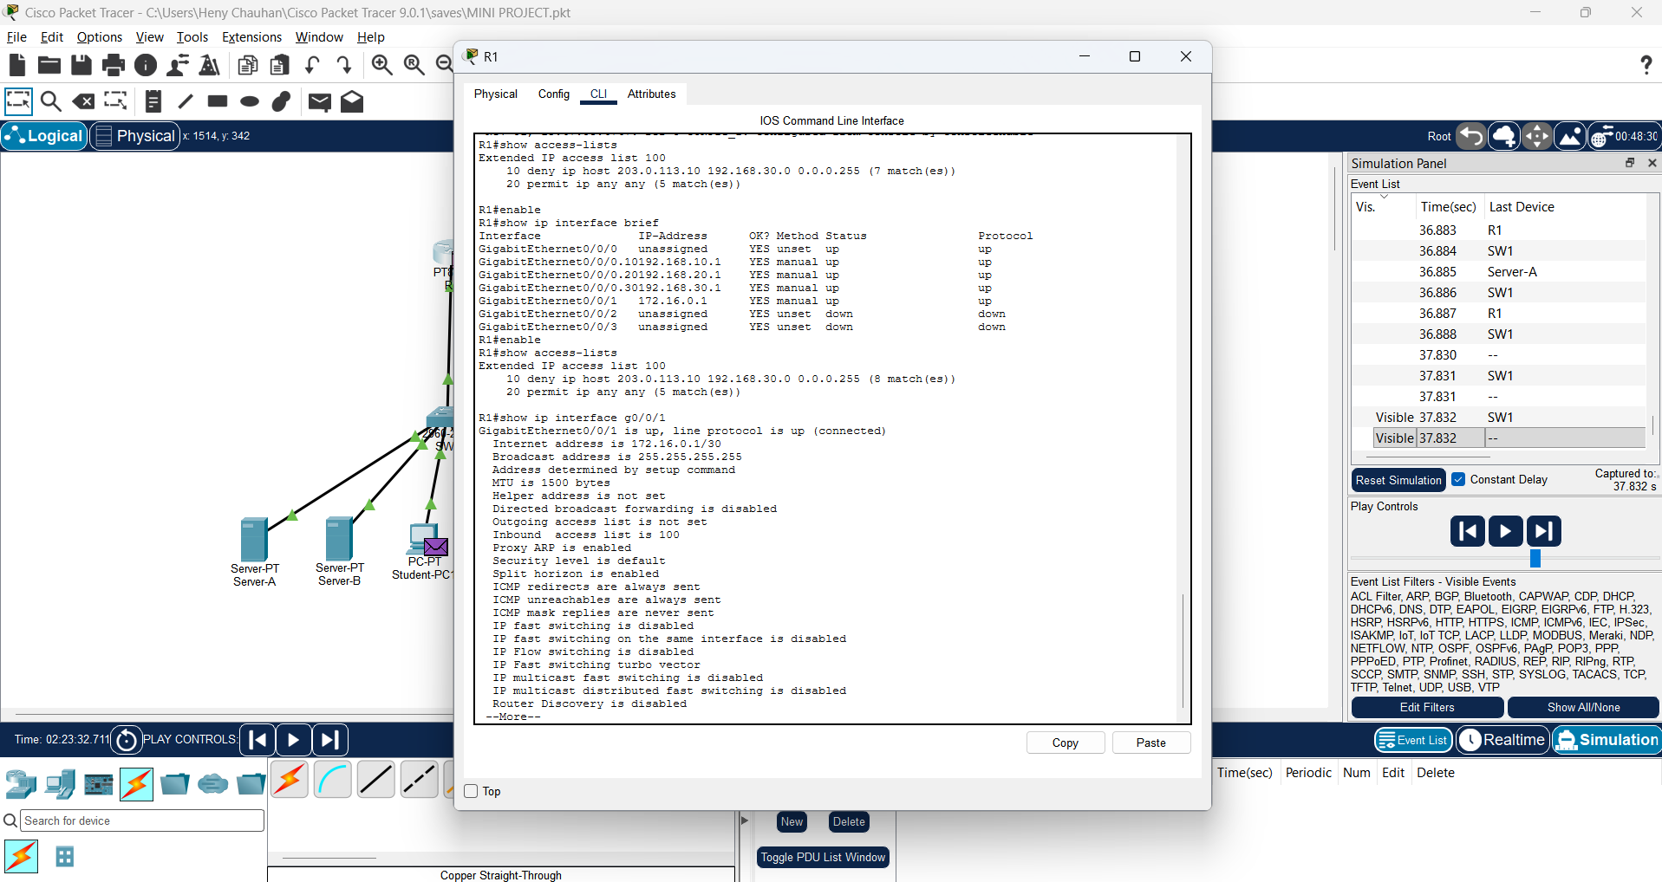

Figure 11. Attacker-PC blocked-access test
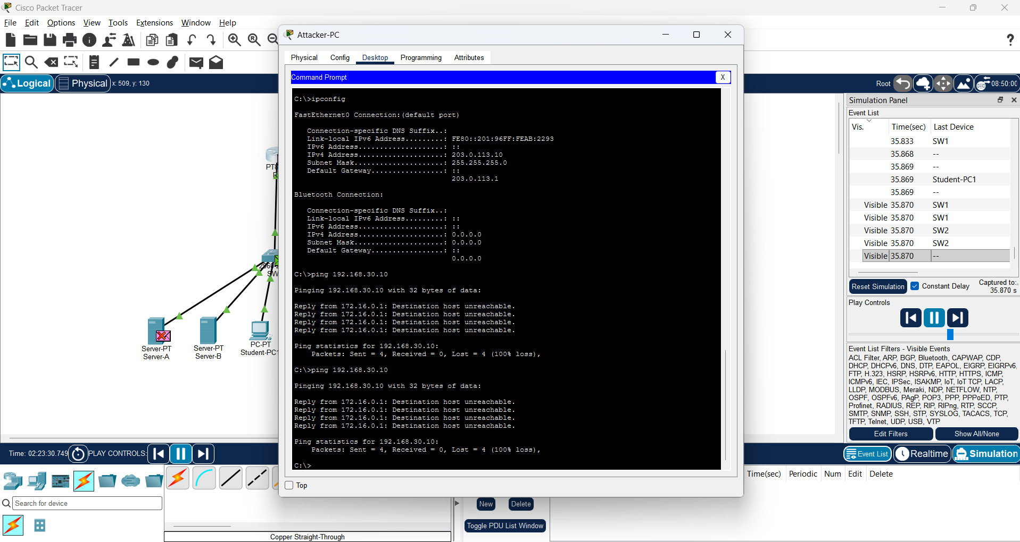

Figure 12. ACL counters (show access-lists)
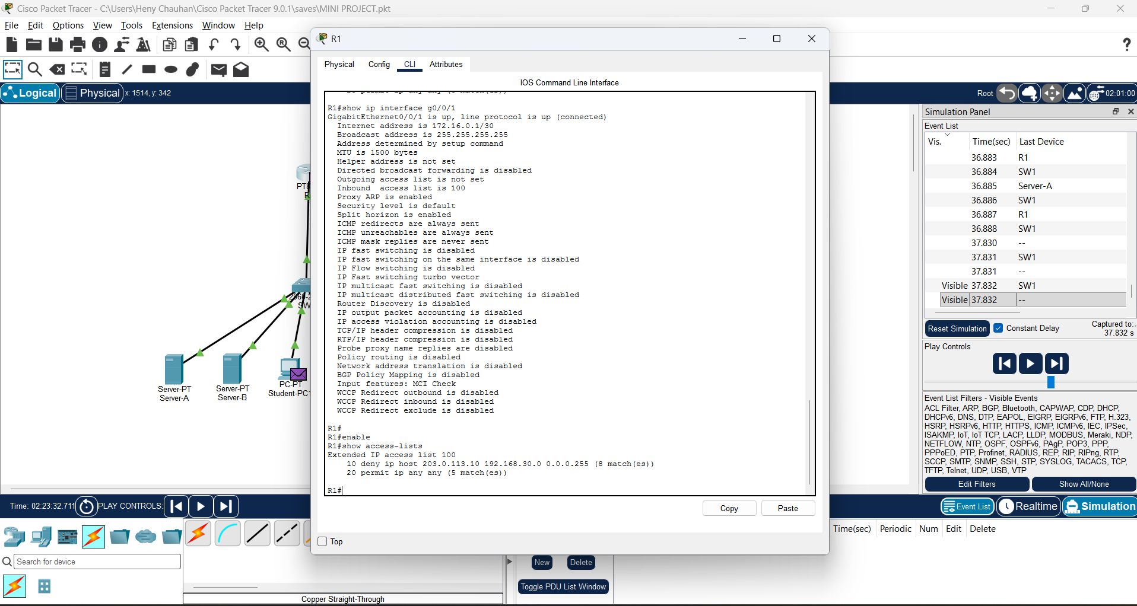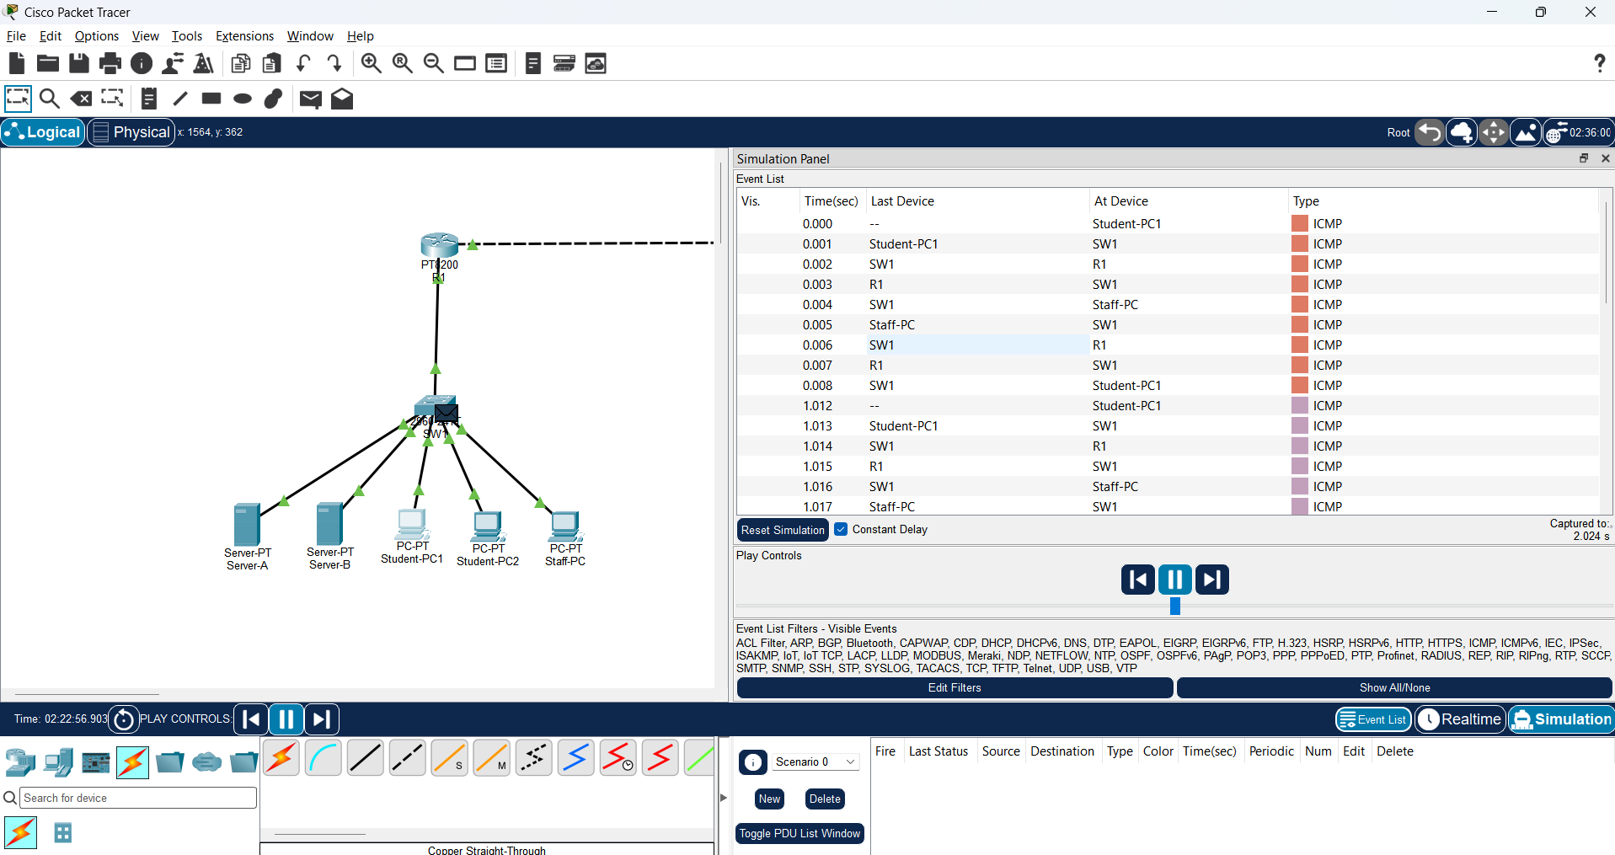
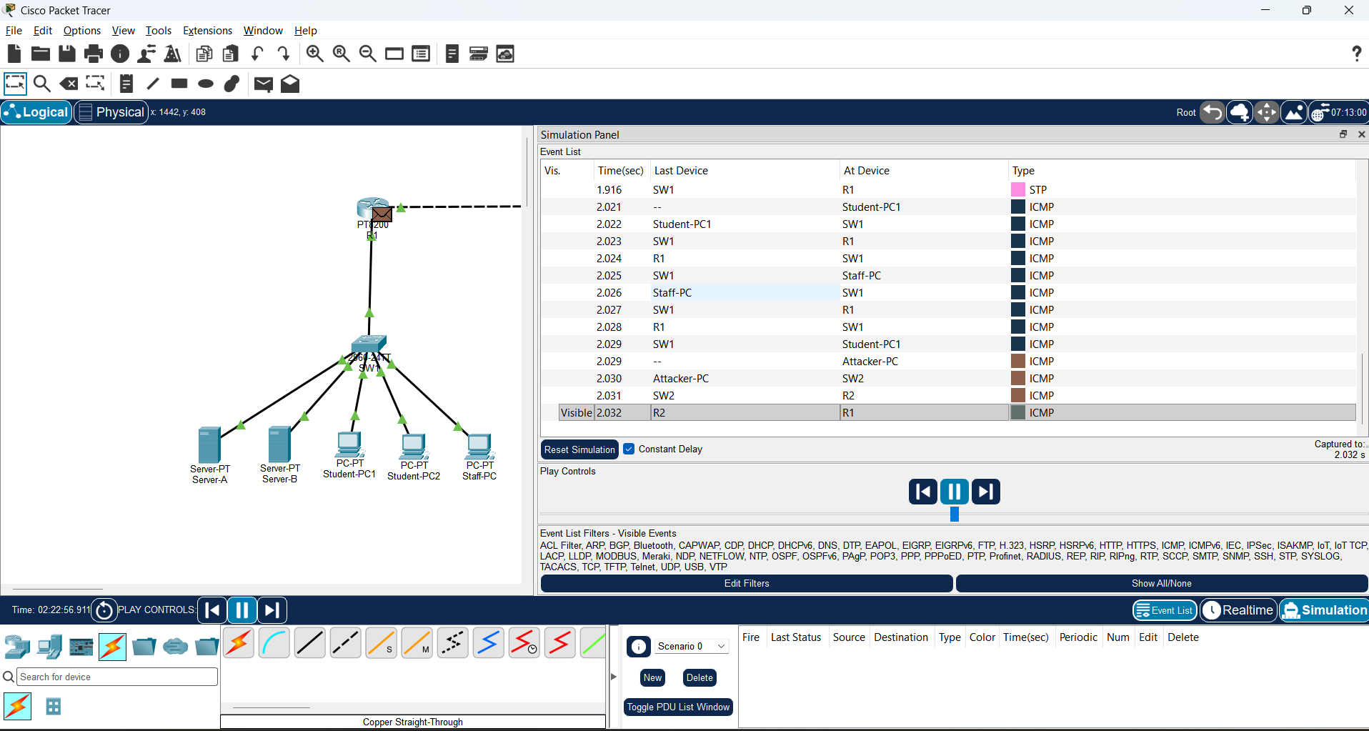
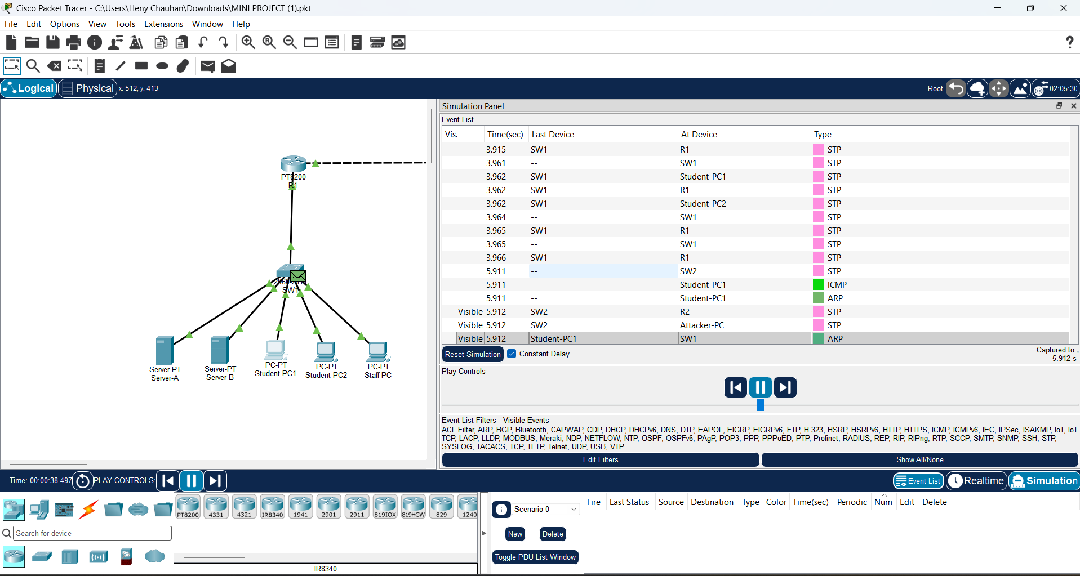

Evaluation Measures for the AI/ML Model
Metric | Meaning in this project
Accuracy | The proportion of all evaluated flows that the model classified correctly.
Precision | Of the flows predicted as Suspicious, the proportion that are actually Suspicious.
Recall | Of all truly Suspicious flows, the proportion correctly identified by the model.
F1-score | The harmonic mean of precision and recall; useful when both missed attacks and false alarms matter.
Confusion matrix | A table showing true and predicted classes, including true positives, true negatives, false positives, and false negatives.

5. CONCLUSION
The project presents an academic prototype for AI-assisted network intrusion detection, supported by a simulated computer-network environment. The Packet Tracer component demonstrates a campus network divided into Student, Staff, and Server VLANs. Router-on-a-Stick routing and 802.1Q trunking provide inter-VLAN communication, while static routing connects the campus to an external test network. DNS and HTTP services demonstrate application access, and an extended ACL is used to restrict the external test host from reaching the server subnet.
The proposed AI/ML component is designed to analyse labelled network-flow features and classify traffic as Normal or Suspicious. Its methodology includes data inspection, preprocessing, train/test separation, classifier training, prediction, and evaluation using standard classification metrics. The network simulation and the AI model serve related but distinct purposes: the Packet Tracer ACL enforces a predefined rule, whereas the machine-learning model is intended to learn patterns from labelled examples.
At the current report stage, the networking simulation has been configured and tested. The AI/ML model results must be added after dataset preparation, model training, and independent testing have been completed. Therefore, this report does not claim measured model accuracy or production-level intrusion detection capability.

6. FUTURE SCOPE
- Complete the Python environment setup and implement the dataset loading and preprocessing pipeline.
- Use a documented dataset such as CIC-IDS2017 after reviewing its official documentation and selecting suitable flow features.
- Train and compare multiple classifiers, including Decision Tree and Random Forest, using a properly separated test set.
- Evaluate class imbalance, false-positive rate, false-negative rate, and performance on attack categories.
- Add explainability or feature-importance analysis to help users understand why a flow was flagged.
- Develop a Streamlit dashboard to show traffic summaries, predictions, evaluation charts, and selected suspicious records.
- Explore authorised traffic capture or supported flow-export methods for future live or near-real-time analysis.
- Test the model on a separate dataset or later time period to assess generalisation and reduce the risk of overly optimistic results.
- Apply privacy and ethical safeguards when handling network data, including permission, minimisation, and secure storage.

REFERENCES
- Canadian Institute for Cybersecurity, University of New Brunswick. CIC-IDS2017 Dataset and documentation. (Consult the official dataset documentation and record the access date before final submission.)
- Scikit-learn Developers. Scikit-learn User Guide: Random Forests and Model Evaluation. https://scikit-learn.org/stable/user_guide.html
- Cisco Networking Academy. Cisco Packet Tracer learning and simulation resources. (Add the exact resource or course material used.)
- Wireshark Foundation. Wireshark User’s Guide. https://www.wireshark.org/docs/
- Computer Networks course notes and laboratory materials provided by the faculty. (Add the exact unit or experiment references used.)

— END OF REPORT —

