**ex3-0**

#!/bin/sh

echo "hello world"

exit 0

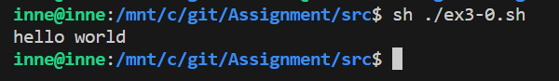

**ex3-1**

#!/bin/sh

n=$1

if [ -z $n ] ; then

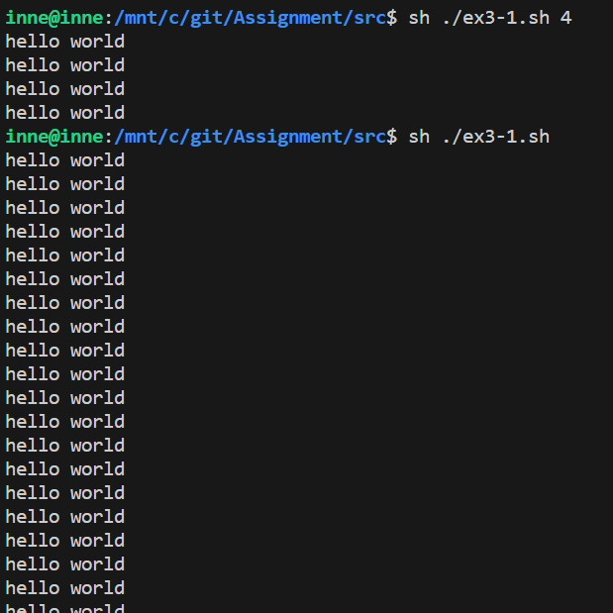 while [ 1 ]

do

echo "hello world"

done

else

while [ $n -gt 0 ]

do

echo "hello world"

n=$(($n-1))

done

fi

exit 0

**ex3-2**

#!/bin/sh

n=`expr $1 $2 $3`

echo $n

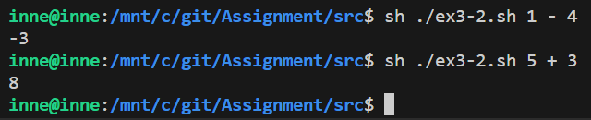exit 0

**ex3-3**

#!/bin/sh

bmi=`expr $1 \* 100000 / \( $2 \* $2 \)`

if [ $bmi -lt 185 ] ; then

echo "저체중입니다."

elif [ $bmi -ge 230 ] ; then

echo "과체중입니다."

else

echo "정상체중입니다."

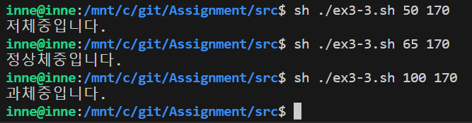fi

exit 0

**ex3-4**

#!/bin/sh

echo "리눅스가 재미있나요? (yes / no)"

read answer

case $answer in

yes | y | Y | Yes | YES)

echo "yes";;

no | n | N | No | NO | noooo | nono)

echo "no";;

*)

echo "yes 또는 no로 입력해 주세요."

exit 1;;

esac

exit 0

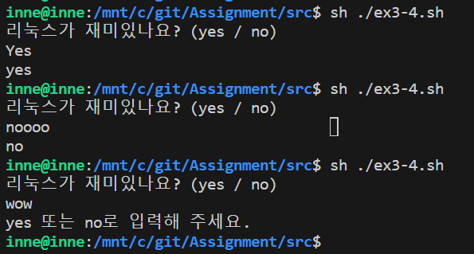

**ex3-5**

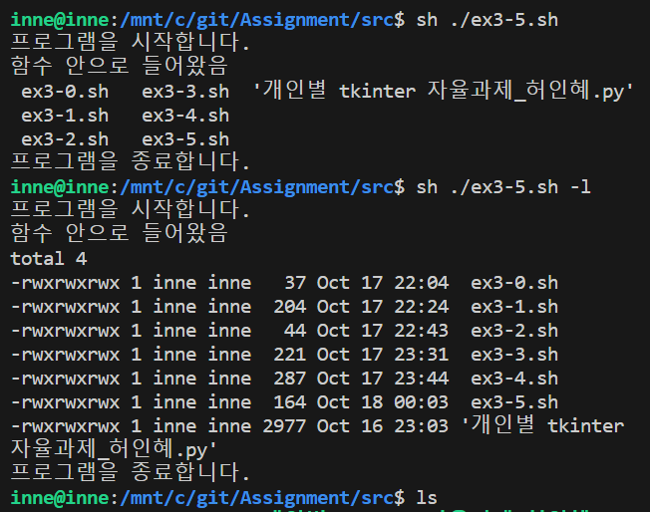#!/bin/sh

cf(){

echo "함수 안으로 들어왔음"

ls $1

}

echo "프로그램을 시작합니다."

cf $1

echo "프로그램을 종료합니다."

exit 0

**ex3-6**

#!/bin/bash

if [ ! -d "$1" ]; then

mkdir $1

cd $1

i=0

while [ $i -lt 5 ]

do

touch "file$i.txt"

i=$((i + 1))

done

tar cvf $1.tar file0.txt file1.txt file2.txt file3.txt file4.txt

mkdir $1

mv $1.tar $1

cd $1

tar xvf "$1.tar"

fi

exit 0

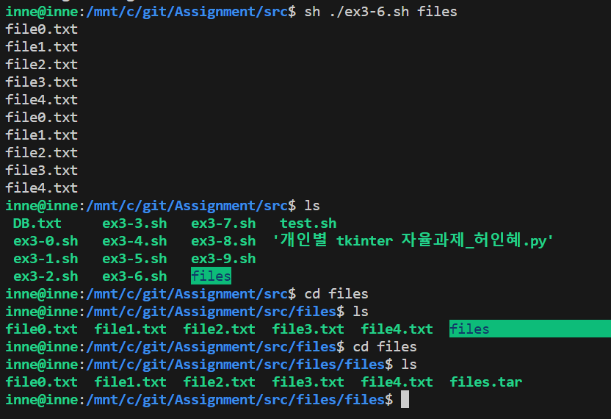

**ex3-7**

#!/bin/bash

if [ ! -d "$1" ]; then

mkdir $1

cd $1

i=0

while [ $i -lt 5 ]

do

mkdir file$i

touch file$i.txt

ln -s file$i.txt file$i/file$i.txt

i=$((i + 1))

done

fi

exit 0

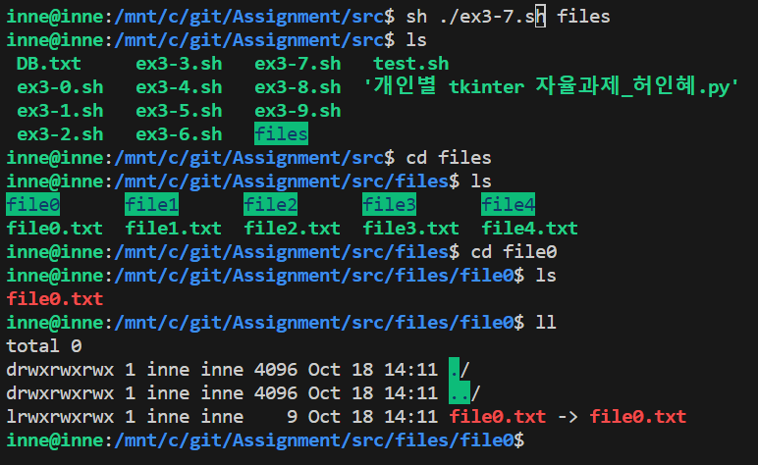

**ex3-8**

#!/bin/bash

echo "$1 $2" >> DB.txt

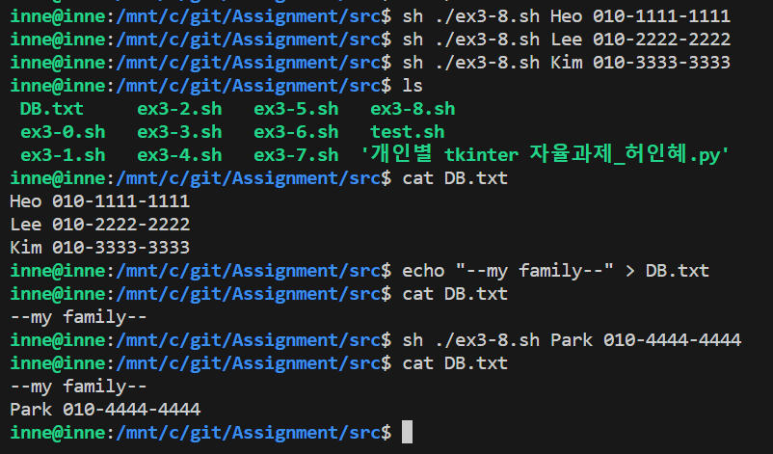exit 0

**ex3-9**

#!/bin/bash

grep -i $1 DB.txt

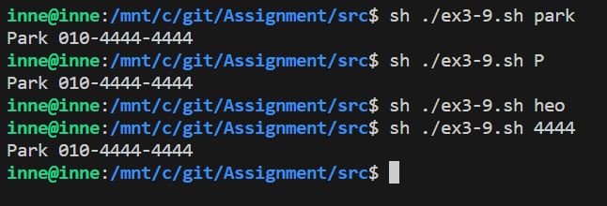exit 0