The code of UI and test can be found here - https://github.com/Heorhi-Puhachou/java-playwright-cucumber

CUCMBER BASE

Now developers have a lot different instruments to test code. Here is no universal best solution so I will just describe my experience that can be useful for you.

My last project was related to reusing exited codebase (some kind of engine) and adapting this one to customer purposes. It means that we didn't test base functionality and mostly concentrated on addons that are mostly available on UI. And we created UI-test for this. The project has a standard for testing: they must be created on Java with Cucumber and Playwright libraries.

Cucumber is a good instrument to describe tests by human language. You have a line that looks like usual text and this line is related to a method that has logic to check. These lines can be combined for specific scenarios, but one line can be used in other scenarios. Also, you can use variables in lines because it is the method that can use params.

@browser
Scenario: Check elements on second page
When load third page
And wait loader is not shown
Then list "LIST NAME" contain records
| position | value |
###########################
| 1 | First value |
| 2 | Second value |
| 3 | Third value |

@Then("list {string} contain records")
public void checkPackageQuantity(String listName, DataTable dataTable) {
List<ElementHandle> listsByName = thirdPage.getListsByName(listName);
assertEquals(1, listsByName.size());
ElementHandle listToCheck = listsByName.get(0);
List<Map<String, String>> rows = dataTable.asMaps(String.class, String.class);
thirdPage.checkListElements(listToCheck, rows);
}

PLAYWRIGHT BASE
But most interesting part related to Playwright. It is library that allowed navigate through brouser UI and check-click-wait elements on the page.

We need some preparation before start use it. You can see @browser annotation for Cucumber scenario. It is for BeforeHook that allowed us perform some actions before scenario starting. And here we inizialize our Playwright related entities:

@Before(value = "@browser")
public void preparePlaywright() {
UIContext uiContext = UIContext.getInstance();
uiContext.setPlaywright(Playwright.create());
BrowserType.LaunchOptions browserOptions = new BrowserType.LaunchOptions()
.setArgs(Arrays.asList("--use-fake-ui-for-media-stream", "--use-fake-device-for-media-stream"))
.setHeadless(HEADLESS);
Browser browser = uiContext.getPlaywright().chromium().launch(browserOptions);
BrowserContext browserContext = browser.newContext();
browserContext.setDefaultTimeout(TIMEOUT);
uiContext.setBrowserContext(browserContext);
Page page = uiContext.getBrowserContext().newPage();
uiContext.setPage(page);
}
We created Playwright instance, after that we started browser from it and in the end we opened new pages. One small but important boolean parameter – HEADLESS. This flag defined will be started browser visible until end of the test. On my local machine I use «false» to see what happened. It is very usefull in debug mode. But if you need just fast start all tests and get result «try» will be better.

Feature: First page
@browser
Scenario: Check elements on first page
When load first page
And wait loader is not shown
Then text "First page" is visible
And button "GO TO SECOND PAGE" is visible
And button "GO TO THIRD PAGE" is visible

So lets start our UI-checking. We have address (http://localhost:3000/firstPage for my example) and we need check content of page.

protected void navigateFromBaseUrl(String pagePath) {
Page page = getPage();
String pageUrl = BASE_URL + pagePath;
page.navigate(pageUrl);
}

We created Page instance with BeforeHook and now we can go to address with navigate method. Page not loaded immediatly. And here is very important how loading implemented on UI. I think that best variant is preloader that is visible when page is loading and dissapear when all data is ready. In this case we must check by Playwright tools that preloader is hidden. Or we can wait until needed element is visible.

If we just nedd wait element

getPage().waitForSelector(buttonSelector)
If we are waiting for state
getPage().waitForSelector(buttonSelector).waitForElementState(ElementState.DISABLED);
But here we can see argument – buttonSelector. So selectors are special strings that decides what kind of element we need to check\click\wait

@Then("button {string} is visible")
public void checkButtonVisible(String text) {
String textElementLocator = "button >> text=" + text;
getPage().waitForSelector(textElementLocator);
}

Here selector has 2 levels. On first level we decide that we need button. Our page can contains more than one button. To search concrete one we decide inner level – button must contain specific text.

We can decide a lot of levels and go to back on top level by >> ..
Here is example of more difficult selector:
String rowSelector = "li " +
">> div[test-locator='position'] " +
">> text=" + position +
">> .. " +
">> div[test-locator='value'] " +
">> text=" + value;

Here we check all <li> elements, that have special inner div with specific mark test-locator='position' and this div must has specific text. After that we go to level up to check div on same level but with other specific locator test-locator='value' and specific text.
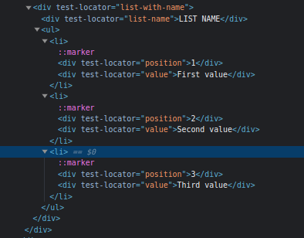
This specific locator is very usefull for testing. When we created UI components we added special technical attribute to search components easier. For my demo it is «test-locator» attribute. HTML from demo:

By values on page and technical atributes we can easy find any element on page. But it isn“t enough for a testing. To perform actions we need fill fields and click buttons.

We can fill field by locator
// Fill [placeholder="Username"]
getPage().fill("[placeholder=\"Username\"]", username);

Or we can find field element and fill it later
getPage().waitForSelector(searchCustomerInputSelector).fill(customerName);
Same for click:
getPage().click(buttonSelector);

Most important here to be sure that element is available. More safe will be wait firstly
getPage().waitForSelector(buttonSelector).click();

But what if we don“t need action right now? We can store finded element or elements for future manipulations. As storage for finded elements used objects of class ElementHandle

It is type that returned from waitForSelector it means that you can call click() or fill() methods for this object. You also can search inner elements for this objects like for page.

public void checkListElements(ElementHandle listToCheck, List<Map<String, String>> rows) {
listToCheck.querySelectorAll("li").size();
...
}

If you need just find element by selector you can use querySelector

getPage().querySelector(testSelector);

But if more than one element will match to provided selector will be returned first one. To get all elements by selector you can use querySelectorAll
public List<ElementHandle> getListsByName(String listName) {
return getPage().querySelectorAll("div[test-locator='list-name'] >> .. >> ul");
}

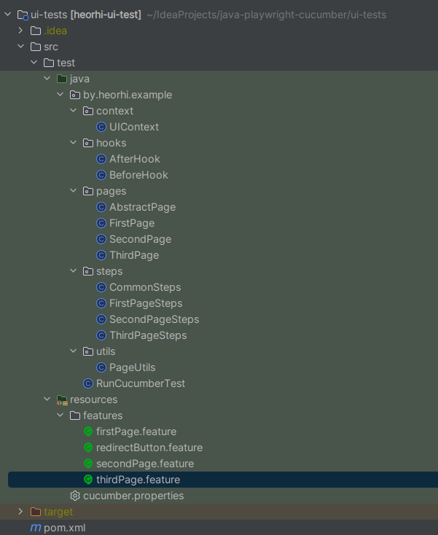
TEST PROJECT STRUCTURE
How to separate logical entities for project with Java, Cucumber and Playwright?

All started from scenarios. We describe our steps by human-language in ***.feature file
Lets check firstPage.feature

Feature: First page
@browser
Scenario: Check elements on first page
When load first page
And wait loader is not shown
Then text "First page" is visible
And button "GO TO SECOND PAGE" is visible
And button "GO TO THIRD PAGE" is visible
As we discussed before each line of scenario is method. Those methods are placed in Steps-classes. FirstPage specific steps are placed in FirstPageSteps, common – in CommonSteps.
public class FirstPageSteps {
private static final FirstPage firstPage = new FirstPage();
@Given("load first page")
public void loadFirstPage() {
firstPage.openPage();
}
}

public class CommonSteps {
private Page getPage() {
return UIContext.getInstance().getPage();
}
@And("wait loader is not shown")
public void waitLoaderIsNotShown() {
PageUtils.waitForElementNotThere(getPage(), "div.preloader");
}
@Then("text {string} is visible")
public void checkTextVisible(String text) {
String textElementLocator = "text=" + text;
getPage().waitForSelector(textElementLocator);
}
@Then("button {string} is visible")
public void checkButtonVisible(String text) {
String textElementLocator = "button >> text=" + text;
getPage().waitForSelector(textElementLocator);
}
@Then("click button {string}")
public void clickButton(String text) {
String textElementLocator = "button >> text=" + text;
getPage().waitForSelector(textElementLocator).click();
}
}

Steps class can contain logic more than for one page. Page specific logic placed in page classes that has one parent with some overal details:
public class ThirdPage extends AbstractPage {
public void openPage() {
this.navigateFromBaseUrl("thirdPage");
}
public List<ElementHandle> getListsByName(String listName) {
return getPage().querySelectorAll("div[test-locator='list-name'] >> .. >> ul");
}
public void checkListElements(ElementHandle listToCheck, List<Map<String, String>> rows) {
listToCheck.querySelectorAll("li").size();
for (Map<String, String> row : rows) {
String position = row.get("position");
String value = row.get("value");
String rowSelector = "li " +
">> div[test-locator='position'] " +
">> text=" + position +
">> .. " +
">> div[test-locator='value'] " +
">> text=" + value;
List<ElementHandle> elementsForRow = listToCheck.querySelectorAll(rowSelector);
assertEquals(1, elementsForRow.size());
}
}
}

public class AbstractPage {
private static final String BASE_URL = "http://localhost:3000/";
protected void navigateFromBaseUrl(String pagePath) {
Page page = getPage();
String pageUrl = BASE_URL + pagePath;
page.navigate(pageUrl);
}
protected Page getPage() {
return UIContext.getInstance().getPage();
}
}

Logic that not related to specific page or step can be placed to utils class

public class PageUtils {
public static boolean waitForElementNotThere(Page page, String selector) {
int i = 0;
do {
try {
Thread.sleep(500);
page.waitForSelector(selector, new Page.WaitForSelectorOptions().setTimeout(1000));
System.out.println("Element is there: " + selector);
i++;
} catch (Exception e) {
System.out.println("Element is not there: " + selector);
return true;
}
} while (i < 30);
return false;
}
}

This simple structure is enough to create test on UI. Adding new one scenario will be easier in compare with previous because structure is defined and clear and some logic can be reused.

