CALORIES BURN
PREDICTION MODEL
Machine Learning Regression using XGBoost
PROJECT REPORT
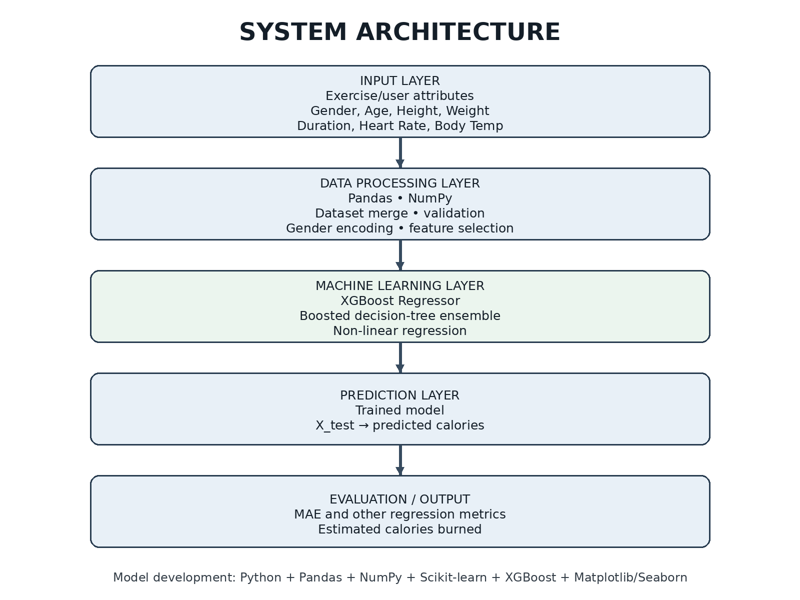
Python • Pandas • NumPy • Scikit-learn • XGBoost
Prepared as a structured technical report based on the supplied Calories Burn Prediction Model notebook.

1. Problem Statement
People often want to estimate how many calories are burned during an exercise session, but the value depends on several interacting factors such as age, body measurements, exercise duration, heart rate and body temperature. A fixed calorie estimate cannot represent these differences accurately.
The project develops a supervised Machine Learning regression model that learns the relationship between exercise-related inputs and the measured calorie value. The supplied notebook combines the exercise and calories datasets and trains an XGBoost Regressor to predict calories burned.

Project Objectives
- Build a clean dataset by combining exercise attributes with the calorie target.
- Explore the dataset using descriptive statistics and visualizations.
- Convert categorical gender information into numerical form suitable for the model.
- Use relevant exercise and physiological attributes as prediction features.
- Train an XGBoost regression model on 80% of the data.
- Evaluate predictions on unseen test data using Mean Absolute Error (MAE).

2. Proposed Solution
The proposed solution is an end-to-end regression pipeline. User/exercise attributes are prepared as model inputs, the trained XGBoost model estimates calories burned, and the prediction is evaluated against the actual calorie value.
Stage | Purpose | Main Technique
Data Integration | Combine exercise attributes with calorie labels | Pandas concat
Exploratory Analysis | Understand distributions, statistics and relationships | Pandas + Seaborn
Preprocessing | Convert categorical data to numerical values | Gender encoding
Feature Selection | Separate inputs from prediction target | X / Y separation
Training | Learn the mapping from inputs to calories | XGBRegressor
Evaluation | Measure prediction error on unseen data | MAE

3. Dataset Description
The supplied notebook works with 15,000 exercise records and 9 columns after combining the datasets. User_ID is retained in the combined data for identification but is removed before model training.
Feature | Type / Meaning | Role
User_ID | Integer identifier | Dropped before training
Gender | Categorical: male/female | Input feature; encoded 0/1
Age | Numeric, years | Input
Height | Numeric, cm | Input
Weight | Numeric, kg | Input
Duration | Numeric, minutes | Input
Heart_Rate | Numeric, bpm | Input
Body_Temp | Numeric, °C | Input
Calories | Numeric | Target
Dataset dimensions reported in the notebook: 15,000 rows × 9 columns. The notebook's missing-value check reports no missing values for the listed columns.

4. SYSTEM WORKFLOW DIAGRAM
The workflow below expands the notebook into a clear system-level pipeline, while keeping the actual implemented steps and values from the supplied model.
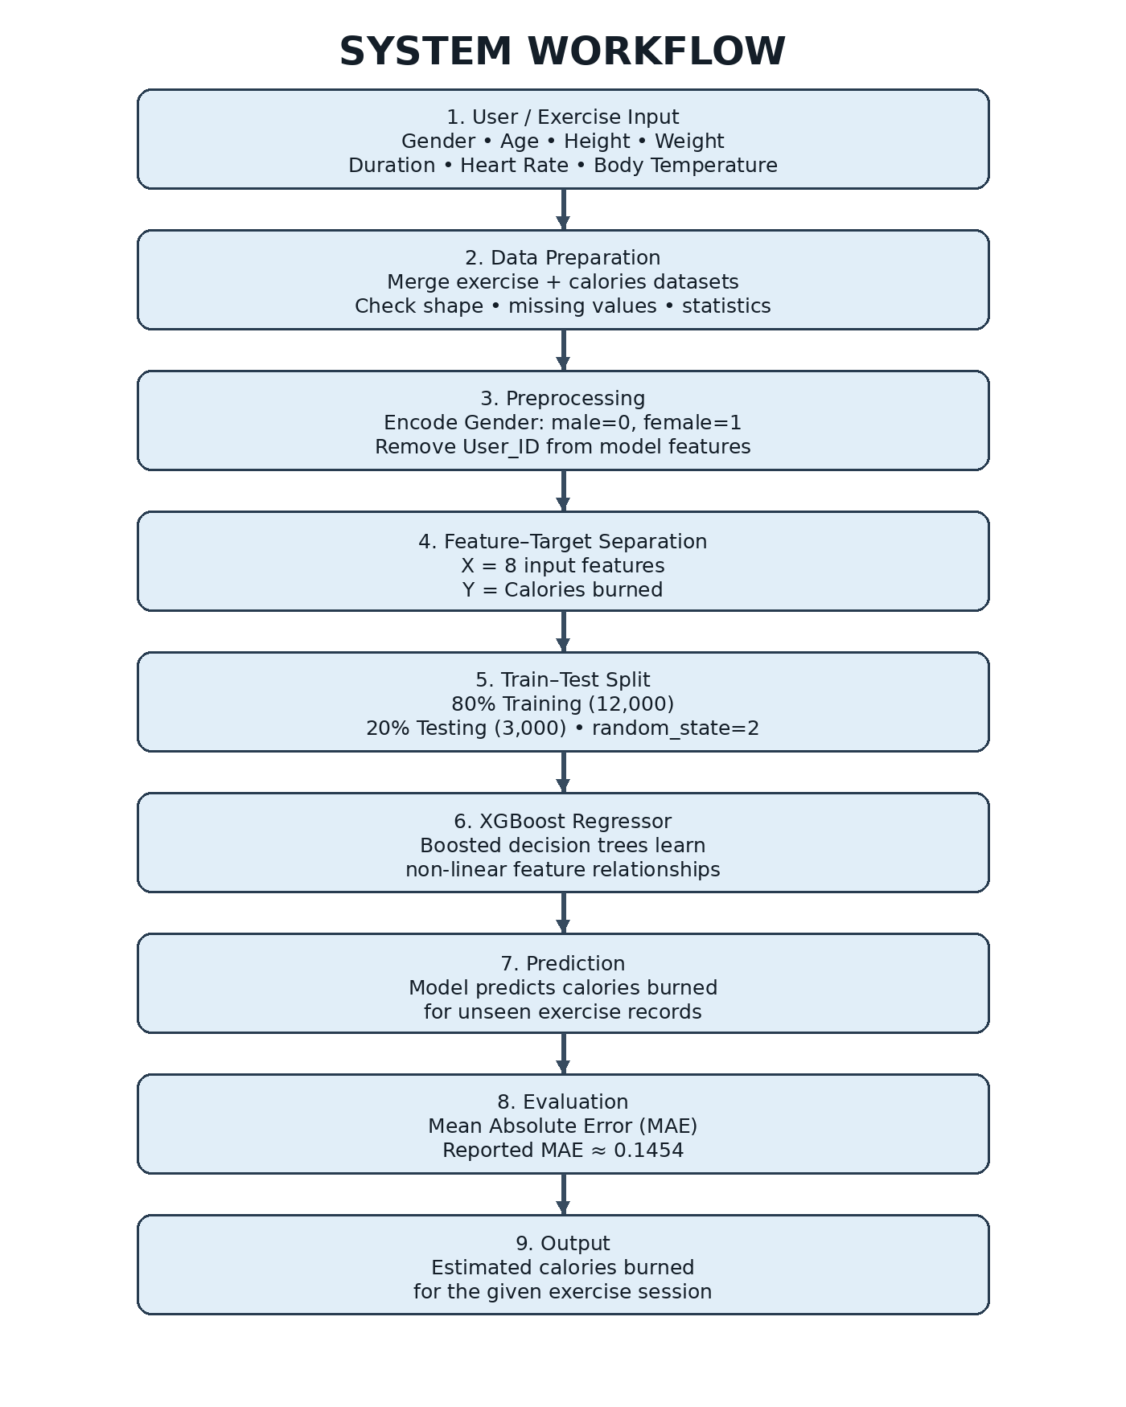
Figure 1. System workflow for calories-burn prediction.

Workflow Explanation
- Input: exercise/user information such as gender, age, height, weight, duration, heart rate and body temperature is available.
- Data preparation: the exercise and calories tables are combined column-wise using Pandas.
- Exploratory analysis: shape, data types, missing values, descriptive statistics, distributions and correlation are inspected.
- Encoding: gender is converted from text into numerical values (male = 0, female = 1).
- Feature-target separation: User_ID is dropped; the remaining 8 variables form X, while Calories forms Y.
- Data split: train_test_split uses 80% training data and 20% test data with random_state=2.
- Model training: XGBRegressor is fitted on X_train and Y_train.
- Prediction and evaluation: the trained model predicts Y_test and the predictions are evaluated using MAE.
- Output: the system produces a numerical estimate of calories burned for an exercise record.

5. SYSTEM ARCHITECTURE DIAGRAM
Figure 2. Layered architecture of the Calories Burn Prediction system.

6. CORE CONCEPTS USED

6.1 Supervised Machine Learning
Supervised learning uses labelled examples. Here, each exercise record has input features and a known Calories value. The model learns from these examples and then predicts the target for unseen records.

6.2 Regression
Calories burned is a continuous numerical value, so the task is a regression problem rather than a classification problem. The output can be a value such as 66, 127.1 or 223.7 rather than a class label.

6.3 Gradient Boosting
XGBoost belongs to the gradient-boosted decision-tree family. Instead of depending on one tree, it builds a sequence of trees where later trees focus on reducing the errors made by the existing ensemble. This makes it effective for structured/tabular data and non-linear relationships.

6.4 XGBoost Regressor
The notebook imports XGBRegressor from the xgboost library and trains it directly using X_train and Y_train. The supplied notebook does not show custom hyperparameter tuning; therefore, this report does not claim that a tuned configuration was used.

6.5 Feature Engineering and Encoding
The main preprocessing operation shown is categorical encoding of Gender. The model then uses eight input variables after removing User_ID. In a production version, additional feature engineering could be investigated experimentally, but such features are not claimed as part of the supplied implementation.

6.6 Correlation Analysis
A correlation matrix is generated for the numerical variables. This provides an exploratory view of linear relationships among variables and Calories; it is useful for understanding the dataset but does not by itself prove causation.

7. MODEL TRAINING ALGORITHM

XGBoost Training Process
1. Load the prepared dataset.
2. Separate model features (X) and target (Y = Calories).
3. Split the data into training and test sets using an 80:20 ratio.
4. Initialize XGBRegressor().
5. Fit the model using X_train and Y_train.
6. Generate predictions for X_test.
7. Calculate Mean Absolute Error by comparing predicted and actual calories.

Why XGBoost is relevant here
- It can model non-linear relationships between physiological/exercise inputs and calorie expenditure.
- It works naturally with structured tabular data.
- An ensemble of boosted trees can capture interactions among multiple input variables.
- The model provides a direct numerical prediction, matching the regression nature of the problem.

8. EXPERIMENTAL RESULTS
The supplied notebook reports the following implementation-level results. These values should be distinguished from future targets or expected production performance.
Item | Reported Value
Total records | 15,000
Total columns | 9
Training records | 12,000 (80%)
Testing records | 3,000 (20%)
Input features used | 8
Target | Calories
Model | XGBRegressor
Split random_state | 2
Evaluation metric | Mean Absolute Error (MAE)
Reported MAE | ≈ 0.1453538559

8.1 Understanding MAE
Mean Absolute Error is the average absolute difference between actual and predicted values. In simple terms, it answers: 'On average, how far is the prediction from the actual value?' Lower MAE indicates smaller average absolute prediction error. The notebook reports an MAE of approximately 0.1454 on the test predictions.

8.2 Prediction Examples
The notebook displays test-set predictions such as approximately 127.08, 223.70, 38.02, 144.86, 23.97 and 90.01 calories. These are examples of model outputs, not a separate validation benchmark.

9. EXPECTED RESULT
After successful training, the system is expected to accept the eight model features and return an estimated calorie-burn value. The immediate experimental result demonstrated in the supplied notebook is a trained XGBoost regression model with test-set predictions and a reported MAE of approximately 0.1454.
- Numerical calorie prediction for unseen exercise records.
- Fast prediction once the model has been trained and loaded.
- Ability to capture non-linear relationships in structured exercise data.
- Quantitative evaluation through MAE rather than relying only on visual inspection.
Important: the reported MAE is the notebook's result and should not automatically be interpreted as a guaranteed real-world error rate. Generalization should be checked on an independent dataset and with additional evaluation metrics.

10. EVALUATION METRICS TO ADD IN A STRONGER VERSION
Metric | What it tells us | Use in this project
MAE | Average absolute prediction error | Already reported
MSE | Penalizes larger errors more strongly | Useful for regression comparison
RMSE | Error in target units with stronger penalty for large errors | Useful to detect large mistakes
R² Score | How much target variance is explained by the model | Useful as a complementary goodness-of-fit measure

11. ADDITIONAL TECHNICAL INFORMATION

11.1 Practical Application
The model can form the prediction engine of a fitness or exercise-monitoring application. A user could enter or receive exercise measurements from a device, pass the values to the trained model, and display an estimated calorie count. The model should be presented as an estimate rather than a medical-grade measurement.

11.2 Possible Deployment Architecture
- Frontend: a web/mobile form for entering exercise information.
- Backend/API: a Python service loads the trained XGBoost model and receives feature values.
- Prediction engine: the saved XGBoost model generates the calorie estimate.
- Response layer: the estimated calories are returned to the application.
- Storage (optional): predictions and exercise sessions can be stored for history and analytics.

11.3 Recommended Production Improvements
- Use a separate validation set or cross-validation for more robust model comparison.
- Perform systematic hyperparameter tuning for learning rate, tree depth, number of estimators and related XGBoost parameters.
- Compare XGBoost against baseline regressors such as Linear Regression, Random Forest Regressor and Gradient Boosting Regressor.
- Check for outliers and data leakage before deployment.
- Evaluate on data collected from users or sessions not represented in the training data.
- Use model persistence (for example, joblib) and an API layer for application integration.
- Track MAE, RMSE and R² on future test data rather than relying on a single metric.

12. LIMITATIONS
- The supplied notebook is an experimental Jupyter workflow rather than a complete deployed application.
- Only one model configuration, XGBRegressor(), is explicitly shown; extensive hyperparameter optimization is not shown.
- Only MAE is reported in the supplied notebook.
- The available PDF does not provide a detailed description of how the original calorie labels were collected.
- Real-world accuracy can vary when the model is applied to populations, exercise conditions or devices different from the training data.

13. TECHNOLOGY STACK
Category | Technology
Programming | Python
Data handling | Pandas, NumPy
Machine Learning | XGBoost, Scikit-learn
Visualization | Matplotlib, Seaborn
Development environment | Jupyter Notebook
Algorithm | XGBoost Regression
Primary evaluation | Mean Absolute Error

14. CONCLUSION
The Calories Burn Prediction Model demonstrates a complete introductory Machine Learning regression workflow: dataset integration, exploratory data analysis, preprocessing, feature-target separation, train-test splitting, XGBoost training, prediction and quantitative evaluation. The supplied experiment uses 15,000 records and reports a test MAE of approximately 0.1454. With stronger validation, additional metrics, tuning and deployment as an API/application, the project can be developed into a practical exercise-calorie estimation system.

— END OF PROJECT REPORT —

