**High Impact Skills Development Program**

**in Artificial Intelligence, Data Science, and Blockchain**

**Capstone Project Report**

Land Cover Classification Using Deep Learning

**Submitted By**

Sania Arif

Shazia Sifat

Behram Khan

28-12-2024

### **Introduction**

Land cover classification is a critical task in remote sensing that involves identifying and categorizing the physical surface of the earth, such as forests, urban areas, water bodies, agricultural land, and other natural or man-made features. This classification is vital for applications in environmental monitoring, urban planning, agriculture, disaster management, and climate change research. Traditionally, land cover classification has been performed using a combination of satellite imagery, aerial photography, and manual classification techniques. However, with the advent of deep learning technologies, automated land cover classification has gained significant attention due to its ability to handle large datasets with high accuracy and minimal human intervention.

In this project, we aim to utilize deep learning techniques to classify land cover types using the EuroSAT RGB image dataset, a comprehensive remote sensing dataset that contains high-resolution satellite images from the Sentinel-2 mission. The dataset includes 27,000 images of 10 distinct land cover classes, ranging from urban areas and forests to agricultural lands and water bodies.

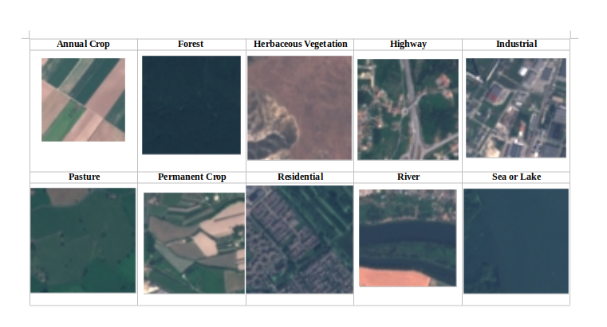

**Methodology**

Transfer Learning VGG16 Model: Standard 16-layer convolutional neural network, initially trained on ImageNet. Additional dense and dropout layer were added in the process.

Fine-Tuning: Freezing the first 15 layers, modifying the fully connected layers to match the dataset's number of classes.

Training Setup: Adam optimizer, learning rate of , early stopping.

**Implementation**

1. Instantiating a sequential model after loading vgg16 model without it’s classification layer.

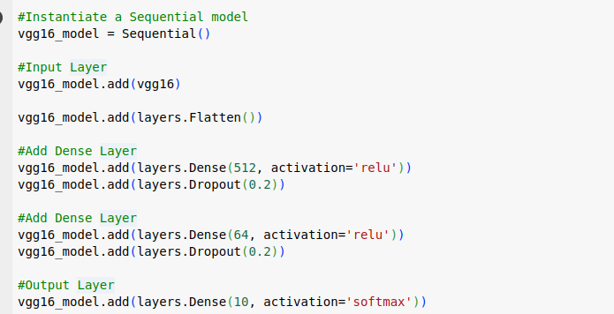2. Vgg16 layers were frozen

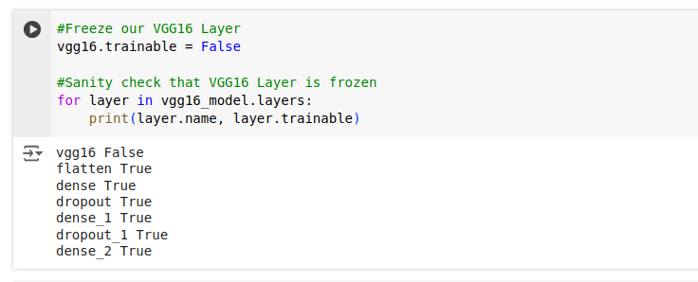

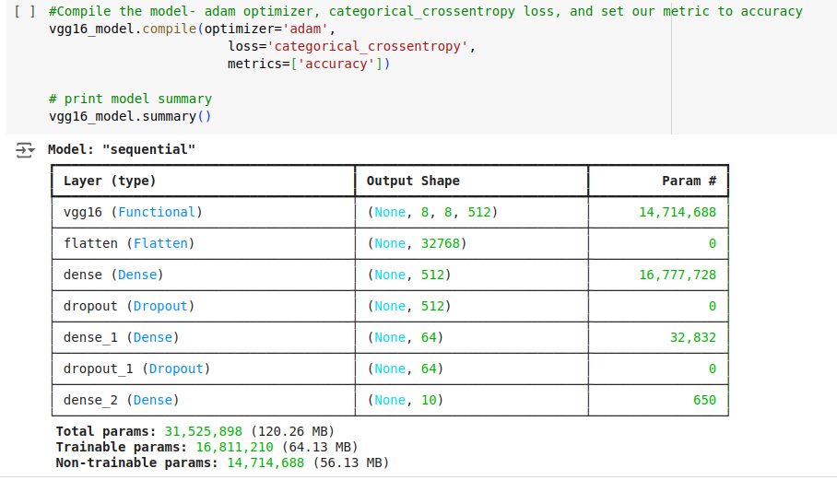3.

4. 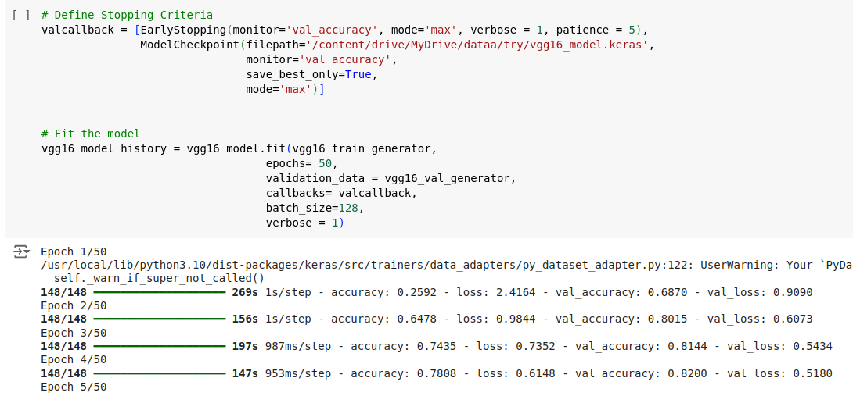Saving the model during training for future use

5. 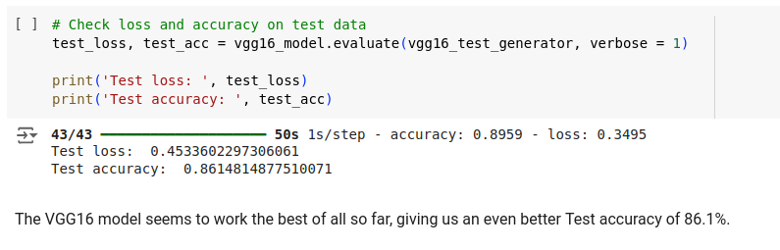 Testing the transfer learned vgg16 model on test data.

6. Fine tuning vgg16 at layer 15.

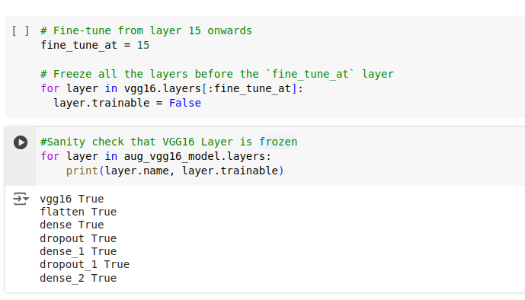

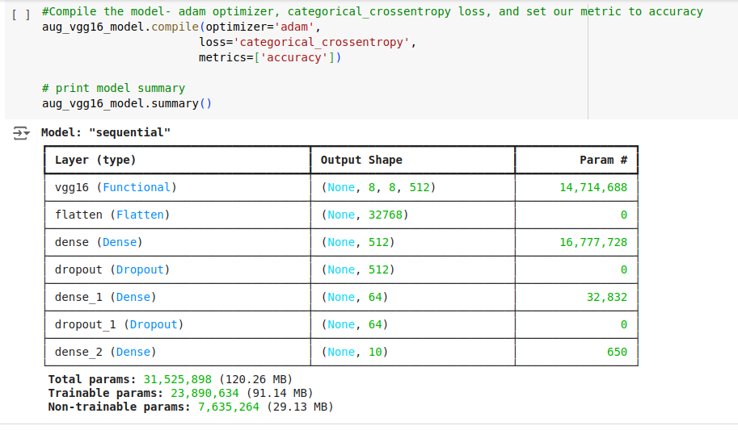7.

8.

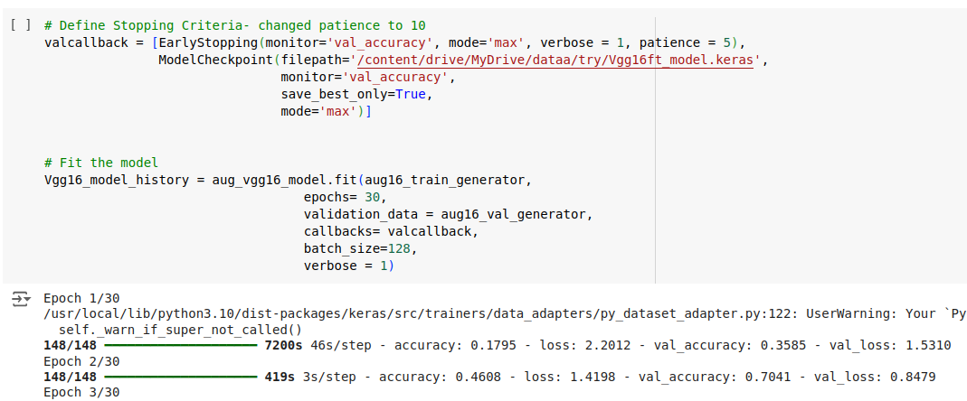

9.

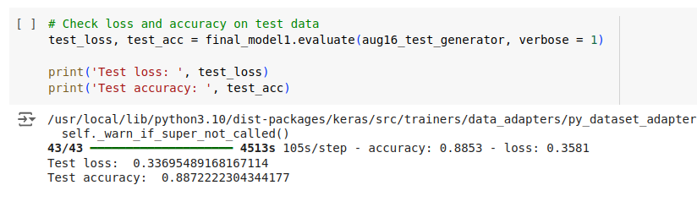10. The confusion matrix is a crucial diagnostic tool for identifying where the model performs well and where it struggles, helping to fine-tune and improve the classification system.

Th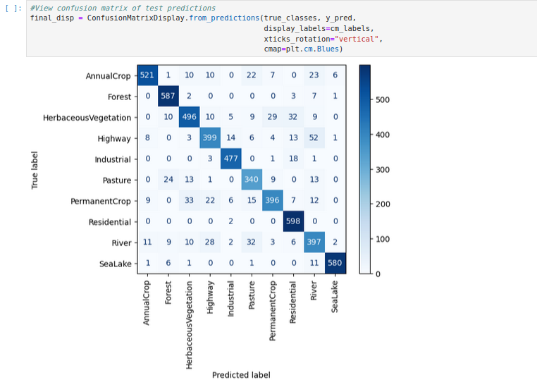e model has strong performance on the "SeaLake" class, as indicated by the high value (580) on the diagonal for "SeaLake".

* There is some confusion between classes, such as "PermanentCrop" being misclassified as "Residential" (value of 33) and vice versa.
* Some classes like "HerbaceousVegetation" and "Highway" also show moderate levels of confusion.