Client intermediate table has both tin and npi table

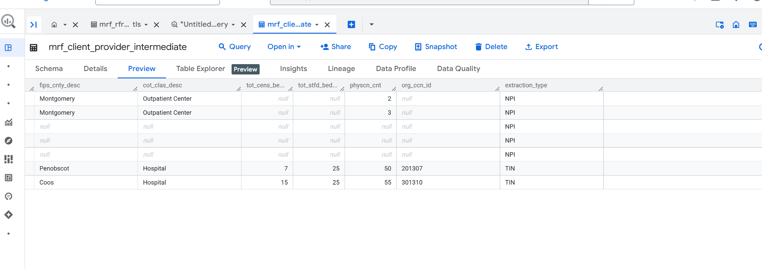

Sp ran:

DECLARE client_name STRING DEFAULT NULL;

DECLARE in_file_group_id ARRAY<INT64> DEFAULT NULL;

DECLARE service_code ARRAY<STRING> DEFAULT ["01", "10", "11", "12", "19", "20", "21", "22", "23", "24", "31", "65", "CSTM-00","01","03","04","05"];

DECLARE billing_code_type ARRAY<STRING> DEFAULT ["CPT","HCPCS","MS-DRG","RC"];

DECLARE billing_class ARRAY<STRING> DEFAULT ['professional','institutional'];

DECLARE npi_list STRING DEFAULT NULL;

DECLARE tin_list STRING DEFAULT NULL;

DECLARE use_komodo BOOL DEFAULT NULL;

DECLARE run_rc_to_drg BOOL DEFAULT NULL;

create temp table npi_sanket as (SELECT distinct npi FROM `dip-gcp-myratefinder-preprod.zashtestenv.npilist`);

create temp table tin_sanket as (select distinct tin from `dip-gcp-myratefinder-preprod.zashtestenv.tinlist`);

set tin_list= "tin_sanket";

set npi_list = "npi_sanket";

CALL `dip-gcp-myratefinder-preprod.MRF_Payer_Extract.mrf_analytical_complete_load`("tin_vs_npi_6459_final", [7861683739969114121], service_code, billing_code_type, billing_class, npi_list, tin_list, false, false);