**UF1:** Sistemes ERP-CRM. Implantació.

**NF2:** Instal·lació ERP

**EA4:** Admin and configure Nav

**Pràctica 2**

**Tasks:**

From pdf “MODULE 2: USER INTERFACE” answer these questions:

1. What can you use the **Search** box for?
   1. To find any page, report, or view present on the Departments page.
   2. To find any page, report, or form present on the Departments page.
   3. To find any page or report present on the Departments page.
   4. To find any page, report, or view present on the Home page.

Answer:_A___

1. Which of the following statements about the navigation pane is true?
   1. You can remove the Home menu.
   2. You cannot remove the Departments menu.
   3. At a minimum, the navigation pane contains the Home and the Departments menu.

Answer:_C___

1. Name some of the advantages of the ribbon?

Answer: Ribbon és molt customizable i això fa que es faci una tarea molt més senzilla i millor. Altres avantatges es que pot veure fàcilment les seves funcions i característiques que té el programa, això condiciona a que l’usuari tingui un recorregut d’aprenentatge molt més veloç i eficient.

1. Assign a Role Center:

**Scenario**

You are the accounting manager at CRONUS International Ltd., and uses the default Role Center (Sales Order Processor). However, this Role Center is not aligned with your daily activities. Therefore you are advised to use the accounting manager profile.

Assign the accounting manager profile to your user account.

Answer: Per poder canviar el compte a farem els passos següents.

Primer anem al menu “Departamentos”



Despres anem al apartat Administració i després seleccionem usuaris.

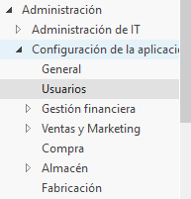

Després seleccionem la configuració d’usuaris.

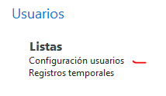

Una vegada estem dins cliquem a nou.

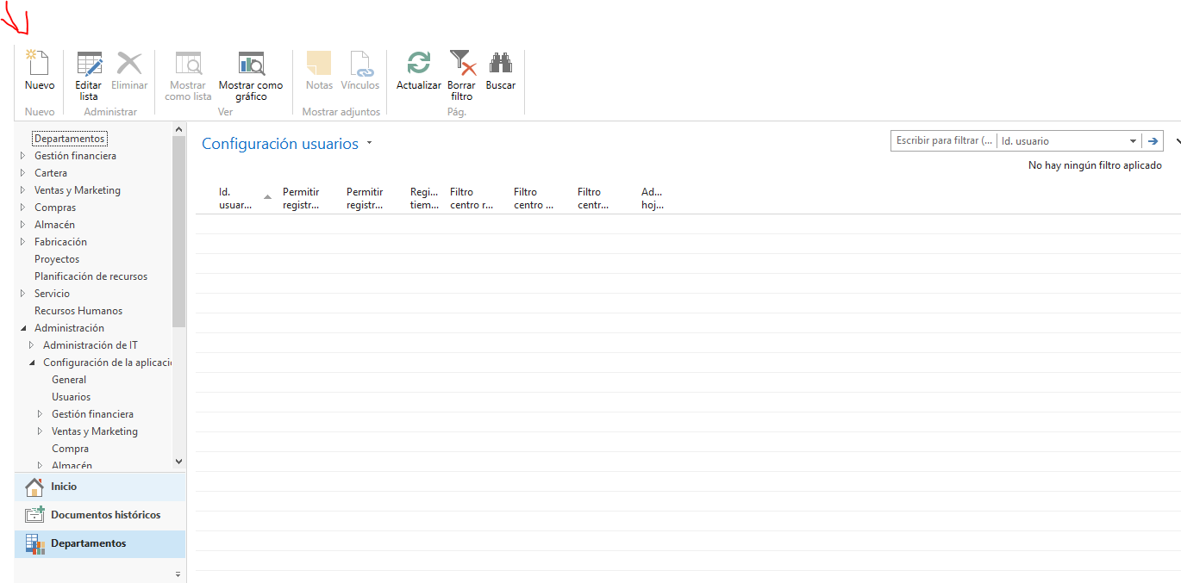

Seleccionem el nostre equip



Ara que tenim l’usuari ens anem al rols de client a la barra lateral. y a personalització d’usuari

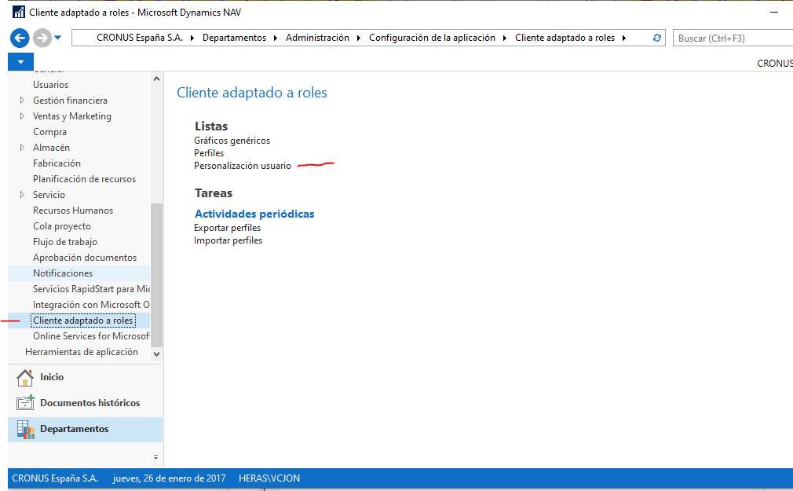

Seleccionem el nostre i fem doble clic

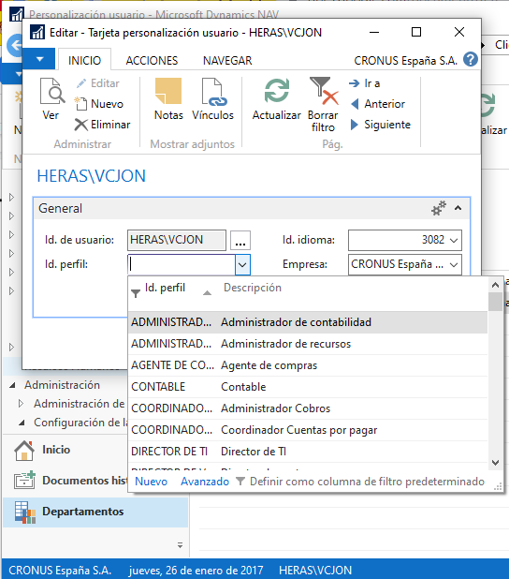

Seleccionem Adminsitrador de contabilidad

From pdf “MODULE 3: USER PERSONALIZATION” answer these scenarios:

1. Add a ListPlace to the Navigation Pane

**Scenario**

As the order processor at CRONUS International Ltd., you generally perform tasks in the sales order processes. Your profile has provided you with the corresponding available activity buttons in the navigation pane.

However, sometimes you have to perform some tasks outside your usual job description. You want to perform the following tasks from the navigation pane:

• Send out mailing lists, by using the Segments and Contacts of the Marketing application area.

• Process a Purchase Order, for the supply of office material or a specific order related to a sales order.

• Process and follow up on Approval Request Entries and Approval Entries.

Answer:____

Primerament obrirem el desplegable de dalt i anem a Personalizar > Personalizar panel de exploración.

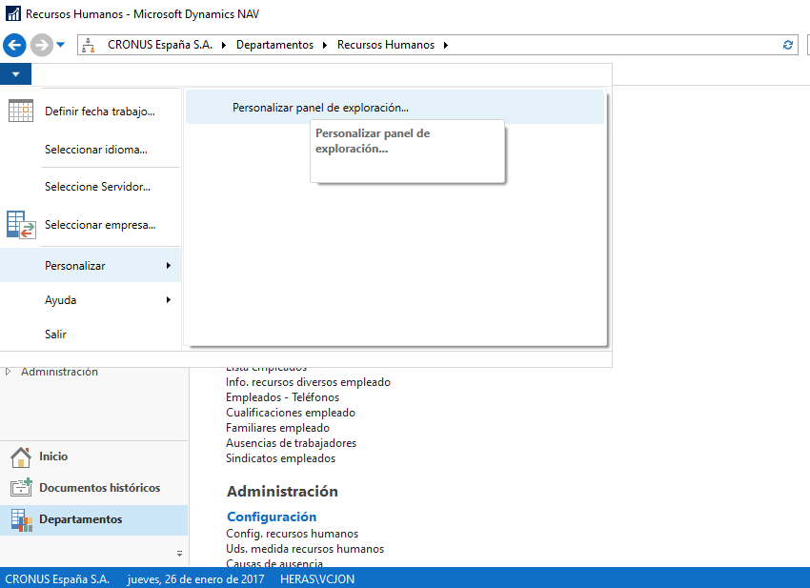

Aqui tenim que anar a Agregar i despres seleccionem Contactos i Segmentos dentro de Marketing que esta dins de Ventas y Marketing

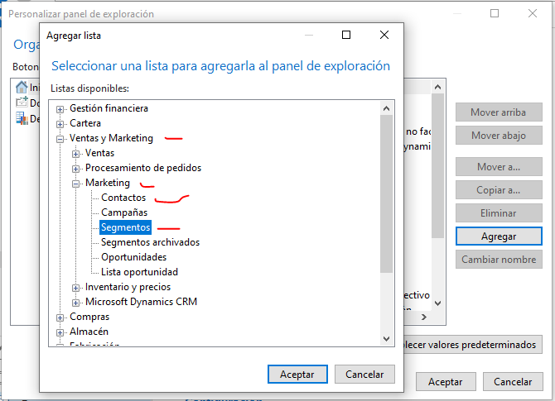

I podrem veure’ls en la llista

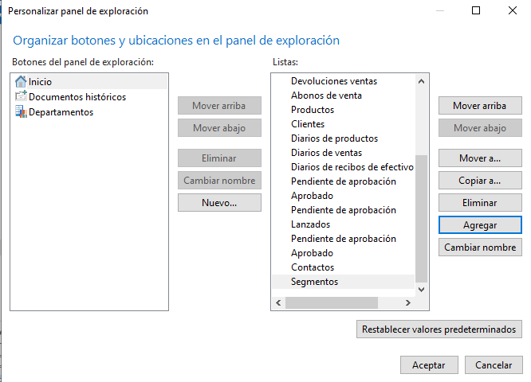

Per poder afegir les comandes de compra, tenim que fer el mateix process pero agregan Pedidos de compra y Solicitudes para aprobar.

Ja podem veure tots el elements que em seleccionat.

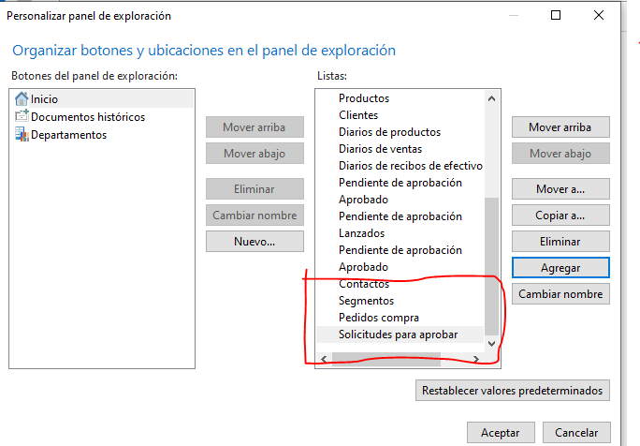

1. Add a Chart to the Role Center

**Scenario**

As the sales order (SO) processor you want to adjust your Role Center by adding the following charts:

• Customer Sales and Profit (generic)

• SO per location (generic)

Answer:

Primer tenim que canviar el rol del nostre usuari i per fer-ho ho tenim que fer com ho he fet a la primera pregunta.

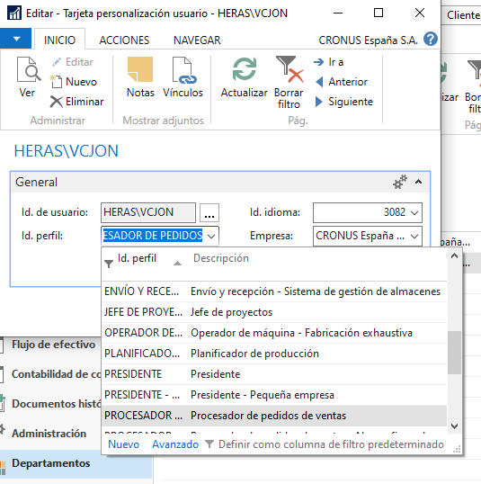

Ara anirem a personalitzar la pagina seleccionem Personalizar > Personalizar esta página

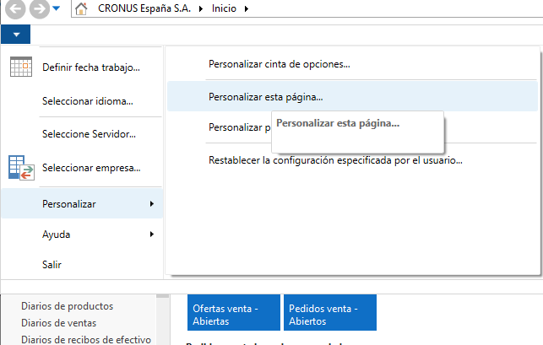

Seleccionem el Elemento grafico i li donem a Agregar. Ho hem de fer dos cops per aixi ens demanara dos grafics.

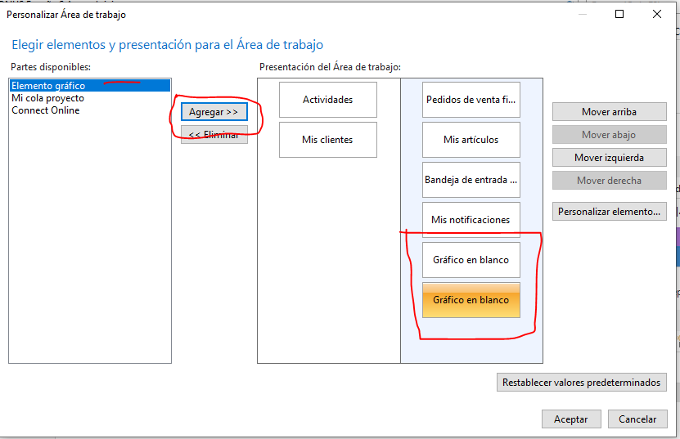

Ara tenim que anar al elemento que posa Personalizar elemento. i seleccionem el gràfic que demana, aquest cop sera Ventas y beneficios cliente.

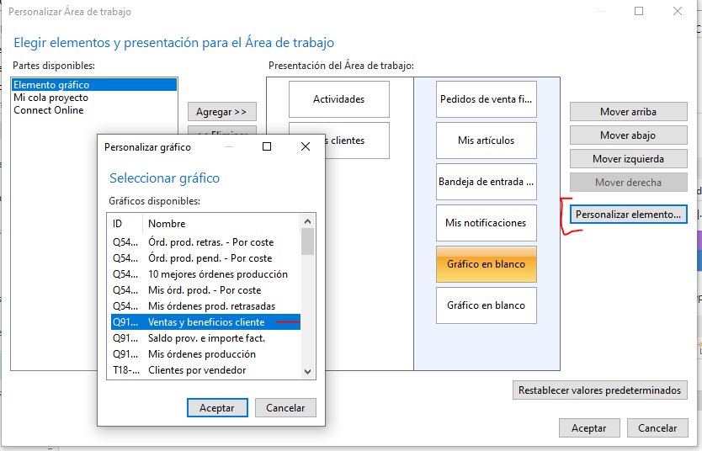

I el segon gràfic ho farem PV por ubicación

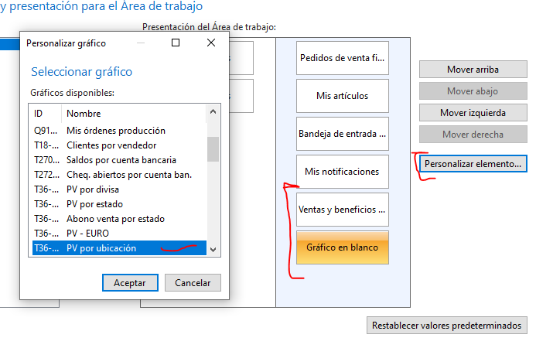

Ara podem visualitzar el gràfic que hem seleccionat amb anterioritat, pero el de Ventas y benificios cliente deu tenir algun error porque no es pot visualizar.

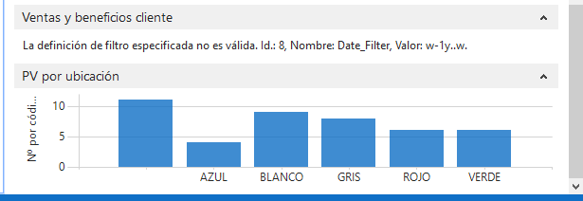

From pdf “MODULE 4: BASIC FUNCTIONALITIES” answer these questions:

1. How many employees are there in CRONUS International, Ltd.?

Answer:__8__

1. Who is the contact at customer ”Beef House” ?

Answer: Frau Karin Fleischer

1. Who is the contact at customer with number 47563218?

Answer: Thomas Andersen

1. How many bank account are set up in Cronus International, Ltd. ?

Answer: 6

1. What is current inventory of item no. 70000?

Answer: 2202 /

1. Who is the contact at customer 49525252, Beef House?

Answer: Frau Karin Fleischer

1. What is the current balance (LCY) on customer 49525252, Beef House?

Answer: 17346,60

1. How many open invoices does customer 49525252, Beef House, have?

Answer: 5

1. What is the unit price of item number 70040?

Answer: 85,40

1. What keys do you press to delete a customer?

Answer: CTRL + Suprimir

1. What would the following filter expression display: 1100..2100?

Answer: Aquells elements que el número d’identificació comenci entre 1100 i 2100

1. From what type of field can you drill down to related entries?

Answer: Per claus

1. What is the e-mail address of vendor Mountain Fisheries ?

Answer: mountain.fisheries@cronuscorp.net

1. What is status of sales order 6003?

Answer: Lanzado

1. Who is purchaser responsible of purchase order no. 104002?

Answer: Muebles Lido