1. We need to calculate the hours of nurses and keep record of it. Total hours for every nurse is 208. That should show sum in the dashboard, that total nurses are X and total available hours are Y.
2. When we assign nurse to any patient. Assigned hours should be deducted from patients’ available hours.
3. We need to show presentable nurses and patients data
4. On employee dropdown next to their name show the available hours.

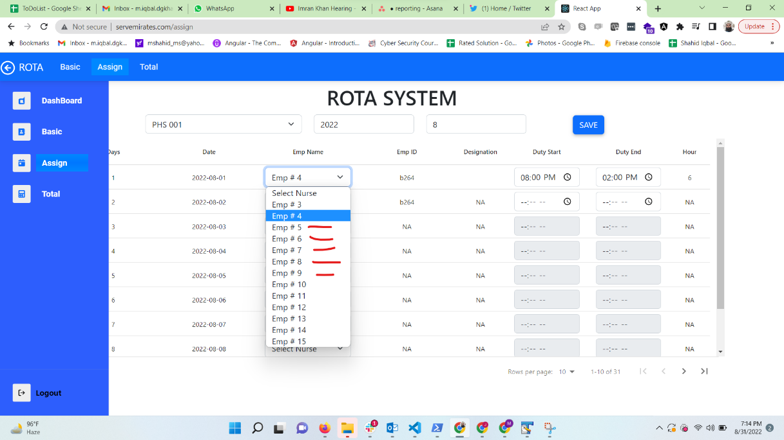

In above image where the red line is, we can show available hours of that nurse for specific month.

1. Remove circled data from dashboard.

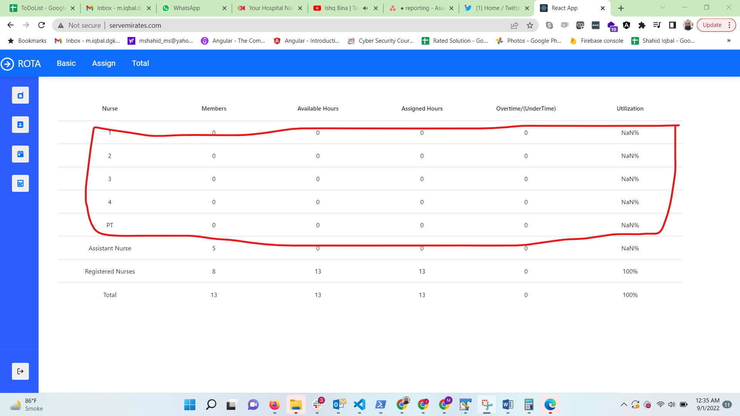

1. Rename Rota system to Duty Roaster.