We need to calculate the hours of nurses and keep record of it. Total hours for every nurse is 208. That should show sum in the dashboard, that total nurses are X and total available hours are Y.

1. When we assign nurse to any patient. Assigned hours should be deducted from NURSES available
2. We need to show presentable nurses and patients data
3. On employee dropdown next to their name show th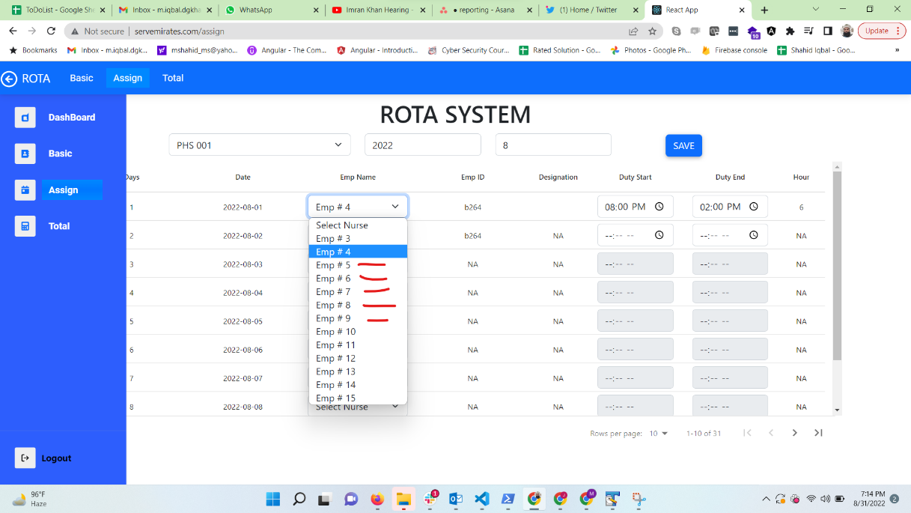e available hours.

In above image where the red line is, we can show available hours of that nurse for specific month.

1. Remove circled data from dashboard.

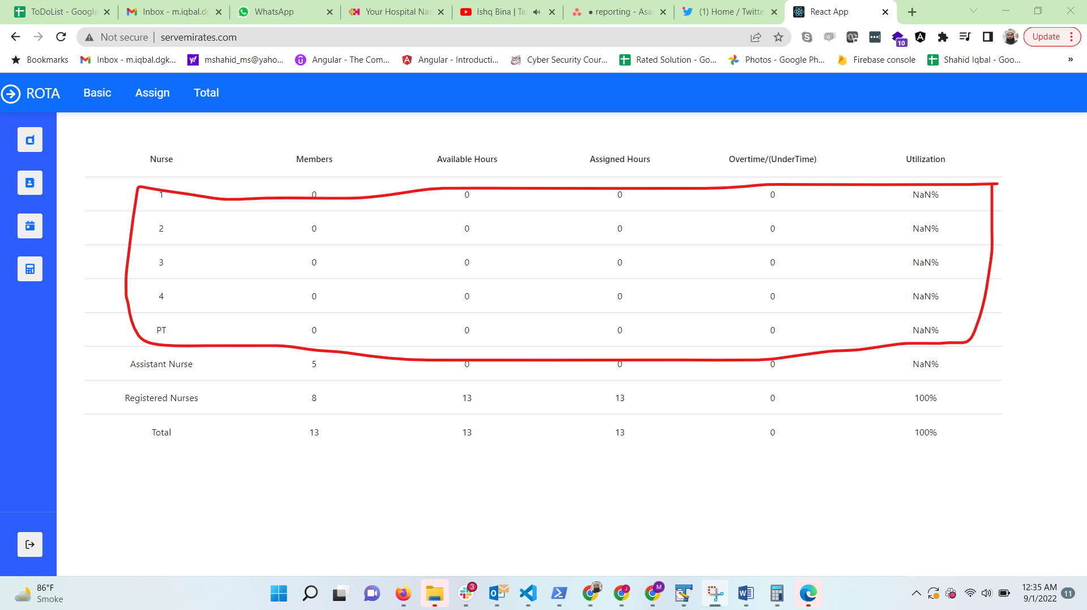

1. Rename Rota system to Duty Roaster.
2. If we try to assign duty to a nurse and her duty is already set for other patient, system will tell us popup that “Nurse is allocated for 8am to 12pm to Alex. You want to overwrite?”. It will have option yes or no.
3. Admin login page, when we fill credentials, we should be able to login with enter
4. On rota page, when we set duty start, duty end time cannot be selected before duty start time.