A Project Report on

Electviz: Data Visualization and Analysis of Elections

Infosys Spring board Virtual Internship 6.0

Submitted by
Team Details:
- Neelapu Herambudu
- Francis Daniel
- Swathika Murugan
- Shaik Shabeena Praveen
- Gopi Krishna
- Tanmay Parulkar
Internship Duration: 8 weeks (2 months)
1.Project Title:
ElectViz is an interactive data visualization project designed to analyze, interpret, and present election data in a clear and engaging way. Developed using Power BI, this project transforms large-scale election datasets into intuitive dashboards that help media organizations, analysts, and the public gain meaningful insights into voting patterns, party performance, and regional election dynamics.
The project demonstrates how data analytics and visualization can enhance political reporting by offering fact-based, data-driven stories. By simplifying complex datasets into visual narratives, ElectViz empowers users to make informed interpretations of election outcomes.
2.Project Objective:
The objective of ElectViz is to transform raw U.S. election data into a clear, interactive, and trustworthy visual story. The project aims to help users, students, analysts, media teams, and the general public, quickly interpret voting patterns, party performance, and state-wise outcomes using an intuitive Power BI dashboard. By simplifying a complex national dataset, ElectViz enables fast insights, evidence-based conclusions, and more informed democratic understanding.
3.Project Description:
ElectViz is a data visualization project designed to improve how election results are understood by the media and the public. It is an interactive data visualization project designed to analyze, interpret, and present election data in a clear and engaging way.
The problem addressed by this project is that election data is often presented in complex tables and articles, making it difficult for audiences to quickly grasp trends, regional patterns, and key outcomes.
Developed using Power BI, this project transforms large-scale election datasets into intuitive dashboards that help media organizations, analysts, and the public gain meaningful regions and parties insights into voting patterns, party performance, and regional election dynamics. The project demonstrates how data analytics and visualization can enhance political reporting by offering fact-based, data-driven stories. By simplifying complex datasets into visual narratives, ElectViz empowers users to make informed interpretations of election outcomes such as :
• Quick identification of key trends and close races
• Improves audience engagement and trust
• Faster election result analysis
• Easy comparison across
3.1 Project Overview
ElectViz is a multi-page Power BI dashboard developed to analyze historical election data spanning several decades. The dataset contains information related to election year, state, party affiliation, vote counts, vote share, candidates, and seat allocation.
The dashboard enables:
* Macro-level analysis (national trends)
* Meso-level analysis (state and party comparisons)
* Micro-level analysis (candidate performance)
Through interactive filters and visual elements, ElectViz supports exploratory analysis and informed interpretation of electoral patterns.
3.2 Project Approach
Our team followed a structured and iterative workflow to convert a messy, inconsistent US Election dataset into a fully interactive analytical dashboard.
Step 1 – Understanding the Raw Dataset
- The initial dataset contained several issues:
- Missing district names
- Mixed party abbreviations and full names
- Incorrect vote share values (e.g., 0.01 instead of 1%)
- Duplicate and inconsistent state formatting
- Fragmented election type fields (special, runoff, fusion, etc.)
The team first analyzed the structure to identify all cleaning and transformation steps needed.
Step 2 – Data Cleaning & Preparation (Power Query)
Using Power Query, the team:
- Standardized state names and party labels
- Removed duplicates and unused columns
- Handled missing values and inconsistent formatting
- Created a reliable base table ready for modeling
- Ensured numerical fields like candidate votes and total votes were properly typed
This step ensured that the dashboard visuals produced correct insights.
Step 3 – Data Modeling & Measure Creation (DAX)
Custom DAX measures were created to support analysis:
- Total Votes
- Total Candidates
- Average Vote Share
- Seats Won by Party
- Year-over-Year Vote Trends
- Party Vote Share %
DAX also fixed logical issues created by the raw dataset (e.g., recalculating correct percentages).
Step 4 – Designing Visual Pages
Three dashboard pages were built with a clear structure:
Page 1 – Election Overview & Trends
Page 2 – Special Elections & Fusion Ticket Analysis
Page 3 – State-wise Candidate Vote Distribution
Page 4 – Party & Candidate Performance
Page 5 – Seat Distribution by Party and State
Page 6 – State Wise Election Participation
Page 7 –Election Results-Final Overview
Step 5 – Usability & Visual Refinements
We refined:
- Map color contrast
- Data label visibility
- Slicer interactivity
- Clean layout spacing
- Improved title clarity & page names
3.3 Technology Used
Dataset:
- Microsoft Excel (US_House_Election.csv file)
Dashboard:
- Power BI
- Power Query (M Language)
- DAX (Data Analysis Expressions)
Documentation:
    - PDF
    - GitHub
3.4 Insights from dashboard
These insights reflect our actual ElectViz visuals:
- Voting Trends Over Time

- Total votes show long-term growth, indicating increasing voter participation.

- Presidential election years show significant spikes compared to midterms.

- Party Dominance Patterns

- Republican and Democratic parties hold the largest share of votes consistently.
- Third parties like Libertarian and Independent show niche but stable contributions.
- Certain states exhibit long-term loyalty to a specific party.

- State-Level Distribution

- Coastal and high-population states contribute significantly larger vote volumes.
- Several central and mountain-region states show more competitive, shifting trends.

- Candidate-Level Insights

- Top-performing candidates cluster heavily in key battleground states.
- Candidates with fusion tickets or multiple party endorsements show distinct vote patterns.

- Election Type Behavior

- Special elections and runoffs have substantially lower participation.
- Vote share and margins fluctuate more heavily in these non-standard elections.
3.5 REAL-WORLD IMPACT (MEDIA & PUBLIC COMMUNICATION)
For Newsrooms & Media
- Journalists can rapidly filter by year, state, and party for instant storytelling.
- The visualization layout replicates real-time election-night dashboards.
- Helps decode complex patterns like vote swings, seat changes, and party shifts.
- Converts thousands of messy records into clean, broadcast-ready graphics.

For the General Public
- Simplifies election results for non-experts.
- Builds transparency in democratic processes.
- Enables citizens to explore historical patterns, turnout, and vote share.
- Helps students and analysts understand long-term political shifts.
For Researchers & Policy Analysts
- Generates insights on party performance history.
- Useful for studying turnout patterns and electoral behaviors.
- Can be extended to demographic analysis for deeper political research.

4. Timeline Overview:

WEEK.NO | EXECUTIVE SUMMARY
Week 1: | Project Initialization, Dataset Setup, Data cleaning and preprocessing
Week 2: | Dashboard development: Page 1, 2, 3
Week 3: | Optimization and documentation
Week 4: | Dashboard development: Page 4, 5
Week 5: | Optimization and documentation
Week 6: | Dashboard development: Page 6, 7
Week 7: | Optimization and documentation
Week 8: | Documentation and Final Presentation
5a. Key Milestones
- Dataset successfully cleaned and standardized
- Power BI data model finalized
- All dashboard modules implemented
- Insights validated through cross-filtering
- Final report prepared
5b. Project Execution Details
The project was executed using an iterative development methodology, allowing continuous refinement of visuals, calculations, and narrative coherence. Regular internal reviews ensured alignment with analytical objectives.
6. Snapshots / Screenshots – Page-wise Explanation
6.1 Election Overview and Trends:

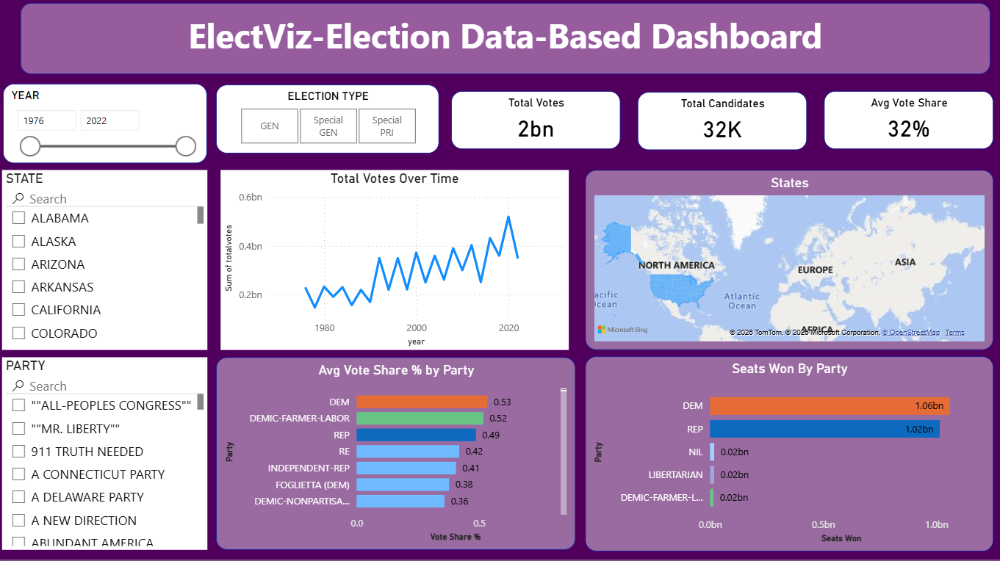
Summarizes key metrics such as total votes, candidate count, and average vote share. Provides temporal and geographic insights into voter participation.

  - Special Elections and Fusion Ticket Analysis
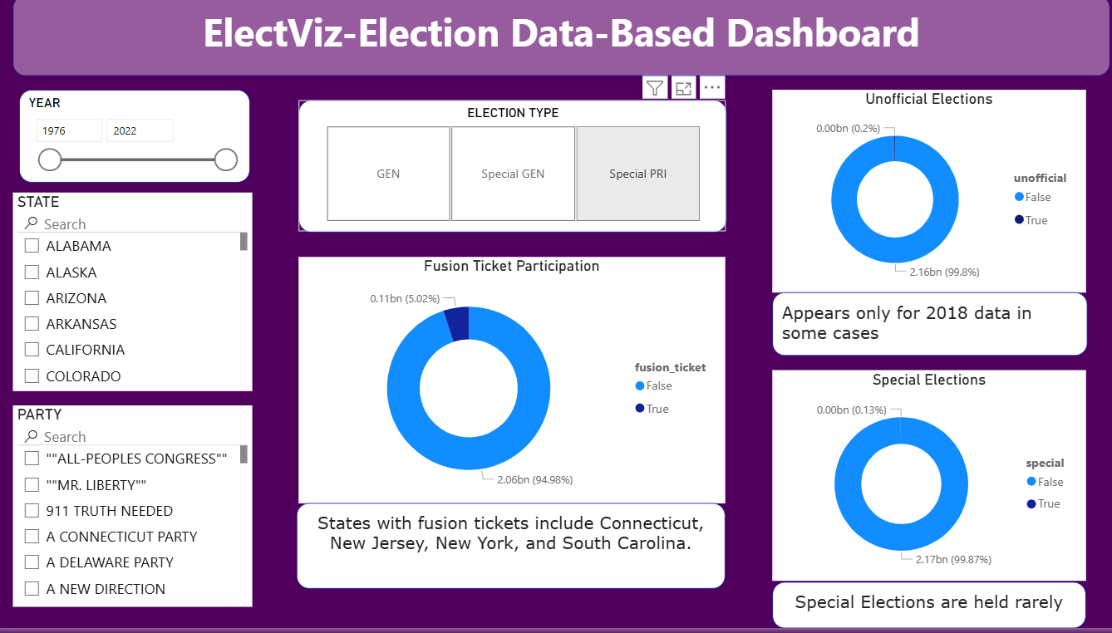
Analyzes the frequency and distribution of special elections and fusion tickets, highlighting their limited occurrence.
  - State-wise Candidate Vote Distribution

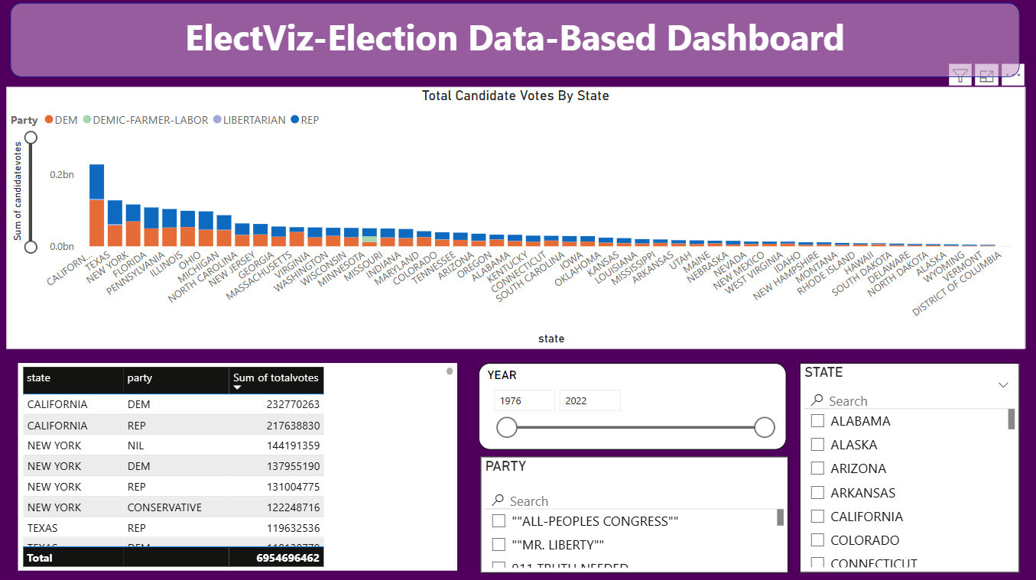Examines vote distribution across states and parties, enabling comparative analysis of regional political behavior.
  - Party and Candidate Performance
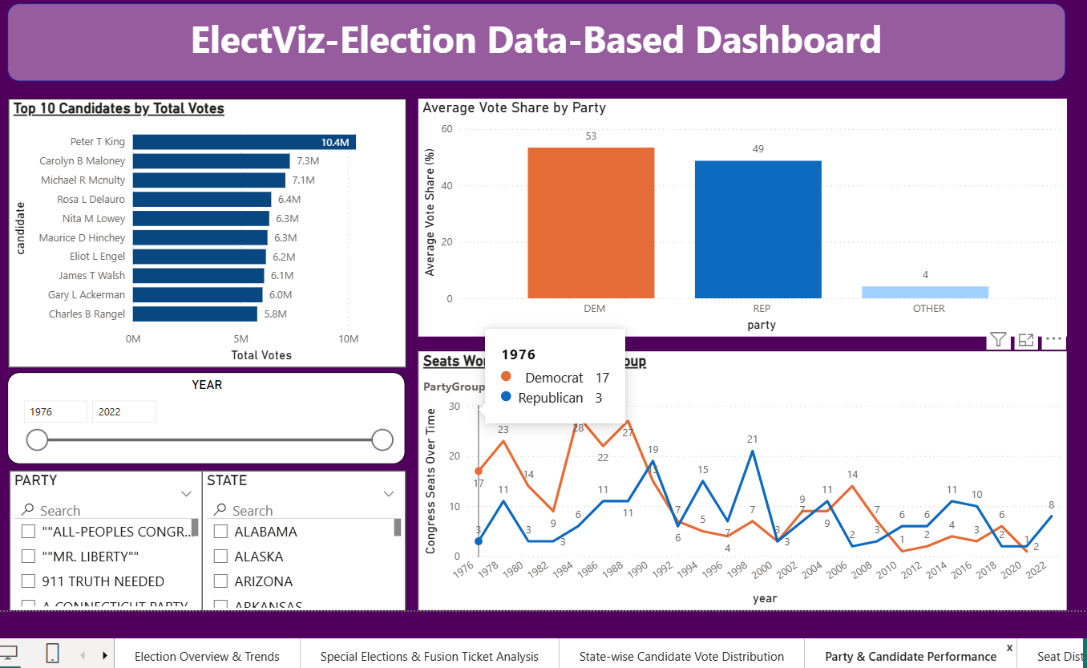
Identifies top-performing candidates and evaluates average vote share across parties.
  - Seat Distribution by Party and State
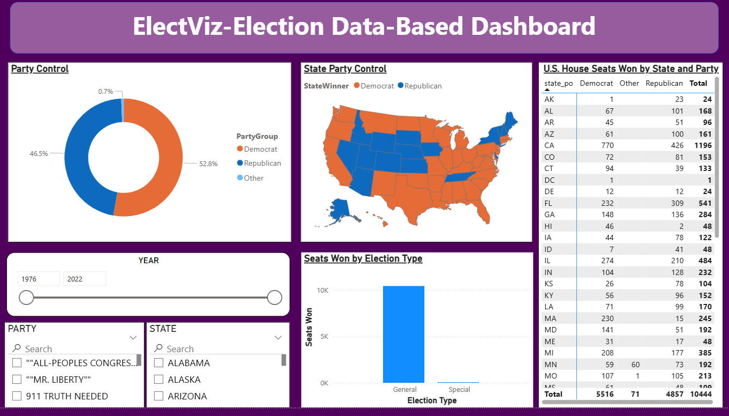
Illustrates party dominance at national and state levels through maps and tables.
  - State-wise Election Participation and Comparison
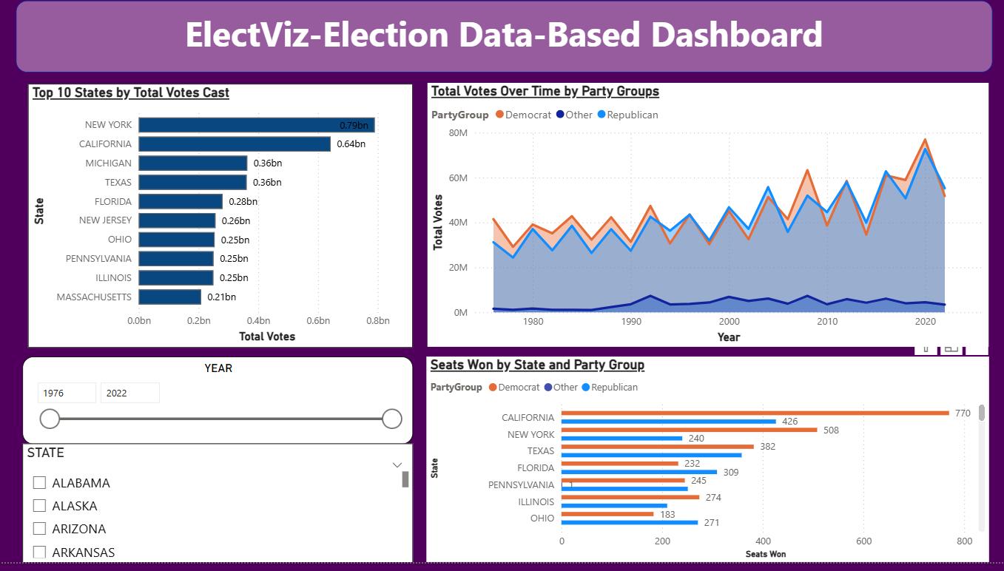
Compares total votes and seat wins across states and party groups.
  - Vote Share and Party Group Analysis
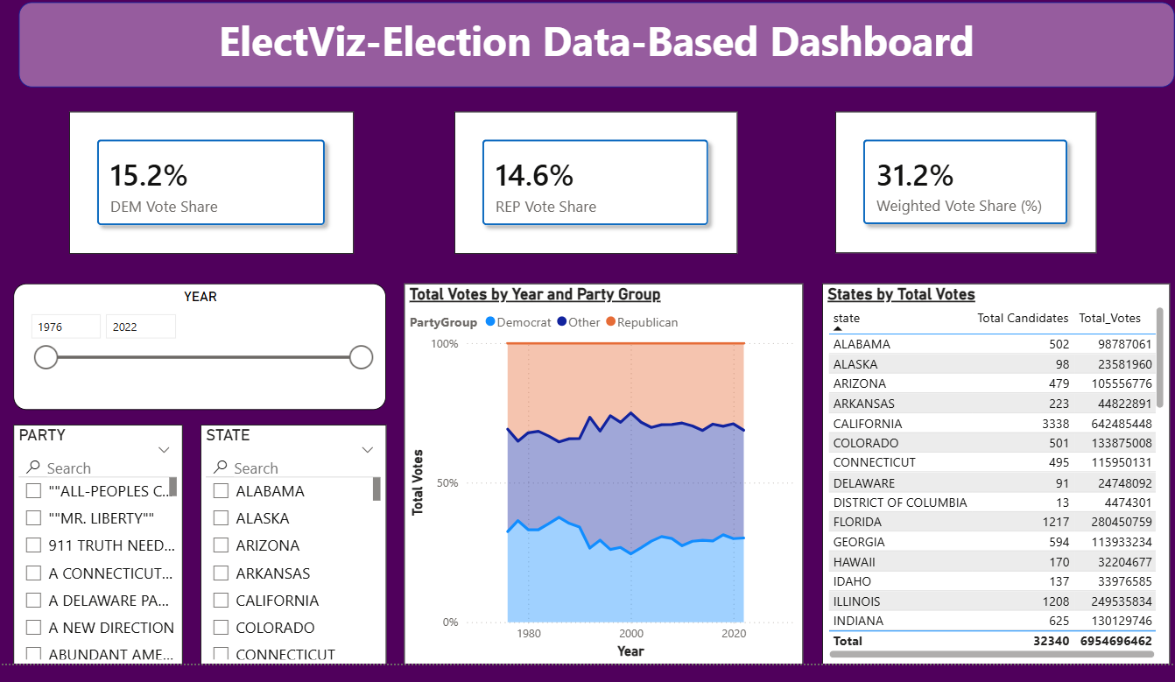
Analyzes weighted vote share and long-term party performance trends.

7. Challenges Faced
7.1 Managing Heterogeneous Election Data
The election dataset contained records from multiple years, states, and parties with varying formats and structures, making it challenging to ensure uniformity and analytical consistency across the dashboard.
7.2 Designing Meaningful Data Relationships
Establishing correct relationships between fact tables and multiple dimension tables required careful validation to avoid incorrect aggregations and misleading insights.
7.3 Handling High Cardinality Dimensions
Large numbers of parties and candidates increased visual complexity and affected dashboard readability, requiring thoughtful aggregation and filtering strategies.
7.4 Balancing Visual Detail with Interpretability
Including comprehensive information while maintaining visual clarity was challenging, as excessive detail could overwhelm users and dilute key insights.
7.5 Ensuring Analytical Accuracy Across Filters
Maintaining consistent and accurate results when multiple slicers (year, state, party, election type) were applied simultaneously required extensive testing and refinement.
8. Learnings and Skills Acquired
8.1 Advanced Data Structuring Techniques
Developed a deeper understanding of how to structure and normalize complex datasets to support scalable and efficient analytical models.
8.2 Contextual Data Interpretation
Learned to interpret numerical outputs within the broader political and historical context, improving the quality and relevance of insights generated.
8.3 Visualization Strategy and Design Thinking
Gained experience in selecting appropriate visualizations based on the nature of data and the analytical question being addressed.
8.4 Performance-Aware Dashboard Development
Acquired knowledge on optimizing calculations, reducing unnecessary visuals, and improving overall dashboard responsiveness.
8.5 Analytical Storytelling for Decision Support
Learned how to connect individual visuals into a coherent narrative that guides users toward data-driven understanding and informed conclusions.
9. Testimonials from Team
> “The project enhanced our technical and analytical capabilities while providing real-world data experience.”
> “Collaborative development improved both our technical and interpersonal skills.”
10. Conclusion

The ElectViz project demonstrates the effectiveness of data visualization and analytics in interpreting complex electoral datasets. The interactive Power BI dashboard provides a comprehensive analytical framework for understanding voting behavior, party dominance, and regional political trends.

11. Acknowledgements

- We would like to express our heartfelt gratitude to: Infosys Springboard Team – for organizing this valuable internship opportunity.
- Our Mentor – Mrs Nithyasri S J for her continuous support and feedback.
- My Teammates –Neelapu Herambudu, Francis Daniel, Swathika Murugan, Shaik Shabeena Praveen, Gopi Krishna, Tanmay Parulkar for collaboration, encouragement, and insights
- This internship has been a significant step in our professional growth and technical journey.
- References: Election Dataset (Election Commission of India / Kaggle source)
Microsoft Power BI Documentation
Infosys Springboard Virtual Internship course materials

