GAN Dashboard (POC)

As part of Proof of concept, I tried implementing an Agglomerative Clustering algorithm on random data points, As the algorithm which uses different types of linkages to cluster the points all the different linkages are provided in dropdown. User can select the data points using some features provided by plotly.

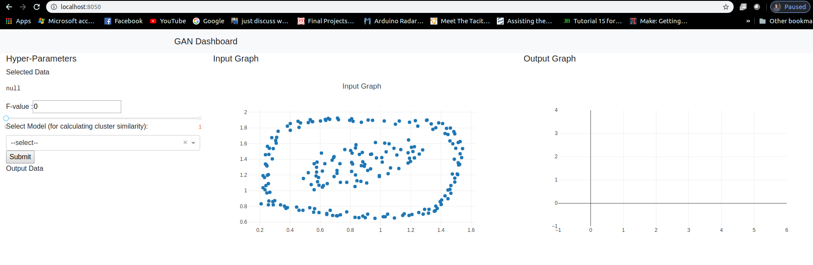

Selecting the data points.
User can select the desired data points by using built-in features provided by plotly.

When we hover on the graph we can see a tool bar on top right of the graph. In that toolbar(surrounded by Blue Line) we can use the option with a dotted box or the ring(marked red, 4th and 5th options) to select the data

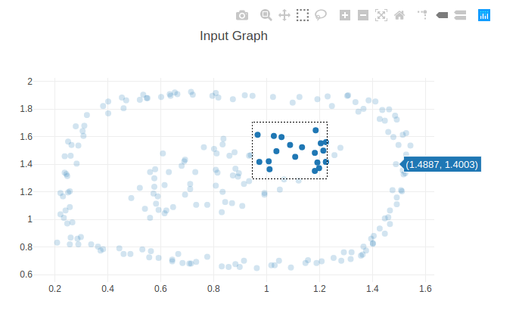
All the data points selected are displayed on the left side under selected data label.
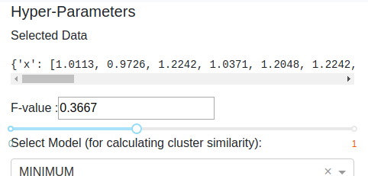

We can use the slider to change the f-value and select the linkage type from the dropdown. Below image shows the dropdown options to select

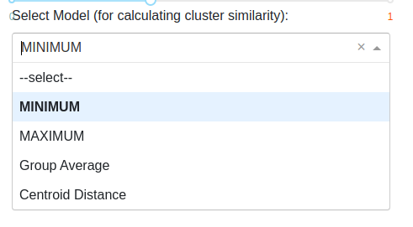

After selecting all the parameters, the dashboard looks like below
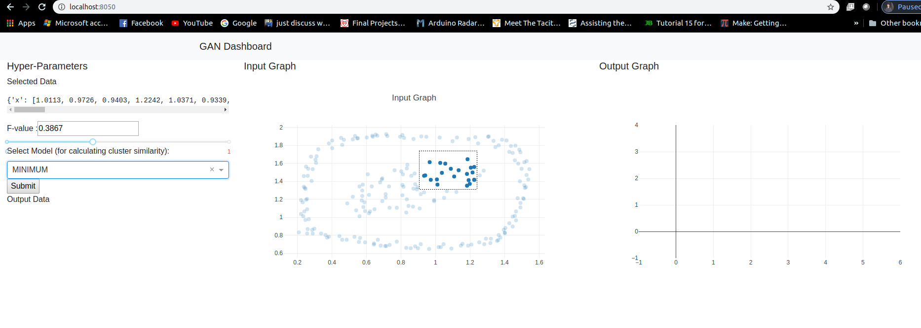

Click on Submit , the output data displays the modified data in JSON format and Output graph displays the output result of modified data which is fed to the selected model.

The f-value gets added to the y-axis points and the modified y-axis points are fed to the clustering model to get the clusters.

Below is the image for reference.

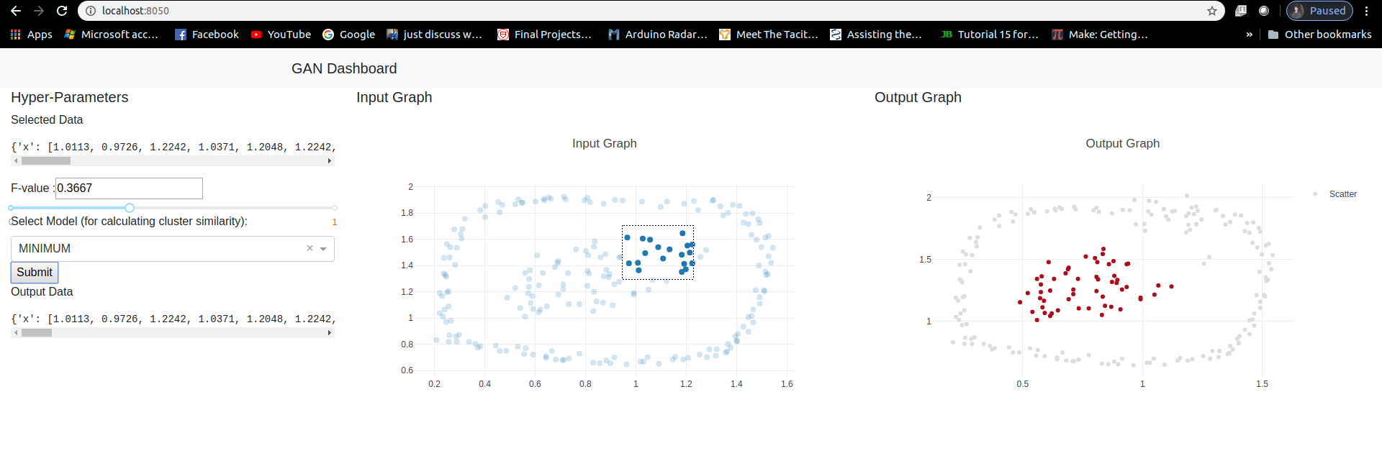
We can see that the selected data points have been modified and fed to a model which clusters the data and then the modified clusters are plotted as shown in the image above.

